
A partnership between
Cardinia Shire Council and Johns Hill Landcare Group


Why don’t they manage their weeds?
A community-based ‘Behaviour Change’ Research Project
December 2012
Contributors
Karen Alexander
M.App.Sc. – President, Johns Hill Landcare Group Inc; Project Leader, Victoria Naturally Alliance. Wide experience with behaviour change programs. Passionate about ensuring good returns on the major volunteer investment, plus dollars, in weed work by Landcare, Friends groups and councils.
Contact Johns Hill Landcare via email info@johnshill.org.au or visit www.johnshill.org.au
Julie Thompson
B.Sc., B.Bus. – Member of Johns Hill Landcare Group Inc. and has extensive experience in accessing research and report writing as well as working with community groups.
Marianne Sawyer
B. Nat Ther. Dip NRM – Weed Management Officer at Cardinia Shire Council. Contact Council’s waste management officer via email m.sawyer@cardinia.vic.gov.au
Rosalie Cooper
MBBS, MSc, MPH – Member of Johns Hill Landcare Group Inc., has taken part in scientific research in her career and has epidemiological and statistical skills.
Libby Smith
Marketing Consultant, Motive Market Research Pty Ltd. Extensive experience in qualitative market research over a period of 40 years. Worked as independent moderator for the focus groups.
Contact Motive Market Research via email libsmith@iprimus.com.au
Roger Cooper
B. Bus. – Data consultant and analysed results from telephone survey.
Thanks and acknowledgements
Staff at Cardinia Shire Council
Members of the six Towns Reference Group
Doug McKenzie-Mohr
Community members who have contributed to postal, telephone surveys and focus group discussions and all others who like to discuss weeds.

EXECUTIVE SUMMARY
This document records the progress of a ‘behaviour change’ research project that has examined, through a variety of research methods, the barriers and benefits to landholders carrying out weed control work on private land. Alongside the research project, Cardinia Shire Council has undertaken on-ground work to reduce roadside weeds on public land through the ‘6 Towns Weed Control Project’.
The research shows that community-based programs are likely to be effective in changing behaviour and provide momentum to complete agreed tasks on a wider scale. Crucial to these programs is a skilled facilitator; to form and maintain community groups; to connect groups to technical weed knowledge; and, to empower landholders to effectively change their behaviour towards sustained weed management on private land. A pilot project to test these findings is being developed including synergies with the Blackberry Task Force approach.

Partnership
The collaboration of Council and Johns Hill Landcare, working with the community on weed control outcomes, has been successful for both partners. This is due to a clear understanding of purpose, joint decision-making and sufficient commitment of time and resources from each partner.
The ‘6 Towns Weed Control Project’ is a very good example of community and local government working together. After four years of on-ground works, this project has resulted in a dramatic reduction of roadside weeds. To assist this work, research into community behaviour towards weed control has revealed some important findings that can assist in the development of a community-based weed program.

Methodology and methods
Correct methodology is crucial to the outcomes of research of this nature, in order to ensure that the information sought is done so with appropriate timing and sequencing.
The methodology adopted for use in this project is called ‘fostering sustainable behaviour’. It was considered appropriate for the following reasons:
- primarily for community-based ‘behaviour change’ programs
- provided a clear process
- costs were within the available resources
- could be dovetailed with Council’s evaluation of ‘6 Towns Weed Control Project’.
The Fostering Sustainable Behaviour steps are to:
- select behaviours that you want to encourage and your target audience
- list and prioritise the barriers and benefits for the behaviour you want
- research the barriers and benefits to the behaviours you want
- map the tools and strategies that will encourage the benefits and overcome the barriers for the desired behaviours
- select a pilot to test the strategy.
Several distinct research methods were employed and are presented here as one research project. The methods included a postal survey, telephone survey, focus groups, and a comparison of ‘behaviour change’ programs. As each research method has been undertaken it has informed the direction of the next stage of research.

Recommendations
The recommendations from this research project are to:
- Develop a pilot project that features a neighbourhood approach; uses a skilled facilitator; and sources appropriate expertise specific to each private landholder.
- Secure financial resources for a pilot project and further research.
- Continue to support the partnership between Council and Johns Hill Landcare.
- Ensure the successful results of the project are progressively promoted to the community, Council, the Landcare network and other relevant agencies.

TABLE OF CONTENTS
Why don’t they manage their weeds? 1
1 EXECUTIVE SUMMARY 3
1.1 Partnership 3
1.2 Methodology and methods 3
2 INTRODUCTION 6
3 BACKGROUND 6
3.1 Project context 6
3.2 Cardinia Shire Council 7
3.3 Partnership between Council and Landcare 9
4 MILESTONES ACHIEVED 10
5 Methodology and methods 11
5.1 The Fostering Sustainable Behaviour Methodology of Doug McKenzie-Mohr 11
5.2 Application of the methodology by the research project 11
6 FINDINGS AND RESULTS 14
6.1 Postal survey – Emerald area postcode 3782 14
6.2 Telephone survey 16
6.3 Focus groups 18
6.4 Comparison of ‘behaviour change’ programs 19
7 CONCLUSION 22
8 RECOMMENDATIONS 24
APPENDIX A: POSTAL SURVEY QUESTIONS 25
APPENDIX B: TELEPHONE SURVEY QUESTIONS 27
APPENDIX C: CARDINIA SHIRE ON-GROUND WORKS 30
APPENDIX D: JOHNS HILL LANDCARE ACTIVITIES AREA 30
Diagram 1: Weed research and on-ground projects 10
Diagram 2: Preferred Council action 18
Diagram 3: Stages of behaviour change 20

Table 1: Summary of replies for ‘Why don't you remove all weeds from your property?’ 15
Table 2: Summary of replies for ‘are there benefits to you if you removed your weeds?’ 16

INTRODUCTION
Following discussions to resource and outline a course of action through the weed control meetings an approach was made by Council to Johns Hill Landcare, to undertake a joint community-based ‘behaviour change’ research project.
It was clear that as Council was undertaking weed control on roadsides, private landholders also needed to match this work otherwise reinfestation would rapidly occur. However, traditional methods of encouraging landholders to remove weeds had not been particularly successful hence the need to seek a better way.
The project started with a postal survey to a targeted community group followed by a telephone survey and focus group discussions to tie together the data produced by the two surveys.
Analysis of the data gathered revealed some meaningful results in regards to landowner attitudes to weeds and provided valuable insight to the main barriers preventing people from undertaking weed control on their property. It became evident from this ‘behaviour change’ research that a community-based program addressing these barriers was needed before any sustained community action on weed control could be expected.
A review of the key components of community-based programs was then conducted to compare what elements of these programs contributed to their success, and what lessons may be learnt to apply to a community-based weed control program in Cardinia Shire.
This document records the progress of the ‘behaviour change’ research project that has examined, through a variety of research methods, the barriers and benefits to landholders carrying out weed control work on private land.
It brings together several distinct research methods and presents these as one research project. The methods included a postal survey, telephone survey, focus groups and a comparison of ‘behaviour change’ programs. As each research method has been undertaken it has informed the direction of the next stage of the project.
Finally, the appendices include the postal survey questions, telephone survey questions, a map of Cardinia Shire on-ground works and research areas, and a map Johns Hill Landcare activities area.

BACKGROUND

Project context
Cardinia Shire is the third fastest growing local government area in Victoria. It is located south-east of Melbourne between Western Port Bay and the Shire of Yarra Ranges on the outskirts of Melbourne. The Shire covers an area of 1,280 square kilometres and has an estimated population of 77,233 (June 2011). In the last 10 years, the population of Cardinia Shire has increased by 60 per cent and it is predicted to grow to a size similar to the city of Darwin.
Cardinia Shire is divided into three sub-regions:
- Growth area - Central region of the Shire which is the most urban and contains Beaconsfield, Officer and Pakenham.
- Hills - North of Princes Highway including Upper Beaconsfield, Guys Hill, Dewhurst, Emerald, Clematis, Avonsleigh, Menzies Creek, Cockatoo, Nangana, Gembrook and northern rural.
- Rural (south and east) - South of Princes Highway including Koo Wee Rup, Lang Lang, Nar Nar Goon, Tynong, Garfield, Bunyip and southern rural.
The two target areas for this project included the Hills sub-region for on-ground weed control works and the smaller postcode area of 3782 being Emerald, Avonsleigh and Clematis for the research.
Originally the on-ground works focussed in the Hills sub-region and encompassed the four towns of Emerald, Cockatoo, Gembrook and Upper Beaconsfield. It was known as the ‘4 Towns Weed Control Project’. Subsequently, Pakenham Upper and Maryknoll were added to become the ‘6 Towns Weed Control Project’. All references to the ‘4 Towns Weed Control Project’ and ‘6 Towns Weed Control Project’ are interchangeable.
All six townships contain significant areas of indigenous vegetation on private property, in bushland reserves, Dandenong Ranges National Park and the Bunyip State Park which book-end the project area. Any weed control would increase biodiversity values as well as aesthetic appeal of the Hills sub-region which is a popular tourist destination. Refer to Appendix C – On-ground Works Project Area which shows the six towns north of the Princes Highway and the postcode area of 3782 for Emerald.

Cardinia Shire Council
The Council established the ‘6 Towns Weed Control Project’ for roadside weed control and provided a number of educational opportunities for private landholders to manage their weeds, How then to bring about and sustain community action on private property?

6 Towns Weed Control Project
The project is an ideal example of a project where the benefits of community and local government working together have had a significant effect on project outcomes. The project arose out of community concern for the ever increasing issue of roadside weeds.
In 2007, the then ‘4 Towns Weed Control Project’ commenced as a pilot program with two main aims to:
- reduce the level of roadside weed infestations, and
- educate and motivate the community to act on weeds on private land.
This pilot program was jointly funded by Council and the Department of Primary Industries. It focused on three priority weeds in the Hills sub-region – blackberry, ragwort and sweet pittosporum.
At about the same time, a reference group was formed to guide the project. It consisted of representatives from Council, including two councillors, John’s Hill Landcare Group and other local environment groups. Subsequently in 2009, the community welcomed the expansion of the project area to include the roadsides of two additional towns and the project then became known as the ‘6 Towns Weed Control Project’.
Four years into the project, weed infestation on roadsides had significantly reduced in the targeted areas.

Education campaign
Community education and engagement were considered fundamental to the weed control outcomes. Not only were roadside weeds a problem, but weeds on private land also needed addressing. Council embarked on an education campaign including distributing weed management literature, weed control workshops, personalised advice on weeds through Weedbusters Week and the promotion of Council’s Weed Grant Scheme which provides financial assistance to landholders to manage weeds.

Sustaining weed management
However, the ‘6 Towns Reference Group’ recognised that educational material alone could not be relied upon in isolation to drive a desired community action. It considered that it was important to understand community behaviour and attitudes towards weed management, and that ‘behaviour change’ research could be a useful tool to determine appropriate and effective ways to motivate sustained community action on weeds.

Johns Hill Landcare Group
Johns Hill Landcare Group was formed in 2002 and has around 30 members. The group takes its name from the hill, Johns Hill, which rises 418 metres above sea level and overlooks the surrounding area of Menzies Creek, Emerald and Avonsleigh.
Landcare activities for this group are located around the ridge line separating the Port Phillip and Western Port catchments. It extends north to Ridge Road, Kallista and is traversed by the Puffing Billy railway and south to Cardinia Reservoir. The area includes Menzies Creek, Clematis and Emerald.
With a vision to ‘reconnect’ the Bunyip State Park (east of Gembrook) and Dandenong Ranges National Park (north of Belgrave), weed management had been identified as a major threat to the quality of the remaining bushlands between these two significant parks.
By 2005 however, the group became very aware of the need to be more strategic and evidence-based in engaging the community in environmental weed removal and management. It was recognised that the existing ‘awareness raising-’ and ‘information-’based strategies were clearly reaching only a fraction of the local community. There seemed little evidence of the returns on the investment in time and energy by volunteers as to how well and how much residents were actually achieving with their environmental weed control.
The removal of environmental weeds had been poor even for the minimum key environmental weeds. As existing environmental weeds continued to flourish, concern also grew about early identification and management of new and emerging weeds.
Johns Hill Landcare Group posed the question:
“How confident are we, given the dollars and time going into our Landcare activities, that the desired long term behavioural changes will occur?” Refer to Appendix D – Landcare Activities Area which shows the two significant parks, Johns Hill and a rough outline of the activities area.

Partnership between Council and Landcare
To gauge the level of impact on the community project, the reference group decided to seek community feedback. This was undertaken through a series of surveys and focus group discussions. The results of these was analysed and are presented in this report.
The specific objectives of the research included, to:
- explore barriers and motivators in respect to managing weeds. Why do some residents make great effort to remove weeds from their land and others do not?
- assess the effectiveness of Council educational materials relating to weeds and weed management, including the effectiveness of current delivery methods and the consideration of alternative methods that may be more effective
- determine the actions or approaches which are most effective in encouraging residents to make greater efforts in respect of weed management on their properties. This would in turn advise Council how to best revise its strategies for assisting the community with weed management.
This was the beginning of a joint effort between Council and Johns Hill Landcare for a community-based ‘behaviour change’ research project.
Council found resources to enable this project to occur and Johns Hill Landcare Group dedicated three people to work with Shire Council. The project became known as the ‘6 Towns Weed Control’ and ‘Behaviour Change’ Research Project.

MILESTONES ACHIEVED
The diagram below illustrates the sequence of events from 2005 through to 2012 and shows how the on-ground weed control works by Council have dovetailed into the weed research. The pilot project is intended to test the weed research with on-ground works hence the arrows point both ways.
Weed research On-ground projects
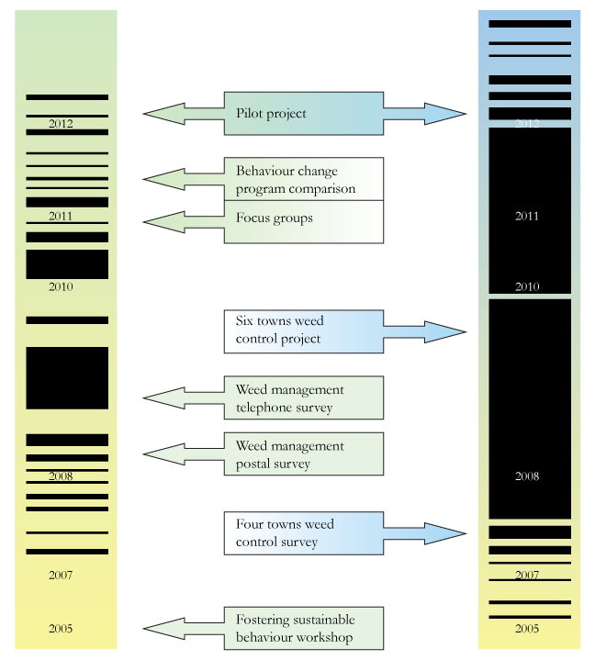
Diagram 1: Weed research and on-ground projects

Methodology and methods

The Fostering Sustainable Behaviour Methodology of Doug McKenzie-Mohr
A representative from Johns Hill Landcare, funded in part by the Port Phillip and Westernport Catchment Management Authority (PPWCMA), attended the Doug McKenzie-Mohr fostering sustainable behaviour workshops in 2005. Karen Alexander then wrote a report in 2005 with the take home messages being:
- Community-based social marketing (or fostering sustainable behaviour as it is now known) challenges some very common assumptions for which there is no evidence where:
  - the ‘intuitive’ belief that a changed attitude will lead to changed behaviour.
  - self-interest has a major influence over changing behaviour.
- Community Landcare is a process aimed at behavioural change so fostering sustainable behaviour is a tool worth assessing further for its relevance to Landcare groups both at the local group level, and at a regional and even state level.
It was recognised that the fostering sustainable behaviour process was a potential template for the research because it:
- was primarily for community-based behaviour change programs
- provided a clear process
- costs were within the available resources
- could be dovetailed with Council’s need to evaluate its ‘6 Towns Weed Control Project’.
The fostering sustainable behaviour steps are:
- select behaviours that you want to encourage and select your target audience
- list and prioritise the barriers and benefits of the behaviours you want
- research the barriers and benefits to the behaviours you want
- from this information map the tools and strategies that will encourage the benefits and overcome the barriers for the desired behaviours
- select a pilot to test the strategy.

Application of the methodology by the research project
The detail below shows an adaptation of the Fostering Sustainable Behaviour methods which the 6 Towns Weed Control Project used.

Select behaviours and target audience
Behaviours to be encouraged were selected based on their ability to improve weed management on private land.
The project group decided that the target audience was to be those residents with a high likelihood of actually changing their behaviour and this was tested for in the postal survey. Refer to Appendix A – Postal Survey Questions for the details of the nine questions asked on the postal survey.

List the barriers and benefits
With each of the selected desired behaviours, the research team worked through the impacts that the behaviours could realistically be expected to have and then listed the perceived barriers and perceived benefits of those behaviours.
The team then tested the barriers and benefits of the desired behaviours via a postal survey conducted in early 2009 by Cardinia Shire Council who surveyed the ratepayers of the 3782 postcode (Emerald, Clematis, Avonsleigh).
The postal survey tested for:
- recognition of major weeds (blackberry, ragwort, sweet pittosporum, cotoneaster, cape wattle, ivy, boneseed and holly)
- awareness of the ‘4 Towns Weed Control Project’
- benefits and barriers to removal of weeds on resident’s private property
- The postal survey was sent to just over 2,000 households (with no distinction between owners and renters). It was not personally addressed. Staff from Council performed the statistical analysis.

Prioritise barriers and benefits
The step of giving priorities to the list of barriers and benefits was incorporated into the postal survey. Priority was given to behaviours that have:
- the highest impacts and get the highest benefits provided they overcome the barriers (If the behaviours cannot overcome the barrier then do not undertake the activity)
- low impact but are very strategic.

Research chosen barriers and benefits
The aim of this step is to research two or three desired behaviours with respect to the target audience including a literature search, observations, surveys and focus groups.
Information from the postal survey regarding community perceptions to the barriers and benefits to controlling weeds guided questions for a telephone survey. The target audience was narrowed down (see below) from the telephone survey and two focus group discussions were conducted with selected individuals.
The telephone survey, held in late 2009, was conducted with the 58 respondents to the postal survey who had agreed to participate and who fitted the target audience criteria of people who were willing to remove (more) weeds from their private property but had not done so. The telephone survey was very labour intensive with each interview taking an average of 15 minutes. Three people were involved in interviewing. An external consultant undertook the statistical analysis. Refer to Appendix B – Telephone Survey Questions for the details of the eight questions.
Two focus groups, using an independent moderator, were conducted with participants from the target audience. Note that these were not ‘workshops’ of selected people but intended to be a random sample of the target audience. The focus group research was qualitative in nature and the findings must be interpreted accordingly. The approach relied upon a relatively free conversation between the participants and the moderator with prompting used to steer the conversation and introduce new topics. The results were based on the observation and interpretation of the moderator. The sample is small and caution is needed in reading the findings.

Objectives of the focus group discussions clarified, what was to become, the overall objectives of the project was to:
- explore barriers and motivators in respect to managing weeds
- assess the effectiveness of Council educational materials
- determine the actions or approaches which are most effective in encouraging residents to make greater efforts in respect to weed management on their properties.

Identify tools
Determine the tools that will overcome the barriers and boost the benefits of the behaviours to be encouraged. There are many tools that might work to overcome a barrier to enacting a behaviour. For instance, if a barrier is lack of motivation, then appropriate tools might be incentives such as tip vouchers (positive incentive) or fines (negative incentive).
The research team identified the tools via the surveys and from participants in the focus groups. In addition, the target audience was asked to rank what difference the following barriers and benefits would make to them:
- physical assistance
- financial assistance e.g. cost of weed spray, tip voucher, green bins
- neighbours working together on weed issues e.g. sharing knowledge
- information e.g. brochures, websites, etc
- expert advice e.g. from an expert, Council, in a workshop, hardware store, local stalls
- reward system from Council e.g. rebate on rates.

Identify strategies
Strategies to overcome barriers and boost the benefits were evaluated in a comparison of five locally-based ‘behaviour change’ programs. From the five, two programs were identified as potentially suitable programs to implement. Some key factors for the success of these two programs were:
- skilled facilitators with expertise in community development
- adult education and empowerment with breakdown of large problems into manageable tasks
- formation of partnerships and community mobilisation giving the program momentum
- inter-agency relationships improvement lead to greater communication and understanding of agreed roles with clear points of contact.

Conduct a pilot to test the strategy
The pilot will aim to test the following hypotheses in order to deliver better weed management strategies on private land:
- use a neighbourhood approach to see how effective it is in removing weeds in a specific area
- ensure the skilled facilitator assists the private landholders to control their weeds on an ongoing basis
- provide access to various tools for dealing with barriers and benefits to landholders controlling their weeds.
The basis for a pilot project has been developed. It is planned to be run in two neighbourhoods where private properties are predominantly:
- less than two hectares
- greater than two hectares.
An expert facilitator will work with these two neighbourhoods in an action research model i.e. through learning by doing. In addition, two control groups are planned to be set up for qualitative and quantitative analysis to be done independently of any stakeholder.
Measurement methods for positive impact are planned to include:
- weed audits before weed control commences and after it finishes
- project areas to be compared with identical audit of another chosen site in the township being the control site
- the comparison between the research areas and control areas to be conducted by someone ‘blind’, as far as possible, to the status of weed intervention and control areas
- the results of this pilot project and the lessons learned will be publicised in the sequel to this report.

FINDINGS AND RESULTS
The results described in this section include: the postal survey analysis, telephone survey analysis, results of the focus group discussions, and the comparison of ‘behaviour change’ programs.
The initial postal survey to over 2,000 Emerald residents was followed by a telephone survey of 58 residents and two focus groups. The intention of the whole program was to assess the various benefits and barriers to managing weeds on private property and to guide the project on possible steps to establishing ‘behaviour change’ programs in the community.

Postal survey – Emerald area postcode 3782
In 2007, Council conducted a postal survey on weeds and weed management, among local residents of Emerald. Refer to Appendix A – Postal survey questions for the details of the nine questions asked.
The survey was posted to approximately 2,000 addresses in the postcode 3782 area covering the township of Emerald and nearby Avonsleigh and Clematis. It was designed to ask residents whether they were aware of the then ‘4 Towns Weed Control Project’ (now the ‘6 Towns Weed Control Project’). The first few questions related to knowledge of weed types and the observation of weed improvement on roadsides and private property following the initiation of the ‘4 Towns Weed Control Project’. The next section assessed the effect of the project on the individual’s awareness of and attempt to remove weeds on their property. The final sections asked about their perception of the need for weed removal and the personal and community benefits to be gained.
A remarkable 25 per cent response was received for the survey, with 501 completed surveys returned.

Summary analysis of postal survey
The percentage of responses to question 1 about weed varieties, showed the general weed knowledge level. Most people knew blackberry, holly and ivy, about 70 per cent also knew ragwort and sweet pittosporum, about half the total also knew cotoneaster and cape wattle and 10 per cent also knew boneseed. Asking the number of these weeds they had seen in the Emerald area gave a similar pattern but slightly lower numbers.
Above half (274) knew of the ‘4 Towns Weed Control Project’ and slightly fewer (211) did not, 26 did not answer this question. The three major sources of information about the project were signs on roadsides, Council Connect magazine and local newspapers. The perceived major aims of the project were to remove three major weeds, to get rid of blackberry and ragwort, or to encourage landowners to remove weeds. The educational aspect of the project; ivy, holly and ‘other weeds’ were selected by at least 10 respondents each.
The information in the survey questionnaire stimulated and encouraged 345 (69 per cent) people to consider weed removal, 148 (30 per cent) saw ‘no benefit’ as they had already removed their weeds and 8 (1 per cent) did not consider weed removal to be a priority.

Priority of barriers
The survey then looked at identifying the major barriers for those people who wanted to manage their weeds. The major problems reported were time constraints and lack of finances to pay for services or to buy sprays. Physical restrictions to undertake weed control, invasion by neighbours’ weeds and lack of information on how to approach the control were reported less often but still were significant factors.
Table 1 shows the respondents replies to the prioritised list of barriers to weed control.
Why don’t you remove all weeds from your property? | No. of respondents | % of all answers
I (do) have removed all weeds on my property | 164 | 28
Time constraints | 77 | 13
A constant battle, too hard, given up, can’t manage it all | 70 | 12
Difficulty due to cost, disposal, sprays etc. | 61 | 11
Difficulty due to physical ability, health, size of plants, size of property  etc. | 5 | 9
Misinformation or lack of sufficient information | 52 | 9
Neighbours don't do their bit | 45 | 8
Other or nil answers | 56 | 10
Total answers – some gave multiple reasons | 580 | 100
Table 1: Summary of replies for ‘Why don't you remove all weeds from your property?’

Priority of benefits
The postal survey asked for reasons why weed removal is of benefit to the respondent.
Table 2 shows the priority of the benefits from the respondent replies.
Are there benefits to you if you removed your weeds? | No. of respondents | % of all answers
Contribution to enhancing natural environment, encouraging native flora and fauna | 177 | 28
Allow wanted plants to grow thus increasing the aesthetics of the garden | 170 | 26
Reduce seedling spread and weed regrowth | 113 | 18
Reduce weeding time in garden | 69 | 11
Self-satisfaction and achievement | 55 | 8
Community spirit (contributing to a better Emerald) | 37 | 6
Other answers | 22 | 3
Total answers – some gave multiple reasons | 643 | 100
Table 2: Summary of replies for ‘are there benefits to you if you removed your weeds?’

Telephone survey
In late 2009, the second stage of the research commenced. A telephone survey of eight questions was conducted with 58 participants who had responded to the mail survey and who had agreed to a follow up survey. Refer to Appendix B – Telephone survey questions for the details of the eight questions.
The objectives of the telephone survey were to examine:
- in more detail the effectiveness of the ‘4 Towns Weed Control Project’
- the barriers to weed removal on private property
- what are the Council actions e.g. local by-laws, that may aid further weed reduction on private property.
The results from the telephone survey have been encoded and recorded in a database that enabled the analysis as discussed below. Council’s weed survey analysis.report was written in 2010 summarising the results.
Included in the survey were two questions that segmented the target audience into those on: a suburban block; a larger block up to 2 hectares; and a block more than 2 hectares. The other question asked about age group ranges.

Summary analysis of telephone survey
Respondents were first asked to rate the effectiveness of the ‘4 Towns Weed Control Project’ in relation to the weed problem on roadsides in the area over a two year period since 2007. Over half (54 per cent) replied positively to a reduction in weeds on roadsides, about a third (31 per cent) indicated the weeds stayed the same, and an eighth (12 per cent) said that weeds on roadsides had increased. Note: the remainder did not comment.

Identify and rank the tools
Question 4 asked the 58 respondents to rank a range of possible tools or weed control assistance methods that could be offered by Council or other providers e.g. community groups. One striking result shows that over two-thirds (39 or 67 per cent) believed that a consultant’s home visit would make a great difference to removing weeds.
For the various types of consultative methods and visual prompts, all positive replies were combined (which included a great difference and a little difference) to make up the given numbers of respondents and percentages below.
The consultative methods positively favoured were:
- Consultant come visit: 51 or 87 per cent
- Mitre 10 advice: 49 or 84 per cent
- Council staff: 49 or 84 per cent
- Landcare: 44 or 76 per cent
- Town stall advice: 43 or 74 per cent
The visual prompts positively favoured were:
- Rates notices: 78 or 83 per cent
- Leaflets: 46 or 79 per cent
- Website: 45 or 78 per cent
In a surprising result over 80 per cent (47 or 81 per cent) of respondents said that giving assistance to people not physically able to remove weeds themselves would make no difference. This is likely to be due to respondents determining themselves physically capable.
Assistance with cost of weed sprays or labour did polarise opinion with nearly a third (17 or 29 per cent) saying it would make no difference, as did the free tip voucher with just over half (31 or 53 per cent) saying it would make a great difference and just under a third (19 or 29 per cent) saying no difference.
Respondents were then asked to give preference to one weed control assistance method. The results were widespread although three methods stand out at least double to the others i.e. labour, cost and consultant’s home visit.
Finally, the preferred Council initiative for respondents to remove weeds from their property clearly shows that a significant portion i.e. 68 per cent chose a Council reward system such as a rebate on rates.
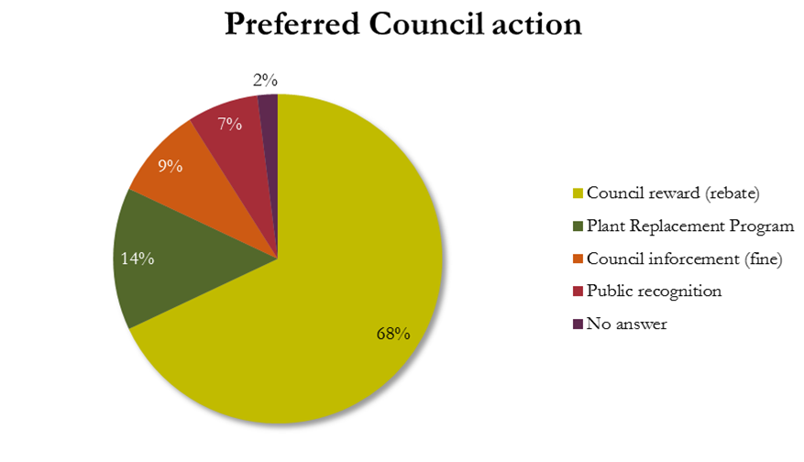
Diagram 2: Preferred Council action

Focus groups
In 2010, the third stage of the research commenced. Participants in two focus groups were selected from the original postal survey respondents that were not amongst the members who did the telephone survey. By analysing the results of both the postal survey and telephone survey, a series of potential actions Council or volunteer groups such as Johns Hill Landcare might initiate or help facilitate in order to encourage weed management were developed. The focus group discussions were undertaken with the aim of testing these actions and approaches and focussed on the following:
- perceptions of current behaviour towards weed management
- responses to possible Council initiatives or tools
- responses to Council’s education material
The results of the focus group discussions were analysed in the report: Weeds Project – communications development, qualitative research report.
The recruitment method produced a sample of residents who were already working on managing their weed problems but who were either dissatisfied with the extent to which they were controlling their weeds or who felt they would benefit by expert assistance and more information.

Current Behaviour toward Weed Management
There was strong agreement amongst participants that weeds are a major problem in the Emerald area. While weeds are often perceived as inevitable in a rural environment and, as something that will always need to be contended with, there was some criticism that Council was not doing sufficient work to manage weeds on roadsides and reserves for which it is responsible. Lack of weed management on the part of both Council and neighbours was a source of continual frustration to residents who were putting effort into controlling the weeds on their own property.
“We have a reserve behind us with significant bushland but it has weeds. It’s frustrating, the neighbours are quite good but the Council isn’t doing much and it means we have to keep doing things over and over again.”
“Is there a problem with spraying over the fence? It’s the only thing we can do when our neighbours don’t do anything.”
Participants initiated discussion on the need for Council to penalise landowners who do not take action to eradicate the weeds on their property, since they compromise the efforts made by their neighbours and others in the community.
In terms of work undertaken to control weed species a range of different measures were mentioned. These included: pulling or digging out, cutting and dabbing with herbicide, burning, mowing and using herbicides either in diluted or undiluted form. However, it was evident in the conversation about the methods used in weed management that there was both a lack of information and misinformation about the most effective methods for addressing weed problems.
Participants noted that their motivation to control their weeds came from their enjoyment of their environment and their feelings of responsibility for their land. They talked of plants being a major attraction on their properties. Weed management was also seen as necessary to protect the capital value of the land. When weeds are controlled, participants on larger acreages felt that, the land would be more productive and the pasture better for animals.

Responses to possible tools
In order to ascertain which actions or tools are likely to be most effective in helping Cardinia Shire landowners to manage their weed problems, participants were exposed to a number of initiatives which could be offered and their reactions to these were freely explored.
The two proposals that received the most positive reception were offer of:
- advice from a weed expert
- help from Landcare volunteers to clear weeds.
The offer of advice from a weed expert was strongly endorsed. While currently working on their weeds, those attending the focus groups were often unsure as to whether they were employing the most effective measures. Participants ideally envisaged a scenario where the weed expert would visit their property and carry out an audit detailing weed species on the property. They would subsequently provide a management plan detailing how to manage each weed type, including the best time of year to intervene and giving detailed instructions in methods of intervention. Some also wanted information about which local species were likely to be indigenous to their property in order to inform future plantings. They were receptive to some sort of monitoring by Council in return for this service being provided.

Council literature
Most participants attending the groups were aware of and had seen the Cardinia Shire’s Weed Identification Guide. Overall the content in the brochure was endorsed as useful but would benefit from the inclusion of more comprehensive information.
The Indigenous Plant Guide was also deemed useful. Some participants voiced the desire to be able to find out what species were indigenous to their land to aid in future plantings.

Comparison of ‘behaviour change’ programs
In 2011, the fourth stage of the research project commenced with examination into the characteristics and success of community based ‘behaviour change’ programs. The objective of this stage was to find, list and compare ‘behaviour change’ programs that are neighbourhood based. The programs were those that had been conducted in the community for the purpose of educating and motivating residents to carry out a specific activity. Full details can be found in the report on Community ‘Behaviour Change’ programs.

Apply theory to weed control
The strategies used in the community ‘behaviour change’ programs can be explained by three theories.
Social capital theory includes bonding capital and bridging capital. Bonding capital is represented by the ties between people with similar demographics such as neighbours. Bridging capital is shown as the links or ties across communities by agencies like Country Fire Authority (CFA) and Landcare.
Diffusion of innovations theory explains who actions a new idea and when. About three per cent of people readily take to new ideas. At the other extreme, about 20 per cent actively resist any changes. In the middle, the remaining 77 per cent have varying degrees of acceptance to change.
Social marketing looks at how to influence a change in behaviour using marketing techniques. The premise of social marketing is the application of commercial marketing to social well-being and benefits to society. To adopt a new social behaviour, a target audience evolves through four ‘behaviour change’ stages which are: an individual’s ‘awareness’ to ‘understanding’ to ‘involvement’ through to an ‘informed decision’ in undertaking an activity.
As the type of engagement moves from information to partnering with groups, the level of engagement shifts from ‘awareness’ to ‘informed decision’. Madill refers to four stages of behaviour change and Diagram 3: Stages of behaviour change shows as the type of engagement changes there is an increase in the level of engagement.
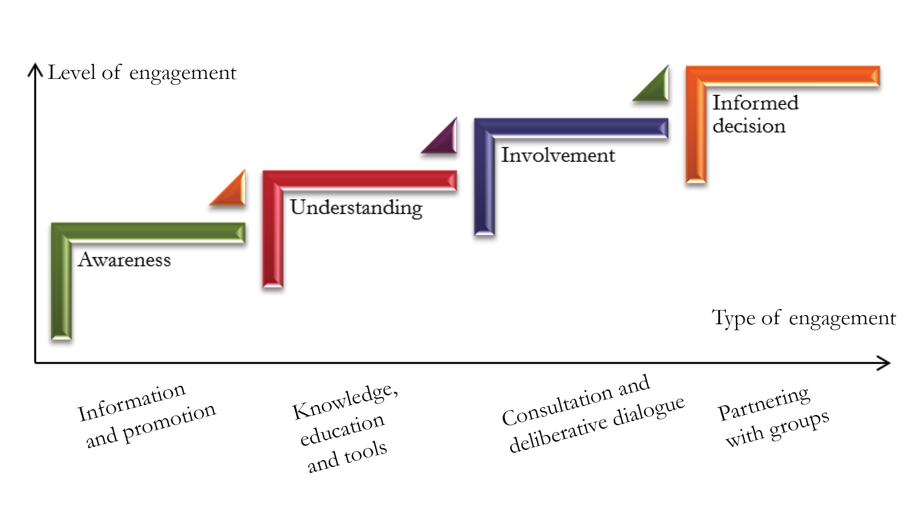
Diagram 3: Stages of behaviour change
Bridging capital is active in the Hills sub-region. Many of the residents are familiar with the benefits of the Country Fire Authority and Landcare as avenues of knowledge sharing and social activities.
Using diffusion of innovation theory, when introducing new ideas, it could be expected that about 80 per cent of the population are willing to change their behaviour.
The application of the ‘behaviour change’ stages to weed management can be explained with examples of actions.
Create ‘awareness’ and interest by distributing brochures and informative posters. Move to ‘understanding’ where residents attend training sessions and have access to educational tools. Act by having ‘involvement’ of a skilled facilitator who consults and engages with the residents in purposeful dialogue. (Previous work in this weed research project found that behaviour change was strongly stimulated by a move from individual to facilitated group involvement.)
Finally, the ‘behaviour change’ is maintained and reinforced when groups of residents make ‘informed decisions’ and continue to undertake the ‘behaviour change’ so that it becomes wide-spread and established as the normal and accepted way of operating.

Compare strategies
Five community programs were chosen for comparison:
- Bushfire alerts – Ferny Creek fire alert siren (Melbourne)
The Ferny Creek fire alert siren is an end product of a collaborative community, local government and emergency service working group process. The working group established an alerting system that would enhance the bushfire preparedness, planning and survival activities of a specific community in Ferny Creek. The project was initially set up as a response to a community request for ‘early warning’ as a result of the bushfires which ravaged a significant area of Ferny Creek in the Dandenong Ranges in 1997 and the subsequent coronial inquiry into the fatalities of three people which occurred as a result of that bushfire.
- Bushfire preparedness – Community Fireguard Program (Victoria-wide)
The Country Fire Authority (CFA) Community Fireguard program, launched in 1993, is a community development program that aims to help residents develop local bushfire survival strategies that correlate with their lifestyle, values and the local environment. The objective is to ‘reduce the loss of life and property by developing self-reliant communities who have made a commitment to managing their own fire safety’. CFA facilitators deliver the program and provide information and support to residents so that they can establish Fireguard groups and develop survival plans. The program is delivered over four or five meetings that provide information on fire behaviour, personal safety, house survival, fire protection equipment and includes a street walk around the group’s local area.
- Community gardens – Gilles Plains Community Garden Program (Adelaide)
The program effectively applied a bottom-up approach whereby professional community development workers from the local health service facilitated the engagement of the community who then played an active role in both developing and planning the garden. The project has forged a strong social coalition and brought various agencies at the campus together when previously they were acting separately.
- Sustainable living – Sustainability Street Community Capacity Building Program (Melbourne)
Sustainability Street is a community education project, devised by the Melbourne-based company Vox Bandicoot, which provides practical information, solutions and support to help people live more sustainably. This is achieved by a skilled facilitator helping to build connections, knowledge and skills with neighbours in the same street. These communities have become adept at growing their own food, using water tanks, carpooling, composting, shopping in an environmentally friendly way, saving money on their power and water bills, thereby reducing their impact on the environment.
- Natural recreational areas – Tuggerah Lakes estuary restoration (New South Wales)
The three interconnected lagoons that comprise the Tuggerah Lakes estuary are largely isolated from the sea which has created an environment that supports a huge diversity of plants and animals. The lake attracts residents and tourists. As a result, a wide range of commercial activities, including fishing, boating and tourism, take place on or around the lakes. Extensive planning and consultation with the local community has provided a clear path to implement desired environmental changes. This program is located in a tourist destination as is Puffing Billy railway.

Key success factors (tools)
Across the five programs there were a variety of key ingredients utilised for the achievement of their intended outcomes. They were:
- Allowing sufficient time for planning. This was an important factor as it allowed for an agreed direction to be reached that was relevant to the program and was then able to be communicated to the target audience.
- Skilled facilitators who were dedicated and forward thinking and able to draw on skills in community development.
- Formation of partnerships and community mobilisation which gave the programs momentum and the resources to be able to complete agreed tasks.
- Inter-agency relationships improvement, lead to greater communication and understanding of agreed roles and clear points of contact.
- Training which enabled groups to focus on achieving specific tasks even under extreme circumstances. The individuals in the group were empowered by their knowledge.
- Use of training materials for practical understanding. The breakdown of a large problem into manageable tasks that can successfully be completed.

Common difficulties (barriers)
The common difficulties experienced across the five programs included:
- Maintaining interest with the target audience over many years due to various reasons such as low threat (e.g. of wildfires), lack of variety, poor access to current knowledge.
- Advising new residents of the program and encouraging them to join established groups was not easy.
- The assumed presence of underlying skills needed to foster group formation. The capacity of the facilitators or coordinators to organise groups varied depending on their previous experience.
- Sourcing ongoing funding to ensure the program built on previous success e.g. for skilled facilitators.

Potential strategies
Two of the five programs had elements that were suitable to be utilised for the Weed Management Program. The Sustainability Street Program could be translated to weed management, biodiversity, and native vegetation. Community fireguard could similarly be translated to each neighbour managing their own weeds. Both require bridging to Landcare or similar groups for technical knowledge. Both approaches indicate a strong need for skilled facilitators to assist in organising contiguous neighbours, where some neighbours may be government agencies.

CONCLUSION
Analysis of the data gathered in this research revealed some meaningful results in regards to landowner attitudes to acting on weed issues and provided valuable insight as to the dominant barriers influencing people in this activity. It became evident from this ‘behaviour change’ research that a community based program addressing these barriers was needed before any sustained community action on weeds could be expected.
Community based programs allow the formation of partnerships and community mobilisation which gives the program momentum and the resources to be able to complete the agreed tasks of managing weeds.
Skilled facilitators would perform multiple functions of fostering neighbourhood weed groups and to connecting technical weed knowledge specific to the group’s needs. They would maintain interest over many years, engage new neighbours and include a feedback loop to support ongoing improvements. The role of a skilled facilitator would therefore significantly aid community cohesion, encourage social inclusion and consolidate the works of neighbourhood groups.
Ongoing funding provides the surety that the value, in terms of dollars and time, of previous on-ground work is enhanced rather than endlessly repeated with no obvious improvement.
Another important factor, concluded from this research, is the benefits of collaboration of Council and community groups such as Landcare, working with the community towards weed control outcomes.
Ongoing discussion between Cardinia Shire Council and Johns Hill Landcare Group provides a mechanism to scope and implement a community based pilot program.
This research has provided Council with a better way of understanding community behaviour and attitudes to weeds and their impact on the environment and a more sustainable way of utilising scarce Council resources.

RECOMMENDATIONS
The recommendations arising out of the findings of this research project is to:
- develop a pilot project that features: a neighbourhood approach; uses a skilled facilitator; and sources appropriate expertise
- secure financial resources for a pilot project and further research
- continue to support the partnership between Cardinia Shire Council and community groups such as Johns Hill Landcare
- ensure the successful results of the project are progressively promoted to the community, Cardinia Shire Council, the Landcare network and other relevant agencies.
- continue to support the community with ongoing funding, through incentives programs.

APPENDIX A: POSTAL SURVEY QUESTIONS
- There are many weeds in the Emerald district; some have financial and operational impacts on farming, our gardens and bushland, creating potential long-term impacts on our native plants and animals.
Which of the following environmental weeds are you aware of or would you expect to find in Emerald? Please tick all that apply.

❑ Blackberry
❑ Ragwort
❑ Pittosporum
❑ Cotoneaster
❑ Cape wattle
❑ Ivy
❑ Boneseed
❑ Holly

- Council is running a program called Four Towns Weed Control Project aimed at reducing weeds along the roadside in your area, over the past two years.
Are you aware of this program?

❑ Yes – continue to question 3
❑ No – skip to question 6

If you answered yes, please complete questions 3, 4 and 5.
- Where did you hear or read about the program? (Please tick all that apply)

❑ Received information in the mail from Council
❑ Council’s Connect magazine
❑ Signs on roadsides
❑ Local environment groups (e.g. Landcare)
❑ Local newspapers (e.g. Pakenham Gazette, Ranges Trader, Leader)
❑ Contractor implementing program
❑ Council officer or contractor
❑ Other (please specify)

Please note where you first heard about the program, by writing the number that corresponds from the above list, in this space:
- Do you remember what the main aims of the program are?  YES  NO
If yes, what do you think were the priorities (please tick and number the boxes 1 to 6 with 1 being the highest priority).

__ Take out 3 major weeds along roadsides get rid of blackberry and ragwort
__ Take out all pittosporums
__ Encourage local landholders to do their weeds
__ Other

- Thinking about the Council’s ‘4 towns project’, did the information provide:
(Tick one answer which best reflects how you responded to the information.)
❑ Made me think I should be removing weeds on my land; but I haven’t done anything yet.
❑ Encouraged me to remove weeds from my property and plan to keep them under control.
❑ It had little effect as I already remove all weeds I’m aware of.
❑ It had little effect as weed removal is not a high priority for me.
- There are a number of environmental weeds, such as ivy, holly and pittosporum, in gardens and properties in this area. In your opinion, are there any benefits in removing these plants from gardens and properties around the area?
❑ YES  NO
Why? Please provide information supporting your answer to Question 6.
………………………………………………………………………………………………………
………………………………………………………………………………………………………
………………………………………………………………………………………………………
- Thinking now specifically about your property, is there any particular reasons why you don’t remove weeds from your land? Please describe your reasons below.
  - ………………………………………………………………………………………………
  - ………………………………………………………………………………………………
  - ………………………………………………………………………………………………
- If you were to remove these weeds from your property, what do you feel would be the benefit for you?
  - ………………………………………………………………………………………………
  - ………………………………………………………………………………………………
  - ………………………………………………………………………………………………
- Council officers will be conducting a telephone survey to talk with people further about how Council can help them deal with their environmental weeds. This phone survey should take about 15 minutes, and all participants will receive a $20 voucher for Mitre 10 in Emerald. Would you be happy to participate in the phone survey?
❑ YES  NO
If yes, please indicate days and times convenient.
Thank you. You have now completed the survey.
Yes! I would like to be kept informed about the results of this project.
Name: ………………………………………………………………………………………………
Phone: ………………………………………………………………………………………………
Address: …………………………………………………………………………………………….
Email: ………………………………………………………………………………………………

APPENDIX B: TELEPHONE SURVEY QUESTIONS
- Since the ‘4 Towns Weed Control Project’ began in 2007, would you say the weed problem on roadsides in the area has:
❑ Significantly reduced
❑ Reduced a little
❑ Stayed the same
❑ Increased a little
❑ Increased significantly
- What is the approximate size of your property?
❑ Suburban block
❑ Larger than 2 hectares
❑ More than 2 hectares
- In the last two years have you noticed any change in the local community in terms of weeds on private property? Which of the following best reflects your observations?
❑ Fewer weeds on private property
❑ Same amount of weeds
❑ More weeds on private property
❑ Don’t know
- Making a difference to you in terms of assisting you to remove weeds from your property; for each measure that I read out, can you tell me if it would make:
❑ a great difference
❑ a little difference
❑ no difference
  - Assistance for people not physically able to do weed removal themselves
  - Assistance with cost of weed sprays or labour
  - Neighbours working together on weed issues, e.g. sharing knowledge, equipment or contractors
  - Increased education through leaflets. Access to websites. Regular newsletters. Displays in library or community house.
  - Expert advice and demonstration from: Consultant visiting your street or property Advice at local town stall or events
    - Local Landcare Group
    - Council staff assistance
    - Community house workshops
    - Mitre 10 advice
    - Information with rates notices
  - Free Tip vouchers
  - The use of Green bins for weeds
- Do you have a green bin?  Yes  No
If yes, do you use it for weeds?  Yes  No
If no; why not: …………………………………………………………………………………
- Are there any additional measures that you would like to mention that would assist you with removing weeds from your property?
  - Please describe them
…………………………………………………………………………………………
  - If only one of these actions could be taken, which would you choose?
…………………………………………………………………………………………
- In order to improve weed control on private property, the Council has a number of options. Which one of these options would you prefer to see the Council introduce? Why would you prefer this option?
❑ A reward system for properties where weeds are controlled e.g. rate rebate
❑ Council enforcement of fines on properties where weeds are not controlled
❑ Plant replacement program for the weeds removed
❑ Public recognition for your weed work e.g. sign on fence
- Finally, a few details about yourself and household to help us analyse the survey data.
  - Into which age groups does your age fall? _____
  - Are you renting or do you own or are you purchasing this property? _____
  - How many people over the age of 18 years, including you, lives here? _____
APPENDIX C: CARDINIA SHIRE ON-GROUND WORKS
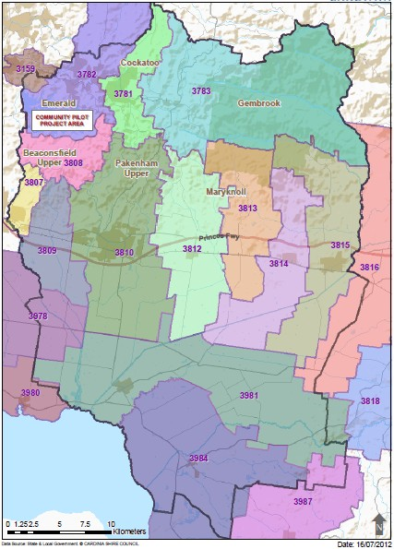
APPENDIX D: JOHNS HILL LANDCARE ACTIVITIES AREA
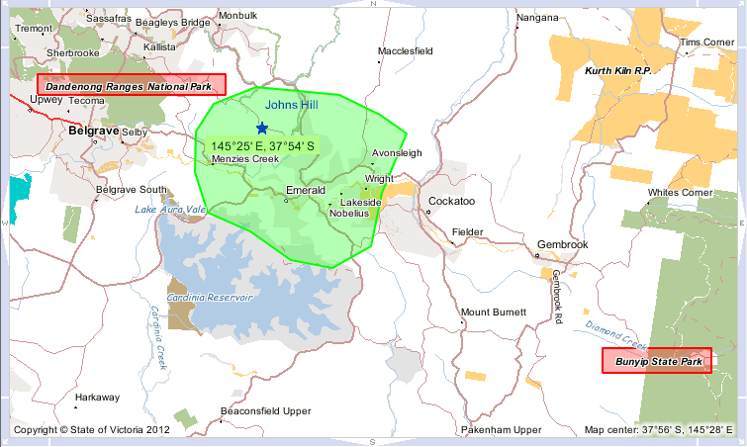

McKenzie-Mohr, D. and Smith, W. (1999). Fostering Sustainable Behaviour, An Introduction to Community-Based Social Marketing, New Society Publishers, Canada.
Alexander, Karen, (2005). Report on Fostering Sustainable Behaviour Workshop, May 2005. Sent to Port Phillip and Westernport CMA.
Cooper, Roger, (2010). Cardinia Shire Council – Weed Survey Analysis – May 2010
Smith, Libby, Motive Market Research (2010). Cardinia Shire Council Weeds Project – communications development, qualitative research report
Thompson, Julie, (2011). Report on community ‘behaviour change’ programs
Madill, J. (2005). Review of social marketing – Social marketing workshop, January

