SPECIAL RATE AND CHARGE SCHEME POLICY


March 2020

Contents
REVIEW OF SPECIAL RATE AND CHARGE SCHEME POLICY 1
February 2020 1
1 Background 1
2 Policy Objective 1
3 Policy Rationale 1
4 Legislative Overview 2
5 Definitions 3
5.1 Special Benefit 3
5.2 Benefit Ratio 3
5.3 Scheme Total Cost 3
5.4 Total Levy 4
6 Scope 5
6.1 Provision of new infrastructure 5
7 Future Schemes Program 5
8 Scheme Initiation 6
9 Extent of Works and Scheme Boundaries 6
10 Scheme Prioritization 8
10.1 Road and Drainage Construction 8
10.2 Other Infrastructure and Services 9
11 Community Consultation 9
12 Financial 10
12.1 Amount to be recovered 10
12.2 Council Contributions 11
12.2.1 Street/Road Construction 11
12.2.2 Footpaths & Combined Pedestrian / Cycle Paths 12
12.2.3 Drainage Construction 12
12.2.4 Commercial / Industrial Scheme 12
12.3 Distribution of Costs Amongst Contributors 13
13 Limiting Contributions 14
13.1 Infrastructure Related Projects 14
14 Financing of Schemes 15
15 Special Rate Schemes 15
15.1 Payment of Monies 15
15.2 Social Responsibility 16
16 Infrastructure Specific Provisions - Minimum Construction Standards 17
16.1 Street Construction in Township & Urban Areas 17
16.2 Footpaths & Combined Pedestrian / Cycle Paths 18
16.3 Drainage Construction 18
16.3.1 Drainage - Public Health 18
17 Guidelines 19
18 Ceiling Amount for a Special Rate or Charge 19
Appendix 1 – Flow chart of Scheme Process 20
Appendix 2 - Calculation of benefit ratio (R) 21
Appendix 3 - Benefit Unit Multipliers – Zoning and Subdivisional Potential. 23
APPENDIX 4 – FUTURE SCHEMES PROGRAM LIST 24
(Federal Government Funded Roads for the Community Initiative) 24

Background
Under Section 163 of the Local Government Act 1989 empowers Council to levy a special rate or special charge on rateable properties to fund or part fund works or services that are of special benefit to those properties.
This policy is focussed on ensuring that a fair and consistent approach is maintained when preparing and implementing a scheme and engaging with affected land owners
The introduction of rate capping has had a significant impact on Council’s ability to both investigate and implement new Special Charge Schemes. Any new scheme needs to consider the broader community benefit in comparison to other Council funded Capital works while taking into consideration the available funding.
Council actively pursues external funding including government grants to reduce the costs of infrastructure scheme works resulting in a reduction of the level of contribution required from relevant land owners
This policy is structured having regard to the requirements of the Local Government Act, the associated Ministerial Guidelines and past decisions of VCAT in relation to special rates and charges.

Policy Objective
Cardinia Shire Council is responsible for managing provision of a range of new infrastructure as well as maintaining and eventually renewing existing infrastructure. In general, Cardinia Shire Council will fund renewal and maintenance of existing infrastructure and will not seek to recover those costs from benefiting landowners.
The objective of this policy is to provide a framework for the provision of additional necessary infrastructure via a process, which enables costs to be recovered from benefiting parties in a fair and equitable manner.
This Policy is based on the following principle:
Where it can be demonstrated that properties will receive special benefits from constructing necessary infrastructure works and where other arrangements are not practical, Council will pursue through an extensive consultative framework, the philosophy of contributory schemes through implementation of the Special Rate or Special Charge Scheme process.
Council will work in partnership with the benefitting property owners to improve the standard of infrastructure through the implementation of land owner contributory schemes

Policy Rationale
Council is committed to providing its community with Infrastructure that continuously meets its needs. In the past, many areas within the municipality have been developed without the provision of suitable infrastructure, which has placed increasing hardship on these local communities. In many instances, unsuitable infrastructure produces conditions that are inadequate and environmentally unacceptable.
Council considers that the provision of infrastructure (for example roads and drains) that is safe, functional and meets environmental and health standards is a pivotal role to good governance.
Council applies its powers under the Planning and Environment Act 1987 and Subdivision Act 1989 to require new developments to be serviced with infrastructure by the developer. These costs are subsequently past on to purchasers of the land. However, these powers cannot be applied retrospectively to land subdivided in the past without necessary infrastructure.
Council alone does not have the necessary resources to meet all the infrastructure demands and will seek to increase the level of funds available through other means such as grant applications, public private partnership arrangements and the use of beneficiary contribution principles. Therefore, where it can be demonstrated that properties will receive special benefit from implementing necessary infrastructure works, Council will pursue, through an extensive consultative framework, the philosophy of contributory schemes through the implementation of the Special Rates or Charge Scheme process.
Under the provisions of Section 163 of the Local Government Act, 1989, Council has the power to raise funds for works that are of special benefit to properties within the Municipality. Where Council determines that improvement to existing infrastructure is necessary in order to improve the public amenity and accessibility, protect the environment from human activity associated with land occupation and ensure the safety and wellbeing of the community, it may declare and levy special rates and charges.

Legislative Overview
Section 163 of the Local Government Act 1989 empowers Council to levy a special rate or special charge on rateable properties to fund or part fund works or services that are of special benefit to those properties. In addition, Section 221 (3) empowers Council to levy a special rate or special charge for the purpose of street construction on non-rateable land that is not crown land.
- Important amendments to the Act that have been introduced over time include: Limit the maximum proportion of the cost that could be recovered from owners to a proportion less than or equal to the Benefit Ratio; and
- Restricted Council’s ability to recover more than 2/3rds of the cost if the owners of more than 50% of the properties object.
- Limit Council’s ability to vary a special rate or charge so that any property’s contribution is increased by 10% or more without in effect recommencing the process;
- Require an instalment plan for schemes involving capital works with instalments payable over at least 4 years; and
- Limit the interest component of instalments to a maximum of 1% greater than the Council’s borrowing rate.
This policy is to be read in conjunction with Sections 163 – 166 and Section 221 of the Local Government Act 1989 and the associated Ministerial Guidelines

Definitions

Special Benefit
A ‘special benefit’ test is required to be applied to enable council to implement a cost recovery scheme. Only properties receiving ‘special benefit’ may be levied with a special charge or a special rate.
A work or service is of Special Benefit to land and consequently the owners of that land where:
  - No other portion of the municipal district derives a benefit from that work; or
  - the benefit derived by the selected portion of the municipal district is in addition to or greater than that derived by other properties not included in the selected (‘scheme’) area.
Special benefits can be deemed to arise if the proposed works or service meet any of the following criteria:
  - improve access and egress from a property;
  - improve safety for vehicles and/ or pedestrians;
  - improve ease of nature strip maintenance;
  - protect properties from stormwater flows or provide a point of discharge for those properties;
  - Improve the quality of waste water or storm water emissions from a property or road serving a property to meet environmental guidelines and the principles of Water Sensitive Urban Design;
  - improve road and property drainage;
  - address health and/ or amenity issues;
  - improve neighbourhood amenity;
  - embellish property values;
  - increase opportunities for leisure;
  - attract potential customers.

Special Benefit includes the potential benefit arising from the best possible use of a property and has no regard to the intentions of the landowner with respect to the land.

Benefit Ratio
The costs to be incurred are required to be fairly divided proportionately to the benefits received. Those included in the scheme and levied shall only be required to meet their fair share of the costs based on the relative proportion of special benefit they receive. The statutory Benefit Ratio is calculated to assist with this process.
The Benefit Ratio is the estimated proportion of the total benefits of the scheme including special benefits and community benefits that will accrue as special benefits to those people required to contribute to the scheme. This is defined in more detail in Sec 163(2B) of the Local Government Act 1989.

Scheme Total Cost
This is the total cost of the work or service to be funded through the special charge or special rate scheme. It is the amount to which the Benefit Ratio is applied to determine the maximum amount in aggregate that may be levied by Council.
The phases in preparing a scheme comprise:
Investigation – scoping, initial landowner consultation and assessment to enable a project to be considered. These costs are generally not to be included in the Scheme Total Cost and will be met by Council.
Development – preliminary design, resident consultation, preparation of apportionments, administration, land acquisition and legal costs (except those specifically excluded by Sec 163(9) of the Act. These costs are included in the Scheme Total Cost.
Initiation – comprises the formal statutory process including preparation of detailed design, final estimates of cost and apportionment and administration. These costs are included in the Scheme Total Cost.
The Scheme Total Cost also includes the cost of construction works, project management, and scheme finalisation including any variations.
Where a proposed scheme fails to proceed, the costs of the development and initiation phases shall be met by Council except that Council may recover the costs of those elements that are re-used in a future scheme.
Where works to be carried out through a scheme are adjacent to or include other works previously funded by Council and for which a contribution has not been made either through a scheme or developer contribution, Council may include those costs or portion thereof in the Scheme Total Costs and retrospectively levy the benefitting properties.
Council may determine to undertake additional works or services within the scheme area and at the same time as the delivering the scheme works or services. In these circumstances, the additional works or services and their associated costs would not form part of the scheme and will be separately recorded and accounted for. Where additional works are identified as being required during the scheme process but prior to Council declaring the special rate or special charge, Council may:
  - Refer those works to a future works program;
  - Amend the scheme or recommence the scheme process to include those works depending on the impact on individual contributions; or
  - Implement those works under an alternative funding program having regard to Council’s relevant funding policies.
Where practical, additional works identified prior to and during the scheme process shall be included as part of the scheme works and associated total costs. Council may increase its contribution to the scheme with respect to these additional works having regard to its funding policy (if any) relevant to the works.

Total Levy
Total Levy is the amount in aggregate to be contributed by persons liable for the special rate or charge.

Scope

Provision of new infrastructure
The scope of this policy applies to the provision of all new infrastructure including:
  - Road and street construction;
  - Kerb and channel construction;
  - Footpath construction;
  - Drainage construction including associated water treatment in accordance with water sensitive urban design principles;
  - Carpark construction;
  - Local area traffic management;
  - Streetscapes/shopping centre upgrades;
  - Recreational and Community facilities; and
  - Any other category of infrastructure that meets the Special Benefit criteria.

Future Schemes Program
Council will maintain a future program of schemes relating to new and enhanced infrastructure works. The program will set out the relative priority of projects, a description of the works, the preliminary estimated project cost and amount to be recovered.
The future schemes program will be reviewed annually in conjunction with the 10 year Capital Works Program.
In certain circumstances, the future schemes program may require review and amending as occurred when the Federal Government Funded Roads for the Community Initiative was announced involving a nine year $150M funding plan for infrastructure works.
The Manager Infrastructure Services may investigate and assess any capital works project that creates new, upgraded or enhanced infrastructure for inclusion in the Future Schemes Program.
All referred projects shall be investigated and assessed in accordance with this policy and considered for inclusion in the Future Schemes Program. The Manager Infrastructure Services will determine the priority for investigating and assessing proposed projects having regard to their likely priority when assessed under this policy. Scheduling a potential project for investigation and assessment does not guarantee its inclusion in the Future Schemes Program.
The Future Schemes Program will be periodically reviewed and submitted to Senior Leadership Team (SLT) and Council for adoption as the preferred order for developing schemes. These schemes will be considered for funding through the development of the forward Capital Works program.

Scheme Initiation
A scheme investigation will normally be initiated through a request from affected land owners, although a scheme may also be initiated by Council to address maintenance and improvement requirements.
A Special Rate or Charge Scheme may be “Initiated” by Council resolving to give ‘Notice of Intention’ to declare a special charge or special rate in accordance with the statutory process.
Schemes should be considered for “Initiation” once they have been “Developed” in line with the forward Capital Works Program referred to in Section 7. However where the particular circumstances require, Council may determine at its discretion to vary that order or to initiate a scheme not listed on that schedule. This situation occurred when the Federal Government Funded Roads for the Community Initiative was announced in 2019.
Where a potential project has not been included or has a low priority on the adopted Future Scheme Program and landowners seek to have it implemented ahead of schedule, Council may develop and initiate a scheme on the basis of property owners contributing the maximum amount permitted to be levied under the Benefit Ratio calculation provided Council’s Strategic Resource Plan and Annual Budget can provide for any Council contribution.

Extent of Works and Scheme Boundaries
In determining the extent of works and boundaries of individual schemes, Council shall:
- Pursue provision of the full range of infrastructure required in that area and its coordination to minimize physical intrusion, disruption and subsequent re-work.
- As far as practical, include all properties deriving special benefit from the proposed works or services within the scheme boundary. This “Whole of Catchment” based approach to schemes is to be pursued where practicable to minimize cross subsidies and maximize fairness, equity and efficiency of construction. Catchments shall be identified by reference to actual and potential usage patterns for the particular infrastructure as follows:
  - Road & Footpath Construction – Road or footpath under consideration together with other lower order roads that utilize it for access.
  - Drainage Construction – Drain under consideration and all up stream drains & properties within the catchment.
If after detailed analysis and consultation with the community a majority of the owners in the ‘catchment’ remain opposed to the scheme, Council may consider a lesser scheme subject to it remaining fair, administratively efficient, and not unreasonably increasing the extent of cross-subsidies.
- Pursue administrative efficiency through larger schemes that minimize administration as a proportion of total costs.
- Ensure “natural coherence” of the works or services within the scheme boundary by ensuring the works or services to be provided under the proposal will:
  - Be physically or logically connected; or
  - Provide special benefits, of a related nature, to a common, or overlapping, group of properties.
Where a road forms a boundary with an adjoining municipality, Council shall negotiate and vary this policy as necessary to achieve consistency and to ensure Cardinia Shire property owners are treated fairly.

Scheme Prioritization

Road and Drainage Construction
Council will consider the following matters when determining the priority for development of a Special Rate or Charge Scheme for road and/or drainage construction:
- Support of affected landowners.
- Proper and timely servicing of new development and the opportunity to collect contributions from the developer rather than purchasers of newly developed properties.
- The provision of external funding including Government grants to reduce the total scheme levy
- Degradation of the Environment and local amenity arising from:
  - Dust generation and silt laden runoff from heavily trafficked unconstructed roads;
  - Erosion of open drains due to concentrated runoff from abutting properties and the roads that service them;
  - Contamination and degradation of waterways from untreated runoff and discharges from roads and drains servicing private properties and from the private properties.
- Community equity, fairness and benefits.
- Existing conditions, the standard of construction, maintenance requirements and requirements of service authorities and emergency services.
- The need for the project taking into account matters of health, safety and amenity.
- Preliminary estimate, apportionment of costs and required Council contributions.
In general, where a special rate or charge scheme does not proceed due to inadequate support from proposed beneficiaries during the development phase or through objections pursuant Section 163B of the Local Government Act, the project will not be re-investigated within three years of its previous date of abandonment.

Other Infrastructure and Services
The matters to be considered when determining the relative priority of road and drainage schemes do not necessarily apply to other infrastructure or services.
Council will determine the relative priority for these works or services on a case-by-case basis.

Community Consultation
Council shall undertake significant consultation with owners and occupiers considered to receive a Special Benefit from the proposed project having regard to the cost and extent of proposed works and likely landowner contributions.
Consultation with property owners will be undertaken to determine the level of support for the project by requesting landowners to respond individually to a Council questionnaire. All properties that are considered to derive a special benefit from the works will be included in the consultation process and be provided with a preliminary assessment of the extent of works and estimated costs to allow them to make an informed choice on whether to support the proposal or not.
The costs associated with community consultation form a legitimate component of the Total Cost of a scheme to be funded through the special rate or charge. The initial investigation phase costs associated with land owner consultation are not included as part of the total cost. However, the cost of consultation through the detailed scheme development phase is included in the total cost.
The consultative process shall be designed to obtain essential input from the local community into the scheme concepts & details and where appropriate may incorporate an Advisory Panel consisting of representatives from property owners & occupiers considered to be affected by the proposed project.
Council shall establish protocols for each Advisory Panel. The protocols will be designed to ensure fair representation and orderly conduct of their meetings and should be endorsed by the panel at the commencement of its first meeting. Advisory Panel meetings shall be conducted in accordance with those protocols.
Council will consider Advisory Panel recommendations and information gathered through community consultation process; however, that advice is not binding on Council. At all times contemporary best-practice engineering, planning and administrative standards and what Council considers to be in the best long term interests of the community shall apply.

Financial

Amount to be recovered
In determining the total amount to be recovered from properties to be levied in Cost Recovery Schemes, Council shall:
- Undertake initial investigations and scoping required to determine a project’s relative priority.
- Determine the Scheme Total Cost by including:
  - All of its directly incurred expenses relating to scheme preparation and implementation after Council resolves to Develop a scheme. This may include detailed investigations, engineering survey, preliminary and detailed design, consultation, preparation of apportionments, project management, administration, land acquisition and legal costs (except those specifically excluded by Sec 163(9) of the Act.
  - All expenses associated with Initiation of a scheme including engineering survey & detailed design, consultation, preparation of apportionments, project management, administration, and legal costs (except those specifically excluded by Sec 163(9) of the Act.
  - All expenses associated with implementation of a scheme including the costs of construction, service delivery, land acquisition, supervision and administration.
- Determine the maximum proportion of the Scheme Total Cost that may be recovered from liable contributors and the contributions from others by calculation of the Benefit Ratio in accordance with the Ministerial Guidelines and the Benefit Calculation Principles appended to this policy as Appendices 2 & 3 respectively.
- Ensure contributors are levied no more than their fair share of costs as calculated by applying the Benefit Ratio to the Scheme Total Cost as specified in Section 163(2B) of the Local Government Act 1989.
In determining the amount to be recovered, Council shall also:
- Consider making a direct financial contribution where:
  - Council’s objectives determine that the scope or standard of work or service to be provided is in excess of that normally required to service the contributors;
  - Council determines there are advantages to the broader community from the scheme proceeding. Advantages may include improved safety, lessened environmental impacts or reduced maintenance costs that justify a council contribution; or
  - Council determines it is imperative that the works proceed;
  - Council owns land within the scheme boundary;
  - The merits of a particular case warrant a contribution in excess of that required by the Benefit Ratio.
  - External funding including Government grants is available to reduce the schemes total cost and the level of contribution by affected land owners.
- Recognize that projects involving reconstruction of infrastructure will not be subject to a further special charge or rate scheme except where:
  - Specific agreements have been negotiated to the contrary;
  - The further cost recovery relates specifically to the incremental cost of raising the standard of infrastructure above replacement to the existing standard; or
  - Subsequent development/ usage requires discarding of infrastructure prior to the end of its normal life, in which case Council will contribute funding equivalent to the depreciated value of the existing infrastructure.

Council Contributions
Council’s contribution to this infrastructure shall be treated consistently when calculating the Benefit Ratio and Scheme Total Cost. Council’s contribution is in recognition of:
- the broader community benefit from the works.
- The level of land owner contributions based on the special benefit they receive
- The availability of external funding/Government grants to reduce the Scheme Total Costs

Street/Road Construction
Council’s contribution to a road and drainage scheme includes allowances for:
- Construction cost for widths and pavement depths in excess of minimum standard where required to meet traffic volumes, bike lanes and road hierarchy requirements
- Road safety infrastructure including traffic management works, islands, intersection treatments, roundabouts & chevrons where included as part of a scheme;
- Outfall drainage comprising the storm water drainage system;
- Downstream of that required to collect road drainage; and
- Increased drainage capacity above that required to service the road and properties within the scheme boundary.
- Any other works Council deems necessary to successfully deliver the project.

Footpaths & Combined Pedestrian / Cycle Paths
- Council will contribute in accordance with the proportion of total benefits accruing to others not included in the scheme as calculated consistent with the Benefit Ratio and may contribute a greater proportion of the cost where the path forms part of the strategic network.
- Non strategic network footpaths will be contributed to in proportion to the benefit accruing to others not included in the scheme.
- Council shall meet the cost of constructing paths to a standard greater than the minimum specified in the Cardinia Shire Development Design Specification.

Drainage Construction
Drainage infrastructure is deemed to provide Special Benefit where it provides:
- A point of discharge to where the property may connect and discharge;
- Protection from upstream flows;
- Improvements to the water flow path downstream of the property that are not physically connected to the property by new works; or
- Improvement to the quality of waste water or storm water emissions from a property or road serving a property to meet environmental guidelines and the principles of Water Sensitive Urban Design.

Council Contributions to Drainage Schemes
- Council shall contribute to the cost of a particular drain (outfall drains) in proportion to the additional capacity required to service areas draining from outside of the scheme area.
- Council may meet the full cost of outfall drains where the flow contribution from the scheme area is 30% of the total flow or less.
- Council may also fund major outfall structures and water quality improvement works (litter traps, sediment basins etc) that provide broader environmental benefits.
- Council reserves the right to seek to recoup its outfall drainage contributions to road and drainage schemes via “Outfall Drainage Schemes” that may be prepared to recoup the costs of major outfall drainage infrastructure required to service the whole catchment.

Commercial / Industrial Scheme
The development of industrial areas lies solely with the land owners of these commercial / industrial properties.
Through the regulations under the Local Government act, Council has the delegated authority to enable a scheme on behalf of land owners in such an area.
In these instances, Council will not make any financial contribution to such a scheme. Should a Scheme of this type be entered into, all costs incurred by Council in project managing and delivering the scheme will be borne shall be borne by the scheme.

Distribution of Costs Amongst Contributors
In determining the manner in which the amount to be levied is apportioned to those to be made liable, Council:
- Shall ensure the method of distribution is fair and provides for:
  - Sharing of costs associated with each type of special benefit across the properties in receipt of that benefit; and
  - A logical nexus between the amount paid and the quantum of Special Benefit accruing to individual properties.
- May utilize any of the following methods:
  - Frontage;
  - Area;
  - Benefit Units
  - Property value; or
  - A combination of any or all of the above.
- Shall have regard to the zoning and subdivisional potential in determining Benefit Units accruing to each property and have regard to the multipliers as detailed in Appendix 3 when considering other basis of apportionment.
- Shall determine the apportionment method to be adopted on a scheme by scheme basis.

Limiting Contributions

Infrastructure Related Projects
Council may reduce the total amount payable in respect of any particular property to a predetermined maximum contribution in the interests of fairness and ensuring the needs of the greater community are achieved. Any reduction shall be via a rebate determined on a property by property basis and taking into account factors including:
- Number of existing lots and whether the property is capable of subdivision;
- Whether it forms a principal place of residence;
- Where it consists of a principal place of residence whether one of the lots or portion of the lot may be reasonably subdivided and sold without demolishing the house or causing its siting to breach the current building regulations;
- Whether the apportioned contribution exceeds 1.5 times the average contribution applicable to the typical single lot within the scheme; and
- The assessed impact of the apportioned cost on the affected property owner and their ability to fund the cost after taking into account items (i) to (iv) above without seriously financially affecting their lifestyle or business associated with that property.
Any rebate shall:
- Be a separate defined amount calculated by reference to the apportioned costs set out in the declaration and the predetermined maximum desirable contribution for a single property within the scheme area forming a principal place of residence and not reasonably capable of subdivision or part sale;
- Not form part of the special charge or special rate or be subject to adjustment as part of the scheme finalization process;
- Be separate to consideration under the Social Responsibilities provisions of this policy.

Financing of Schemes
Council may finance the cost of scheme works by any reasonable means including:
- Making advances from its general fund;
- Making advances from its overdraft;
- Raising funds by borrowing; or
- Entering into long term contracts for construction of the works whereby the constructor finances the works.
- Seeking grants and applying the proceeds towards the cost of scheme works.
Council may also consider levying special charges or special rates on a periodic basis over an extended timeframe (e.g. annual payments over several years) to fund the works as an alternative to a once off amount that may be paid by instalments.
Council may consider partnership opportunities with the private sector for specific projects where it can be demonstrated the arrangement offers best value and meets all legislative requirements.
Any scheme to be considered shall be incorporated into the forward planning and development of the future Capital Works Program.

Special Rate Schemes
In determining the amount to be recovered from owners in Special Rate Schemes, Council shall:
- Ensure the method of cost recovery is equitable and fair; and
- Use current valuations as the basis of apportioning the amount to be recovered amongst owners.

Payment of Monies
Amounts to be recovered from owners under Special Rate and/or Charge Schemes will become due and payable at a date set by the Council regardless of the payment option chosen. The date set by Council will generally be one month after the commencement of works in-situ with the exception of projects valued at less than $100,000 where payment in full will be sought upon completion of the works.
Council shall provide contributors to schemes involving the construction of capital works with the options of paying their contributions as a lump sum or by instalments of principal & interest. The instalment period shall be determined by Council having regard to the amount of individual contributions and shall not be less than four (4) years nor generally exceed seven (7) years. Should Council be able to fund the Special Charge Scheme from its own cash reserves then the interest rate levied on Scheme debtors shall be 1% above the published 180-day bank bill rate as reported in the Australian Financial Review at the start of the quarter for which interest is to be calculated.
Should Council be unable to fund the Special Charge Scheme from its cash reserves then it will borrow the necessary funds to finance the Scheme. If this occurs then the interest rate levied on Scheme debtors will be the interest rate incurred by Council to fund the Scheme plus 1%.
Council shall also assist those in necessitous circumstances based on the facts of the particular situation and the Social Responsibility section of this policy.
At the completion of the scheme the actual costs of the scheme (final costs) shall be determined and the amounts to be recouped shall be adjusted:
- All contributions shall be adjusted proportionately to the amount of the estimated contribution as determined when the scheme was declared.
- The total amount to be recouped shall not exceed the estimated amount to be recouped on which the scheme was declared by more than 10%. Any amount in excess of 10% shall be borne by Council.
- Council may determine to adjust its contribution to absorb any minor cost increases where it determines the circumstances warrant that action.
Where the final cost of the scheme is less than the estimate the saving shall be returned to the current property owners in the case where Council has resolved that a ceiling amount will apply to the benefit unit rate in accordance with Clause 18 of this policy, any cost savings will first be deducted from any subsidy provided by Council above the ceiling amount.

Social Responsibility
Council shall as far as practicable provide opportunity for members of the community facing personal or family circumstances that warrant special consideration to meet their obligations as property owners without prejudicing continued occupation of their principal place of residence.
Council shall establish a Financial Hardship Panel comprising the Chief Executive Officer Chief Financial Officer and General Manager Infrastructure and Environment or their delegates.
Applications/ applicants for assistance shall:
- require submission of relevant financial and/or circumstantial information to support the case;
- be treated confidentially;
- be treated with dignity & respect and in a manner that respects their privacy;
- be treated in a manner that does not increase their emotional burden; and
- be assessed on the merits of the individual case and having regard to treating all applicants in a fair and equitable manner.
This policy shall be applied to ensure that wherever possible, all outstanding debts will eventually be recovered and in a way that does not prematurely reduce the applicant’s equity in their principal place of residence as their sole remaining property to an unsustainable level. At all times the debt recovery will be undertaken in a professional and compassionate manner.

Council may:
- extend the period for repayment of the debt including interest, (this can include establishment of a personal repayment plan);
- refer the applicant to other agencies for further financial assistance;
- allow the accumulation of the debt and interest as a charge against the land;
- may waiver part or all interest for a 12 months period (subject to annual review) whilst holding the charge against the property in circumstances where the applicant has basic or minimal assets and minimal income with no way of servicing the debt, or other special personal or family circumstances considered warranted by the Panel; and
- waive any part of the debt (this can include part or all of any interest).

Infrastructure Specific Provisions - Minimum Construction Standards

Street Construction in Township & Urban Areas
Urban street infrastructure to be provided via schemes shall comply with the following minimum standards for which the contributors shall be liable:
- Council’s adopted road standards as specified in the Engineering Design Construction Manual (EDCM) provided by Victorian Planning Authority (VPA)
- Widths may be varied to meet special circumstances including tree preservation and for environmental reasons on the recommendation of the Advisory Panel and subject to the proposed variation preserving the suitability and functionality of the road together with its safety & structural integrity. Except at slow points, widths of less than 5.5metres inclusive of the kerb tray are not supported.
- Commercial & industrial streets width to take into account the scale of the development and the general size, configuration and access requirements of the vehicles needed to service or access the abutting development including on street parking requirements.
- Pavement construction and 30mm asphalt final seal (preferred) or two coat sprayed seal. The pavement shall be designed taking into account the subgrade conditions, projected traffic loadings and whole of lifecycle costs and particularly the future and ongoing maintenance and renewal costs to be met by Council. In general lightweight and temporary standards of construction that are not sustainable in the longer term shall not be employed.
- Sustainable constructed drains comprising kerb & channel with underground drains or swale drains will be constructed in accordance with Melbourne Water’s Water Sensitive Urban Design Guidelines .
- Provision of driveway cross-overs constructed compliant with Council’s Standard. Where the standard of an existing constructed cross-over complies with Council Standard, it will be reinstated to the previous standard within the scheme Total Cost. In general, other driveway cross-overs shall be constructed under a separate arrangement between the relevant land owner and contractor but not as part of the scheme.

Footpaths & Combined Pedestrian / Cycle Paths
Footpath, cycle path and shared path infrastructure to be provided via schemes shall comply with the following minimum standards for which the contributors shall be liable:
- Council’s adopted standards as specified in the the Engineering Design Construction Manual (EDCM)

Drainage Construction
Drainage infrastructure to be provided via schemes shall comply with the following minimum standards for which the contributors shall be liable:
- Underground easement and roadside collection drains – Council’s adopted standards as specified in the Cardinia Shire Development Design Specification as amended from time to time and required to service the properties within the scheme boundaries.
- Drains shall be sized in accordance with Council’s Design standard applicable to the situation and as specified in the Cardinia Shire Development Design Specification as amended from time to time.
- Open drains in urban and township areas, particularly open earthen drains shall not be employed except where they form part of a drainage system complying with Melbourne Water’s Water Sensitive Urban Design Guidelines as approved by the General Manager Assets & Services.

Drainage - Public Health
Section 163B of the Local Government Act empowers Council to proceed with a drainage scheme that is required for reasons of “public health” notwithstanding that there may be limited community support.
Council shall exercise this power with care and following thorough community consultation with all proposed contributors.
Public Health considerations include:
- Unsewered areas where surface drainage may be contaminated with sullage or other materials that pose a hazard to the health of residents;
- Water logging and saturation of residential areas including house yards, and areas of active community recreation that may be considered to be detrimental to the health of those residents;
- Flooding of township and urban areas where the flow or depth of that water may pose a serious and real threat to the health of those inhabitants.

Guidelines
Ministerial guidelines issued to assist in calculation of the Benefit Ratio and determining the maximum amount of a levy. These are appended to this policy as Appendix 2 and are to be read in conjunction with and provide guidance in the application of this policy.

Ceiling Amount for a Special Rate or Charge
(Federal Government Funded Roads for the Community Initiative)

In 2019 the Federal Government announced a nine year $150m funding plan (Sealing the Dandenong Ranges and Surrounds) for the construction of unsealed roads in the Dandenong Ranges and surrounds.

Council have resolved that a ceiling amount of $7,000 will apply to the Benefit Unit Rate associated with special charge schemes implemented using the Federal Government Funded Roads for the Community Initiative. Land owners with large/multi lot properties will have more than one Benefit Unit and therefore will contribute on a pro-rata basis depending on the number of Benefit Units accrued with their contribution exceeding $7,000.

Existing methods of apportionment of landowner cost, contained within this policy, shall still apply to roads and associated infrastructure constructed under this initiative.

Road that Council endorsed for scheme initiation utilising the Federal funding are included in the Future Schemes Program List in Appendix 4

Appendix 1 – Flow chart of Scheme Process

SPECIAL CHARGE PROJECTS – (Section 163 – Local Government Act 1989)
Stage | Description
Survey of Landowners | Initial survey of property owners to assist in determining the need, associated issues and level of support for the proposed works and special rate/charge scheme. Survey based on preliminary investigations.
Approval to prepare scheme | Decision made to prepare scheme or to shelve project following consideration of surveys of property owners and feedback from the community. Council may proceed by placing the project in the budget system or commencing immediately to prepare a scheme. Scheme preparation involves survey, design, detailed estimates and preparation of an apportionment of costs.
Intention to Declare Scheme | Report to Council providing information on proposed scheme including advice of impending advertising of scheme and declaration of charge. Report seeks Council approval by resolution to proceed with process.
Advertisement and Notification | The proposed scheme is advertised in the local newspaper and all affected property owners are notified by mail of proposed works, costs and contributions. This advertisement and notification indicates Council’s intention to ‘declare’ a scheme in a month’s time and seeks submissions from affected property owners. Details of the scheme may be inspected at the Shire Offices.
Submissions | From the time of advertising, property owners have 28 days (as set down by the Act) to lodge submissions, either in support or opposing the proposed scheme. If intending to recover more than 2/3 of scheme cost from contributors, they have 28 days to object to the scheme.
Submissions Review Panel Hearing | A Submissions Review Panel is convened (may be Council Committee or whole Council) and meets to consider submissions. Some submissions are written only. Submitters may also request to be heard before the Committee. The Panel makes a recommendation to Council regarding the scheme.
Abandonment of scheme | The Panel may recommend to Council that the scheme be abandoned. After considering the Panel’s report, Council may proceed to abandon the scheme following which property owners are notified and the scheme does not proceed.
Declaration Report | Alternatively, the Panel may recommend to Council that the scheme proceed. After considering the Panel’s report, Council may proceed to “declare” the charges in accordance with its advertised intent.  Subsequent to this the Finance Manager issues the levy notices and there is a formal charge placed on the property.  This is the final step in the process for Council to make a decision on the scheme.
Appeal | Property owners may lodge an application for review of Council’s decision with the Victorian Civil and Administrative Tribunal (VCAT) within one month of issue of the levy notice. An appeal is listed, heard and determined by the Tribunal and this process generally takes four to six months. Decisions made by VCAT are binding on all parties.
Construction | Council may then proceed to construction. Tenders are invited and a contractor appointed to construct the works. Invoices are issued seeking payment of the estimated cost within one month of commencement. Payment may be by instalments or lump sum. The Social Responsibility provisions of Council’s Special Charge Policy provides for those facing financial difficulty.
Final Cost Report | At the completion of the works the scheme is “finalised” taking into account actual costs incurred and payments are adjusted accordingly.

Appendix 2 - Calculation of benefit ratio (R)

In Section 163(2A) of the Local Government Act as a result of the Local Government (Democratic Reform) Act, there is a requirement to limit the total amount which can be levied on potential Scheme contributors.

From a total estimate of Scheme cost (C), Council is to determine the total amount to be levied as a Special Charge (S) and the criteria to be used in the declaration. The maximum amount to be levied is a ratio of the relative special benefit to total benefits. In turn, total benefits are the sum of special benefits and community benefits.

The formula quoted in the Act is R x C = S

If R = special benefits .
special benefits + community benefits

Then the formula can be restated as
special benefits x total cost = maximum amount which can
special benefits + community benefits be levied to contributors

Because the asset classes involved vary in consideration of benefit, it is considered most appropriate that analysis should be completed on each of the individual components of the construction estimate. These are typically as attached in the table for Urban Roads.

The mechanism to access the total benefits is to sum the special benefits and the community benefits before calculating the Benefit Ratio. In this respect, note that mathematically the following relationships exist for calculation of the overall value of S for the Scheme –

Urban Streets -
S_{Scheme} = R_{RP}x$RP + R_{RS}x$RS + R_{KC}x$K&C + R_{D}x$UD + R_{FP}x$FP + 1.0x$X + 1.0x$ST = SUM(SB) x C_{Scheme}
SUM(SB) + SUM (CB)

Urban Street cross-section

Item  No. | Description | Special Benefit  (SB) | Community Benefit  (CB) | Benefit Ratio  ( SB )  SB + CB
1 | Road Pavement (RP), including –  - Earthworks required for the road pavement  - Asphalt surfacing  - Crushed rock pavement  - Subgrade improvement, if underlying foundation material is weak  - Capping layer if underlying foundation material is moderately to highly expansive  - Line marking | Cost of minimum-depth pavement to accommodate –  - One parking lane on either side of the street  - One through lane for vehicles  - Sufficient property access/egress turning movement, important for service vehicles and in industrial areas | Additional cost to provide a pavement which  - Has a greater depth than the urban minimum to account for additional traffic or heavy loads  - Is wider than minimum standards of 5.5m (refer clause 16), in order to accommodate higher levels of through traffic or for bike lanes | $Urban minimum  $Urban min + extra cost
2 | Road Safety (RS) installations, including –  - Splitter islands  - Roundabouts  - Platforms or humps | Cost of road safety installations required to serve the Scheme properties alone | Additional cost for road safety installations required for the Scheme, due to –  - Wider road pavements  - The need to provide for through traffic | $Minimum road safety  $Min RS + $Extra cost
3 | Kerb and channel (KC), including –  - Kerb and channel concrete  - Underground agricultural pipe and backfill  - Vehicle crossing laybacks  - Pram crossing laybacks  - Side entry pit lintels and chutes | Cost of kerb and channel required for minimum urban pavement standard | Additional cost for the proposed Scheme due to  - Additional facilities to cater for higher traffic levels,eg. kerb returns, tree outstands | $Min kerb & channel  $Min K&C + $Extra cost
4 | Drainage (D) structures, including –  - Junction pits  - Side entry pits  - Underground stormwater pits  - House connections to SW pipes  - Swale drains  - Water Sensitive Urban Design (WSUD) requirements of swale drains | Cost of drainage structures required for minimum urban standard, servicing or protecting the Scheme area | Additional cost for the proposed Scheme because of  - Drainage from other areas passing through or adding to Scheme flows  - Provision of major outfall drainage | $Min Urban Drainage  $Min UD + $Extra cost
5 | Footpath (FP), including –  - Footpath construction and bedding  - Drainage pits and pipes where reverse fall occurs on naturestrips and requires additional drainage collection | Cost of minimum urban concrete footpath, per standard detail, servicing and abutting the Scheme | Additional cost to provide  - A wider width because of a use as a shared footway  - Additional length at intersections or crown land to link up with other footpaths  - Footpaths providing benefit to others outside the scheme | $Min Urban Footpath  $Min UF + $Extra cost
6 | Driveway crossings (X), including –  - Driveway construction and bedding material between the kerb layback (if provided) and the property boundary, per standard detail | 100% to property owners | Nil | 100%
7 | Street trees (ST), including –  - Provision of tree and stake  - Planting and establishment | 100% to property owners | Nil | 100%
 |  | $ (SUM) TOTAL SPECIAL BENEFIT | $ (SUM) COMMUNITY BENEFIT | BENEFIT RATIO CALCULATION

Appendix 3 - Benefit Unit Multipliers – Zoning and Subdivisional Potential.
Benefit Units shall have regard to the zoning and shall be determined by applying appropriate multipliers as detailed below:
Town Planning Zone | Benefit Unit
Residential | 1
Industrial | 2
Commercial | 2
Recreational | 1
Benefit Units shall have regard to the subdivisional potential and shall be determined by applying appropriate multipliers as detailed below:
Potential Allotments | Benefit Unit
1 | 1
2 | 2
3 | 3
etc | etc
The number of potential allotments shall
- Be determined by reference to a standard size allotment where no minimum size is specified in the Planning Scheme.
Take into account the practicality of subdivision in the near future having regard to the existing physical development of the site. Eg new dwelling spread over a double allotment may warrant discounting to 1.5 Units in view of impracticality and likelihood of subdivision in the near future
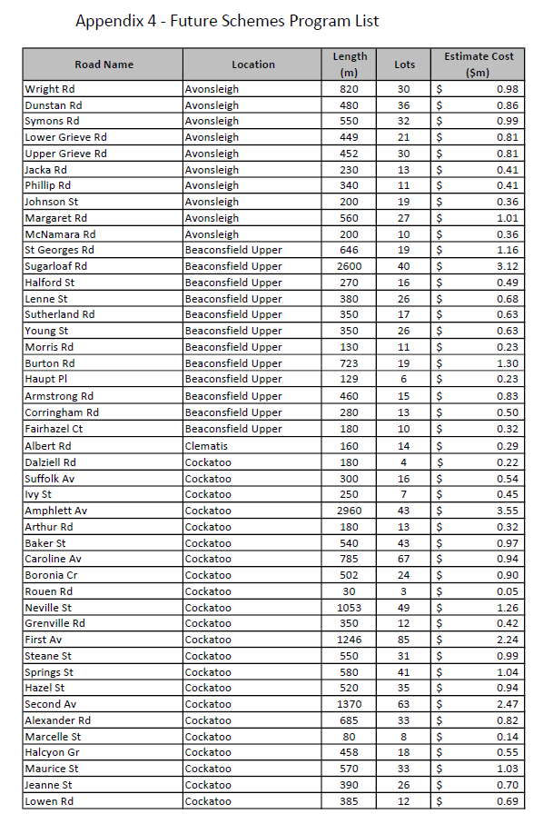
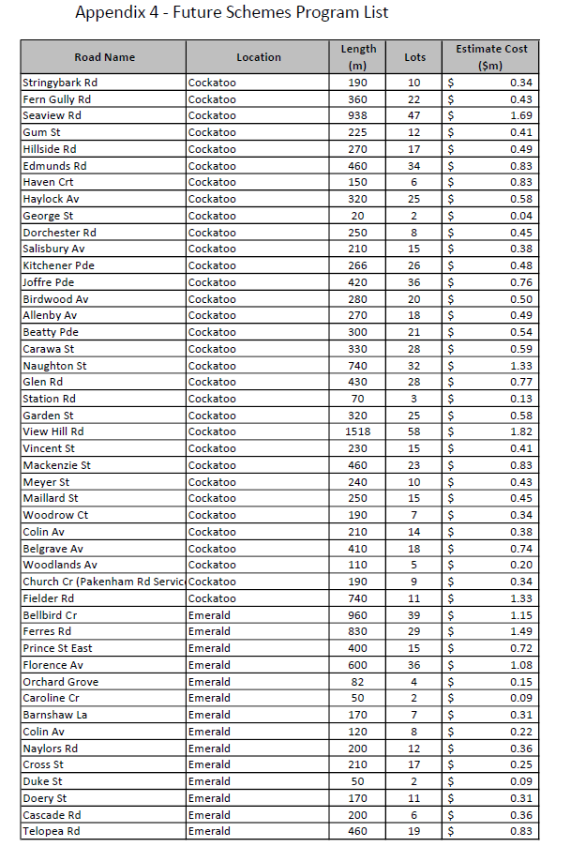
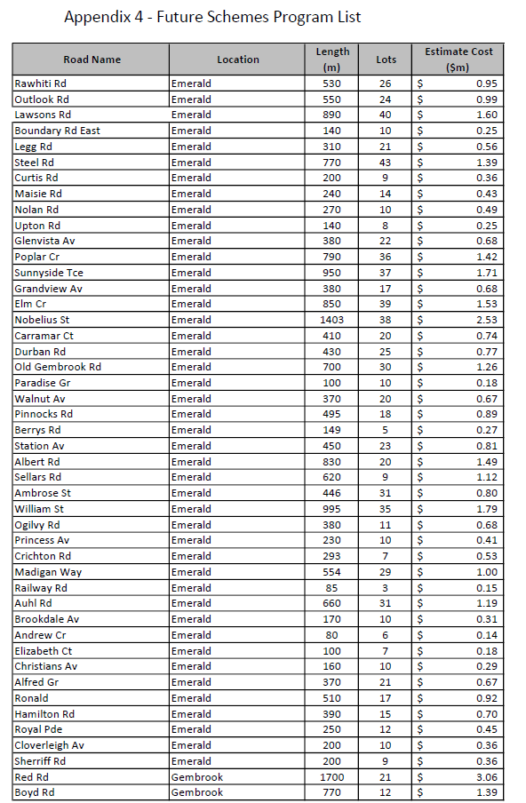
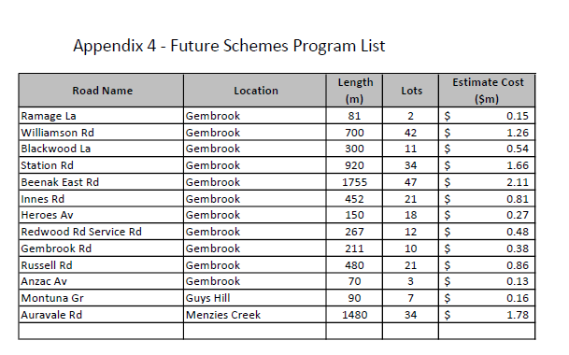

A flow chart showing the various implementation steps is contained in Appendix 1. Sec 163(2) of the Local Government Act 1989 lists the various costs that may be included in the Scheme Total Cost. Sec 163(9) of the Act prevents Council meeting legal costs associated with VCAT from the levy proceeds.
Generally contributions would be sought to maintain fairness between neighbouring property owners and where Council has implemented works ahead of a scheme to overcome immediate safety or amenity issues. Council should generally provide notice to landowners who may benefit from these works at the time of construction that they may be subject to a retrospective levy, however, that is not absolutely necessary. Council has legal advice confirming its ability to retrospectively recover costs.
Section 163(3) of the local Government Act prevents Council varying a special rate or charge to increase any contribution by 10% or more without in effect recommencing the scheme process.
Council may also consider implementing schemes to assist in providing any infrastructure required to service an area. Infrastructure that will become the responsibility of another authority must be coordinated and installed with the written agreement of that authority. This may include infrastructure such as gas mains, underground power, or sewerage works particularly where it is opportune to provide it in conjunction with Council’s infrastructure for reasons of construction, efficiency, urgency or to minimise disruption and inconvenience.
A variety of capital works projects create new or upgraded assets. It is important these projects are assessed under this policy and contributions from those receiving special benefit from those works are considered to ensure equity and fairness in the provision of municipal infrastructure
Periodically, a revised draft Future Program is referred to Council with recommended priorities for implementation. Once adopted, this program becomes the priority order for developing schemes for implementation.
Appendix 1 contains a flow chart depicting the various stages in preparation of a scheme.
Council maintains an adopted Future Schemes Program of Special Rate and Special Charge Schemes setting out the relative priorities for development of schemes having regard to known circumstances. Occasionally it is necessary to implement a project that is not included on the list. This may be due to a range of circumstances including the provision of external funding, the need to connect to a new private subdivisional road or other developments where the developer can only be required to fund his fair share of those works. It is very difficult to plan ahead for these types of works.
The Benefit Ratio calculated pursuant Sec 163(2A) of the Local Government Act limits the amount that may be levied on contributors. Schemes may not proceed without the remaining portion of the costs being funded which generally requires a Council budget commitment.
The community requires servicing with a broad range of infrastructure including utilities such as electricity, water supply & sewerage, roads and drainage as well as community infrastructure such as preschools, recreation, cultural and health care facilities. Whilst Council is only directly responsible for a narrow range of these services, there is potential for significant administrative and construction efficiencies through coordinated and integrated approaches to their provision.
“Whole of Catchment” - Often the beneficiaries of infrastructure projects stretch beyond the immediate abutting properties and are located within a broader “catchment”. These catchments need to be identified and the beneficiaries located in them included as scheme contributors if a fair and equitable beneficiary-based distribution of costs is to be achieved. To ignore this situation will result in some beneficiaries being subsidized by the broader community whilst others will be required to pay. The principal works being funded via the levy should be used to determine the boundaries of the catchment. For example, if it is primarily a road construction scheme involving road drainage, it would be more appropriate to use the traffic catchment rather than the ancillary drainage catchment.
Administrative costs in preparing a scheme do not increase in proportion to the number of properties involved. There are significant savings per property in larger schemes. Larger construction schemes also tend to be more efficient by generally attracting lower unit rates for works
Properties being apportioned costs in relation to particular works must all receive special benefit from those particular works. For example costs associated with the drainage part of a joint road and drainage scheme may only be apportioned to properties receiving special benefit from those drainage works. (The exception is where those drainage works primarily service the road and abutting properties in which case they may be included with the road costs apportionment.).
The Scheme Implementation Procedures detail a prioritization method used to assess potential schemes against these criteria by reference to: Support from contributors by reference to survey returns, petitions and correspondence. Individual listing in the Council Plan or other strategic plans, number of properties involved, relative importance of infrastructure and degree of impact of substandard infrastructure. Roads: Alignment, Grades, Riding surface quality and dust generation Drainage: Severity of flooding of properties,/ roadways, pavement scouring, deep roadside table drains Risk to the community through proximity to schools, commercial/ retail precincts & public areas, usage of infrastructure & impacted area and degree of danger/ loss of amenity community is exposed to. Degree of equity and overall reasonableness of costs in relation to prevailing economic issues.
It is far more efficient to involve one or two developers in a scheme rather than multiple purchasers of newly developed property. Purchasers in new developments have an expectation their property is properly and fully serviced and their share of the cost was met by the developer. It is difficult for Council to collect cash contributions from developers without preparing a scheme and inflation reduces the value of contributions where works are deferred.
There is a significant demand on Council to implement schemes for new infrastructure. It is fair that all members of the community be provided with reasonable opportunity for their infrastructure needs to be met without undue delay. However, generally Council will not penalize the majority of contributors by deferring recommencement of an amended scheme where a minority successfully appeal to VCAT.
The consultation process is costly and may significantly increase scheme costs particularly where an Advisory Committee is appointed. The costs of consultation and their impact on individual levies needs to be carefully considered when designing the consultation process for a particular project.
An Advisory Panel is appointed for larger projects involving many contributors and where Council considers it will provide a meaningful and cost effective channel of communication with potential contributors.. It will act as a communication link between Council and owners & occupiers. It is designed to gather input from owners & occupiers into the type of development having regard to Council’s overall objectives. The Panel will commence in the ‘Development’ stage of a project and will continue through the construction phase to scheme finalization. The Panel may recommend design concepts & design standards to Council. It may also recommend the proposed apportionment methodology and advise on any other relevant matter. Council .
Advice provided to Council through the consultation process including that from an Advisory Panel is only advisory and not binding on Council. Council will consider that advice but at all times reserves its right to apply its own standards and requirements on any proposal.
Refer also to Section 5.3 - Definitions for Scheme Total Cost
All scheme costs are to be identified and included in the Scheme Total Cost to ensure transparency of process and fairness and equity across all schemes. However, Council will meet costs up to the point where it decides whether to prepare a scheme including the costs of initial investigation and prioritization. Council may also meet some of the ‘Development’ costs incurred prior to Council determining to ‘Develop’ a scheme.
It is inequitable for scheme contributors to fund the proportion of the cost of the work or service that is associated with beneficiaries that are not being levied. (non levied properties/ people may include crown land, Council land and people from outside the scheme area who benefit). Calculation of this ratio and determining this maximum levy is a statutory requirement.
Council may decide to contribute to a scheme where it has raised the standard of infrastructure above normal standards in order to achieve broader community benefits. eg additional road width to provide a ‘collector’ road standard
Some projects may result in longer term savings to the community (eg lessened road trauma, lowered road maintenance costs) that will accrue to council or other levels of government. It is appropriate to quantify these and for council to make a comparable contribution.
Except for drainage schemes that Council determines are required for reasons of public health, Section 163B of the Local Government Act requires Council to contribute at least 1/3rd of the scheme cost where the owners of 50% or more of the properties to be levied ‘object’ to the scheme if Council wants to proceed regardless of contributor support.
This contribution is generally included via the Benefit Ratio calculation. It treats Council owned land as non-leviable property within the scheme boundary for which Council must contribute proportionately to the benefit accruing to it.
This policy recognizes that once funding has been contributed through a scheme to new infrastructure or infrastructure upgrades, eventual renewal to the same standard will be at Council’s cost and no further contributions will be imposed on property owners. Where a third party requires that infrastructure to be upgraded prior to the end of its life, it is reasonable for that party to reimburse the community for the remaining life of the infrastructure that has to be discarded.
The Benefit Ratio is applied to the Total Scheme Cost to determine the amount of the maximum levy. For consistency the Benefit Ratio must be based on the benefits accruing from all of the works included in the Total Scheme Cost and only those works.
Traffic safety provides wider community benefit through reduced cost of trauma, reduced property damage etc and will be funded by Council either directly or through grant funds.
The basic principle applying is that those levied with the charge are not required to fund works providing benefit to others. Outfall drainage also services areas outside of the scheme area. Where larger pipes are required (ie >225mm diameter) as a result of drainage inflows from outside of the scheme area, the cost of the increased drain capacity will be funded by Council. Extension of drainage lines beyond the immediate road reserve to a legal point of discharge is to be treated as outfall drainage.
Recognizes benefit to the wider community that may be in excess of that measured by reference to the Benefit Ratio calculation.
Non strategic paths will be funded relative to the community benefit as determined by reference to the calculated Benefit Ratio.
Protection and immediate discharge benefits are fairly obvious. However benefits from upgrading the drainage system at some distant downstream point are not as obvious. These improvements accrue benefits to all upstream properties including the potential to discharge increased flows.
The State Environmental Protection Policies require contaminated runoff to be contained within the boundaries of the site of generation. Clearly systems that treat that water and enable it to discharge beyond the boundaries of the originating site are of special benefit to the owners of that site.
Contributors are only required to contribute the proportion of cost attributable to draining their properties
Council recognizes that outfall drains service a broader area and will err on the side of providing greater funding assistance where possible and where significant costs are involved.
Recognises high costs and broader community benefits from increased standards.
Prior notice of this eventuality would normally be given to all potential contributors where this is likely. Such proposals would normally only involve very significant and urgent works that have precluded preparation of a broader scheme initially.
The particular special benefits need to be identified together with their costs of provision and the properties to which they accrue. The cost of providing each benefit should only be distributed over the properties to which that benefit accrues. (For example:- the cost of roads should not be distributed over properties that only receive a drainage benefit in a combined road and drainage scheme). In general the basis of apportionment needs to be relevant to and try to reflect the way in which the magnitude of the Special Benefit varies across the properties included in the scheme. .
Benefit Units may be overall, Access or Amenity or any combination of these. Council’s preference is to utilise a simple fixed contribution per Benefit Unit.
This policy allows for section of the most appropriate form of apportionment. Large variations in combinations of lot sizes and frontages (ie: irregularly shaped lots) may product inequities if an inappropriate basis of apportionment is selected.
This policy recognizes that different properties may derive different benefits from infrastructure provision based on the usage (actual & potential) which is largely regulated by the Planning Scheme zones. This benefit may be totally independent of frontage &/or area. Likewise the benefit derived from infrastructure is substantially affected by subdivision potential of properties and this policy details a mechanism for incorporating this into the apportionment process.
The basis of apportionment for each scheme will be individually determined as part of the consultation/ implementation process for each scheme.
Occasionally the variation in lot characteristics and / or zoning result in the best apportionment formula allocating several properties with contributions several times greater than the average thereby prejudicing the scheme. Council may decide to reduce the impact on individual property owners to achieve greater support and achieve the overall benefits of the scheme proceeding.
A special rate or charge may be levied so it is payable as an annual amount over a period of several years. Annual contributions may be more affordable to landowners and works may be delayed until sufficient funds have been collected to construct the works without borrowing. With larger schemes it is possible to construct the works over several years and at a rate that the outgoing cash flow matches the cash available from annual contributions and other available funds. It has the advantage of avoiding the need to borrow funds and a slight disadvantage of inflationary increases on costs due to delayed implementation.
Payment one month after commencement of works matches cash flow from contributors to contractor payments thereby minimizing the need for bridging finance. Payment at completion of works for smaller schemes (eg footpaths) saves the administrative cost of adjusting contributions and providing refunds to match actual costs. This saving more than offsets the cost financing the works for this short period of time.
Section 167 (5) & (6) of the Local Government Act require Council to provide an installment plan over at least four years where the scheme relates to capital works. The maximum rate of interest to be applied to installments is limited to the estimated borrowing rate plus 1%
Refer Section 15.2Social Responsibilities.
Council is required to finalize the scheme once all costs are known so that contributors pay no more than their portion of the actual costs. Section 165 of the Act requires all contributions to be reduced proportionate to the amount of the initial contributions where costs are less than estimated. Refunds are to be returned to the current property owners. Section 166 (3) of the Act requires Council to recommence the scheme process if there is an increase in scheme costs to any contributor in excess of 10% or meet those costs from alternate sources. This requirement places an emphasis on accurate estimating at the early stage of the process.
The Act enables municipalities to assist ratepayers facing financial difficulty in a number of ways including negotiating different methods of debt payment and waiver of interest and/or the whole or part of any outstanding rate or charge. This policy also recognizes that providing financial relief for one ratepayer in effect redistributes those costs to other ratepayers within the municipality, many of whom may be in similar financial circumstances. It is therefore important that where this relief is provided that it is done so in a socially just and fair manner for all involved including the broader community. It is important that Panel members not to know applicants personally as this may affect its ability to be objective and raise anxiety/ cause embarrassment for applicants. Potential panel members knowing applicants personally should seek to be excluded. The principle place of residence is seen as a necessity to the applicant to which they should not be denied. However, this policy is not intended to preserve it as a nest egg for the benefit of future generations at the expense of the community There are other sources of support including State and Federal agencies whose primary function is to assist people facing financial hardship. These avenues need to be pursued to relieve the burden on the immediate community. The objective is to assist contributors to meet their financial commitments in a supportive manner.
Council has comprehensive design standards (EDCM) that apply to all development within the Shire including new subdivisions.
5.5m is the general minimum trafficable width required to safely service a residential lot on a local access road.
Drainage systems may present a traffic hazard if deep and an environmental and health danger through erosion, puddling of stagnant water and harboring of weeds if allowed to remain as open side-cuts. Council applies a practical application of Melbourne Water’s Water Sensitive Urban Design Guidelines .
Driveway access can be a critical element to scheme success in steep terrain. Properly graded and constructed driveway crossovers are necessary to ensure adequate vehicular access.
Council has comprehensive design standards that apply to all development within the Shire including new subdivisions.
Basic drainage infrastructure to service properties and roads is to be provided by contributors and to a sustainable standard.
Drains shall be of adequate size to avoid unacceptable flooding. which is generally: A 1in 5 year return period (residential, industrial) or 1 in 10 year (commercial) without surcharge, and Provision of an overland flow path that does not threaten private buildings for 1 in 100 year storm events.
Open earthern drains are subject to erosion, weed growth and unacceptably high maintenance demands. Open swale drains constructed in accordance with Water Sensitive Urban Design Guidelines offer significant environmental advantages. They generally include a component of subsurface drainage and are to be encouraged in appropriate locations.
Drainage schemes may be difficult to implement as generally it is only the downstream recipients of flows that are adversely affected and these adverse affects may have serious health consequences. Section 163B of the Local Government Act waivers the requirement for Council to contribute in excess of one third of the cost of the works where they are drainage works declared by Council as required for reasons of public health. This power needs to be exercised with care and where reasonable attempts have been made to explain the necessity of the works to those affected.

