

Cardinia Shire Council

Asset Plan 2025-35

October 2025

Prepared by:

Cardinia Shire Council

Published October 2025

© Cardinia Shire Council 2025
ABN: 32 210 906 807
20 Siding Avenue, Officer

PO Box 7, Pakenham Vic 3810

Phone: 1300 787 624
Email: mail@cardinia.vic.gov.au
Web: cardinia.vic.gov.au

Acknowledgment of Country

Cardinia Shire acknowledges the Traditional Custodians of the land across our municipality, the Bunurong and Wurundjeri Peoples of the Kulin Nation, and pays respect to their Elders past and present.
We recognise the deep and ongoing connection that Traditional Owners have to Country, and we honour their continued care for the land, waters, and skies.
We value our partnerships with Traditional Owners and remain committed to supporting the ongoing role in the care, management, and stewardship of these lands, places, and assets throughout Cardinia Shire.

Contents

Acknowledgment of Country 2
Contents 3
Executive summary 4
Purpose of the Asset Plan 4
What are assets and what is asset management? 5
Key challenges 5
Key focus areas 6
Mayor’s message 7
Asset portfolio overview 8
Cardinia Shire’s community 10
Strategic alignment 12
Valuation 15
Current state of assets 17
Community engagement 19
Key documents 25
Future demands 25
Funding levels 30
Renewal Gap 24
Risk management 31
Improvement plan 32
Glossary 34
Frequently asked questions 39

Executive summary
Cardinia Shire is home to over 130,000 residents who cherish its unique blend of scenic hills, vibrant urban growth areas, historic railway townships, rich agricultural land, and a small stretch of picturesque coastline.
Spanning approximately 1,281 square kilometres, the Shire is expected to grow by more than 30,000 people in the next decade, reaching a population of around 160,000.
Strategic asset management has never been more important to meet the evolving needs of our community and enable the delivery of our important and diverse services.

Purpose of the Asset Plan
The Asset Plan is a document that communicates the importance and magnitude of the infrastructure assets for which Cardinia Shire Council is the custodian. It is intended to be a strategic public facing document that informs the community on how Council assets are to be managed to achieve the Council Plan objectives and Community Vision statement.
This allows for greater informed community engagement, by building the community's understanding of investing and sustainably managing infrastructure assets in the long-term. This supports the delivery of services and strategic outcomes for the benefit of the community as outlined in the Council Vision and Council Plan.
Specifically, the Asset Plan aims to improve transparency around asset value and performance, inform the community about council-managed assets and associated costs, embed responsible asset management into integrated strategic planning and reporting frameworks, support council’s long-term goals and finances, enhance asset management efficiency through engagement, align asset decisions with community needs and financial sustainability, and clearly communicate challenges related to service levels, costs, risks, and decision-making.
The Asset Plan has been part of an integrated review of the draft Council Plan 2025-29, Community Vision 2040, Long-Term Financial Plan and Liveability Plan. It has been informed by the community through a deliberative engagement process. It focuses on built infrastructure assets and does not consider plant and equipment, furniture, information technology, trees or property. These assets are managed separately.
The Asset Plan is a legislative requirement under the Local Government Act 2020 which requires all Councils to develop and adopt a 10-year Asset Plan after each council election.

What are assets and what is asset management?
Assets are all around us – they are the things you see when you leave your front door: the local roads you drive on, the footpaths you walk on, the bridges that help you cross from one side of the creek to the other, the playgrounds and open spaces you visit, the buildings you enter to meet with other community members — the list goes on.
Cardinia Shire Council manages more than $2.7 billion in infrastructure assets, including those mentioned above, along with stormwater pits and pipes, cycleways, major culverts, park and street infrastructure, sporting surfaces, and more.
Asset management is not solely concerned with maintaining physical assets—it is fundamentally about realising value from those assets and ensuring they align with the strategic objectives of Council. Realising value involves ensuring that assets are appropriate for current and future community needs, are well-utilised, maintained in a safe and fit-for-purpose condition, and managed in a way that is financially sustainable.
Effective asset management requires a balanced approach: it involves preserving and optimising existing assets, disposing of assets that are no longer required, and ensuring that any new assets are necessary, affordable, appropriately scaled and designed, and accessible to a broad cross-section of the community. This approach supports responsible stewardship and enables Council to deliver services efficiently, while adapting to growth and changing community expectations. Cardinia Shire Council continues to strive towards effective asset management and apply responsible stewardship in managing its assets.

Key challenges
Cardinia Shire Council’s 2025–26 Budget reflects the need to make careful investment decisions in the context of limited and finite resources. As part of this, there is an increasing emphasis on reviewing the need for renewing and maintaining existing infrastructure to ensure it continues to meet the evolving needs of the community, whilst balancing our overall financial sustainability. Funding allocations are guided by data and long-term planning, supporting upgrades and ongoing maintenance through the capital works program.
As a designated growth area, Cardinia Shire faces the dual challenge of supporting rapid population growth while maintaining and renewing ageing infrastructure. Balancing these priorities is complex, especially as Council often relies on developer contributions to fund new community infrastructure. Infrastructure and funding gaps are identified to guide advocacy efforts for additional support from Victorian and Australian governments.
Cardinia Shire’s growth areas are still in their early stages. Continued advocacy is essential to secure the infrastructure needed to support a growing population, particularly considering the Victorian Government Housing Policy, which projects an additional 36,000 new homes by 2051. This will require significant investment in roads, community facilities, and public spaces that promote social connection, physical activity, and resilience.
Cardinia Shire Council remains committed to long-term asset planning, guided by this Asset Plan alongside the Long-Term Financial Plan, Asset Management Policy, and other strategic documents.
These frameworks support responsible stewardship and ensure infrastructure investment is sustainable and aligned with community needs.

Key focus areas
Cardinia Shire Council is committed to strengthening asset management to support a growing community and ensure long-term sustainability. Over the coming years, our focus will include:
- Infrastructure delivery: Upgrading roads, drainage, and public assets to meet current and future needs.
- Strategic planning: Developing and implementing strategies for unsealed roads, drainage, and facility utilisation.
- Technology and data: Enhancing asset systems, condition audits, and data-driven decision-making.
- Financial sustainability: Aligning asset planning with long-term financial strategies and improving cost transparency.
- Community engagement: Transparency in decision making, and incorporating community feedback to help with balancing cost, risk and expectations.
- Climate resilience: Enhancing consideration of climate change impacts into asset design, and lifecycle and funding models.
- Advocacy and growth management: Advocating for infrastructure funding and maximising developer contributions.
- Governance and reporting: Enhancing asset management reporting, asset checks, and improving transparency and information for the community.
These priorities will guide our efforts to deliver reliable, inclusive, and sustainable infrastructure for the Cardinia community.

Mayor’s message
The 2025-2035 Asset Plan is one of Council’s key strategic documents, outlining how Council will manage its assets to support the delivery of the Community Vision 2040 and Council Plan. It provides our community with insight into the assets we rely on to deliver services, and the approach we take to manage those assets efficiently and effectively.
For many of us, asset management isn’t always front of mind. Yet, how often do we walk along a footpath and assume it will always be there, without considering the planning, funding and maintenance required to keep it functional for years to come.
Asset management plays a vital role in ensuring our infrastructure continues to support the community now and into the future. It involves thoughtful planning and long-term investment – and it benefits all of us.
As part of our deliberative engagement for the new Council Plan, community panel members were introduced to the asset management process and the challenges involved in planning for the community’s future needs. Many were surprised by what they had learned, and gained valuable perspective on the many things Council must take into account when making decisions about our assets.
I would like to take this opportunity to thank members of the community panel whose feedback and insights have helped shape this Asset Plan, which presents a high-level strategic and financial overview of how Council will manage its assets over the next 10 years, aligning with the requirements of the Local Government Act 2020.
It’s also important to recognise and acknowledge the many volunteers who support the management and care of Council’s assets, including township groups, ‘Friends of’ groups, environmental organisations, sporting clubs and committees of management. These groups volunteer endless hours of their time to help maintain and enhance our shared spaces. Their work and dedication is deeply valued and appreciated.

Cr Jack Kowarzik
Cardinia Shire Mayor 2024–25

Asset portfolio overview
This Asset Plan has been developed to communicate the importance and magnitude of the infrastructure assets for which Council is the custodian. This allows for greater informed community engagement, by building the community's understanding of investing and sustainably managing infrastructure assets.
This supports the delivery of services and strategic outcomes for the benefit of the community as outlined in the Council Vision and Council Plan.
It has been prepared in accordance with the requirements of the Local Government Act 2020

Transport
Asset class | Value
Roads (sealed) | $631.77M
Roads (unsealed) | $246.24M
Kerbs | $133.98M
Off-street car parks | $29.02M
Pathways | $239.37M
Bridges | $241.70M
Other road infrastructure | $16.86M
Total value | $1.54B

Drainage network
Asset class | Value
Stormwater pipes | $390.82M
Stormwater pits | $129.80M
Surface drainage (all other drainage) | $14.23M
Total value | $535M

Buildings
Asset class | Value
Buildings | $496.83M
Total value | $497M

Open space network
Asset class | Value
Open space infrastructure | $133.80M
Total value | $134M

Cardinia Shire’s community
We value our partnerships with Traditional Owners and remain committed to supporting the ongoing role in the care, management, and stewardship of these lands, places, and assets throughout Cardinia Shire.

Population and people
Measure | Value
Australian citizen (%) | 85
Estimated resident population - females (no.) | 63,995
Estimated resident population - males (no.) | 62,965
Working age population (aged 15-64 years) (%) | 65
Population density (persons/km2) | 102
Median age - persons (years) | 35
Median age - males (years) | 34
Median age - females (years) | 35
Estimated resident population (no.) | 130,383
Person born overseas | 27,730

Land and environment
Measure | Value
Land area (ha) | 128,257
Total protected land area (%) | 11

Income
Measure | Value
Median employee income ($) | 56,549
Superannuation and annuity income earners (no.) | 892
Superannuation and annuity income earners - median age (years) | 54

Family and community
Measure | Value
Average family size (no. of persons) | 3
Worked from home (no.) | 11,036
Used at least one form of public transport (train, tram, bus, ferry) (no.) | 1,585
Travelled to work by car (as a driver or passenger) as at least one method of travel (no.) | 37,955
No motor vehicles (no.) | 1,006
Homeless persons per 10,000 persons (rate) | 29

Economy and industry
Measure | Value
Total number of businesses | 11,940

Aboriginal and Torress Strait Islander
Measure | Value
Estimated resident Aboriginal and Torres Strait Islander population (no.) | 1,395

Strategic alignment
The Asset Plan is one of the legislated documents Council develops to support the delivery of the Community Vision 2040 and Council Plan.
Assets are needed and important for most Council services and aspirations. Therefore, it is important they are considered and developed alongside the Long term Financial Plan, Budget, Rating and Revenue Plan and Liveability Plan, in consideration of the Council Plan and Community Vision.
The way Council manages and plans to care for these Assets is known as asset management. A key part of ensuring Council coordinates and plans asset management activities is to have clear plans and strategies.
These outline how this will be done, and improvements plans to continue to increase asset management maturity. Council business and operational plans also impact or are impacted by assets.
The role of each of these documents is outlined in the Glossary section of this Asset Plan.

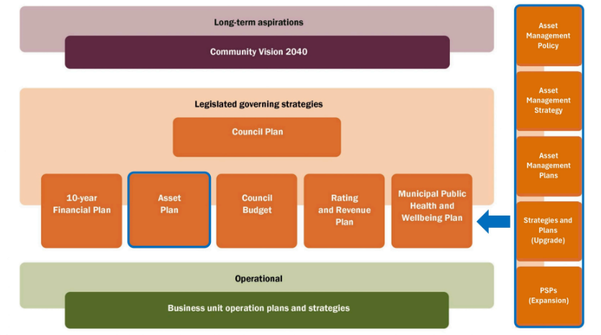
Figure: Council's strategic framework

Strategic objectives
The Council Plan is structured around five strategic objectives. Assets are critical in achieving these objectives. The table below outlines how Council's asset management activities support each strategic objective.

Strategic objective and summary | How does the Shire's assets and asset management support the delivery of the Community Vision and Council Plan?
Thriving Communities  The programs, facilities and places that we support are safe, inclusive, and enhance participation, wellbeing and resilience | Assets are required to provide the services needed for the community to thrive. Council seeks that community facilities, sports facilities, and public spaces are well-maintained and well planned, providing infrastructure that meet community service needs by being accessible and promoting health, connection, and resilience.  Community facilities and open space assets provide spaces for social and health support, arts and culture, education and active recreation.
Vibrant places  We value our well-designed towns and infrastructure that fosters belonging and connections | Council works to optimise capital and maintenance expenditure of roads, car parks, bridges, pathways, community facilities and open space assets to ensure assets are safe, inclusive and provide adequate connectivity between places.  Upgrading of Council’s road network within the Shire continues to improve safety and connectivity while considering traffic demand and  freight transport needs.
Adaptive environments  We care for our natural environment and support recovery from challenges | Parks, open space and natural reserves provide areas to ensure biodiversity is protected. The stormwater drainage network actively treat stormwater runoff. Council also makes use of stormwater harvesting assets to reduce the demand for water and help manage stormwater flows.  A future initiative is to further mature and embed climate change impact assessments within Council's asset management.
Prosperous economies  We encourage urban and rural business and local employment to grow | Ensuring that existing transport and connectivity infrastructure is well maintained and upgraded. This aims to improve access to productive and employment lands, making it easier for businesses to operate and grow and for residents to access job opportunities.  Buildings and facilities provide spaces for numerous programs, meetings and other activities which promotes the support for education and skill development initiatives, enhancing the local workforce and attracting new industries and innovations.

Strategic objectives continued…

Strategic objective and summary | How does the Shire's assets and asset management support the delivery of the Community Vision and Council Plan?
Responsible leaders  We demonstrate responsible leadership and financial stewardship | Council practices responsible leadership by ensuring transparency and accountability in asset management decisions, ensuring decisions are made in the best interest of the community and future generations.  Asset management provides data for decision making and helps us to make appropriate financial decisions, ensuring we are funding the infrastructure we are currently using and not putting unreasonable burdens on future generations.  Council utilises asset management industry standards and make data driven decisions in conjunction with community engagement to manage the lifecycle of Council's asset portfolio to balance Council's budget and community needs.

Valuation
Council's asset portfolio is made up of a variety of categories, each playing a crucial role in the functioning, wellbeing, safety, and prosperity of Cardinia Shire.
The total value and scale of assets is substantial. Valuation data comes from independent assessments or data analysis and is governed by legislation and reporting requirements.
This information is used to consider, plan, and make decisions on the budgets required, to ensure assets remain in useful condition, and appropriate for needs now and into the future.
Among these, Council road assets hold the highest value, highlighting their critical role in facilitating efficient movement and connectivity throughout the Shire

Valuation overview
Replacement value | Accumulated depreciation | Written down value
$2.70BN | $488.18M | $2.22BN

Replacement value by asset category
Open space | Buildings | Drainage | Transport
$133.80M (4.9%) | $496.83M (18.4%) | $534.85M (19.8%) | $1,538.95M (56.9%)

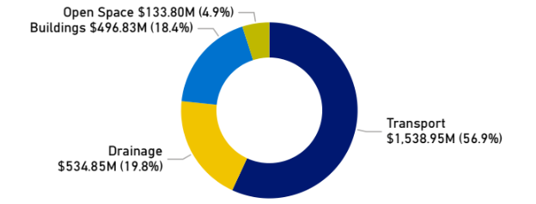
Figure: Replacement value by asset category

Replacement value and written down value by asset category
 | Replacement value | Written down value
Transport | $1,539M | $1,327M
Drainage | $535M | $446M
Buildings | $497M | $359M
Open space | $134M | $84M

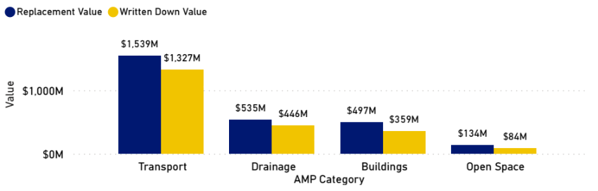
Figure: Replacement value and written down value by asset category

Bridges
Asset Class | Replacement Value ($M) | Accumulated Depreciation ($M) | Written Down Value ($M)
Bridge and culverts | $241.70M | $63.42M | $178.29M

Pathways
Asset Class | Replacement Value ($M) | Accumulated Depreciation ($M) | Written Down Value ($M)
Pathways | $239.37M | $43.48M | $195.89M

Roads
Asset Class | Replacement Value ($M) | Accumulated Depreciation ($M) | Written Down Value ($M)
Roads (Unsealed) | $246.24M | $12.84M | $233.40M
Roads (Sealed) | $631.77M | $63.30M | $568.48M
Other Road Infrastructure | $16.86M | $3.79M | $13.07M
Off Street Car Parks | $29.02M | $2.90M | $26.13M
Kerbs | $133.98M | $22.48M | $111.50M

Drainage
Asset Class | Replacement Value ($M) | Accumulated Depreciation ($M) | Written Down Value ($M)
Surface Drainage (All other drainage) | $14.23M | $1.55M | $12.68M
Stormwater Pits | $129.80M | $21.95M | $107.85M
Stormwater Pipes | $390.82M | $65.44M | $325.38M

Buildings
Asset Class | Replacement Value ($M) | Accumulated Depreciation ($M) | Written Down Value ($M)
Buildings | $496.83M | $137.69M | $359.14M

Open space
Asset Class | Replacement Value ($M) | Accumulated Depreciation ($M) | Written Down Value ($M)
Open Space Infrastructure | $133.80M | $49.35M | $84.44M

Current state of assets
This section considers the current physical condition of Council infrastructure assets using a 0 - 6 scale rating with 0 being a brand-new asset and 6 being end of life. Overall, Cardinia Shire Councils assets are mostly young and in good condition.
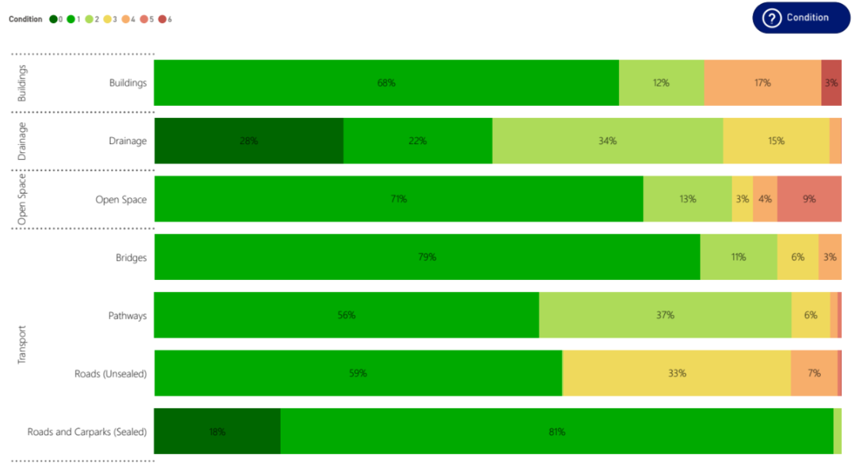

Community engagement
Community engagement has been vital in developing the Council Plan and Asset Plan.
In line with the Local Government Act 2020, Council undertook a deliberative engagement process in February 2025 with a representative panel of community members.
The panel met over four sessions and considered the challenges and opportunities facing Cardinia Shire, informed by a wide range of data and information.
One of the sessions focussed on asset management. The panel was presented with information on how Council manages its assets and was asked to respond to three questions (below) – The responses are summarised below, along with the activities Council is undertaking and planning to address these panel suggestions.
Some of these suggestions have formed part of the Asset Plan itself, and many are also useful for Council internal business planning and broader asset management.
For more information on the community engagement process and the full community panel outcomes report, visit our Creating Cardinia Future Cardinia webpage.

How should Council invest in assets over the next 10-years to achieve the Community Vision?
What the Community Panel suggested/said | How will Council / How has Council considered this feedback
AI Technology and technological advances to improve planning decisions. | Council, via its Digital Transformation roadmap initiative is currently preparing for significant uplift in their digital systems. A key consideration will be to make the most of emerging technology, such as Artificial Intelligence (AI) in future work.  AI is a rapidly emerging technology sector, and there are many innovative ways that AI can improve and augment Council operations. This could include streamlining complex decision processes, such as planning applications.  Another example is gathering and analysing large data sets, such as large volumes of asset condition data, which helps to build a more accurate picture of the condition of our assets and better schedule maintenance.  Another powerful use of AI is to improve financial modelling and decision making. Council will ensure that our technology platforms are ready and able to incorporate solutions that improve our decisions and processes.
Use of data to define community needs over wants. | Council service strategies aim to provide a clear understanding of the need for assets, spaces, and functionality that support the delivery of services that meet community needs.  Council is committed to use of data to support decision making and will continue to invest in achieving the data needed through condition assessment and valuations.  Council Digital Transformation initiative will help ensure our internal data programs are effective and integrate. Likewise planning for open space, sport and active recreation and other community assets is informed by a range of data and benchmarked with other local government areas.  A service attraction gap analysis will be conducted to inform the gaps and opportunities to meet the future populations service needs.
Ensure assets and infrastructure supporting healthcare, creative arts, sporting events. | Council develops and reviews strategies related to the trends and needs of certain assets.  These documents are developed using data and information and include consultation with stakeholders. Examples include the Active Cardinia Strategy, Open Space Strategy, Liveability Plan and Community Infrastructure Plan.  Council aims to support and attract health and social services through local data and research that informs advocacy to all levels of government.

How should Council invest in assets over the next 10-years to achieve the Community Vision, continued…
What the Community Panel suggested/said | How will Council / How has Council considered this feedback
Climate mitigation and sustainability. | Councils Climate Change Adaptation Strategy 2022-33 guides Council investment and action on climate change.  Council has a dedicated capital works financial allocation for waste and energy efficiency infrastructure projects which includes projects focussed towards climate mitigation.  Climate change is embedded in Council's asset management process, to consider the vulnerability of assets to climate change and how this should be planned for. This will be an ongoing focus and opportunity.
New assets must meet high sustainability standards to reduce long-term costs. Sustainability measures such as renewable energy, solar street lighting and LED lighting, water-saving initiatives, fire-retardant native plant landscaping, reducing Council maintained lawns and ensuring environmental responsibility in road and infrastructure management. | Council is committed to high sustainability standards within their asset planning and projects.  Renewable energy (Solar PV systems) are installed on many council buildings. Council funds the Community Capital Works Grants program, which has seen Solar PV systems and battery storage installed in community buildings occupied by committees.  Council has a dedicated capital works financial allocation for water and energy efficiency infrastructure upgrades, and considers Environmental Sustainable design principles within our Building projects.

How can we ensure Council’s decisions are fair and balances across different community needs?
What the Community Panel suggested/said | How will Council / How has Council considered this feedback
Engagement and two-way communication with council and council staff, engaging with the people who use assets or need services i.e. voting, referendums, advisory groups and consultative committees to do ongoing work with council etc. | Council's Community Engagement Policy outlines a commitment to authentic and inclusive engagement, ensuring all members of the community have the opportunity to provide feedback on issues or projects that will impact them.  Council is always looking at ways to reach different parts of the community when undertaking engagement in an effort to hear from people who don't often engage with Council.  Council will continue to engage with advisory groups and consultative committees who provide a diverse range of perspectives.  Council will also continue their 'Creating Cardinia - On the Move' pop-up engagement sessions, to enable face to face interactions with community to have a conversation and encourage their participation in the decision-making process.
Better promotion and communication of engagement through media. | Council is committed to improving the 'close the loop' process with the community on engagement projects, to assist community members in understanding how their feedback has been used to inform Council's decision making.  While Council frequently promote the opportunity for community to participate in engagement projects through Council's communication channels and the local newspaper, Council will also explore ways to better promote the result of engagement activities.  This includes the development of a regular engagement electronic newsletter to participants who have subscribed to Council's 'Creating Cardinia' engagement platform.
Increased reporting to community such as through progress reports. | Council reports and progress reporting are already public, though the reports are not always easy to access or digest.  Most reporting is prepared for Council meetings in each quarter, including construction projects, operating budgets, progress of projects and major initiatives, as well as performance indicators.  Council regularly reviews Council reports to promote readability and the value of the information.  An improvement plan within this plan is to enhance reporting for asset management for the community.

How can we ensure Council’s decisions are fair and balances across different community needs, continued…

What the Community Panel suggested/said | How will Council / How has Council considered this feedback
Improved transparency in decision making process. | Council reports and progress reporting are already public through Council's website and Council meeting minutes, though the reports are not always easy to access or digest. The community can attend or listen to live Council meetings, though participation is low.  Most reporting is prepared for Council meetings in each quarter, including construction projects, operating budgets, progress of projects and major initiatives, as well as performance indicators.  We regularly review Council reports to promote readability and the value of the information. An improvement opportunity within this plan is to enhance reporting and feedback for the community on asset management.
Standardised set of criteria for community needs assessment, informed by data and community needs. | Council service strategies aim to provide a clear understanding of the need for assets, spaces, and functionality that support the delivery of services that meet community needs.  Council is committed to use data to support decision making and will continue to invest in achieving the data needed through condition assessment and valuations. Council's Digital Transformation initiative will help ensure Council's internal data programs are effective and integrate.  Likewise planning for open space, sport and active recreation and other community assets is informed by a range of data and benchmarked with other local government areas.  An example of this type of work is Council's Community Infrastructure Plan, which helped Council understand the needs in the early years service area due to population growth and changed Victorian Government policy.  This is an ongoing need and will benefit from enhanced data and growing maturity in Council's Project Management Framework.
Risk assessment and climate mitigation in decision making. | Reports to the executive team and Council briefing and Council meetings must consider a response to climate change.  Climate change risks are included in Council's Risk register, and vulnerability of assets to climate change and rising sea levels are assessed within asset management plans for relevant assets.

What should Council’s approach be if there are assets that are underutilized, have excessive ongoing costs or are over the agreed level of service?
What the Community Panel suggested/said | How will Council / How has Council considered this feedback
Increase use of facilities through advertising, cost incentivisation and changing function to create multi-use facilities. | Council already has a commitment to designing and delivering multi-use facilities where appropriate.  A facility utilisation audit will be occurring in the next two years, which will help to identify underutilised facilities and identify opportunities for expanded and multipurpose utilisation.
Assess the viability and need of facilities, cost efficacy, and the possibility of increasing user fees. | This is supported through the strategic planning undertaken through the Community Infrastructure Plan, Active Cardinia Strategy, and Open Space Strategy.  Usage data and industry trend, and asset condition results support decision making. Fees & charges are reviewed annually, and where possible, benchmarked with other local governments.  Specific policy and strategy review will also shape the development of fees and charges, where grants or subsidies are provided.
Having voluntary committees to reduce running costs of facilities or help with maintenance. | Volunteers are important to Cardinia Shire Council, and support Council service delivery, and increase community participation and cohesiveness.  In the new 2025 Council plan, this is recognised through strategy around partnerships and volunteers. Council seeks to partner with community groups and providers and encourage volunteerism.  Council values the many community and recreational facilities that are run by committees, and friends groups and intend to develop and implement a Volunteer Strategy over the next four years.
Selling assets, leasing or privatisation of assets. | Cardinia Shire has a growing population with changing demographics, which Council will be mindful of when looking at the potential future needs for assets.  The disposal of assets is a usual part of the asset management lifecycle. Selling, privatisation, or repurposing assets are options for the future, however, the Shire's growing population means it is less of a consideration.  If this was explored in the future, solid data on utilisation of assets, and modelling of the future needs and risks would need to be undertaken.  Council does regularly lease or rent Council assets within its property portfolio for community use, to attract key service providers, or commercially, as appropriate.

Key documents
Council's asset management approach is governed by legislation, financial and accounting standards and informed by best practice international standards for asset management. Assets
are key to Council's service delivery.
Therefore, many of Council policies and strategies influence or interact with this plan. Some of these are listed below.

Legislative documents
Link to complete directory: www.legislation.vic.gov.au/in-force/acts

- Local Government Act 2020
- Road Management Act 2004
- Environment Protection Act 2017
- Planning and Environment Act 1987
- Planning and Development regulations
- Catchment and Land Protection Act 1994
- Water Act 1989
- Building Act 1993
- Emergency Management Act 1986

Strategic Council documents
Link to complete directory: www.cardinia.vic.gov.au/directory/16/a_to_z

- Asset Management Policy
- Community Infrastructure Plan
- Road Management Plan
- Active Cardinia Strategy
- Community Advocacy Toolkit
- Climate Change Adaption Strategy
- Sustainable Environment Policy
- Enhanced Standard: Sustainable Buildings
- Open Space Strategy
- Pedestrian and Bicycle Strategy (to be reviewed)
- Equestrian Strategy
- Integrated Water Management Plan
- Building and Facilities Maintenance Policy
- Public Toilet Strategy
- Sport Facility Standards Policy
- Crime Prevention Through Environmental Design Policy

Precinct Structure Plans (PSPs), Infrastructure Contribution Plans (ICPs) and Development Contribution Plans (DCPs)
Link to complete directory: www.vpa.vic.gov.au/project-list/?by_status=

- Pakenham DCP
- Cardinia Road DCP
- Cardinia Road Employment DCP
- Officer DCP
- Pakenham East ICP
- Glismann Road DCP
- Pakenham South Employment ICP
- Officer South Employment ICP

Future demands
Our community is growing, changing and becoming more diverse. The Council Plan seeks to foster a prosperous economy, whilst protecting our natural and built environments.
Along with the local government sector, we face significant financial sustainability challenges.
Asset management involves considering these future demands, and how assets or asset management approaches may need to be adapted, changed, or balanced to address these strategically based on funding available. Key future demands and priorities include:

Population growth
- Projection: The population is expected to grow by 20% in the next 10 years. Cardinia Shire Council is one of Victoria's largest growth councils and will continue to experience high population growth.
- Impact on services: Ongoing population growth and the development of new areas will continue to increase the number of assets constructed by, or provided to Council, resulting in greater long-term costs and resource demands for their management.
Existing Council assets will also experience higher utilisation and volumes. There will be greater demand on planning and funding existing assets for renewal, maintenance and upgrade to support community accessibility and connectivity as assets will experience higher utilisation.
Council may need to expand services and facilities to cater for community growth.
Increased rate payer base can provide economies of scale for service provision and help support funding requirements for aging demographic and assets.

Demographic change
- Projection: Forecasting is predicting steady growth in all age demographics with adults and older resident age groups projected to have the highest increase by 2035. Cultural diversity is also increasing.
- Impact on services: A possible higher demand for safety requirements and accessibility for older community members. Community needs and demographic changes will need to continue to be monitored through strategy development, with a focus on providing infrastructure that is multi-use across the community and promotes universal access and equity.

Asset growth
- Projection: Continued asset growth due to new development areas or population growth.
- Impact on services: Council needs to ensure critical infrastructure keeps pace with population changes in growth and community needs.
These requirements are also legislated within precinct structure plans, within funding contributed by the development or infrastructure contribution plans that Council manages.
A growth in asset base will generally increase Council’s long-term renewal and maintenance expenditure over the long term.

Asset renewal and maintenance
- Projection: An increasing demand to ensure assets are kept in usable condition as the asset base ages.
- Impact on services: If assets are not maintained or renewed to an acceptable condition particularly as assets begin to age, this impacts the overall service that assets provide for the community.
Maintaining and renewing assets efficiently with a proactive approach can extended the life of assets, ensure cost effective service delivery and increase community satisfaction.

Financial sustainability
- Projection: Balancing investment choices will be coming increasingly difficult in an income constrained environment.
- Impact on services: New infrastructure investments will need to be supported by strong strategic needs, and consideration of the requirements and scale of new infrastructure and its whole of life costs.
There will be increasing reliance on advocacy and grant funding opportunities for infrastructure and cost-efficient maintenance.
Renewal and maintenance will need to be well planned out, and data driven decision making will be more important than ever.

Integrated planning
- Projection: A growing necessity to ensure enhanced integration of asset management with financial, project and service planning to ensure long-term sustainability.
- Impact on services: Integrated planning ensures that limited resources are directed to the most critical assets.
This avoids over-investing in low-priority assets while underfunding high-impact ones. This leads to more sustainable service levels for the community and avoids future financial pressures.

Increased cost of materials
- Projection: Material and labour costs are expected to continue to rise.
- Impact on services: Capital expenditure and maintenance costs will continue to increase. Council may need to scale back, restage or delay infrastructure projects due to budget constraints.
Infrastructure projects and renewal works programming may need to be reprioritised or postponed which may result in cutting or reduction to services.

Climate change and climate resilience
- Projection: It is expected that climate change will intensify in the medium to long term future resulting in an increase of extreme weather events.
- Impact on services: Periods of low or extreme rainfall events, increasing heat and bushfire events can significantly increase asset maintenance and renewal requirements. There will also be a demand for upgrading of assets to ensure they are climate resilient which would require greater capital expenditure.

Changing design standards and legislation
- Projection: Over time, the design and legislative requirements of particular assets are likely to continue to change.
- Impact on services: As new requirements are introduced, the up-front cost to build or replace assets at a modern standard will likely increase, especially for older assets.
However, newly constructed assets may offer greater longevity and reduced maintenance requirements.
As design and legislative requirements change for infrastructure and services, existing assets may no longer meet requirements.

Community expectations
- Projection: Rising expectations for quality open spaces, transport, and community infrastructure. Desire for more transparency around decision making, and consultation and feedback opportunities.
- Impact on services: Rising expectations will result in increased life cycle costs, unless well managed or mitigated. Additional resourcing may be required to communicate challenging funding trade off decisions.
Providing high quality assets that are up to modern standards will lead to an increase in renewal, upgrade and expansion costs.

Community wellbeing
- Projection: A need to support strong, healthy, and connected communities through inclusive infrastructure.
- Impact on services: Assets like open spaces, libraries, community centres, and footpaths must be accessible to all.
There is greater expectation for Council to invest in assets that promote physical and mental health. Infrastructure is shifting toward flexible, multi-purpose facilities that can host events, services, and programs for diverse groups.
This increases the utilisation and value of assets while fostering community cohesion.

Technology and data
- Projection: Managing increasing amounts of data and maximising its effectiveness and use to support decision-making.
- Impact on services: Strategic asset planning requires data-driven insights to prioritise investments, manage risks, and align with community needs.
Council continues to improve data to monitor asset performance, predict maintenance needs, and optimise lifecycle costs.
This leads to more proactive and cost-effective service delivery and overall better asset management decision making, stewardship and integrated planning.

Future demographics
The ability to predict future demographic demand for services enables Council to plan and identify the best way of meeting that demand.
All data listed below is from forecast.id.com.au, with 2021 from census.

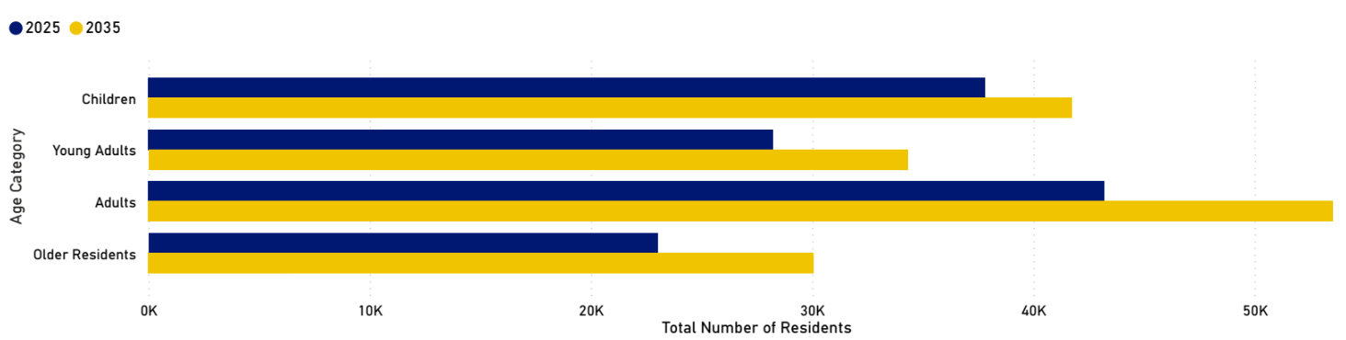

Figure: Number of Cardinia Shire residents in 2025 and the projected number of residents in 2035.

Age category | 2021 | 2025 | 2030 | 2035
Children | 34,735 | 37,826 | 40,803 | 41,761
0 to 4 | 9,372 | 9,815 | 10,440 | 10,804
5 to 9 | 9,487 | 9,653 | 10,161 | 10,336
10 to 14 | 8,518 | 9,376 | 10,058 | 10,222
15 to 19 | 7,358 | 8,982 | 10,144 | 10,399
Young adults | 26,373 | 28,240 | 32,499 | 34,321
20 to 24 | 7,237 | 8,364 | 10,424 | 10,761
25 to 29 | 8,900 | 8,940 | 10,614 | 11,517
30 to 34 | 10,236 | 10,936 | 11,461 | 12,043

Future demographic demand continued…

Age category | 2021 | 2025 | 2030 | 2035
Adults | 38,349 | 43,204 | 50,110 | 53,552
35 to 39 | 9,739 | 11,089 | 12,158 | 11,935
40 to 44 | 7,916 | 9,806 | 11,444 | 11,672
45 to 49 | 7,609 | 8,200 | 10,690 | 11,732
50 to 54 | 6,913 | 7,700 | 8,443 | 10,492
55 to 59 | 6,172 | 6,409 | 7,375 | 7,721
Older residents | 20,064 | 23,009 | 26,641 | 30,061
60 to 64 | 5,462 | 5,857 | 6,074 | 6,765
65 to 69 | 4,502 | 5,141 | 5,790 | 5,896
70 to 74 | 4,051 | 4,313 | 5,040 | 5,611
75 to 79 | 2,850 | 3,659 | 4,084 | 4,720
80 to 84 | 1,722 | 2,233 | 3,135 | 3,472
85+ | 1,477 | 1,806 | 2,518 | 3,597
Summary | 119,521 | 132,279 | 150,053 | 159,695

Funding levels
To manage assets, Council plans for how budget is allocated across asset categories.
This section outlines how Council plans to invest in acquisition, upgrade, operational and maintenance, expansion and renewal of assets over the next 10 years at a network level. It aligns with Council's current Long Term Financial Plan.
Individual projects are prioritised via individual Asset Management Plans and approved via annual budget processes. The recommended funding levels are based on substantial data sources which include condition data, valuation data, renewal priority lists, financial and asset management indicators, and depreciation.
Understanding the current condition, and any safety issues is an important part of asset management.
Council has a program of condition audits and seeks to continue to advance and further mature these processes over the next four years. Condition is assessed via various methodologies ranging from internal visual inspections, or fault information to high technology contracted services, with a general focus on high value or higher risk assets.
The distribution of condition of assets is show

All assets
Note: The 'Acquisitions' funding allocation does not represent the total projected growth. The difference between the forecasted growth and the budgeted amount is accounted for by developer contributions, which are expected to be received as gifted assets.

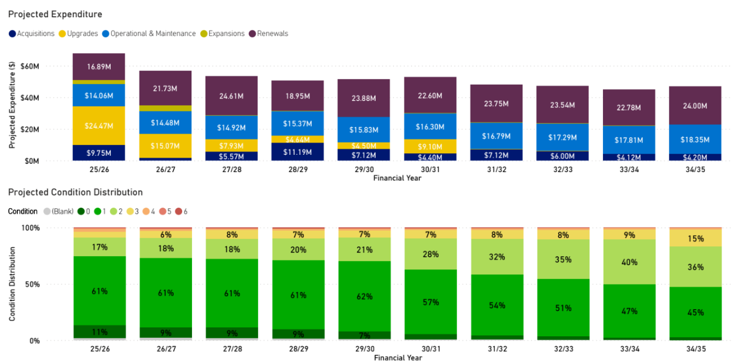

Bridges
Note: The 'Acquisitions' funding allocation does not represent the total projected growth. The difference between the forecasted growth and the budgeted amount is accounted for by developer contributions, which are expected to be received as gifted assets.

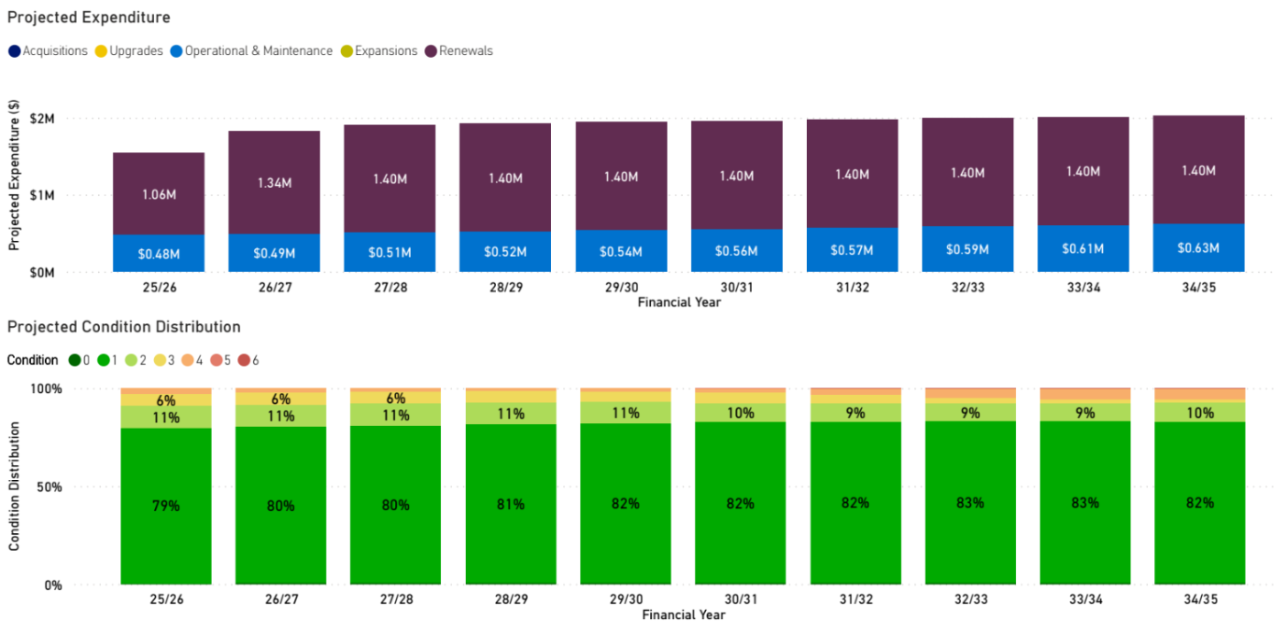

Pathways
Note: The 'Acquisitions' funding allocation does not represent the total projected growth. The difference between the forecasted growth and the budgeted amount is accounted for by developer contributions, which are expected to be received as gifted assets.

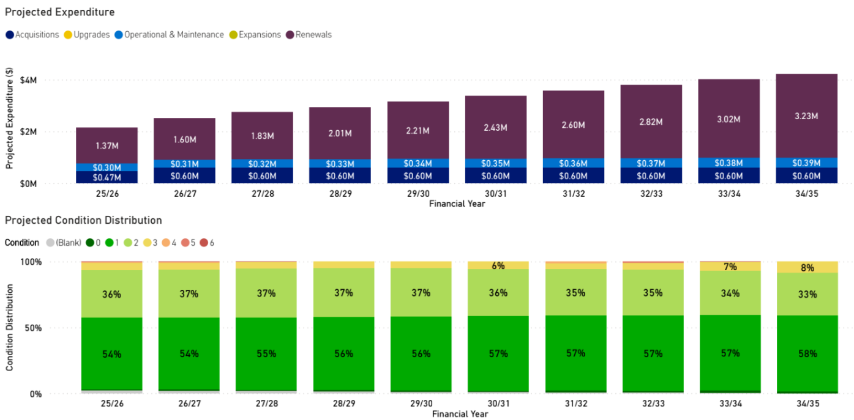

Roads and carparks
Note: The 'Acquisitions' funding allocation does not represent the total projected growth. The difference between the forecasted growth and the budgeted amount is accounted for by developer contributions, which are expected to be received as gifted assets.

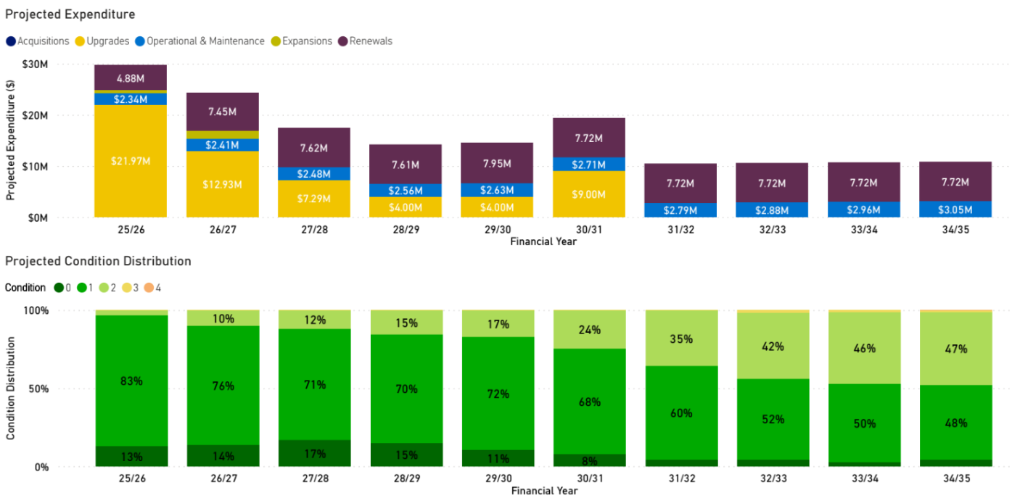

Drainage
Note: The 'Acquisitions' funding allocation does not represent the total projected growth. The difference between the forecasted growth and the budgeted amount is accounted for by developer contributions, which are expected to be received as gifted assets.

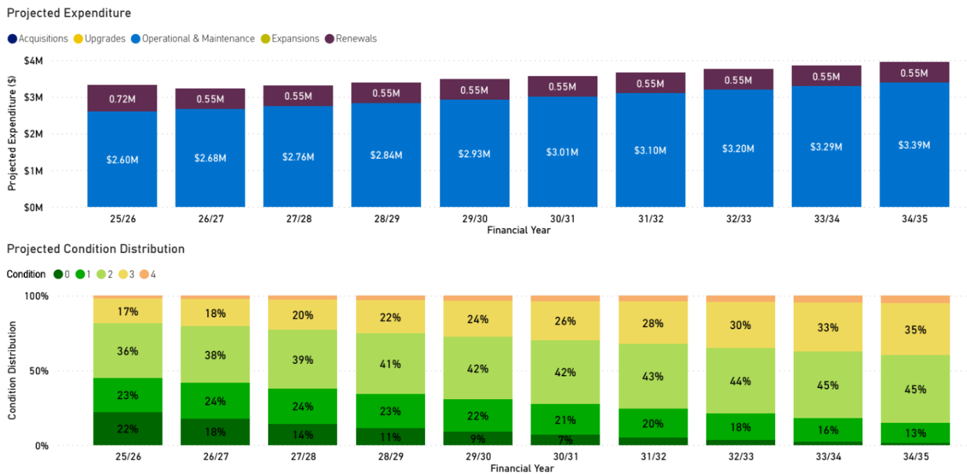

Buildings
Note: The 'Acquisitions' funding allocation does not represent the total projected growth. The difference between the forecasted growth and the budgeted amount is accounted for by developer contributions, which are expected to be received as gifted assets.

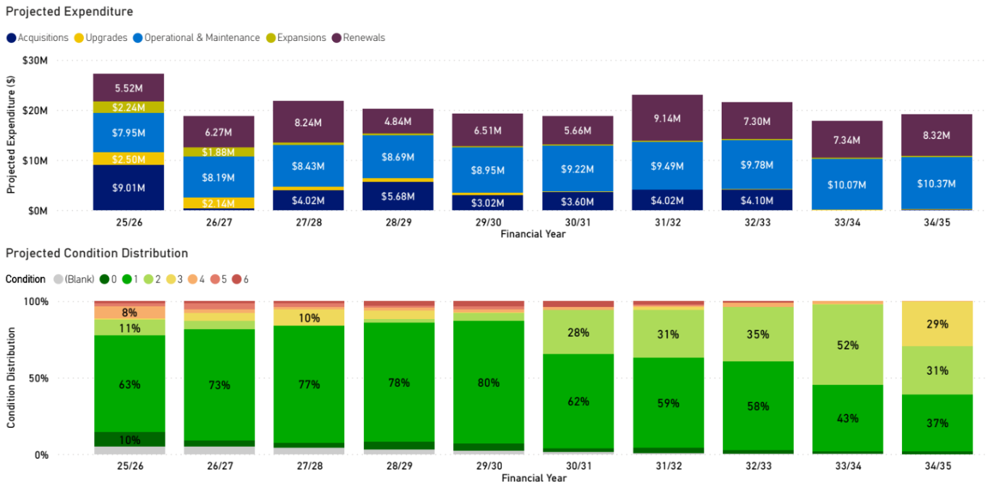

Open space
Note: The 'Acquisitions' funding allocation does not represent the total projected growth. The difference between the forecasted growth and the budgeted amount is accounted for by developer contributions, which are expected to be received as gifted assets.

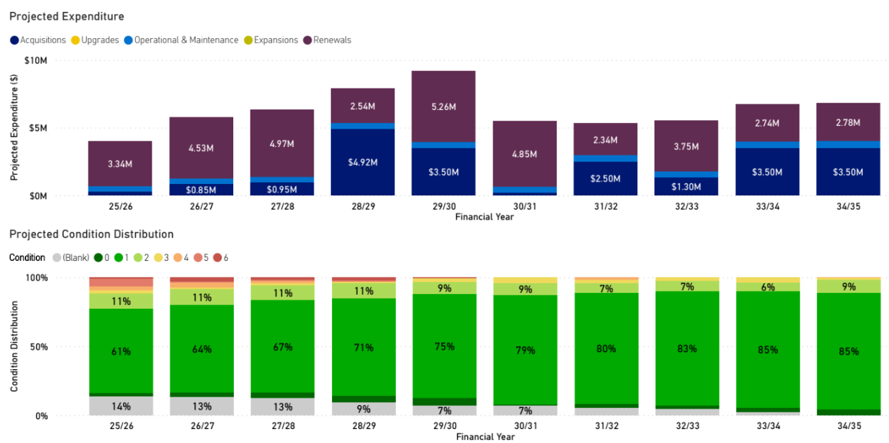

Renewal Gap
This section outlines the current funding levels against the agreed intervention levels, with the renewal gap of assets not receiving treatment across the planning period due to current funding.
When assets reach a poorer condition, intervention is required for renewal (known as the intervention level), however, a renewal gap occurs due to funding limitations to treat these assets.
The bottom graph shows a breakdown of the renewal gap per asset category.
Overall, current funding levels are sufficient to ensure the total renewal gap of assets is kept below the recommended 2% of the total value of the asset portfolio for the next 10 years.
Council aims for a long-term renewal gap trend of less than 2%. Renewal gap ratios above this may indicate underinvestment and potential service risk.
It is important to note that the renewal gap may fluctuate across different asset classes and years, as Council aims to strategically adjust investment priorities to maintain a balanced and sustainable renewal gap across the entire asset portfolio

All assets

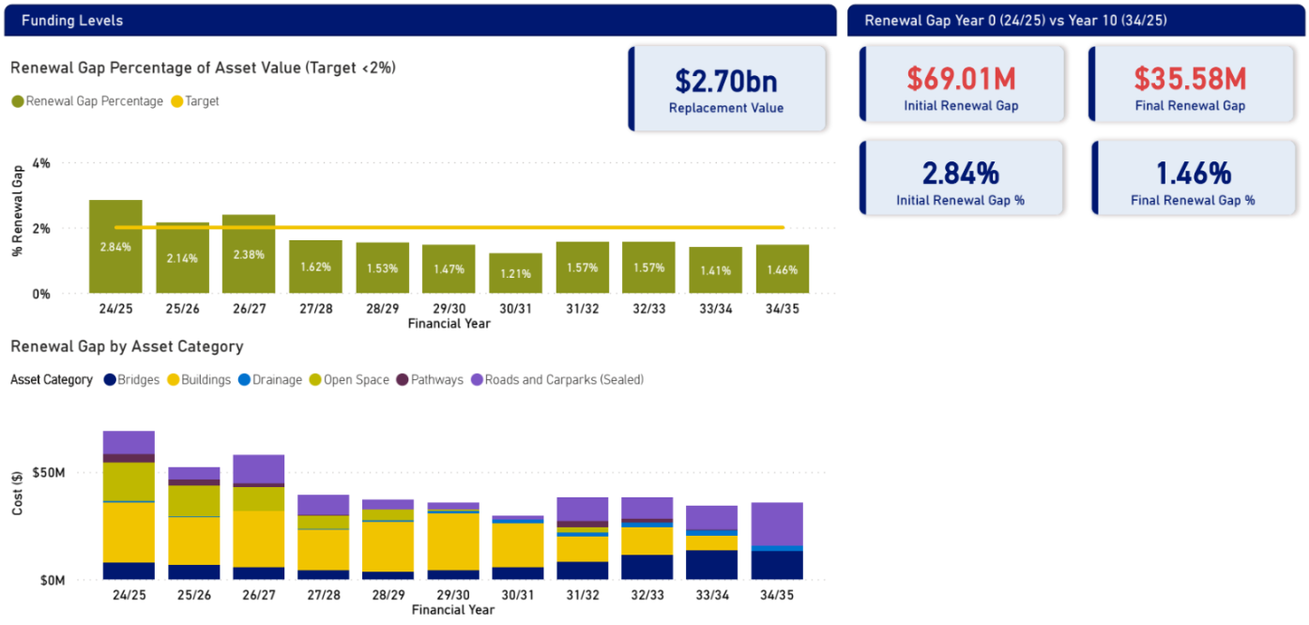

Bridges

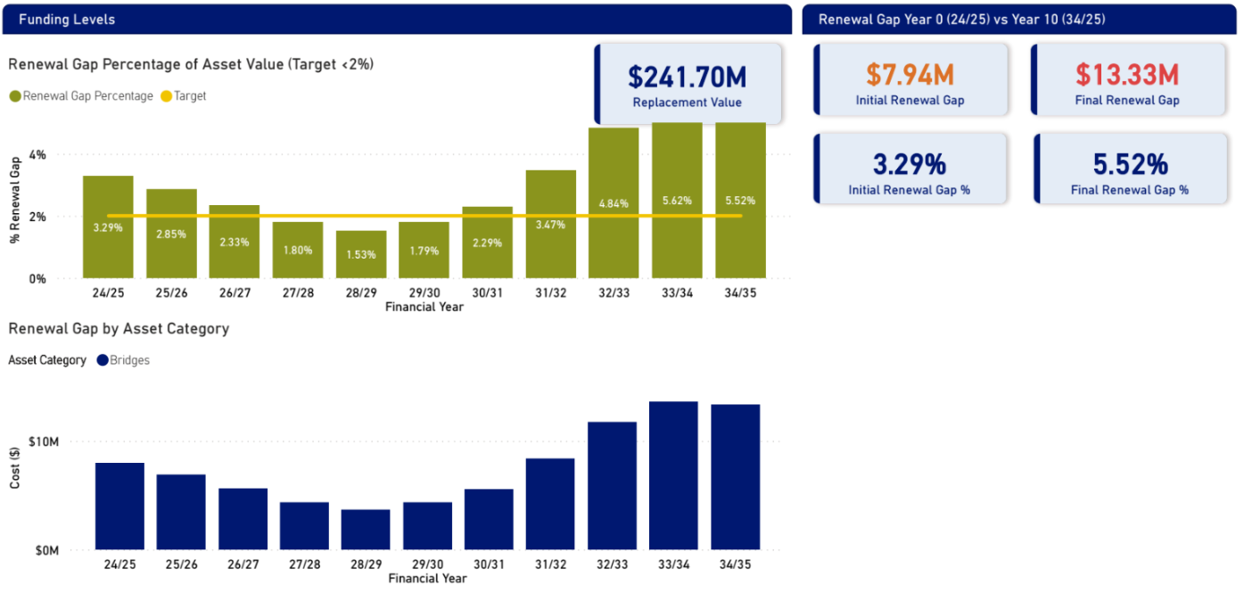

Pathways

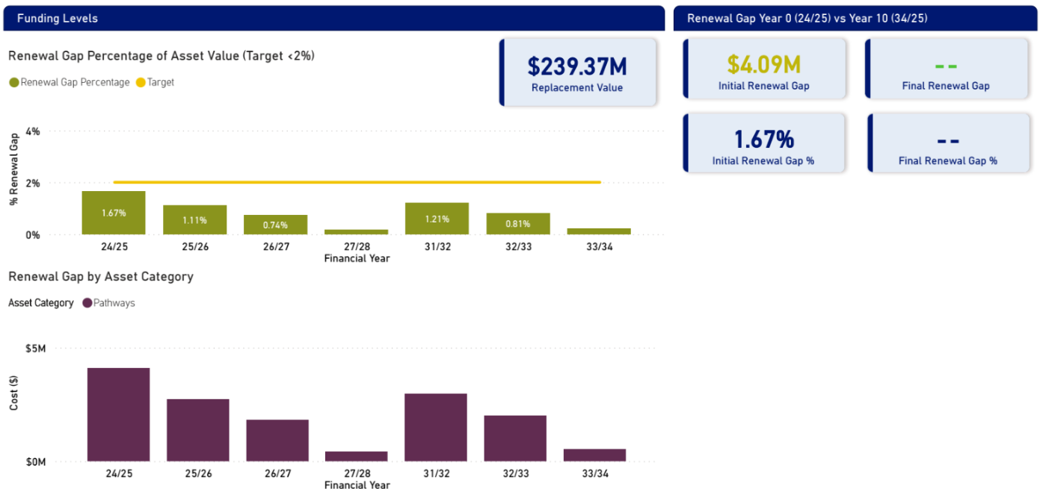

Roads and carparks

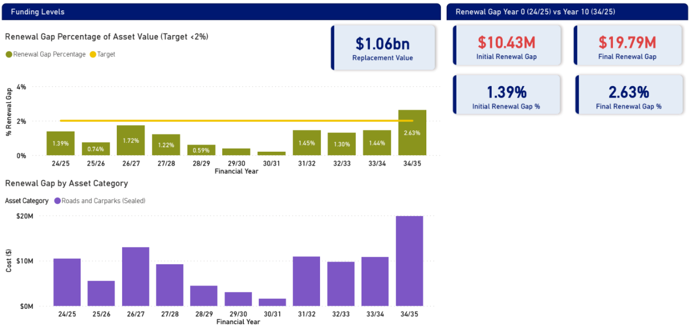

Drainage

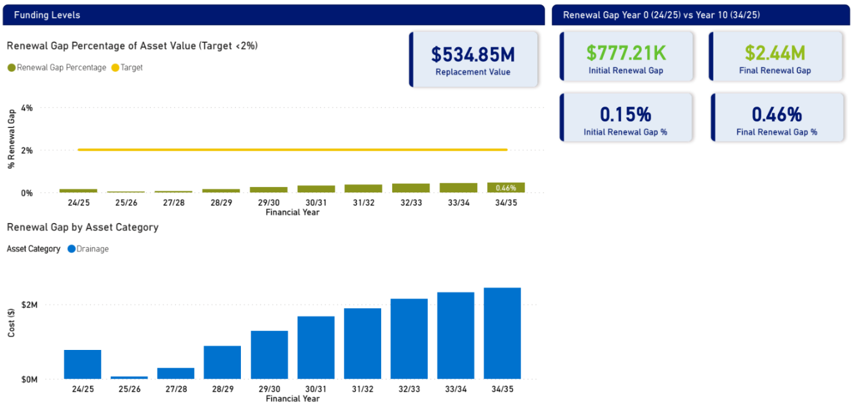

Buildings

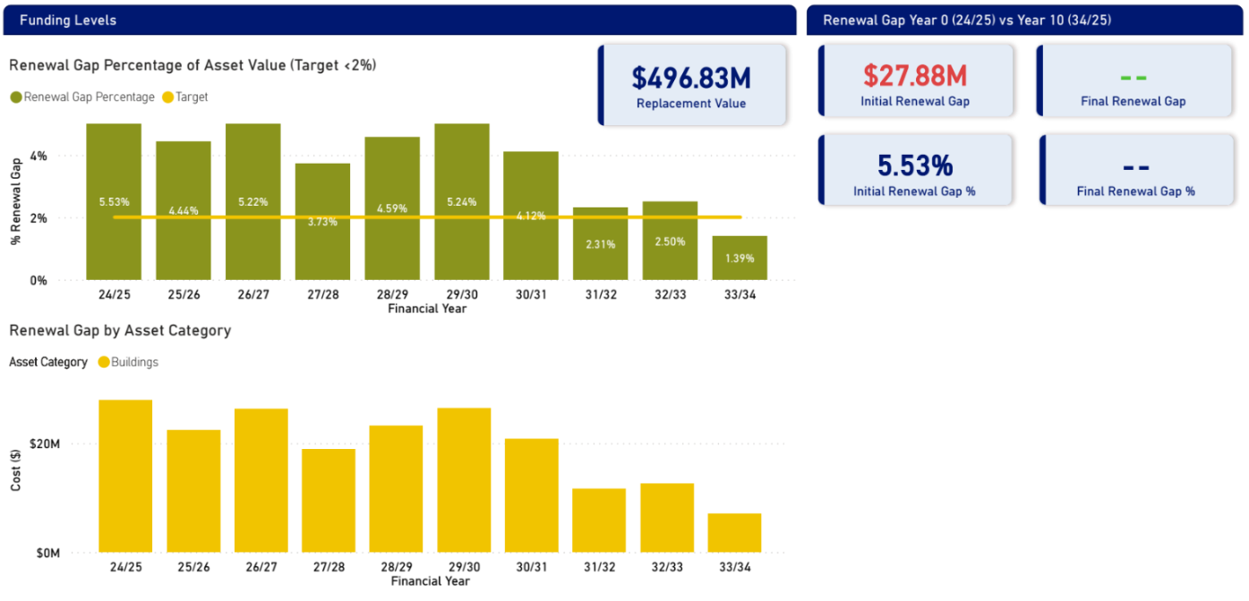

Open space

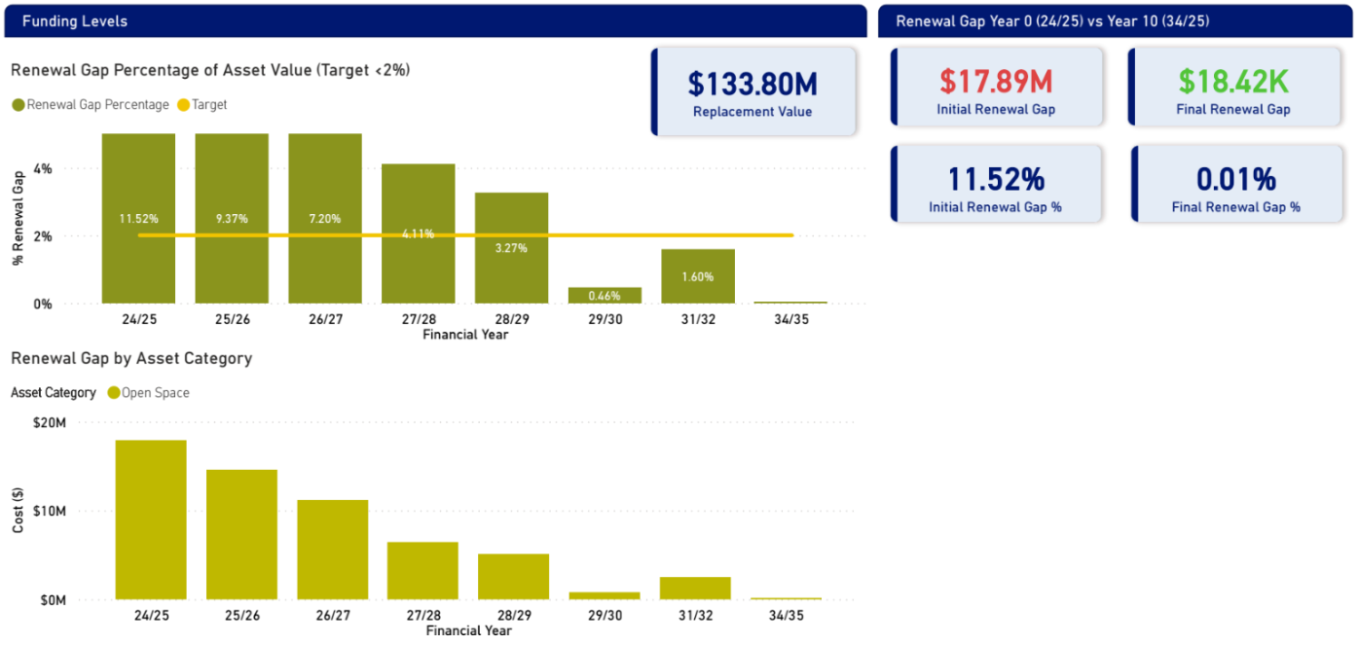

Risk management
Council’s Risk Management Policy sets the overall framework for addressing risk within the framework of ISO31000-2009.
This section of the Asset Plan enables informed decisions to be made regarding the management of risks associated with Council assets.
Council applies a structured and comprehensive approach to risk management in accordance with the Cardinia Shire Council Risk Management Policy.
Risk | Mitigation
Inaccurate Asset Data and Modelling | - Progress asset management improvement initiatives for increased maturity.  - Invest resources and allocate funding for condition assessments and valuations.  - Progress digital transformation initiatives to improve integration between asset information system, customer requests and reactive and proactive operational works.
Inadequate Planning and Strategy | - Update Asset Management Strategy to clearly define roles and responsibilities.  - Enhance project management framework.  - Influence and input into precinct planning projects to protect community interest.
Financial Sustainability and Underfunding | - Integrate asset management with long term planning.  - Monitor renewal funding gaps and other relevant measures.  - Focus on influence and quality standards for assets delivered by others.
Financial Auditing and Compliance | - Long term business planning for asset and financial reporting and adequate upskilling of key staff.
OHS Risk/Safety | - Undertake condition audits and prioritise risk based decision making and prioritisation.
Climate Change | - Considering climate vulnerability and resilience in design.
Community Expectations that cannot be met | - Involve the community in decision making, seek feedback on difficult trade-offs between cost, risk and service levels.  - Transparent communication and reporting.  - Undertake service reviews to identify opportunities for improvement or changing levels of service.

Improvement plan
As part of Cardinia Shire Council’s commitment to continuous improvement in asset management, this 10-Year Asset Plan outlines a series of targeted improvement actions designed to enhance the effectiveness, efficiency, and sustainability of our asset portfolio.
The improvement actions aim to strengthen data quality, refine asset lifecycle planning, improve service delivery outcomes, and ensure alignment with Council’s strategic objectives. They also support better decision-making through enhanced forecasting, risk management, and performance monitoring.
By implementing these actions over the next decade, Council will build greater resilience into its infrastructure systems, reduce long-term costs, and ensure that assets continue to meet the needs of our growing and diverse community
Item | Task
Annual Asset Management Report | Continue development of an annual asset management report for the community containing key asset indicators and measures for greater transparency of our asset management stewardship.
Annual Asset Check | Annual Asset Check in process to be established as part of the budget process using the digital Asset Plan as a tool for discussion.
Levels of Service | Continue to refine levels of service to ensure a balance of meeting community needs while also managing finite resources and finances for management of assets.
Condition Assessments | Allocate budget and implement an ongoing cyclic program of condition assessments for assets.
Data and Technology Improvements | Explore improved technology options for condition audits of pathways, a rolling annual program of the condition of a percentage of our drainage infrastructure, flood modelling analysis, facility utilisation/functionality assessment, improvement of unsealed roads data and data improvement on targeted area-based issues.
System Integration | Work to integrate Council's asset management information system (AMIS), customer request system (CRM), and operations work management system to enable oversight for each asset in terms of failures, customer feedback and analysis of spending patterns across our asset base.
Life-cycle Cost Impacts and Analysis | Review, fine tune and calibrate life-cycle models. For example, road modelling and funding requirements to consider roadside drainage. Enhance project planning to consider whole of life costing through design and planning.

Improvement plan continued…

Item | Task
Review Processes and Measures for Maintenance Requirements | Review processes and measures to accurately determine maintenance funding requirements for ageing and new assets.
Review Budget Process and Modelling for Operational Expenditure | Implement a risk-based approach for identifying and funding sustainable operational and maintenance budgets.
Asset Criticality and Prioritisation | Further develop and formalise a criticality framework and priority rating criteria for asset renewals and maintenance planning. This may involve developing an approach for older and underutilised buildings, needs assessment, utilisation analysis and disposal / repurposing rationalisation.
Proactive Maintenance Enhancement | Continue improvement of our approach to risk management by further employing a proactive / planned maintenance approach.
Integrated Planning | Work to ensure enhanced integration of asset management with financial, project and service planning to ensure long-term sustainability. This includes recommended 10-year funding strategies identified through life cycle modelling exercises and incorporating them into the Long-term Financial Plan.
Climate Change Impacts | Further implement climate change impacts on asset lifecycle and funding requirements.
Unsealed Road and Drainage Council Initiatives | Develop and implement the Council Plan's drainage and unsealed road initiatives to seek opportunities to enhance performance of the critical assets. Develop in consideration of the sealed road network.
Asset Management Plans and Strategy Review | Review and update Council's asset management plans and Asset Management Strategy. This aims to increase transparency, provide further update on key outcomes and improvement areas, clarify roles and responsibilities and explain how Council undertakes asset management.
Gender Data | Obtain and analyse gender data to help understand perspectives and impacts of gender on assets. Data on segregation has been identified as an opportunity for improvement.

Glossary

Key terms
Accumulated Depreciation Depreciation is the reduction in the value of an asset due to usage, passage of time, environmental factors, wear and tear, obsolescence, depletion or inadequacy. Accumulated depreciation is the total amount of that reduction in value of an asset from when it was first recognised as an asset to a given point in time.
Acquisition Creating or acquiring assets that deliver a new service not previously provided.
Asset An item, thing or entity that has actual or potential value to an organisation.
Asset Management The systematic and coordinated activities and practices of an organisation to realise the value of an asset.
Asset Management Plans A more detailed asset specific document that deep dives into the asset class, individual projects, challenges and funding needs over time.
Asset Management Policy Sets the high-level strategic intent and direction on asset management.
Asset Management Strategy The long-term plan which sets out how Cardinia Shire Council does its asset management, roles and responsibilities and our plans to improve asset management maturity.
Asset Plan A key strategic document outlining how Council will manage its assets to support the delivery of the Community Vision 2040. It provides the community with insight into the assets we rely on to deliver services, and the approach we take to manage those assets efficiently and effectively.
Business Unit Operation Plans and Strategies These plans translate strategic objectives into operational actions. They detail specific initiatives, projects, and services that each unit will deliver.
Community Vision 2040 Articulates the community’s aspirations for what Cardinia Shire will be like in 2040. It helps council to understand the community's priorities, guides strategic planning and decision-making.
Condition Physical state of an asset.
Council Budget The budget outlines how the Council plans to spend on delivering the services, projects and infrastructure the community needs, while ensuring financial sustainability in the long-term.
Council Plan A key strategic document that will help guide Council’s activities and decision making over the four years of the Council term. The Council Plan strives to reflect the community’s priorities and provides a roadmap for Council to deliver on the long-term Community Vision 2040.
Customer Any person who uses the asset or service, is affected by it or has an interest in it either now or in the future. This definition does not necessarily require that payment is made for use of the asset.
Expansion Extending the capacity of existing assets to serve new users at the same service standard as current beneficiaries.
Financial Plan A 10-year strategic document that outlines how Council will fund the delivery of services, infrastructure, and initiatives to achieve the goals of the Council Plan and Community Vision 2040.
Levels of Service Describes the quality, quantity, and reliability of services provided by an asset or group of assets to meet community needs and expectations. They are used to guide asset management decisions, measure performance, and communicate service commitments to stakeholders.
Maintenance Ongoing work to keep the asset in its original or good working condition and slows its deterioration for retaining practical asset condition and service.

Municipal Public Health and Wellbeing Plan This is known as the Liveability Plan at Cardinia Shire Council. Provides a clear framework for public health planning within the municipality. The framework outlines the shared agenda that council, partners and the community, will collectively work towards.
Operations Recurrent expenditure that is continually required to keep assets functioning and services running.
PSPs and DCPs Precinct Structure Plans and Development Contribution Plans: Detailed plans legislated by planning authorities that guide the development of new communities and identifies the infrastructure required to support them. DCPS and ICPs outline the funding approach and legislated methodology.
Rating and Revenue Plan Establishes a revenue raising framework within which Council proposes to work and determines the most appropriate and affordable revenue and rating approach to finance the vision and objectives outlined in the Council Plan.
Renewal Replacing or rehabilitating an asset to restore their original condition and service potential.
Renewal Funding Gap The difference between the estimated cost of renewing assets to maintain required service levels and the actual funding allocated for renewal over a given period. It reflects the shortfall in investment needed to sustain asset performance and avoid service degradation or increased risk.
Replacement Value The current cost to replace an existing asset with a modern equivalent that provides the same level of service. This includes all costs associated with construction, installation, and commissioning, but excludes any allowance for improvements or upgrades beyond the original service capacity.
Risk The effect of uncertainty on objectives. Risk events are events which may compromise the delivery of the organisation’s strategic objectives.
Risk Management Coordinated activities to direct and control an organisation with regards to risk.
Strategies and Plans Plans, policies and strategies to achieve our long-term goals while also informing future demands, community needs and levels of service.
Upgrade Enhancing existing assets to provide a higher level of service or extended functionality beyond their original design.
Valuation The process of determining the monetary value of an asset for a specific purpose. It typically reflects the cost to replace the asset (replacement cost), adjusted for factors such as age, condition, and remaining useful life.
Written Down Value The current book value of an asset after accounting for accumulated depreciation. It represents the asset’s value on the financial statements and reflects its remaining economic benefit.

Lifecycle management
Cardinia Shire Council intends to manage its assets through each phase of its lifecycle. Each phase requires different activities and strategies to meet the required levels of service in the most cost-effective manner and to manage the risk and performance of assets. These phases align with best practice asset management.
The key stages Council aims to follow in the asset lifecycle are shown below.

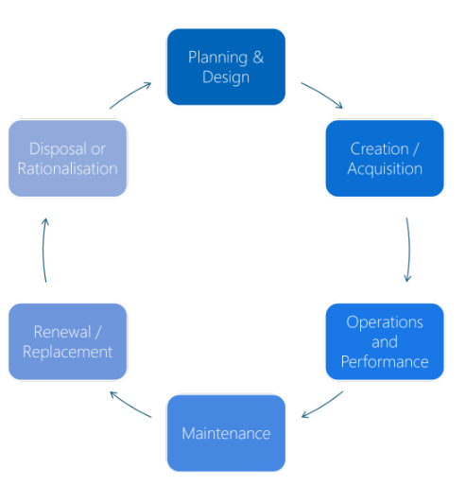
Lifestyle management approach. See next page for definitions.

Lifecycle phase | Lifecycle management approach
Planning and Design | This phase identifies long-term service needs and defines asset requirements. It ensures assets are designed to be affordable, equitable, maintainable, and environmentally sustainable, using evidence-based decisions that consider whole-of-life costs and impacts.
Creation / Acquisition | This phase involves evaluating delivery options, selecting procurement strategies, and constructing or acquiring assets in line with design and service requirements. It includes project planning, contract management, and environmentally sustainable practices, with quality assurance and formal handover before assets are put into service.
Operations and performance | This phase ensures assets operate effectively throughout their useful life. It involves regular monitoring, inspections, compliance and information recording to ensure optimal service delivery. Systems and processes support performance tracking and condition assessment to minimise risks and lifecycle costs.
Maintenance | This phase involves planned and reactive activities such as inspections, servicing, and repairs to keep assets safe, compliant, and operational. Maintenance is scheduled to reduce the risk of failure, extend asset life, and optimise long-term costs.
Renewal / replacement | This phase addresses aging or deteriorated assets that are no longer cost-effective to maintain. It involves assessing asset condition, optimising timing for renewal or replacement, and exploring reuse or co-location opportunities to maintain service continuity and minimise lifecycle costs. Renewal may involve major rehabilitation, while replacement involves decommissioning and substituting with new assets.
Disposal or rationalisation | This phase involves decommissioning, repurposing, or disposing of assets that no longer support service objectives. It includes options like demolition, recycling, or co-location, with a focus on reducing lifecycle costs Rationalisation involves reviewing asset portfolios to eliminate underused or redundant assets, improving asset portfolio efficiency.

Investment categories

Expenditure Category | Activity | Description | Examples
Non-discretionary | Maintenance | Ongoing work to keep the asset in its original or good working condition and slows its deterioration for retaining practical asset condition and service. | - Road patching and pothole repairs.  - Servicing HVAC systems in council buildings.  - Repainting council buildings.
Non-discretionary | Operations | Recurrent expenditure that is continually required to keep assets functioning and services running. | - Electricity and water usage costs for facilities.  - Programmed road inspections and condition audits.  - Cleaning footpaths to ensure aesthetic and safety.
Non-discretionary | Renewal | Replacing or rehabilitating an asset to restore their original condition and service potential. | - Replacing timber decking on a pedestrian bridge.  - Resurfacing a deteriorated road.  - Replacing an aged stormwater pipe.
Discretionary | Upgrade | Enhancing existing assets to provide a higher level of service or extended functionality beyond their original design. | - Upgrading to LED lighting in public parks.  - Sealing an unsealed road.  - Replacing drainage pipes with greater capacity pipes.
Discretionary | Expansion | Extending the capacity of existing assets to serve new users at the same service standard as current beneficiaries. | - Extending a car park to accommodate more vehicles.  - Adding a traffic lane to allow more traffic volumes.  - Adding a new room to a community centre to accommodate new users.
Discretionary | New / Acquisition | Creating or acquiring assets that deliver a new service not previously provided. | - Constructing a new playground in a park without one.  - Installing a new public toilet in an highly utilised public space.  - Constructing a new footpath where required.

Frequently asked questions

Why is asset management important for Cardinia Shire Council?
Asset management is crucial for ensuring that infrastructure and services are reliable, safe, and sustainable for the community. It helps in planning for future needs, optimising resources, and minimising risks associated with asset deterioration.

What are the key methodologies used in asset management practices?
Key methodologies include asset data capture, condition audits, valuation, financial forecasting, lifecycle modelling, risk management frameworks and programming the renewal of assets. These practices help in assessing asset conditions, planning for future needs, and mitigating risks.

What is the Asset Plan 2025?
The Asset Plan 2025 outlines Cardinia Shire Council's approach to managing and maintaining its assets, ensuring they meet community needs and support sustainable growth. It aligns with the Council Plan and Community Vision.

What types of assets are included in the Asset Plan?
The Asset Plan covers a wide range of council’s infrastructure assets including roads, buildings, bridges, pathways, stormwater drainage infrastructure, and open space infrastructure.
Other council assets including plant, machinery & equipment ($19M), computers & telecoms ($3.1M), fixtures, fittings & furniture ($3.8M), land ($1.05B) and vegetation are excluded from this Asset Plan due to having different management, planning and operational requirements, shorter lifespans and valuation complexities to that of major infrastructure assets.
Council plans to develop a Tree Asset Management Plan over the next four years which aims to form part of the next Asset Plan.

How does the Asset Plan address sustainability and climate change?
The Asset Plan incorporates council strategies and other legislation for resilience to climate change and sustainability. The Asset Plan also outlines Council's understanding and planning of the risk climate change has on its assets.
One of council's key focus areas is to further implement climate change impacts on asset lifecycle and funding requirements. Council ensures that climate change adaption is an important factor in management of assets.

How does Cardinia Shire Council collect and manage asset data?
Council maintain and utilise an Asset Management Information System (AMIS) and GIS to store all asset related information.
Field and operations staff utilise an operations works management inspection and maintenance management field system to plan and log maintenance works and inspections which is fed into the AMIS. Data is captured in AMIS and GIS through project delivery, development handover and inspections.
Council is undertaking a Digital Transformation initiative which aims to improve the way these systems integrate with each other and therefore the information that comes from them.

What is lifecycle modelling and how is it used in asset management?
Lifecycle modelling is a process that evaluates the entire lifespan of an asset, from acquisition to disposal. It helps in predicting future maintenance needs, performance and condition deterioration, when assets should be renewed/replaced and the costs involved to apply these treatments. It ensures that assets are managed efficiently and sustainably.

What was the methodology for asset lifecycle modelling to develop this Asset Plan?
Council typically undertakes comprehensive condition audits on 3–4-year cycle of its high-risk asset classes.
The current condition rating from these audits is put into the model.
Each asset has an expected useful life, and the modelling predicts when and how the asset will degrade across its useful life and decrease in condition rating.
When the asset reaches a poorer condition, the model flags the need for asset renewal to replace the asset with the current replacement cost.
Factors including levels of service and hierarchy of assets were also used to determine when an asset is due for renewal. Where current condition data is not available, current condition is determined based on the age and useful life of the asset.
Council lifecycle modelling methodologies follow best practice asset management guidelines.

Where can I find more information about the Asset Plan 2025?
More information can be found on the Cardinia Shire Council's official website or by contacting the Council directly. The Asset Plan document is available for download and review.



Cardinia Shire Council
Civic Centre
20 Siding Avenue, Officer

PO Box 7
Pakenham 3810 (DX 81006 Pakenham)

Phone: 1300 787 624
Email: mail@cardinia.vic.gov.au
Web: www.cardinia.vic.gov.au

National Relay Service (NRS)
TTY: 133 677 (ask for 1300 787 624)
Speak and Listen (speech-to-speech relay): 1300 555 727 (ask for 1300 787 624)


Translator Interpretation Service
131 450 (ask for 1300 787 624)

