Gembrook Emergency and Resilience (GEaR) Group

Shared Responsibility
Safety for the community is a shared responsibility between State based organisations and agencies, Municipal Councils and most importantly the ‘at risk or affected’ community themselves.
Dealing effectively with an emergency in an ‘all agencies, all hazards’ philosophy requires all organisations, agencies and the community working in partnership.
The Gembrook Emergency and Resilience Group developed from an identified need for Gembrook to have a local coordinated response to emergencies.
GEaR works with Emergency Response agencies and Council to increase preparedness and resilience in Gembrook.
What is GEaR’s intent?
Through facilitated workshops, GEaR has identified priority actions to reduce the consequences of fire and other emergencies in and around the Gembrook Community.
GEaR is working towards increasing community participation and engagement in developing local emergency management arrangements.
GEaR does not replace any existing emergency response activities

GEaR – What has it done?
Since its establishment in Gembrook GEaR has;
• Advocated for localised Phoenix bushfire modelling for the district to increase the understanding of localised fire behaviour on the town.
• Worked with Cardinia Shire Council to facilitate an ‘all hazards’ risk assessment which has defined the future direction of the group
• Led discussions on animal welfare in emergencies, exploring opportunities to educate and support animal owners in the area before, during and after and emergency.
How can you help?
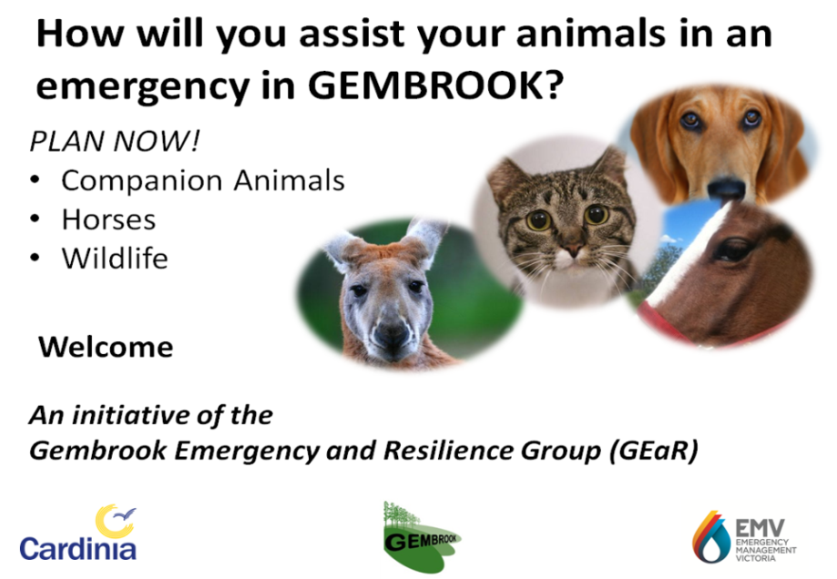
GEaR is looking for more Community minded people in Gembrook interested in developing our emergency management arrangements and provide leadership in our community in times of disaster.
Everyone has something to offer.
Further Information
For further information on how to support GEaR activities contact;
Greg Hoffman 59427346 ghoffmann@westnet.com.au
David Nickel 0400 578 306
sathanai@iprimus.com.au

