Cardinia Shire Access and Inclusion Advisory Committee

Preface
The Local Government Act 2020 provides a new framework for the establishment and operation of all councils, replacing the Local Government Act 1989. From April 2020 this new act came into effect. All delegated committees also known as section 86 committees will be transitioned as part of this change process. The Cardinia Access and Inclusion Advisory Committee (CAIAC) will be one of the many committees transitioned as part of the implementation of the new act. At the July 2020 special Council meeting, councillors resolved to maintain the important function of an advisory committee specific for the area of disability and inclusion.

From 1 September 2020, the members of the Committee shall be those full members serving on the existing Section 86 Committee. Full members will be given the opportunity to continue as a Full Member or rescind their position. Participating members can attend and contribute to future meetings. In November 2021, one third of full members will rescind their role and full members will be appointed via an expression of interest, ensuring serving membership is representative of the diversity within our community. Every three years one third of the membership will rescind their full membership role.

The Advisory Committee will continue to be known as, Cardinia Shire Access and Inclusion Advisory Committee (CAIAC). The terms of reference will act as guide during transition over the ensuing twelve months.

Purpose
To provide a forum for Cardinia Shire: residents, businesses, and community groups, representing the interests of people with disability in the Local Government Area.

Objectives
The Cardinia Shire Access and Inclusion Advisory Committee will:
- Monitor, review, and support Council’s disability policy and associated strategies and implementation plans.
- Provide information and timely advice to council on issues impacting upon people with a disability which prevent their full inclusion in community life.
- Participate in strategic planning issues affecting people with disability in the Shire.
- Act as ambassadors for the disability community through advocacy, promoting information, training, activities, and issues relating to disability in Cardinia Shire.
- Provide advice on, monitor and review Council’s building and facilities Access Upgrade program of works and budget.

Membership and Chairperson
Cardinia Shire is an inclusive organisation valuing our community for unique qualities, ideas, and insights. The committee membership will be diverse in age, culture, life experience, gender identity, race, ethnicity, disability, age, faith, sexual orientation, gender identity or other differences.

Full Membership
The Cardinia Shire Access and Inclusion Advisory Committee full membership will be representative of Cardinia Shire. The CAIAC Full Membership will be appointed from Cardinia Shire residents and/or people working within Cardinia Shire will consist of up to 10 members from the following interest areas:
- Community representatives: people with a lived experience of disability or a carer/support person of a person with a disability.
- Community groups and or disability organisations: Community groups, health care professionals (with associated professional body or associations) and, disability organisations that provide disability support, services, advocacy, and peak bodies. The representative must be endorsed by the organisation or group they are representing.
- Councillor: minimum of one, maximum of two.

Term of appointment
- Full Membership appointment is for a term of three years from date of endorsement.
- Every three years one third of the membership will rescind their full membership role.
- A members’ term of appointment may cease if they fail to attend three consecutive meetings without notice or an apology.
- An expressions of interest process will be undertaken to target underrepresented groups (Appendix 1 and 2).
- Retiring Full Members are eligible to re-nominates at the close of their tenure or become a participating member.
Participating member
Members of the community who have an interest in Disability access and inclusion may take part in meetings. They have the same rights of members, including to receive copies of minutes and other documentation and to contribute to reports, but they are non-voting members. As such, they do not affect the composition of the committee.

Chairperson
- Full Members nominate the Chairperson and Deputy Chairperson.
- A rotating Chairperson, with a three-year tenure, voted by the Committee.
- In the absence of the elected Chairperson the Deputy Chairperson will chair meetings, in the absence of the deputy Chairperson Full Members will nominate a fellow Full Member to Chair the meeting, see figure 1 below.

Figure 1 Process for Chairing meeting.

Roles and responsibilities of Committee Chairperson:
The key responsibility of a Chairperson is facilitating the operations of the Committee. The Chairperson is the leader of the meeting, and as such is responsible for maintaining order, the conduct of business and for ensuring that procedures adopted are correct.
- Provide co-ordination, guidance, and leadership to ensure the successful functioning of the Committee.
- Ensure administrative, and other tasks from meetings are carried out.
- Chair all meetings of the Committee or nominate the Deputy if unavailable.
- Ensure meetings are correctly convened.
- Act as the liaison person between the Committee and the Council.
- Determine if a quorum is present for all decisions.
- Meeting decisions are properly recorded in the minutes.
- The agenda is adhered to.
- All members Full and Participating are given the opportunity to speak and be heard.
- Maintaining order and ensuring conduct of committee members is consistent with the code of conduct (Attachment 3).
- The Chairperson may vote on any motion considered by the meeting and in the event of a tied vote, the Chairperson may exercise a second or casting vote.
- New committee members can only be appointed by recommendation of the committee and ratified by the Chairperson.
- Submit minutes to Councillor members and nominated committees of Council.
- Council will provide administration support for the Chairperson.
- Provide an annual summary of highlights and CAIAC achievements will form part of the annual report provided to council for the Disability portfolio.

Roles and responsibilities of Full and Participating Committee Members
- Be willing to work collaboratively and respectfully within the group, consider ideas, listen, discuss issues, and assist community engagement.
- Prepare for, attend, and actively participate in regular group meetings.
- Keep the committee informed on any current developments, issues, and concerns relating to people with disability.
- Be aware of the activities, interests and concerns of residents, organisations, and groups in the Shire.
- Disseminate information and communicate with their respective communities.
- Represent the diverse needs and interests of people with disability across the Shire rather than drive personal interests and agendas.
- Be informed about the strategic directions of the council.
- Where appropriate, working groups may be established as required to provide an opportunity for members to work collaboratively on specific issues and projects.
- Working groups will nominate a CAIAC member to provide updates/gain input at CAIAC meetings.
- Identify and declare a conflict of interest between public and private roles, refer to conflict of interest.
- Full and participating members of the committee are required to abide by the code of conduct. All committee members full and participating will sign the code of conduct to acknowledge their commitment.
- This code of conduct includes, acting in good faith, with integrity, exercising impartiality, treating others with respect, and exercising due care and diligence when conducting their Committee role and function.
- Act in a reasonable and fair way which is not discriminatory on the basis of gender, disability, religion, or race.
- Ensure that information that is specifically designated by Council as confidential cannot be disclosed until it is no longer designated as confidential by the Council.
- A breach of the code of conduct this will be addressed by the Chairperson with the Committee Member, Full or Participating through a dispute resolution process.

Resignations
- Committee members who resign and leave the Committee should aim to give reasonable notice so that a new member can be recruited, if necessary.
- Resignations should be directed through the Chairperson and submitted in writing to the Committee. The Committee must accept and record the resignation in the minutes.

Council Officer/Secretariat Support
The council officer’s role will be to provide administration support associated with the meeting. Duties include:
- Scheduling meeting date, time, and location.
- Prepare and send out the agenda.
- Invites and guest presenters.
- Arrange inwards and outwards correspondence.
- Receiving all incoming correspondence and bringing it to the attention of the committee.
- Supporting the development of any outward correspondence required by the committee.
- Keeping committee members properly informed by sending them notices of meetings.
- Liaising with the chairperson between meetings so that the business of the committee is attended to and, in consultation with the chairperson, to call extraordinary meetings or working parties as appropriate.
- Prepares the minutes of the previous meeting to be available and other relevant documents such as discussion papers.
- Takes notes that will enable clear and accurate minutes to be written up.
- Writes up the minutes and disseminates to committee members and relevant council committee.
- In consultation with the Chairperson ensures that follow-up actions which arises from the business of the meeting are addressed.
- Include the Chairperson’s annual achievement summation in a formal council report
- Support the committee to achieve their objectives.

Conflicts of Interest
As detailed in Clause 6.2 the Local Government Act 2020 defines general and material conflicts of interest.
- A general conflict of interest arises if a committee member has an interest in a matter that is being considered by the committee if an impartial, fair-minded person would consider that the member’s private interests could result in that person acting in a manner that is contrary to their public duty.
- A material conflict of interest arises if a committee member would gain a benefit or suffer a loss depending on the outcome of the matter before the committee.
At the time indicated in the Agenda, a Committee member with a conflict of interest in an item on that agenda must indicate they have a conflict of interest by clearly stating:
(a) The item for which they have a conflict of interest; and
(b) Whether their conflict of interest is general or material; and
(c) The circumstances that give rise to the conflict of interest.

Immediately prior to the consideration of the item in which they have a conflict of interest, the Committee Member Full or Participating must indicate to the meeting the existence of the conflict of interest and leave the meeting. The key factors in dealing with conflicts of interest are to:
- Avoid all situations which may give rise to conflicts of interest.
- Identify any conflicts of interest, and
- Disclose or declare all conflicts of interest
When circulating the agenda, the minutes of the previous meeting and any reports to be considered at the meeting are usually attached.

At the start of the meeting the Chairperson enquires:
- if there are other items of business that any member wishes to be added to the agenda, and
- if any member wishes to change the order of the agenda. The addition of new items at the meeting is generally acceptable, but if those items are contentious and/or some members are absent from the meeting, the Chairperson may decide to refer such items to a subsequent meeting of the Committee.

Meeting procedures

Meeting frequency
- Meetings will be minimum bi-monthly.
- On each 3rd Wednesday of alternate months, at 10am–12 noon unless otherwise arranged by Council Officer.
- Meeting days and times may change only as agreed by Council Officer in consultation with the Chairperson.
- Meetings can be in person or via a secure electronic mode.

Voting
A quorum is the minimum number of Full Members of the Advisory Committee who must be present in order for the Committee to make decisions, (a majority) (half the membership + 1).
- If, thirty minutes (or some other time generally agreed by the Committee as appropriate) after the start of the meeting a quorum has not been obtained, the Chairperson will decide to:
- postpone the meeting, or
- conduct the scheduled business of the Committee but refer all decisions and motions to a subsequent meeting when a quorum is present for reconsideration and/or ratification.
- If, at any time during the meeting a quorum cannot be maintained, the Chairperson will decide to:
- close the meeting and refer any unfinished business to a subsequent meeting, or
- continue to conduct the scheduled business of the Committee, but refer all decisions and motions made with no quorum present to a subsequent meeting when a quorum is present for reconsideration and/or ratification.

Review and evaluation
- An annual review will be conducted to discuss successes, challenges and learnings that can improve future outcomes.
- Date for three-year tenure: Annually.
- The ToR will be reviewed bi-annually or where a need has been identified by Council.

Reporting procedure
The Cardinia Access and Inclusion Committee is not a formal committee; rather, an advisory group that is established by Council and therefore formal reporting mechanisms to Council are not required.
- Minutes of meetings will be taken and distributed by the Council Officer. Stored on Council’s records management system.
- A summary of highlights and CAIAC achievements will form part of the annual report provided to council for the Disability portfolio.
- Distribution of minutes to Council and member networks, figure 1 below, and others where required.

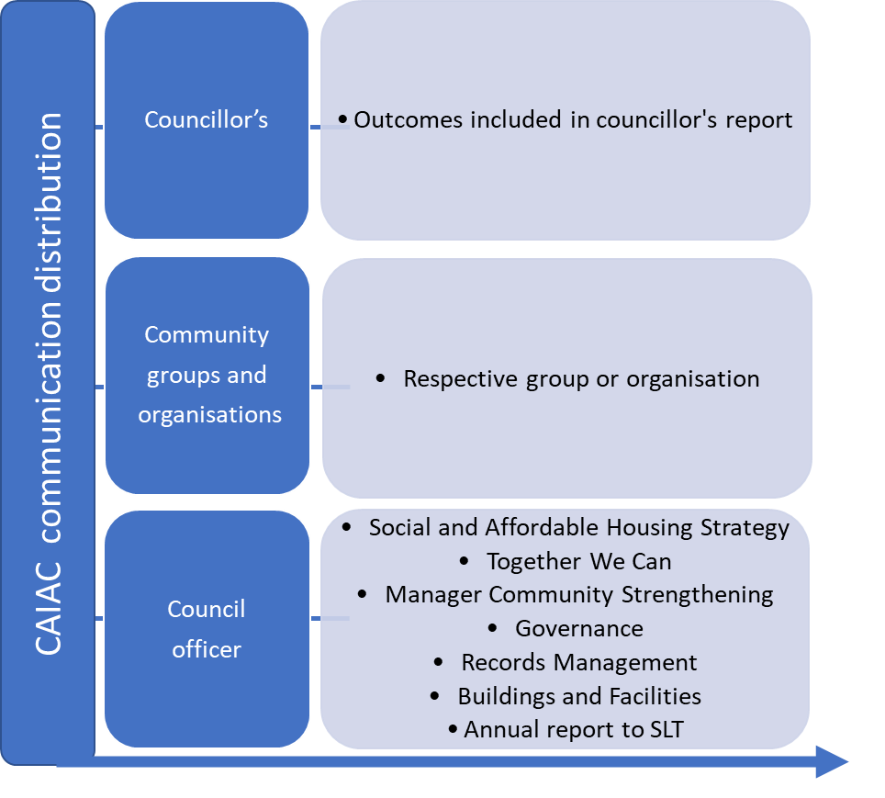
Figure 2. Committee minute distribution table.

Public statements
Any public statements made by members of this advisory group must be in accordance with Council’s communication policies and with the prior approval of the Communications Team in conjunction with the Access and Inclusion Officer – Community Development Team Leader.

Approvals
Approved: September 2020

Review date: September 2021

Full Community Member Selection Process:
Advertising:
Community representatives shall be selected through a nomination process, advertised in local newspapers, Council’s website, Facebook Page and other relevant networks relating to the Advisory Committee.

Selection Panel:
Council officers will provide recommendations for membership in a report for final determination. An assessment panel of at least one delegated Councillor and two Full Committee Members will recommend on the selection of representatives to fill vacancies.

Selection Criteria:
- willingness to make an active contribution to discussion
- strong community networks and linkages
- current involvement in the community in the interest area that relates to the purpose of the Advisory Committee
- capacity to commit to the Advisory Committee for the required duration, and
- reflect our diverse community

Expressions of Interest, Full Member
We are calling for expressions of interest from Cardinia Shire residents and/or people working within Cardinia Shire who would like to join our Access and Inclusion Advisory Committee. The committee provides a forum for Cardinia Shire residents, businesses, and community groups, representing the interests of people with disability in the Local Government Area.

Cardinia Shire is an inclusive organisation valuing our community for unique qualities, ideas, and insights. The committee membership will be diverse in age, culture, life experience, gender identity, race, ethnicity, disability, age, faith, sexual orientation, gender identity or other differences.

Purpose
The Cardinia Shire Access and Inclusion Advisory Committee:
- Monitors, reviews, and supports Council’s disability policy and associated strategies and implementation plans.
- Provides information and timely advice to council on issues impacting upon people with a disability which prevent their full inclusion in community life.
- Participates in strategic planning issues affecting people with disability in the Shire.
- Acts as ambassadors for the disability community through advocacy, promoting information, training, activities, and issues relating to disability in Cardinia Shire.
- Provides advice on, triage, monitor and review Council’s building and facilities Access Upgrade program of works and budget.
Meetings
Are held bi-monthly, on each 3rd Wednesday of alternate months at 10am–12 noon.
Meetings can be in person or via a secure electronic mode and are held at Outlook Community Centre 24 Toomuc Valley Rd Pakenham. A term of membership is 3 years.

Role
The Cardinia Shire Access and Inclusion Advisory Committee are seeking nominations for Full Membership from Cardinia Shire residents and/or people working within Cardinia Shire from the following:
- Community representatives: people with a lived experience of disability or a carer/support person of a person with a disability.
- Community groups and or disability organisations: Community groups, health care professionals (with associated professional body or associations) and, Disability organisations that provide disability support, services, advocacy, and peak bodies. The representative must be endorsed by the organisation or group they are representing.
Selection Criteria:
- willingness to make an active contribution to discussion
- strong community networks and linkages
- current involvement in the community in the interest area that relates to the purpose of the Advisory Committee
- capacity to commit to the Advisory Committee for the required duration, and
- reflect our diverse community
If this sounds like it could be for you, or you would like more information please contact:
Council Officer for Access and Inclusion – Disability
phone: 5943 4605
email: CommStrenAdmin@cardinia.vic.gov.au

Expression of Interest, Participating Member
An invitation to Cardinia Shire residents and/or people working within Cardinia Shire who would like to participate in our Access and Inclusion Advisory Committee.

The committee provides a forum for Cardinia Shire residents, businesses, and community groups, representing the interests of people with disability in the Local Government Area.

Cardinia Shire is an inclusive organisation valuing our community for unique qualities, ideas, and insights. The committee membership will be diverse in age, culture, life experience, gender identity, race, ethnicity, disability, age, faith, sexual orientation, gender identity or other differences.

Purpose
The Cardinia Shire Access and Inclusion Advisory Committee:
- Monitors, reviews, and supports Council’s disability policy and associated strategies and implementation plans.
- Provides information and timely advice to council on issues impacting upon people with a disability which prevent their full inclusion in community life.
- Participates in strategic planning issues affecting people with disability in the Shire.
- Acts as ambassadors for the disability community through advocacy, promoting information, training, activities, and issues relating to disability in Cardinia Shire.
- Provides advice on, triage, monitor and review Council’s building and facilities Access Upgrade program of works and budget.

Meetings
Are held bi-monthly, on each 3rd Wednesday of alternate months at 10am–12 noon.
Meetings can be in person or via a secure electronic mode and are held at Outlook Community Centre 24 Toomuc Valley Rd Pakenham.

Role
A Participating Member takes part in meetings. They have all the rights of members, including the right to share views and contribute, receive copies of submissions and other documentation and to contribute to reports, but they are non-voting members. As such, they do not affect the composition of the committee.

Participating members are bound by the Committees Code of Conduct and terms of reference.

If this sounds like it could be for you, or you would like more information please contact:
Council Officer for Access and Inclusion – Disability
phone: 5943 4605
email: CommStrenAdmin@cardinia.vic.gov.au

Code of Conduct

Full member: endorsed and enlisted representative to the Cardinia Access and Inclusion Committee
Participating member: may take part in meetings. They have all the rights of members, including the right to receive copies of submissions and other documentation and to contribute to reports, but they are non-voting members. As such, they do not affect the composition of the committee.
Participating member: may take part in meetings. They have all the rights of members, including the right to receive copies of submissions and other documentation and to contribute to reports, but they are non-voting members. As such, they do not affect the composition of the committee.
The Committee: Full Members excluding participating members.
A quorum is the minimum number of members required to be present for a meeting to proceed.

