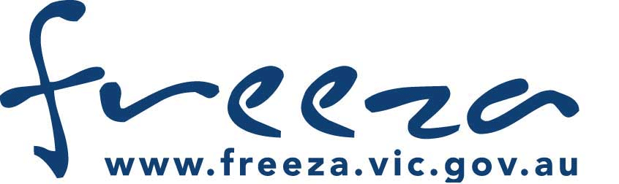

Cardinia Shire Council –Youth Services


Expression of interest form – FReeZA

Personal Details
Name |  |  |  |  |  |  |  | Date of birth
Age | M  F  | Email
Address
Town/Suburb |  |  |  | Postcode |  | Phone
Electric Productions is a FReeZA committee made up of young people aged 14-25 that put on fun, exciting, safe, professionally run drug, alcohol and smoke free events for young people in the Cardinia area. The committee work together to organise a wide range of events including: Battle of the Bands, youth events, community festivals, band gigs and pool parties. Free training is offered to committee members to develop skills in event management, sound and lighting, artist booking, marketing and publicity and more.
What areas would interest you?
 Event Management  Sound Engineering  Volunteering  Stage Management  Graphic Design  Booking bands and performers
 Media and Promotion  Other:
Why would you like to be involved?
What excites you most about the FReeZA program?
Do you have any previous experience in organising events or volunteering?
What are your general interests/hobbies?
What are your current commitments?
School  Part time  Fulltime TAFE  Part time  Fulltime Employment  Part time  Fulltime
❑ Other:
What types of events and projects interest you most? Please tick:
❑ Battle of the bands  Community/Youth festivals  Awareness-raising (youth issues)  DJ/Dance events  Film festivals
❑ Heavy/Hardcore band gigs  Youth Art Shows  Low-key gigs (eg jam sessions)  Mental Health Week
❑ Other (please specify
Thank you for expressing interest in the FReeZA program. A Youth Services Officer may be in contact with you soon to arrange an interview.
Would you like to join Cardinia Shire Council’s distribution list to receive updates about youth services programs and events?
❑ Yes  No – I would prefer to receive information via:  Email  SMS  Mail

