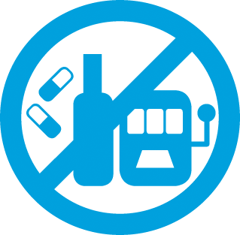
About
Tobacco smoking is the leading preventable cause of ill health and death in Victoria. Smoking not only affects the health of individuals, but also those in environments with second-hand exposure to smoke.
Alcohol consumption is part of many social and cultural activities, however risky drinking culture and harmful levels of consumption have detrimental effects on individual injury and disease, as well as social and economic impacts across communities. Similarly, recreational drug use can impact a person’s physical and
emotional wellbeing and have negative consequences on social, family, work, and financial situation.
Gambling harm is any adverse consequence that comes from gambling that leads to poorer health and wellbeing of the individual, family, community or population. These harms could be financial, relationship, emotional, health, work, cultural or criminal issues.

Key statistics
- 15% of adults in Cardinia Shire smoke
- 11% of pregnant mothers report smoking
- $28.5M lost on poker machines in 2018–19
- 44% at increased risk of an alcohol related injury during a single occasion
- 26% agree getting drunk every now and then is okay
- 0.6 off-license alcohol outlets are within 800m of homes
- In 2019, 476 alcohol-related hospital admissions and 329 ambulance attendances
- 61% have an increased lifetime risk of alcohol related harm
- In 2018–19, 25 illicit drug related hospital admissions per 10,000 population

Priority groups
- Males are more likely to drink at risky levels and be illicit drug users who presented to emergency department, ambulance attendance and episodes of care
- Smoking is higher in people employed in manufacturing, construction, accommodation and restaurant, personal and other services
- Pokies are most concentrated in Officer and Pakenham

COVID-19 impact
- COVID-19 has increased alcohol availability through increases in online sales, take-away and delivery and reducing regulation such as proof of age and sales to intoxicated people
- 20% of residents said they drink more alcohol during lockdowns

Climate impact
- Prolonged heat or extreme weather events create chronic stress situations increasing the risk of alcohol and substance abuse

