Cardinia Shire Council

Child, Youth and Family Strategy 2017–21
Children aged 0–11 and young people aged 12–25 in Cardinia Shire and their families

May 2017

Contents

Introduction 2
Mission statement 4
Outcomes 5
Guiding principles 6
Strategic priorities 7
Be safe 8
Be healthy and happy 9
Be connected 10
Realise their potential 11
Achieve economic wellbeing 12
Review and evaluation 13

Introduction
Cardinia Shire Council’s 2017–21 Child Youth and Family Strategy (for children aged 0–11 years and young people aged 12–25 years) is aligned to its Council Plan and Liveability Health Plan. It provides the framework which supports the prevention and early intervention approaches that respond to priorities and key focus area identified by community, including children and young people themselves. The detail of how we will achieve these will be planned on an annual basis through Council’s business planning process and the development of strategic and operational actions with resources allocated to where they are most needed.

The strategy has been aligned to a number of other Victorian Government plans/strategies/policies that inform the work of Community and Family Services as follows:
- Roadmap for Reform
- Education State
- Victorian Early Years Learning and Development Framework
- Ten Year Early Childhood Compact (between Department of Education and Department of Health and Human Services)
- Starting out Strong (Maternal and Child Health)
- Early Childhood Reform Plan
- Building Stronger Youth Engagement in Victoria.

In determining the priorities contained in this strategy we have carried out:
- a review of the 2012–16 Youth Strategy and Child and Family Plan
- a review of the statistics relating to the health, wellbeing and development of children, young people and their families across the Shire
- consultation with children, young people, professionals and parents/carers
- cross-referencing with the consultation undertaken through the Liveability Health Plan development.

This evidence has provided us with insight into some significant issues affecting children, young people and families in the Shire that are in some cases entrenched and require a whole of community approach such as family violence. There are other emerging needs such as financial hardship, reduced educational outcomes and school non-attendance for our children and young people that require us to plan early so that we can prevent them becoming enduring issues. We know that vulnerability can present itself to families at any time, and we want to ensure that the systems in the Shire will work when and how families need them.

Equally as important is the acknowledgment that broadly our families are strong and resilient and there are positive outcomes being seen. We have a continued role in ensuring that Cardinia Shire is a great place for children and young people and their families to live, work, learn and play. A place where the strengths and differences of our families are celebrated and parenting is supported.

For this reason, the strategy takes a long term approach to making a difference - with the flexibility to plan responsive strategic and operational actions so that we can influence the long term outcomes achieved. It is also broad enough to ensure that we consider the longevity of our priorities and approaches and where we can we will revisit them as community data informs us.

Underpinning the strategy is a set of principles, almost a ‘checklist’ of those things we that we will consider in our planning, design, delivery, evaluation and advocacy. These align with our values around the way in which we support the needs of the community and hold ourselves to account that we are being inclusive and equitable.

Planning and development cycle

Mission statement
Cardinia Shire is a place where children and young people are safe and able to optimise their health, wellbeing and development, with the support and encouragement of their families and trusted adults. Through the adopted Child Friendly City Charter, it promotes a place where they are acknowledged as young citizens in their own right and where their voices help to shape the place where they live and the services and opportunities they receive.

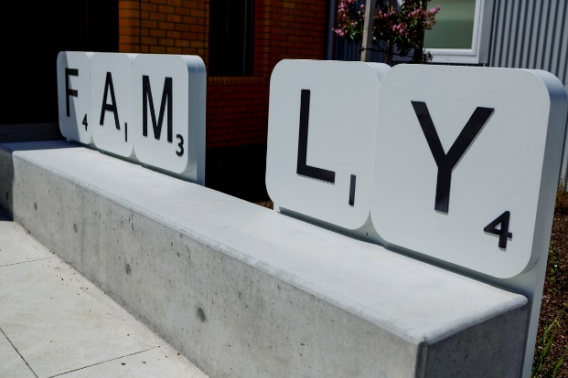
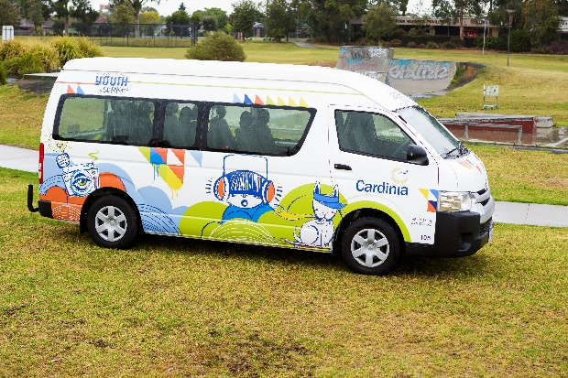

Outcomes
Children, young people and their families will:

Be safe
- They will be protected from harm and receive support to keep safe.
- They will build resilience and help keep themselves safe.
- They will have access to trusted adults.
- Vulnerability, location and disadvantage will not determine outcomes.

Be healthy and happy
- Their mental health and emotional wellbeing will be supported.
- They will experience optimal health and development.
- They will have access to information, advice and education to improve their health and wellbeing.

Be connected
- To culture, their family and friendship networks and their communities.
- They can actively participate in community life and activities; and can access help when they need it.
- They have a range of accessible facilities that encourage community connection.

Realise their potential
- They will have access to quality education and training that takes account of individual learning needs.
- Their talents and strengths will be taken into account and they will have the opportunity to shine.
- Their transitions will be supported.
- Difference will be recognised and celebrated.

Achieve economic wellbeing
- Those experiencing hardship will have access to information, advice and referral to support agencies.
- Volunteering opportunities will support their aims.
- services and activities will be free or low cost and accessible.
- They will have career aspirations and opportunities for employment.

Guiding principles
We will ensure that these principles underpin the design, development, implementation and evaluation of our service actions and activities:

- Evidence-based services that are affordable, relevant, contemporary and high quality.
- Access to information, advice, support and education.
- Voice of the child, young person and parent/carer in the planning and decisions that affect them and the services they receive.
- Safe and trusted adults as role models.
- Free or low-cost, inclusive, accessible, healthy and safe activities/programs – that are family-friendly.
- Place-based approaches.
- Building a better system.
- Attract services to base themselves in the Shire.
- Prevention approaches and workforce development.
- Working in partnership with others to achieve outcomes, provide advocacy and co-design.

Strategic priorities
The strategy will support the following identified priorities for 2017–21 to inform our key focus areas for service development, provision and improvement.

Be safe
- Family violence.
- Vulnerability /health and social care.

Be healthy and happy
- Mental health and emotional wellbeing.
- Healthy lifestyles.

Be connected
- Infrastructure and planning.
- Activities, programs and events.

Realise their potential
- Education, training and employment.
- Personal growth and development.

Achieve economic wellbeing
- Financial welfare.
- Pathways.

Be safe

Family violence

Key focus area
- Work in partnership with Together We Can to help reduce the impact of family violence on children and young people.
- Embed Child Safe Standards across child and youth services.
- Support the respectful relationships agenda.
- Provide information, referral and support opportunities.
- Strengthen the Maternal and Child Health (services) family violence assessment undertaken at the four-week Key Age and Stages (framework) consultation and active follow-up processes for those who are missed, or who engage after the four-week consultation.
- Strengthen processes around engaging and maintaining engagement of vulnerable families in Maternal and Child Health services.
- Workforce development (upskilling of staff across Council and in partnership with the service sector).

Vulnerability/health and social care

Key focus area
- Ensure children and young people with additional needs are clearly represented within the local service planning and delivery, particularly those from Culturally and Linguistically Diverse, Aboriginal and Torres Strait Islander communities, those with a disability and those from particular groups such as LGBTIQ+.
- Improve access for vulnerable children into early childhood education and services.
- Work collaboratively with health and social service agencies to improve early identification and service referral and support systems.
- Support the direction and implementation of the Victorian Government Early Years Compact for Vulnerable Children and a better connected universal, secondary and tertiary service system.
- Collaborative planning for those experiencing vulnerability (e.g. homelessness, mental health, drug and alcohol abuse).

Be healthy and happy

Mental health and emotional wellbeing

Key focus area
- Early identification of mental health problems and referral to support services.
- Building resilience and coping skills.
- Strengthen the voice of children and young people in identifying their needs and having involvement in the decisions that affect them.
- Advocacy for increased service provision.

Healthy lifestyles

Key focus area
- Promote exercise and healthy choices.
- Provide education and awareness.
- Provide programs and activities that encourage active participation and help reduce obesity.
- Work in partnership with Aligned Leisure and maximise healthy lifestyle opportunities.
- Plan for the needs of young people after school hours and during school holidays.
- Strengthen parenting in early childhood.

Be connected

Infrastructure/planning

Key focus area
- Ensure there are adequate kindergarten places for children in the Shire through strategic and integrated planning for child and family centres.
- Provide accessible, safe and quality community facilities.
- Plan for the growth needs of young people and the development of integrated youth facilities.
- Strengthen the role of children and young people as young citizens in identifying their needs and informing and influencing planning.
- Promote the importance of education for children and young people and work collaboratively to help reduce school non-attendance.

Activities, programs and events

Key focus area
- Work across Council departments to support a sense of community through the accessibility of activities within open spaces, sports and recreation and community events.
- Ensure the needs of children and young people living in rural and remote areas are embedded into planning and delivery.
- Plan for the inclusion of fathers and partners in early childhood services.

Realise their potential

Education, training and employment

Key focus area
- Support strategic planning efforts to provide job opportunities for young people in the Shire and advocate with education and training providers to develop affordable employment pathways for young people.
- Promote the importance of education with families and help support the reduction in kindergarten and school non-attendance.
- Promote the importance of individualised learning needs approaches and development of quality teaching methods.
- Support the drive to improve the retention of young people in school to Year 12.
- Advocate for the increase in flexible and tailored education opportunities.

Personal growth and development

Key focus area
- Able to ‘shine’ and make a positive contribution.
- Plan for programs and activities that celebrate difference and promote the talents and strengths of children and young people.
- Celebrate the achievements of children and young people with their families.
- Raise the profile of young people within the community through positive messaging, that promotes intergenerational and cultural understanding and tolerance.
- Collaborate in the identification and support of education and early learning and development transition needs.

Achieve economic wellbeing

Financial welfare

Key focus area
- Ensure Council facilities provide families with information around financial and welfare support agency contacts.
- Plan for free or low-cost activities, services and programs available to families.

Pathways

Key focus area
- Advocate for volunteering and training opportunities.
- Help raise the career aspirations of young people.
- Advocate for improved transport options.

Review and evaluation
This strategy aligns with the Council’s Plan four-yearly business cycle. It will be reviewed on a four-yearly basis to assess outcomes being achieved and make minor amendments as required to continue to align with the Council Plan and the reviews of the Liveability Health Plan. It will incorporate the results of the youth survey which takes place every three years.

Council also reviews its business operations through its annual budget planning process, utilising the evaluations that are carried out across services and programs on an on-going basis. The outcomes will be considered at these times to reflect on emerging trends/issues and where our strategic and operational actions may need to be adjusted to ensure we meet our objectives.

