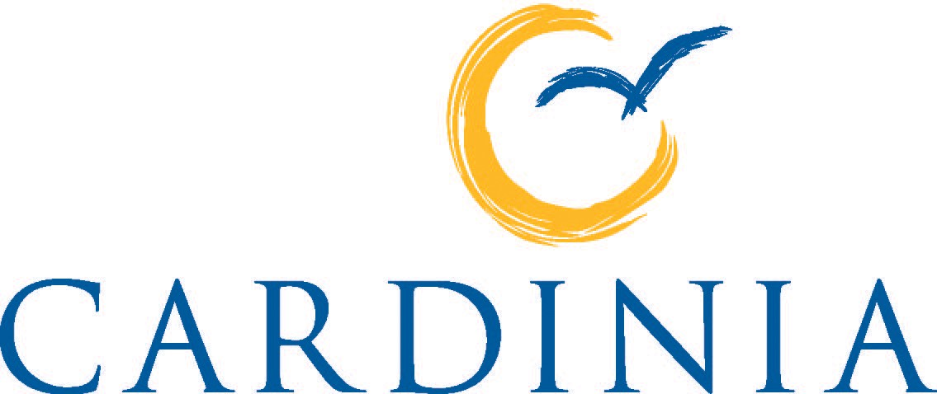

NEIGHBOURHOOD HOUSE POLICY
2013 - 2017

Business Unit: Community Strengthening Unit
Adopted: November 2013
Review Date: December 2017

Introduction
Neighbourhood Houses are at the forefront of service provision, playing a positive role in community development. They place great emphasis on social equality addressing educational, social and health needs and Council acknowledges the important role they play in strengthening communities.

There are currently eight Neighbourhood Houses operating in Cardinia Shire:

- Beaconsfield Neighbourhood Centre
- Bunyip and District Community House
- Cockatoo Neighbourhood House
- Emerald Community House
- Lang Lang Community Centre
- Living Learning Pakenham
- Outlook Community Centre
- Upper Beaconsfield Community Complex

Council will determine the location of future Neighbourhood Houses based on community needs and available funding.

Neighbourhood Houses receive funds from a range of sources including the State Governments Department of Human Services (DHS) Neighbourhood House Coordination Plan (2012-2015); Cardinia Shire Council; Adult, Community and Further Education (ACFE), other government grants and through their own fund-raising initiatives.

Cardinia Shire Council provides assistance to Neighbourhood Houses through the provision of a council building or rental assistance, and with organisational funds calculated on a base model in addition to a percentage of funding calculated on community strengthening program delivery hours which include social support, health promotion and skills development. There are also opportunities for other funding through a variety of Council annual grant programs.

Cardinia Shire Council is dedicated to developing and maintaining a partnership with the Neighbourhood Houses. The partnership that Council have with local Neighbourhood Houses is through both direct and indirect liaison. The support provided will be aligned with the individual needs of each Neighbourhood House. Neighbourhood Houses and Council will be bound by the Neighbourhood House Policy, a Service Level Agreement, a Lease Agreement where applicable, and the Maintenance Policy. Council will work collaboratively with Neighbourhood Houses to determine suitable program delivery for our diverse community.

Definitions

Community
A group of people living in the same geographic location (locality, township or suburb) and/or a group of people having common interests and needs.

Neighbourhood House
Neighbourhood House organisations are known by a variety of names, including Community Houses, Community Centres, Neighbourhood Centres, and Learning Centres. The defining attribute and common thread is that they are all not-for-profit organisations which focus on providing generalist activities, programs and services that respond to diverse community needs.

Neighbourhood Houses provide a place where members of the community are able to access support, information, learning opportunities, and participate in social programs or in the operation and management of the House as volunteers.

Neighbourhood Houses are defined by the following principles:
- They are accountable to the community, operated by a Committee of Management with an employed Coordinator independent of the committee
- A Committee of Management must consist of a broad representation of the community and does not allow the coordinator to sit as a member of committee
- The centre must be a ‘not for profit’ and incorporated organisation
- Provides a range of coordinated programs to primarily service the residents of Cardinia Shire and secondly to the residents of neighbouring areas
- Encourage volunteers to support their programs and overall service delivery
- Deliver a diverse range of programs that are accessible to all sectors of the community.

The different roles Neighbourhood Houses play may include playgroups, child care, training delivery, public internet access, provision of recreation, cultural and social activities, health and wellbeing activities and information and resource centres.

Neighbourhood Houses are a unique agency in that they provide a service which caters for people throughout their lifespan. Moreover, Neighbourhood Houses provide an informal support network for people who may otherwise be isolated and may assist in the delivery of other local initiatives depending on the needs of the community.

Policy context
The Council Plan 2013-2017 refers to a number of key measures of success which relate to the work of our neighbourhood houses, Learning opportunities for all ages; support learning activities for all ages. Our communities actively engaged; foster community leadership. Increased levels of community participation; promote initiatives that connect and strengthen our communities and recognise, support and value volunteerism.

Cardinia Shire Council’s Lifelong Learning Policy 2007 acknowledges the significant value of lifelong learning to Cardinia Shire’s communities through planning and delivery of a range of services and programs in partnership with the community and stakeholders including Neighbourhood Houses.

Cardinia Shire Council’s Municipal Public Health and Wellbeing Plan 2013–17, refers to building the capacity of Cardinia Shire Council and the community through emphasising active consumer and community participation.

Principles of the policy
The key principles are:

- To reinforce the partnership between Council and the Neighbourhood Houses
- To recognise the importance of Neighbourhood Houses’ role in community strengthening
- To clarify the key ways in which Council supports the Neighbourhood House sector

Council’s commitment to Neighbourhood Houses
Cardinia Shire Council works at a strategic level with State and Federal Government and the community, on ways to maximise and develop long term benefits for a sustainable community. The Council’s role is to:

- Identify changing needs and support Neighbourhood Houses to address the needs, e.g. providing statistics and demographical data as well as identifying changing trends
- Advocate on behalf of Neighbourhood Houses
- Strengthen relationships with major stakeholders including Federal and State Government
- Provide financial assistance through the provision of an annual funding allocation to all neighbourhood houses
- Support local community initiatives utilising a community capacity building approach
- Promote the Neighbourhood House sector as a model for community learning and social participation
- Assist in sourcing training opportunities for the Committees of Management and volunteers
- Assist local groups in the establishment of new Neighbourhood Houses where required.

Cardinia Shire Council will partner with local Neighbourhood Houses in recognising the significant role that they play in community strengthening. Council will also work to establish and promote Neighbourhood Houses as key hubs for community learning, community participation, development and capacity building.

Funding/service agreements

Cardinia Shire Council acknowledges that the Neighbourhood Houses play a significant role in the local community providing a diverse range of community strengthening activities. Being a growing interface municipality, Cardinia Shire Council is committed to supporting existing and new Neighbourhood Houses. Council will therefore take into consideration the establishment of new houses in annual budget considerations.

To be eligible for funding from Council Neighbourhood Houses must be:
- community based and not-for-profit
- an Incorporated Association
- operating by a Committee of Management that represent a cross section of groups within the community
- continue to provide programs that benefit the local community
- a member of the Neighbourhood House Network
- recognised under the State Government (DHS) Neighbourhood House Coordination Program.

Subject to annual budget approval processes, Council will provide annual funding to each Neighbourhood House based on the size of the house, and their contribution of delivering community development initiatives within the Shire.

Funding will be paid annually on receipt of the following:
- DHS reports:
  - Annual Data Collection
  - Annual Participant Census
- General:
  - Copies of Term/Semester programs
- Governance documents:
  - Neighbourhood House/Centre’s Annual Report
  - Certified Annual Statement/Financial Statement
  - Committee of Management – emergency contact and out of hours contacts
  - Copy of payment receipt for Annual Incorporation Fee
  - Copy of Certificate of Currency (Public Liability Insurance)

A Neighbourhood House that is not recognised by DHS can make application to Council for funding. Cardinia Shire Council may determine to allocate budget accordingly as part of its commitment to this policy.

Cardinia Shire Council will review the Service Level Agreements with houses annually prior to the funding round and negotiate support with the Committee of Management in accordance to the local needs of the community and the range of programs offered by individual houses.

