Cardinia Shire Council

COVID-19 Community relief service providers for
financial support, housing assistance and food services
VERSION 3.4 – 23 August 2021

Contents

Help Stop the Spread 4
COVID-19 EMERGENCY RELIEF SERVICES 5
Government Assistance……………………………………………………………………………………………….5

Food relief…………………………………………………………………………………………………………………..5
ADRA Adventist Development & Relief Agency – Pakenham………………………………………..5
AfriAus - iLEAC…………………………………………………………………………………………………………..5
Australian Red Cross…………………………………………………………………………………………………6
Bunyip and District Community House……………………………………………………………………….6
Caring Connections of Upper Beaconsfield…………………………………………………………………6
Cockatoo Community House………………………………..…………………………………………………...7
Emerald Community House…….………………………………………………………………………..……….7
Empower Australia (Planet Shakers)………………………………………………………………………….7
Follow Bless Collective (FBC)……………………………………………………………………………………..7
Food Bank………………………………………………………………………………………………………………..7
Gurudwara Baba Budha Sahib Ji………………………………………………………………………………..8
Gurudwara Siri Guru Nanak Darbar……………………………………………………………………………8
Meals on Wheels………………………………………………………………………………………………………8
Salvation Army………………………………………………………………………………………………………….8
St Luke’s Cockatoo……………………………………………………………………………………………………8
Turning Point Church – Koo Wee Rup……………………………………………..………………………...8
Housing services ………………………………………………………………………………………………………9
WAYSS……………………………………………………………………………………………………………………..9

Financial Services…………………………………………….………………………………………………………….9
Anglicare – Financial Wellness Program…………………………………………………………………….9
Commonwealth Bank Australia………………………………………………………………………………….9
Casey North Information and Support Service…………………………………………………………….9
Financial Counselling Southern………………………………………………………………………………….9
Good Money Program…………………….………………………………………………………………………..10
Good Shepherd……………………………………………………………………………………………………….10
NILS (No Interest Loan Scheme)………………………………………………………………………………10
Utilities Relief Grant Scheme – DHHS………………………………………………………………………10

Psychosocial Support Services…………………………………………………………………………………..10
Aboriginal Men’s 24 hour Crisis Support Hotline………………………………………………………10
ERMHA – Eastern Regions Mental Health Association………………………………………………10
Telecross – Australia Red Cross………………………………………………………………………………10

Neighbourhood Houses……………………………………………………………………………………………..11
Beaconsfield Neighbourhood Centre……………………………………………………………………….11
Beaconsfield Upper Community Centre……………………………………………………………………11
Bunyip & District Community House……………………………………………………………………..…11
Cockatoo Community House……………………………………………………………………………………11
Emerald Community House……………………………………………………………………………………..11
Lang Lang Community House………………………………………………………………………………….11
Living and Learning…………………………………………………………………………………………………11
Outlook Community Centre….…………………………………………………………………………………..11

Aboriginal and Torres Strait Islanders…………………………………………………………………………12
Aboriginal Men's 24-hr Crisis Support Hotline……..……………………………………………………..12
Bunurong Health Service………………..…………………………………………………………………………12
Dardi Munwurro Women's Online Support Group………………………………………………………..12
Elizabeth Hoffman House………………………………..………………………………………………………..12
Monash Health………………………………………………..……………………………………………………….12

Cultural Support Services…………………………………………………………………………………………..12
Living and Learning Pakenham………………………………………………………………………………….12
Southern Migrant and Refugee Centre……………………………………………………………………….12
Yarning SafeNStrong Confidential Helpline…………………………………………………………………12

Crisis support…….………………………………………………………………………………………………………12
Aboriginal Men’s 24 hour Crisis Support Hotline…………………………………………………..12
Beyond Blue……………………………………………………………………………………………………….12
Kids Helpline………………………………………………………………………………………………………12
Lifeline Crisis Hotline…………………………………………………………………………………………..12
MensLine Australia……………………………………………………………………………………………………12
Suicide Line Victoria (24/7)……………………………………………………………………………………….12

Disability Support Services…………………………………………………………………………………………13
Disability Gateway…….……………………………………………………………………………………………….13

Family Violence Support Services……………………………………………………………………………….13
1800 RESPECT..…………………………………………………………………………………………………13
Kids Helpline………………………………………………………………………………………………………13
In Touch – Multicultural Centre Against Family Violence……..………………………………………13
Police Assistance Line……………………………………………………………………………………………….13
Safe Steps 24/7 Family Violence crisis service…………………………………………………………..13
Windermere………………………………………………………………………………………………………………13

Help Stop the Spread
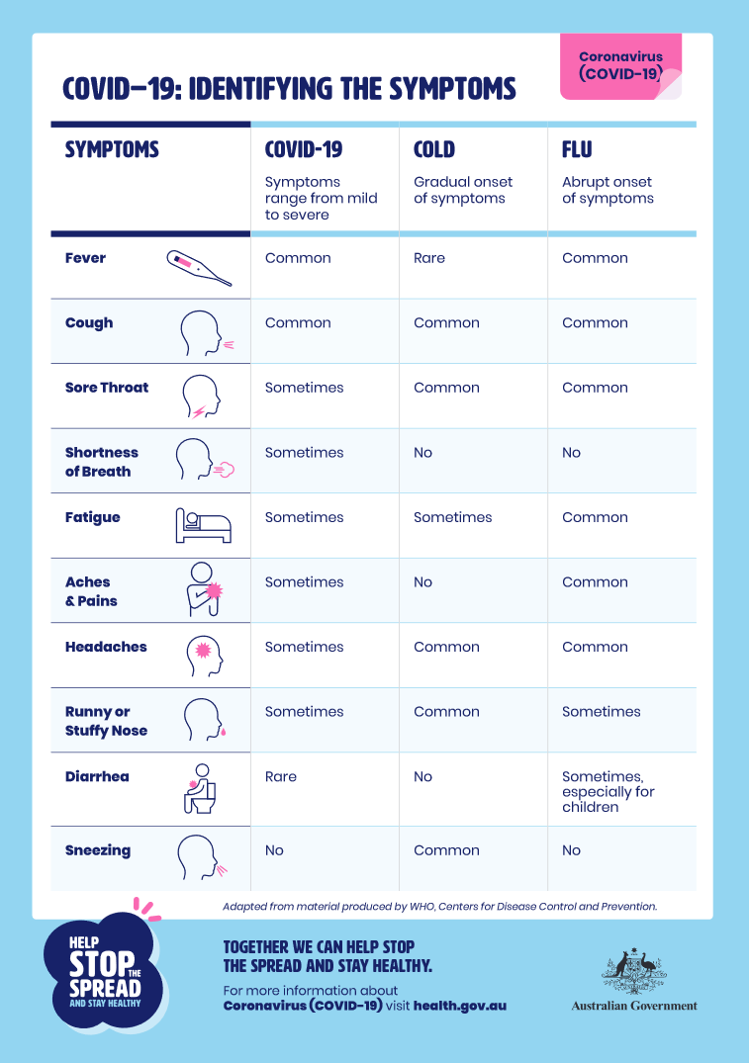
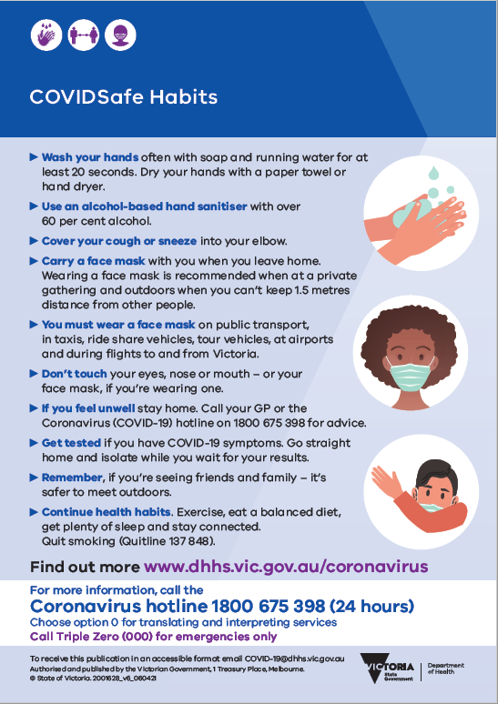

COVID-19 EMERGENCY RELIEF SERVICES

This directory has been compiled by the Cardinia Shire Relief and Recovery Committee.

The following providers have indicated they are available to provide support and relief services during the current Covid-19 crisis. The information contained below is accurate as at the date of publishing but may change without notice. It is strongly recommended to call providers to confirm available services.

Due to changing conditions, unprecedented demand and in the interest of safety, providers require all bookings and appointments to be made over the telephone.

Would you like assistance with accessing services?
If you require assistance in accessing COVID-19 pandemic social, emotional or practical support information, please contact Cardinia Shire Council’s Emergency Management Team. Council can assist you in understanding what support is available and can link you in with services to help meet your needs.
Ph: 1300 787 624

Police Assistance Line to report public gatherings of over 2 persons, non-compliance to social distancing or mandatory isolation
Ph: 13 44 44

Government assistance

Services Australia - COVID-19 Disaster Payment
A support payment for workers adversely affected by a state public health order.
https://www.servicesaustralia.gov.au/individuals/services/centrelink/covid-19-disaster-payment-victoria

Food relief

ADRA Adventist Development & Relief Agency - Pakenham
Services are running for food provision including takeaway meals. Sit down meals are unavailable. Other services include essential care packages and home delivery.
An assessment based on needs and location is required.

You can contact ADRA on 1800 242 372, or email us at adra.info@adra.org.au. We will then put you in touch with the ADRA program closest to you.

AfriAus – iLEAC

Community food pantry and store. Relief emergency culturally appropriate food, personal care, baby items, and safety products (PPE) to vulnerable Victorians of African, other culturally and linguistically diverse heritage, and wider Victorian community.
6B Henry Street, Pakenham
Ph: 0400 808 112

Australian Red Cross
Provision of care packages (primarily food) to members of the community via Crisis hotline registration who are mandatory isolating.

Emergency Relief Assistance

All enquiries and requests for emergency food and essential relief packages and should be directed to the COVID-19 hotline: 1800 675 398. For further information: www.dhhs.vic.gov.au/coronavirus

Food and Water
- Victorians self-isolating due to COVID-19 with no access to food and essential supplies will receive emergency relief packages.
- Eligible households will receive a two-week supply of essential goods including food, personal care, and other essential items as required.
- The packages are for those in mandatory self-isolation, who have little or no food, and no network of family and friends to support them.
Psychosocial Support – phone outreach
- Red Cross is delivering telephone outreach to those requesting psychosocial or wellbeing support on the COVID-19 hotline.
- Trained volunteers are providing telephone outreach to support people self-isolating.
For all Red Cross enquiries and emergencies not related to the COVID-19 social distancing measures, call the Red Cross 24-hour Duty Officer hotline –
Ph: 1800 232 969.
For all COVID-19 enquiries and requests for relief, please call the COVID-19 hotline – 1800 675 398.

Bunyip and District Community House
Provision of free food and material aid to those in need.
Mondays and Wednesdays between 9am-12pm.
Beswick Street, Garfield
Ph: 0481 895 509

Caring Connections of Upper Beaconsfield
Providing assistance to those in the community who may be vulnerable or isolated such as the elderly, chronically ill, pregnant, mothers of infants and people with disabilities.
Services include:
- Assistance with shopping including picking up pharmacy supplies
- Social contact via phone
Only servicing the areas of Upper Beaconsfield, Dewhurst, Guys Hill.
Ph: 0407 952 286

Cockatoo Community House
Free food pantry - non-perishable food
23 Bailey Road, Cockatoo 3781
Ph: 03 5968 9031

Emerald Community House
Free non-perishable food from Food Bank available 24/7, self-serve
Dig In Community Café, pre-prepared frozen meals available during business hrs
Licensed childcare, printing and internet access also available.
Office will be operating between 10am and 3pm Monday to Friday (call first).
358 Belgrave-Gembrook Rd Emerald 3782
Ph: 03 5968 3881
emhouse@iinet.net.au

Empower Australia (Planet Shakers)
Emergency Food Relief Centre, including toiletries and baby products, for anyone facing serious food insecurity.
RCS Products, 12 Bormar Drive, Pakenham.
Sundays 8.30am-10.30am
Just turn up or Ph: 03 9896 7999
Identification is required on arrival for check in.

Follow Bless Collective (FBC)
FBC operates a Food Van from Bourke Park, Pakenham on Tuesday and Thursday evenings. Visit their Facebook page below or call for more information.
FBC provides Care Packs of non-perishable food and toiletries for people in the Cardinia Shire who are in crisis and need support.
Eligibility criteria is as follows:
- People who have lost employment and are awaiting Centrelink payments;
- Individuals/families who are in mandatory isolation due to COVID19;
- Temporary visa holders who have no income;
- Refugees who have no income;
- People in financial crisis

Bookings for Care Packs can be made by Emailing info@bless.org.au or
Ph: 59432137 / 0411543817
Appointments made for people to pick up care packs on weekdays from 30 Tivendale Rd, Officer 3809.
In extreme circumstances, FBC can deliver care packs (non-contact delivery). Please see our website bless.org.au or Facebook page follow bless collective food van for updates.

Food Bank
Preparing meals for distribution by the Australian Red Cross.
Requests for food can be made through Victoria’s dedicated Coronavirus Hotline
Ph: 1800 675 398

Gurudwara Baba Budha Sahib Ji
Providing freshly cooked vegetarian meals for those in need of support. Food is delivered between 6-8pm daily. Phone or text your order before 12pm each day. Ph: 0433 483 335

Gurudwara Siri Guru Nanak Darbar
Providing food relief to members of the community. Delivers twice a week.
To register or for more information:
Email: info@sgnd.com.au
Ph: 0421 061 177

Meals on Wheels
Providing meal delivery service to people aged over 65+ within Cardinia Shire.
For Aboriginal and Torres Strait Islander people, this service is available for those aged over 50+ within Cardinia Shire.
There may be a small cost for this service dependent upon individual circumstances.
Ph: 03 8573 4960

Pakenham Community Pantry
Free food pantry - non-perishable food.
6B Henry Street, Pakenham
Ph: 03) 5941 2389

Salvation Army
Essential services are still running including:
- Homelessness services
- Youth services
- Family violence services
- Aged care
- Doorways and emergency relief
- Bushfire recovery (via telephone)
- Alcohol and other drugs
For those in need of critical financial support, assistance can be provided for immediate basic needs on the number below.
*Care packages are being provided in partnership with ADRA.
Accepting donations of non-perishable goods.
Most services have been adapted to run through phone or digital platforms.
Ph: 03) 5941 4906

St Luke’s Cockatoo
In association with Food Bank Vic are running a food bank service each week for local residents. Open Mondays 10am-2pm or by appointment. Ph: 0422 737 818

Turning Point Church – Koo Wee Rup
Food service preparation and provision is running. Pick up only
Services are provided BY APPOINTMENT ONLY.
KWR also offers health and welfare assistance.
Ph: 03 5997 2217

Housing services

WAYSS
Intake and assessment entry point for all women and children requiring specialist family violence support. All programs are still running. Dandenong branch is open for the following services:
- Family violence support services
- Homelessness support services
- Youth support services
- Support to maintain tenancies

DANDENONG: Ph: 03 9791 6111
PAKENHAM OFFICE: Closed
www.wayss.org.au

Financial Services

Anglicare – Financial Wellness Program
Providing financial support and help accessing hardship programs.
Ph: 1800 966 172
anglicare.org.au

Commonwealth Bank Australia
Commonwealth Bank Australia have developed support programs that are available to anyone experiencing Family Violence and/or Financial Abuse. Note: This is open to everyone, not just Commonwealth Bank customers.
https://www.commbank.com.au/support/dv-assistance.html

Casey North Information and Support Service
Free and confidential financial counselling provided by qualified professionals to people who are experiencing financial difficulties.
Ph: 9705 6699
Email: cnciss@caseynorthciss.com.au.
https://www.caseynorthciss.com.au/financial-counselling

Financial Counselling Southern
South East Community Links
Monday to Friday 9am-5pm
Enquiries and referrals can be emailed to fcs@secl.org.au
Workers can refer via phone or email (contact us and we will send you our referral form)
Consumers can self-refer to either the phone line or email address.
Ph: 9549 5288

Good Money Program
Household relief loans without interest for those who are struggling due to COVID-19. Financial Counselling also available.
Ph: 1300 770 550 www.goodmoney.com.au/

Good Shepherd
COVID Hardship Support Hotline (Financial Support) and Loans without interest of up to $3000 for household bills.
Ph: 1300 121 130 www.goodshep.org.au/

NILS (No Interest Loan Scheme)
The No Interest Loan Scheme (NILS) provides individuals and families on low incomes with access to safe, fair, and affordable credit.
Open week days 9am-5pm.
https://echo.org.au/nils/
Ph: 0427 895 596

Utilities Relief Grant Scheme - DHHS
Call your utility company, ask to speak with the hardship department and request a Utility Relief Grant.
https://services.dhhs.vic.gov.au/utility-relief-grant-scheme

Psychosocial Support Services

Aboriginal Men’s 24 hour Crisis Support Hotline
Talking it over. Brother to Brother – call Dardi Munwurro to discuss family violence issues, parenting issues, communication, separation, relationship stress.
Ph: 1800 435 799

ERMHA – Eastern Regions Mental Health Association
Providing services for people facing challenges resulting from disability, mental illness, trauma or substance abuse.
Ph: 1300 376 421

Telecross – Australia Red Cross
Red Cross initiative can provide a daily telephone call to check on people who live alone and are at risk of an accident or illness that may go unnoticed.
Ph: 1300 885 698

Neighbourhood Houses
Please contact your local neighbourhood house directly by telephone to find out which services, if any, are currently operating.

- Beaconsfield Neighbourhood Centre
8 O’Neil Road, Beaconsfield 3807
Ph: 03 8768 4400
coordinator@bncinc.org.au
- Beaconsfield Upper Community Centre
10-12 Salisbury Road, Beaconsfield Upper
Ph: (03) 5944 3484
office@ubcc.org.au
- Bunyip and District Community House
Garfield Recreation Reserve, 40 Fourteen Mile Road, Garfield 3814
Ph: 0481 895 509
manager@bdch.com.au
- Cockatoo Community House
23 Bailey Road, Cockatoo. 3781
Ph: 03 5968 9031
M: 0401062396
cch@taskforce.org.au

Emerald Community House
356 Belgrave-Gembrook Rd Emerald 3782
Ph: 03 5968 3881
emhouse@iinet.net.au

- Lang Lang Community Centre
7 Westernport Road, Lang Lang 3984.
Ph: 03 5997 5704
LLCC@langlang.net

- Living and Learning Pakenham Inc.
6B Henry Street, Pakenham 3810
Ph: 03 5941 2389
admin@livinglearning.org.au

- Outlook Community Centre
24 Toomuc Valley Road, Pakenham 3810
Ph: 0427 911 935
outlook@outlookvic.org.au

Aboriginal and Torres Strait Islanders
Aboriginal Men’s 24-hour Crisis Support Hotline
Talking it over. Brother to Brother. Call Dardi Munwurro to talk about issues of family violence, parenting, communication, separation, or relationship stress.
Ph: 1800 435 799
Bunurong Health Service
Aboriginal Health Service. Culturally appropriate health and wellbeing care.
Ph: 03 9794 5933
Dardi Munwurro women's online support group
The Dardi Munwurro Women's online support group is an empowering service that supports women who are assisting children with remote learning.
When: Every Monday in August
Time: 1:00–3:00pm
Registration: Please contact the team in the Dardi Munwurro women's unit for the Zoom link.
Ph: 0428 987 905 or 0419 550 981
Elizabeth Hoffman House
Support and counselling services for Aboriginal women and their children experiencing family violence.
Ph: 1800 796 112
Monash Health
Aboriginal Health Service. Culturally appropriate health and wellbeing care.
Ph: 1300 342 273

Cultural Support Services

Living and Learning Pakenham 03) 5941 2389
Southern Migrant and Refugee Centre 03) 9767 1900
Yarning SafeNStrong Confidential Helpline (24/7) 1800 959 563

Crisis support
Further crisis support services can be accessed via the following numbers:

Aboriginal Men’s 24 hour Crisis Support Hotline: 1800 435 421
Beyond Blue: 1300 224 636
Kids Helpline: 1800 55 180
Lifeline Crisis Hotline: 13 11 14
MensLine Australia (1300 78 99 78)
Suicide Line Victoria (24/7) 1300 651 251

Disability Support Services

Disability Gateway
https://www.health.gov.au/contacts/disability-gateway
People with disability and their families, carers and support workers can contact the Disability Gateway to get free, fact-checked information about COVID-19. You can also be referred to other support services if needed, including counselling and advocacy.
Ph: 1800 643 787 www.disabilitygateway.gov.au/

Family Violence Support Services

1800 RESPECT 1800 737 732
Kids Helpline: 1800 55 180
In Touch – Multicultural Centre Against Family Violence 1800 755 988
Police Assistance Line: 13 44 44
Safe Steps 24/7 Family Violence crisis service 1800 015 188
Windermere: 1300 946 337

If you are a community group or relief service provider and would like to be included in this directory, please Cardinia Shire Council emergency@cardinia.vic.gov.au

Cardinia Shire Council
Civic Centre
20 Siding Avenue, Officer

PO Box 7
Pakenham 3810 (DX 81006 Pakenham)
Phone: 1300 787 624
Email: mail@cardinia.vic.gov.au
Web: cardinia.vic.gov.au

National Relay Service (NRS)
TTY: 133 677 (ask for 1300 787 624)
Speak and Listen (speech-to-speech relay): 1300 555 727 (ask for 1300 787 624)
Translator Interpretation Service
131 450 (ask for 1300 787 624)

