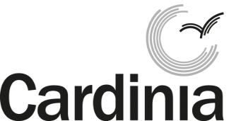
Waste reduction rebates
Application form

Your contact details
Full name: ___________________________________________________________
Phone: Home: _____________________ Mobile: _____________________
Email: ___________________________________________________________

Your property details
Property address (where the product will be used):
___________________________________________
___________________________________________
___________________________________________

Your bank details
Name of account holder: ______________________________
Bank name: _________________________________________
BSB: _________________ Account number: ______________

Select rebate:
Compost bin or worm farm
Garden mulcher
Reusable nappies
Reusable sanitary products

Proof of purchase and property address
Please tick the boxes to indicate that you have attached the following documents:
Purchase receipt for your product
Proof of address (utility bill, concession card, pension card, drivers licence, rates notice)

Signature: __________________________________________ Date: ______________

Please return this completed form to Cardinia Shire Council, Organic waste system rebate, PO Box 7, Pakenham, 3810 or in person at the Civic Centre 20 Siding Avenue, Officer.

Thank you for helping to reduce waste and protect our environment.
Cardinia Shire Council privacy statement
Personal information collected by Council is used for municipal purposes as specified in the Local Government Act 1989. The personal information will be held securely and used solely by Council for these purposes and/or directly related purposes. Council may disclose this information to other organisations if required or permitted by legislation. The applicant understands that the personal information provided is for the above purpose and that he or she may apply to Council for access to and/or amendment of the information. Requests for access and/or correction should be made to Council’s Privacy Officer on 1300 787 624 or mail@cardinia.vic.gov.au
Office use only | Date:
Receipt number: | Store of purchase:

