



Integrated Water Management Plan 2015–25

September 2015

Prepared by:

Cardinia Shire Council  
Environment Unit

in association with Alluvium

Published December 2015

© Cardinia Shire Council 2015  
*(ABN: 32 210 906 807)*

20 Siding Avenue, Officer

PO Box 7, Pakenham Vic 3810  
Phone: 1300 787 624  
Email: mail@cardinia.vic.gov.au  
Web: www.cardinia.vic.gov.au

Contents

1 Executive summary 7

2 Introduction 10

2.1 Aim and objectives 11

3 Context 12

3.1 Population and population growth 12

3.2 Cardinia Shire’s demographics 13

3.3 Cardinia Shire’s regions 13

4 Climate 17

4.1 Rainfall 17

4.2 Evaporation and evapotranspiration 17

4.3 Climate change 18

5 Shire’s water cycle 19

5.1 Water balance summary 19

5.2 Stormwater 20

5.3 Potable water 25

5.4 Residential water consumption 26

5.5 Recycled water 30

5.6 Groundwater 32

5.7 Wastewater 33

5.8 Waterways 35

5.9 Water cycle summary 37

6 Targets and action plan 38

6.1 Target and action plan: Stormwater 39

6.2 Target and action plan: Potable water consumption 43

6.3 Target and action plan: Alternative water supply 46

6.4 Target and action plan: Groundwater 50

6.5 Target and action plan: Wastewater 52

6.6 Target and action plan: Catchments and natural waterways 55

7 Conclusions and recommendations 58

7.1 Partnerships and relationships 59

7.2 Capacity building and training 59

7.3 Urban growth and PSPs 59

7.4 Connecting the community to natural assets 59

7.5 Alternative water supply 59

7.6 Monitoring and review 59

8 References 61

9 Appendices **Error! Bookmark not defined.**

Appendix A **Error! Bookmark not defined.**

Appendix B **Error! Bookmark not defined.**

Appendix C **Error! Bookmark not defined.**

Figure 1. Drivers for Council’s IWMP 7

Figure 2. Study area in greater Melbourne 10

Figure 3. Drivers for Council’s IWMP 11

Figure 4. Anticipated population growth by area (2011–31) 12

Figure 5. Population in major growth areas (2011–31) 13

Figure 6. The shire and its surrounding municipalities 14

Figure 7. Precinct structure plan summary 16

Figure 8. Rainfall bands across the shire (Melbourne Water, 2010) 17

Figure 9. Forecast shift in Koo Wee Rup rainfall distribution (CSIRO projections medium emissions) 18

Figure 10. Elements of the water cycle considered as part of Council’s IWMP 19

Figure 11. Shire’s water cycle and water balance (2012–13) 20

Figure 12. Stormwater volumes by land use source 20

Figure 13. Projected stormwater volumes by land use source 21

Figure 14. Stormwater volumes modelled by locality, base case scenario 22

Figure 15. Annual TSS loads by land use across the shire 23

Figure 16. Average annual TN and TP loads by land use across the shire 23

Figure 17. Location of WSUD elements across the shire 25

Figure 18. Water consumption by end use (2012–13) 26

Figure 19. Residential potable water consumption (total and per capita) 27

Figure 20. Potable water consumption by locality (2012–13) 27

Figure 21. Council per capita potable water consumption 28

Figure 22. Shire water consumption by end-use (2012–13) 29

Figure 23. Cardinia Life quarterly water consumption (2007–08 to 2012–13) 30

Figure 24. Total recycled water use within shire (2011–12 to 2012–13) 31

Figure 25. Recycled water use per household within shire (2011–12 to 2012–13) 31

Figure 26. Groundwater bores (by type) across the shire 32

Figure 27. Groundwater balance (adapted from Southern Rural Water, 2013) 33

Figure 28. Sewerage infrastructure and onsite waste water systems across shire, by suburb 34

Figure 29. Future programmed backlog works by number of lots, location and timing 35

Figure 30. Selected waterways and agricultural drains in Cardinia Shire 36

Figure 31. Anticipated development of the shire’s residential precincts 39

Figure 32. Council water consumption target compared to Cardinia Shire consumption (actual and projected) 44

Figure 33. Location of agricultural areas in relation to employment precincts 47

Figure 34. Sewerage infrastructure provided and lots connected (YVW area) 52

Figure 35. Source of diffuse pollution (Source: better bays and waterways, Melbourne Water and EPA, 2007) **Error! Bookmark not defined.**

Figure 36. Source of TSS, TN and TP within Western Port catchments (Source: better bays and waterways, Melbourne Water and EPA, 2007) **Error! Bookmark not defined.**

Figure 37. Total suspended solids loads by catchment (Source: BMT WBM, 2009) **Error! Bookmark not defined.**

Figure 38. Total nitrogen loads by catchment (Source: BMT WBM, 2009) **Error! Bookmark not defined.**

Figure 39. MUSIC model sequence **Error! Bookmark not defined.**

Figure 40. Primary catchment layers **Error! Bookmark not defined.**

Figure 41. High rainfall band model (relevant to hills region) **Error! Bookmark not defined.**

Figure 42. Moderate rainfall band model (relevant to urban growth region) **Error! Bookmark not defined.**

Figure 43. Low rainfall band model (relevant to southern rural area) **Error! Bookmark not defined.**

Figure 44. TSS loads modelled by subcatchment, base case scenario **Error! Bookmark not defined.**

Figure 45. Residential potable water use 2011-12, by suburb **Error! Bookmark not defined.**

Figure 46. Council water use projections at 1.5 percent of community use **Error! Bookmark not defined.**

Figure 47. Summary of project stakeholders **Error! Bookmark not defined.**

Figure 48. Consultation process for the shire’s IWMP **Error! Bookmark not defined.**

Figure 49. Vision and objectives for the Council’s IWMP **Error! Bookmark not defined.**

Figure 50. Aspirations, issues and opportunities – Objective 1 and 2 **Error! Bookmark not defined.**

Table 1. Hills region population 15

Table 2. Non-residential potable water consumption 27

Table 3. Potential alternative water sources 48

Table 4. Council’s IWMP aspirations and targets 58

Table 5. Timeline and components of IWMP review 60

Table 6. SWMP risk summary **Error! Bookmark not defined.**

Table 7. SWUP (review) Risk Summary **Error! Bookmark not defined.**

Table 8. WIF20520: Action requiring Council involvement **Error! Bookmark not defined.**

Table 9. Domestic wastewater risk summary **Error! Bookmark not defined.**

Table 10. Cardinia Shire Needs Analysis summary **Error! Bookmark not defined.**

Table 11. Stormwater management objectives (CSIRO, 2006) **Error! Bookmark not defined.**

Table 12. Summary of inputs for MUSIC modelling **Error! Bookmark not defined.**

Table 13. MUSIC modelling catchment and sub-catchment details **Error! Bookmark not defined.**

Table 14. Annual average evaporation and evapotranspiration values across shire (BoM, 2013) **Error! Bookmark not defined.**

Abbreviations

|  |  |
| --- | --- |
| Alluvium | Alluvium Consulting Australia Pty Ltd |
| ABS | Australian Bureau of Statistics |
| AEP | Annual Exceedance Probability |
| Alluvium | Alluvium Consulting Australia Pty Ltd |
| AR5 | IPCC’s Fifth Assessment Report |
| ARI | Average Reoccurrence Interval |
| BOM | Bureau of Meteorology |
| BPEMG | Best Practice Environmental Management Guidelines |
| CBD | Central Business District |
| Council | Cardinia Shire Council |
| CRCWSC | Cooperative Research Centre for Water Sensitive Cities |
| DCI | directly connected impervious |
| DSS | Development Services Scheme |
| ESD | Ecologically Sustainable Development |
| ETP | Eastern Treatment Plant |
| GIS | Geographic Information Systems |
| GMA | Groundwater management area |
| IPCC | Intergovernmental Panel on Climate Change (United Nations) |
| IWCM | integrated water cycle management |
| IWM | integrated water management |
| IWMP | integrated water management plan |
| LGA | Local government area |
| MPA | Metropolitan Planning Authority |
| MUSIC | Model For Urban Stormwater Improvement Conceptualisation |
| OLV | Office of Living Victoria |
| PCV  PSP | Permissible Consumptive Volume  precinct structure plan |
| PTP | Pakenham Treatment Plant |
| shire | Cardinia Shire |
| SEW | South East Water |
| STP | sewage treatment plant |
| TN | total nitrogen |
| TP | total phosphorous |
| TSS | total suspended solids |
| WSPA | water supply protection area |
| WOWC | whole-of-water-cycle |
| WOWCA | whole-of-water-cycle assessment |
| WSUD | water sensitive urban design |
| YVW | Yarra Valley Water |

# Executive summary

Cardinia Shire Council’s *Integrated Water Management Plan* (IWMP) encompasses the anticipated growth in population and the impact of urbanisation on Cardinia Shire’s water cycle, and seeks to ensure that the water cycle can support productive land uses, particularly in the context of climate change. The timing of this plan also addresses the need to consolidate Council’s management of water issues under the banner of integrated water management, rather than across reports that focus specifically on potable water use, stormwater and on-site wastewater issues. This plan is intended to reframe Council’s approach to water management within the context of a more integrated water cycle that considers the role, benefits, issues and relationships between each element of the water cycle.

1. Drivers for Council’s IWMP

The aim of the IWMP is to deliver a framework that guides Council towards a more sustainable approach to water management. The plan does this by establishing aspirations, targets and actions for each aspect of the water cycle:

1. stormwater
2. potable water
3. alternative water sources
4. groundwater
5. wastewater
6. waterways

Aspirations and targets

Through consultation with internal Council stakeholders and external agencies, and in consideration of the issues described above, aspirations for the shire’s water cycle over the strategy period and associated targets were developed.

|  |  |  |
| --- | --- | --- |
| Water element | Aspirations | Target (by 2024/2025) |
| Stormwater quantity, quality and water sensitive urban design (WSUD) | To achieve best practice in the adoption and implementation of WSUD | Council: to build the capacity within Council to implement and maintain WSUD assets to achieve best practice environmental management guidelines (BPEMG) targets for new developments  Community: to install information boards on all new WSUD assets across the shire by 2016–25 |
| Potable water consumption | Use water efficiently within Council buildings, recreational facilities and open spaces | Council: to stabilise its potable water consumption at 1.5 % of shire water consumption  Community: to support Victorian Government programs aimed at reducing residential water consumption |
| Alternative water sources | To identify and facilitate the development of feasible alternative water supply schemes | Council: Develop a strategy to identify potential alternative water sources for Cardinia Shire’s agricultural regions including the Bunyip Food Belt, with alternative water  Community: to support Victorian Government programs to use alternative water sources including recycled water, stormwater and rainwater tanks |
| Groundwater | Influence the overall water cycle to preserve groundwater resources | Council: to work with Southern Rural Water to investigate groundwater use and quality in sufficient detail to identify opportunities and impacts of its use  Community: to provide information to the community on groundwater availability, use, quality and conservation. |
| Wastewater | To reduce the impact of wastewater on the shire’s waterways | Council: Work with Yarra Valley Water and South East Water to ensure as many lots on the backlog program as possible have access to reticulated sewerage  Community: work with the responsible water retailer to educate the community regarding the benefits of reticulated sewerage |
| Waterways | To create ‘green pathways’ i.e. open space networks linking waterways, open spaces and the community to Westernport Bay | Council: Prepare a vision for a ‘Green and Connected Corridors’ project linking the community to the shire’s waterways and natural assets by 2025  Community: Engage with community including environmental groups to develop the ‘Green and Connected Corridors’ project. |

A number of key issues have been identified that have the potential to impact the sustainable management of the shire’s water cycle, including community water efficiency, stormwater volumes and quality and the health of Cardinia Shire’s waterways and Westernport Bay. Through consultation, these and other issues have been assigned targets. Under each target a number of actions have been proposed within the IWMP’s Action Plan.

A major consideration in developing these actions and estimating their timing was an understanding of the capacity and resources available within Council to implement the plan. It is recognised that at the commencement of the plan, resources to deliver it are limited. It is also recognised that Cardinia Shire is a rapidly growing municipality that will require additional resources to deliver Council services in future. It is therefore recommended that future additional resourcing needs be identified with an understanding of the requirements set out in this plan.

A number of the targets recommend actions that build capacity and grow relationships and partnerships. Implementation of the plan will involve a range of specialists from technical areas across Council business units and partner organisations. Strong internal and external relationships will be critical to the successful implementation of the plan from the perspective of sharing data, supporting shared actions, engaging the community and being aware of future plans so that opportunities can be realised.

Within the plan there is also an emphasis on training and capacity building, particularly within the area of urban stormwater management, so that future urban growth can be met with best practice stormwater management and implementation and management of WSUD assets.

With capacity and resources at the heart of this plan, it is recommended that the Integrated Water Management Plan undergo an internal review every five years to ensure the aspirations, targets and actions are still delivering on Council’s vision and are reasonable considering the resources available.

# Introduction

Cardinia Shire (the shire) is approximately 45 kilometres south-east of Melbourne’s Central Business District (CBD) as shown in Figure 2. It is bounded by the Dandenong Ranges in the north and Westernport Bay in the south. Princes Highway runs through the shire, bisecting the rapidly growing residential and employment areas in this region.

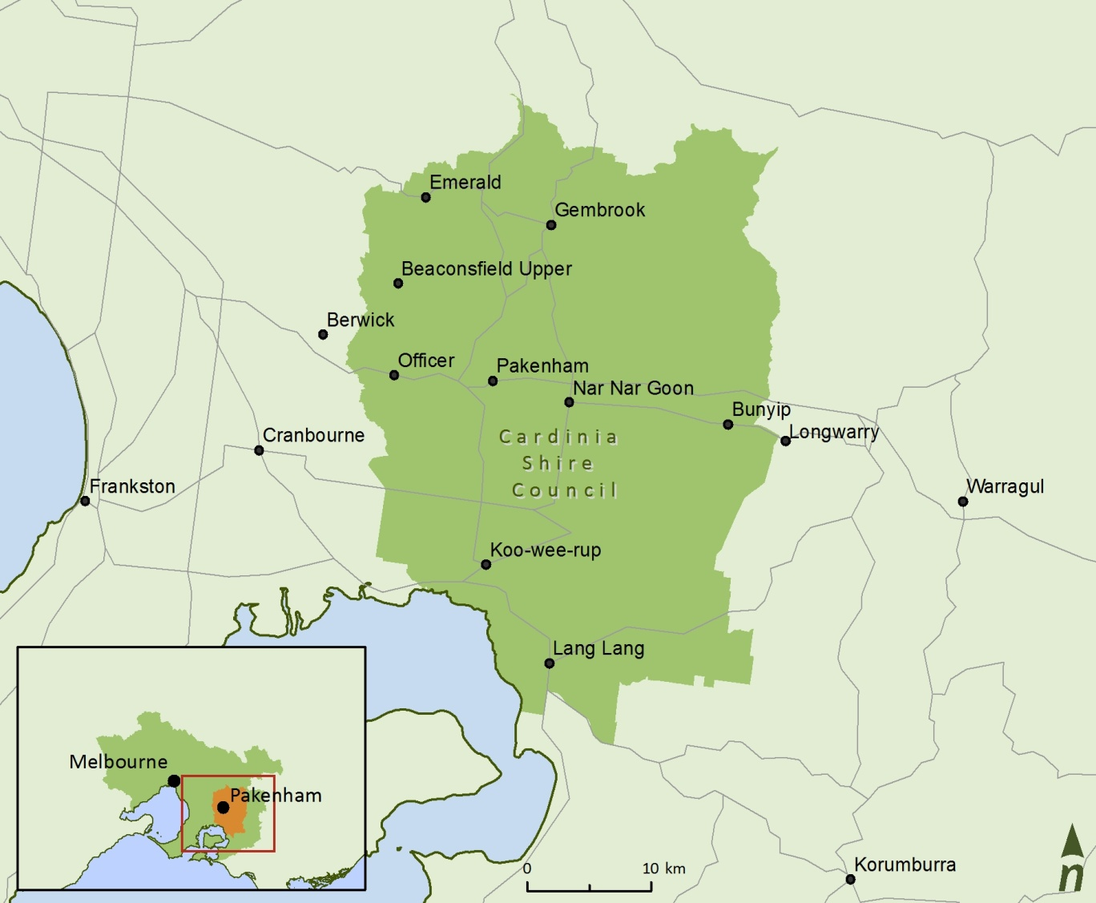

1. Study area in greater Melbourne

Council’s commitment to reducing both potable water consumption and improving stormwater quality within the shire is outlined within the *Council Plan 2014–17*. It also identified an Integrated Water Management Plan (IWMP) as the most appropriate way to achieve these outcomes. (Cardinia Shire Council, 2013). There are several drivers behind the Council’s IWMP illustrated in Figure 3.

1. Drivers for Council’s IWMP

## Aim and objectives

The development of an IWMP was a recommendation of Council’s *Sustainable Water Management Plan* (2010). The aim of this IWMP is:

To deliver a framework that will guide Council towards a more sustainable integrated approach to water management to reduce reliance on potable water and enhance ecological health of receiving waterways (Westernport Bay).

To achieve this aim, the objectives of Council’s IWMP include:

1. **Stormwater:** to quantify and minimise stormwater flows and pollutant loads to the shire’s creeks, rivers and Westernport Bay
2. **Potable water:** to ensure efficient potable water use within Council facilities and encourage the community to reduce potable water consumption
3. **Alternative water sources:** to reduce Council’s reliance on potable water by identifying and utilising alternative water sources
4. **Groundwater:** to contribute to sustainable groundwater management, including exploring the option of alternative water sources for agriculture.
5. **Wastewater:** to reduce the impact of waste water on the environment
6. **Waterways**: to protect the shire’s waterway values and open these assets up to the community.

# Context

## Population and population growth

In 2011, approximately 36,000 people were living within the localities of Pakenham, Officer and Cardinia Road. Just over 70 per cent (72%) of the population who live within what Council terms the growth region are located within the Pakenham precinct. Cardinia Road is home to 22 per cent of the growth region’s population.

Current population distribution is important; however’ it is the shire’s anticipated growth that will have the largest impact on the water cycle in the future. For the purposes of this plan, it is important to understand the nature and location of that growth to link it to potential impacts on water use, surface water quality and environmental values including and local waterways and creeks and Westernport Bay.

Figure 4 provides an insight into projected population growth across the shire over the next 20 years. It demonstrates that population growth is expected to be concentrated within the Officer, Cardinia Road and Pakenham precincts.



1. Anticipated population growth by area (2011–31)

The anticipated timing of population growth is also relevant as this will indicate where the potential water management opportunities will be in future. Population projection data suggests that Cardinia Road will be predominantly built-out by the year 2021. Additional population within Pakenham is likely to be located within the Pakenham precinct which will be significantly built-out by 2026. Pakenham East is expected to grow later in the strategy period (see Figure 5).



1. Population in major growth areas (2011–31)

## Cardinia Shire’s demographics

A summary of the shire’s population and demographic characteristics and projections:

* An estimated population of 90,566 for 2015 (Forecast ID) with an expected increase of 99.29 per cent by 2036 to approximately 180,500 people (Cardinia Shire Council, 2014).
* It is assumed that the number of dwellings in the shire will increase by an average of 1,575 dwellings per annum to 69,213 in 2036 (Cardinia Shire Council, 2014).
* Median age of population across the shire is 34 years old which is three years younger than the average for Victoria and Australia (ABS, 2011).
* Between 2011 and 2021, the age structure forecasts for the shire indicate a 53 per cent increase in population under working age, a 75 per cent increase in population of retirement age, and a 47 per cent decrease in population of working age (Cardinia Shire Council, 2014).
* Employment rates exceed regional and state averages (ABS, 2011).
* Median weekly individual income, household income, and family income is generally in line with Australian averages (ABS, 2011).

## Cardinia Shire’s regions

The shire covers approximately 1,280 square kilometres characterised by three distinct regions: the hills, the growth and the southern rural regions (Cardinia Shire Council, 2013).

The three regions are illustrated in Figure 6 and discussed in greater detail following.

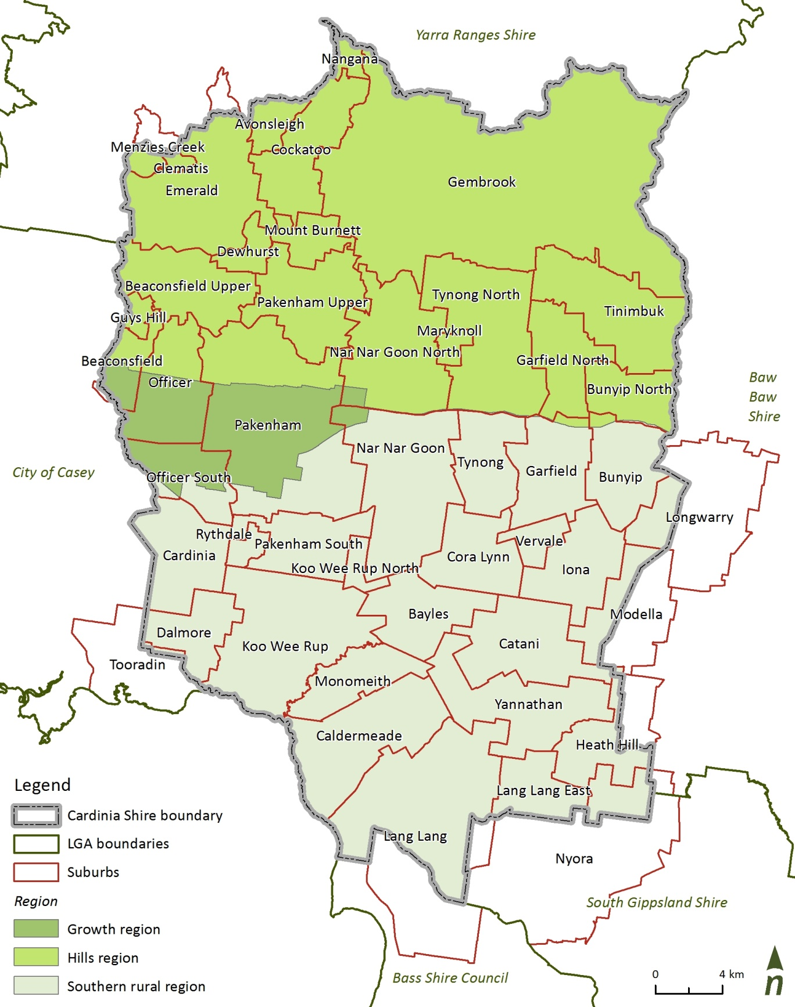

1. The shire and its surrounding municipalities

### Hills region

The shire is bounded to the north by the Dandenong Ranges comprising the suburbs of Gembrook, Cockatoo and Emerald. Land use within the hills region is predominantly rural and rural residential with smaller townships. The region is also home to agricultural activities including dairy farming, orchards, and potatoes particularly around Gembrook.

Some urban growth occurred in these areas in the 1970s with the expansion of the metropolitan area into the Dandenong Ranges; however, the hills region remains relatively sparsely populated. Population in this area has been relatively stable over recent years, and according to Council this stability is expected to continue (Cardinia Shire Council, 2014).

A summary of population and population density within the hills region is provided in Table 1.

1. Hills region population

|  |  |  |
| --- | --- | --- |
| Suburb / region | Population  (2011) | Population density  (people per hectare) |
| Gembrook (including the Bunyip forest) | 2,000 | 0.1 |
| Cockatoo and Nangana | 4,300 | 1.36 |
| Emerald and surrounds | 6,700 | 1.13 |
| **Total** | **13,000** |  |

The Dandenong Ranges within the hills region contains significant natural and social assets including Bunyip State Park, Puffing Billy Railway, Gembrook Park, Emerald Lake Park and the Emerald–Cockatoo Recreational Trail.

Cardinia Reservoir, to the south of Emerald, is a critical element of Melbourne’s metropolitan water supply system storing potable water for supply to consumers within the shire and to other councils across the south east of Melbourne. The reservoir is managed by Melbourne Water.

### Growth region

The shire’s growth area is characterised by those areas that have experienced significant growth in recent times or are planning for urbanisation. The growth region follows the Princes Highway and Princes Freeway west–east through the centre of the shire. The growth region was originally populated by graziers and farmers with Pakenham becoming the commercial and service centre for the area. In the 1980s, the residential population began to grow accelerating rapidly from 1991 onwards.

While Pakenham remains the most populated and established urban centre within Cardinia Shire, the growth region can be further sub-divided into nine residential and employment precinct areas. Precinct structure plans (PSPs) have or will be developed for these six areas by Council in collaboration with the Metropolitan Planning Authority (MPA):

1. Beaconsfield (predominantly developed)
2. Officer
3. Officer Employment
4. Cardinia Road
5. Cardinia Road Employment
6. Pakenham
7. Pakenham West
8. Pakenham South
9. Pakenham East

Further detail illustrating the growth within the shire’s PSPs, including population within respective PSPs, is provided in Figure 7.

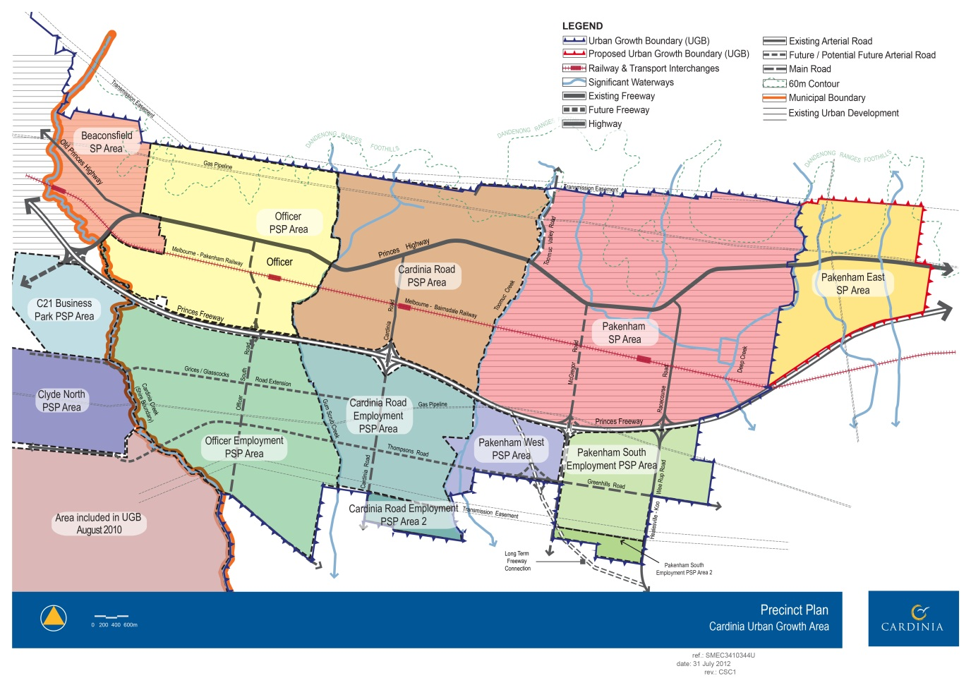

1. Precinct structure plan summary

### Southern rural region

Agriculture represents the major economic and land use activity within the shire’s southern rural region. The southern rural region has been significantly altered as far back as the late nineteenth century as the Koo Wee Rup swamp was drained to open up the region to agricultural activity. The lengths of straight drainage lines that allow the region to be used productively have limited environmental and social value and contribute significant sediment loads to Westernport Bay (Melbourne Water, 2009).

The main townships in the south include Koo Wee Rup that (including its surrounds) is home to approximately 2,900 residents (Cardinia Shire Council, 2013),and Lang Lang (1,300 residents including surrounds) with another 3,000 distributed outside of these centres.

The region produces livestock, vegetables, cut flowers and orchard fruits. Of particular note is the region’s vegetable output. Almost 90 per cent (88%) of Victoria’s asparagus is produced in and around Koo Wee Rup with celery (50%) and leeks (71%) accounting for significant proportions of the state’s output. Within the Casey–Cardinia green wedge, agriculture employs approximately 2,000 people and contributes an estimated $400 million to the local economy making it the most valuable and productive green wedge area in Melbourne (DPCD, 2011).

In recent times the region has experienced pressure from urbanisation and reduced rainfall reliability. In response, Cardinia Shire and Casey councils proposed transferring recycled water 80 kilometres from the Eastern Treatment Plant (ETP) to the Bunyip Food Belt region to provide a climate-independent water source. This proposal relies on Melbourne Water upgrading the ETP to produce water suitable for agricultural irrigation.

# Climate

This section provides a snapshot of the meteorological elements of the water cycle across the shire including: rainfall, evaporation, and evapotranspiration.

## Rainfall

The variation in mean annual rainfall across the shire can be described as three relatively evenly distributed bands. The typical rainfall range across these bands is shown in Figure 8. Each rainfall band represents approximately one third of the shire’s area.

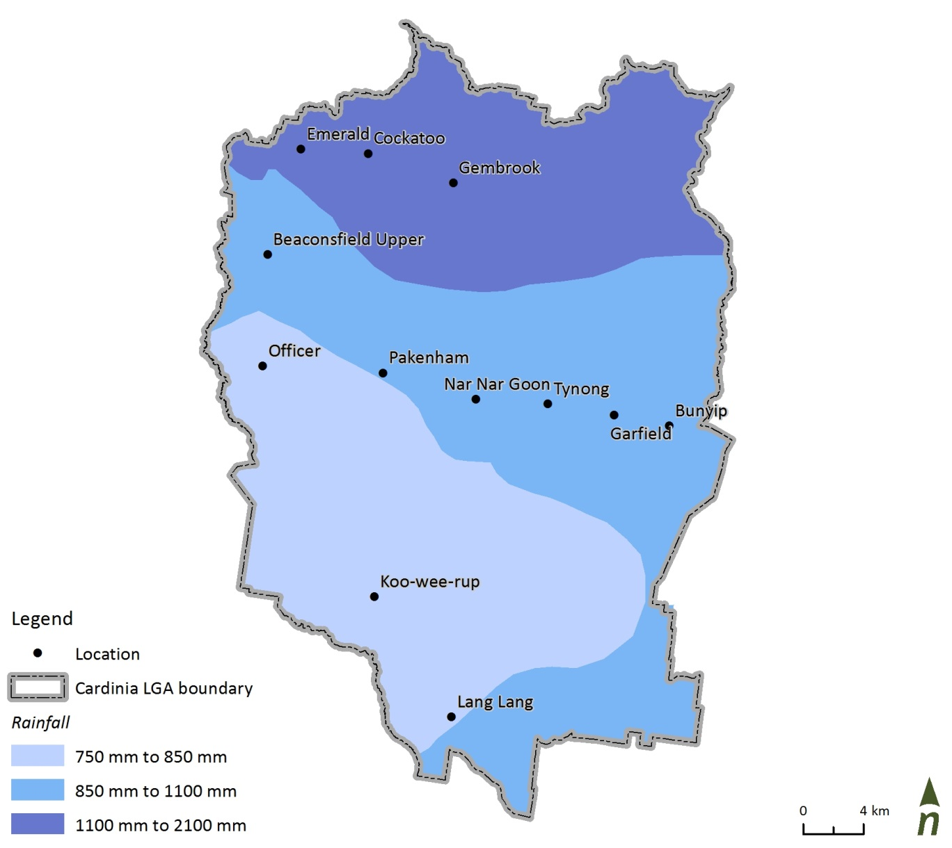

1. Rainfall bands across the shire (Melbourne Water, 2010)

## Evaporation and evapotranspiration

Evaporation refers to the conversion of water to water vapour from a surface of a water body, soil, or plant (BoM, 2013). Its relevance for the urban water cycle of the shire includes the potential for evaporation to influence the level within water holding bodies like ponds or wetlands that may, for example, be associated with stormwater harvesting schemes. Evapotranspiration is a collective term for the transfer of water, as water vapour, to the atmosphere from both vegetated and un-vegetated land surfaces. It is affected by climate, availability of water and vegetation (BoM, 2013). In the context of Cardinia Shire’s water cycle, evapotranspiration is an important factor in the estimation of irrigation demands. Average annual evapotranspiration ranges from 400–600 millimetres (areal actual evapotranspiration) to 1,000–1,200 millimetres (areal potential evapotranspiration).

## Climate change

Climate change has been identified as a significant external driver for Council (and other local government authorities across Australia) to adopt an Integrated Water Management Plan (Cardinia Shire Council, 2013). In doing so, the aim is to create water services and systems that are more resilient and better able to cope with climate variations and anticipated future extremes.

Climate change modelling undertaken by CSIRO indicates a 10 per cent reduction in annual rainfall may be anticipated by the year 2050 under a high emissions scenario (CSIRO, 2013).

To demonstrate the impact a projected 10 per cent reduction in mean annual rainfall may have on the shire by 2050, the reduction has been applied to the Koo Wee Rup rainfall record (see Figure 9).



1. Forecast shift in Koo Wee Rup rainfall distribution (CSIRO projections medium emissions)

The figure above illustrates that, while uncertainties of impacts at the shire scale remain, CSIRO predictions imply that an increased frequency of extreme rainfall and drought events is more likely in future.

Based on discussions with senior CSIRO staff, this is considered a valid method of analysing future rainfall trends (Catchlove, 2013).

The certainty around climate change predictions has increased in recent years. In 2013, the Intergovernmental Panel on Climate Change (IPCC) released the findings from the Working Group’s contribution to the IPCC’s Fifth Assessment Report or AR5 (IPCC, 2013). This report considered new evidence based on independent scientific analyses from observations of the climate system, paleoclimate archives, theoretical studies of climate processes and modelling simulations.

The shire, like many other regions of Australia, can expect increased temperatures, reduced average rainfall, longer periods between rainfall events and more intense events when they occur.

Each of these factors will place pressure on the total water cycle and suggest local and regional planning need to strengthen their ability to meet and cope with these changes.

# Shire’s water cycle

This section provides context and background on specific elements of the shire’s water cycle including: stormwater (volume, quality and treatment), potable water use, wastewater generation, recycled water use, waterway values and groundwater volumes and use.

To establish a dataset and evidence base for Council’s IWMP, a shire-wide pollutant and water balance study was completed. Figure 10 shows the elements of the water cycle that were considered.

1. Elements of the water cycle considered as part of Council’s IWMP

## Water balance summary

The water balance summary is an inventory of water moving through the shire. It is an estimate of the quantity of water entering and exiting the shire through various pathways such as rainfall and evaporation, stormwater that is generated both within the shire and that which enters the shire from upstream, potable, recycled, wastewater, and groundwater stores. The modelling took into account predominant land use types and rainfall bands across the shire to estimate that 356 gigalitres of stormwater exits the shire into Westernport Bay in an average rainfall year. Approximately half of this volume is estimated to be generated from agricultural land use areas. As illustrated by Figure 11 approximately half of the total volume is generated within the shire while the remainder is generated upstream of the municipality.

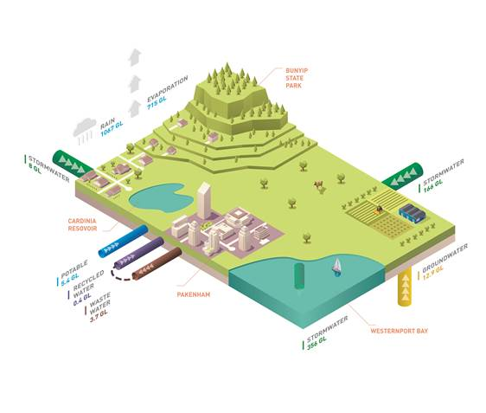

1. Shire’s water cycle and water balance (2012–13)





1. Stormwater volumes by land use source

## Stormwater

Projecting forward, the most significant anticipated change to land use within Cardinia Shire is urbanisation. It is estimated that an additional 25 gigalitres per year of stormwater can be expected within an average year by 2031.

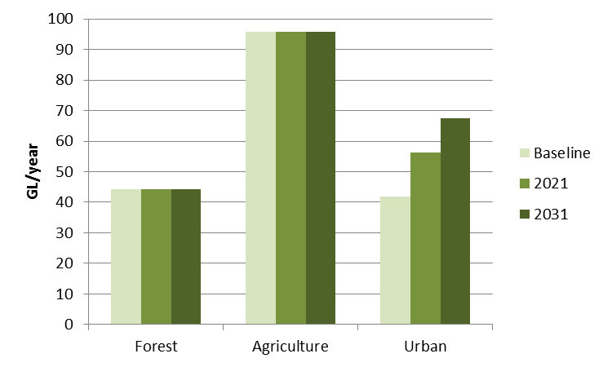

1. Projected stormwater volumes by land use source

Locations within Cardinia Shire where high yields of stormwater can be expected have been modelled in millilitres per hectare per year by suburb and are illustrated in Figure 14. It indicates that central Pakenham has a higher rate of stormwater generation given its higher proportions of impervious areas. Higher stormwater volumes generated within Avonsleigh and Cockatoo in the north are due to those townships being within the highest modelled rainfall band. An urban area, with higher imperviousness was also assumed for the suburb of Avonsleigh.

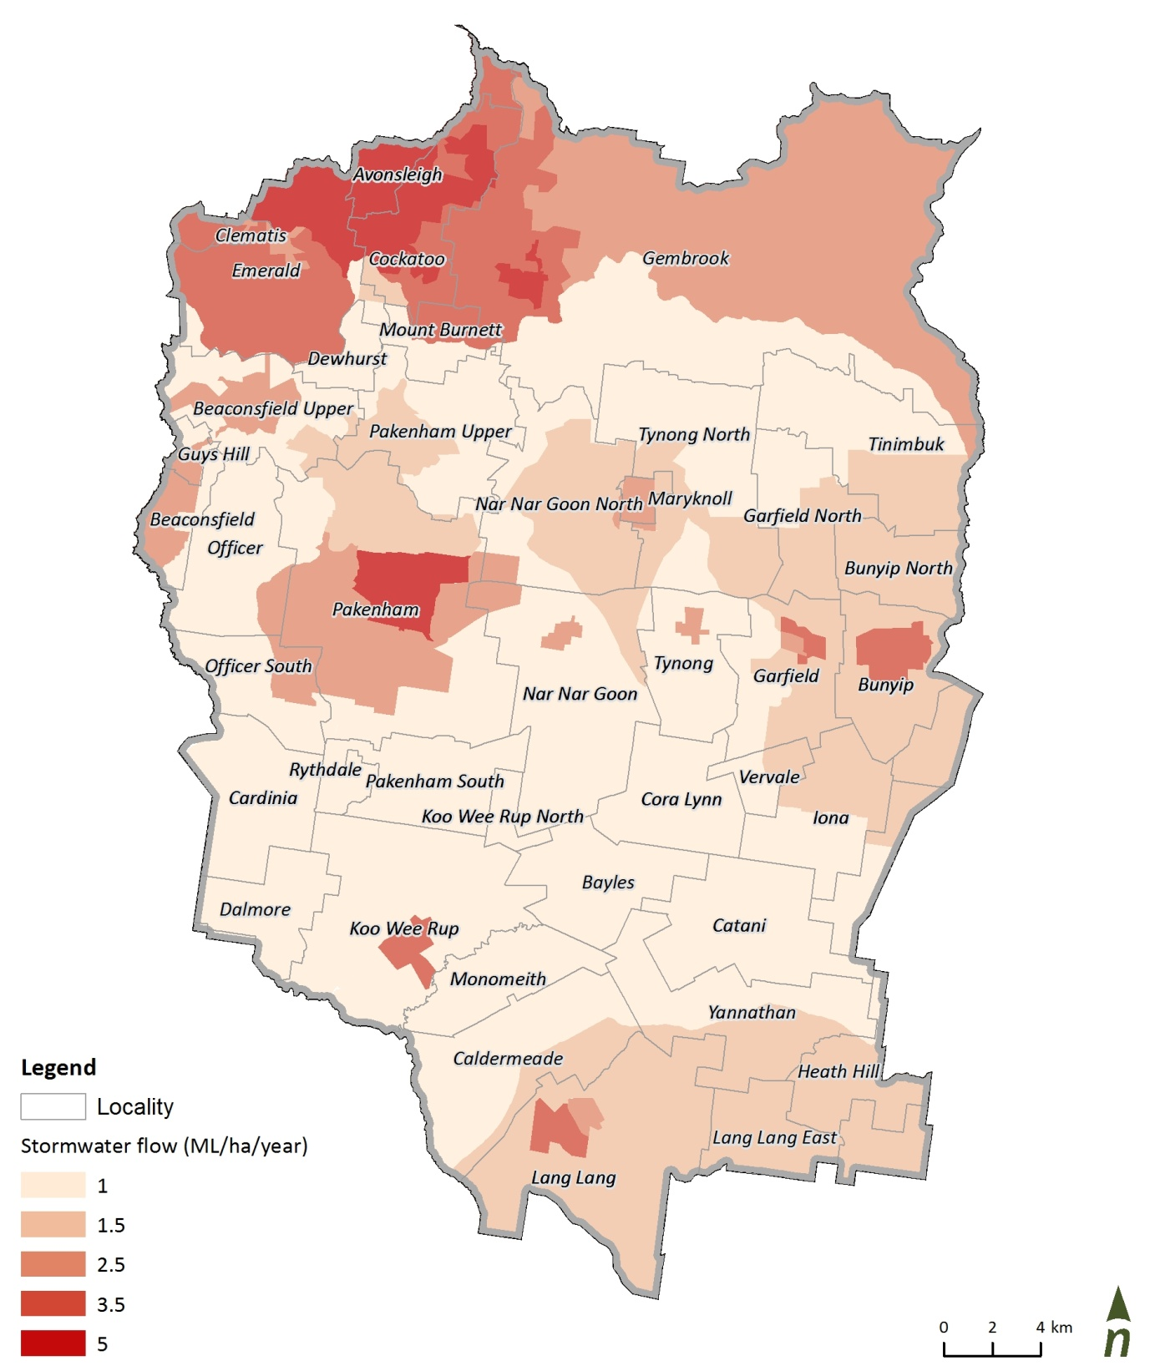

1. Stormwater volumes modelled by locality, base case scenario

Stormwater pollutants originate from different sources distributed across the shire including litter dropped on streets, sediment from streets and building sites, nutrients from agricultural activities and fuel and heavy metals from roadways. Collectively, stormwater flows and the pollutants they carry typically have a detrimental impact on the health of receiving waterways and bays.

Land use is a significant influence on stormwater pollutant loads. The key pollutants of concern from an environmental and modelling perspective include total suspended solids (TSS) that refers to the weight of particles in the water column. TSS is an issue when sediment is deposited within receiving waters obstructing natural ecological processes including photosynthesis. Total nitrogen (TN) and total phosphorus (TP) are nutrients that contribute to reduced concentrations of dissolved oxygen in water, limiting the oxygen available for other organisms and encouraging algal blooms.

Typical concentrations of these pollutants, according to land use have been adopted from Melbourne Water (2010). Modelling results based on 2014 land use estimates for average annual discharge of TSS, TN and TP across the shire are summarised in Figure 15and Figure 16..

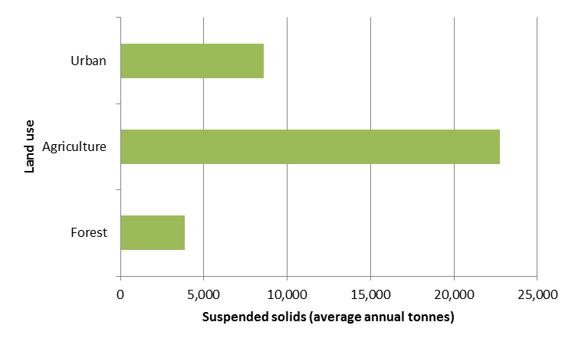

1. Annual TSS loads by land use across the shire

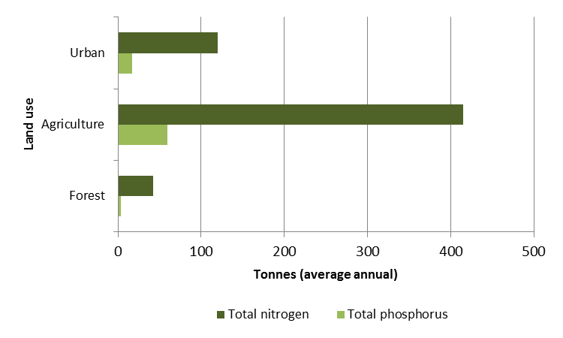

1. Average annual TN and TP loads by land use across the shire

Results of stormwater modelling show that urban areas make up approximately 2 per cent of the Westernport catchment but can contribute up to 15 per cent of total suspended solid sediment to the bay. Rural and agricultural land is the largest generator of stormwater pollutant loads contributing up to 85 per cent of sediment loads to Westernport.

### Erosion

Two elements of the pollutant balance that are not accounted for within modelling are the deposition of sediment associated with waterway and drainage channel erosion, and the sediment loads contributed to Westernport Bay from the erosion of clay shorelines, such as in the Lang Lang area.

Research suggests that the dominant catchment source of fine sediment is from channel and gully erosion of the Bunyip and Lang Lang River systems. Annual loads are estimated to be up to 20,000 tonnes from the Lang Lang system, 22,000 tonnes from the Bunyip River and 6,000 tonnes from Cardinia Creek (CSIRO, 2003).

### Flooding

Greater urbanisation leads to more impervious surfaces which increase the chance of stormwater runoff. With a heavy rainfall event, surface runoff levels can exceed the capacity of stormwater entry points. Areas of the shire are subject to flooding during increased rainfall events and projects such as the Deep Creek wetlands can have a mitigating effect due to their ability for flood storage and the subsequent slowing of water moving over the landscape.

The proposed development of Clyde North in the adjoining municipality of Casey is likely to have future impacts on Cardinia Creek flows. These anticipated increased flows are not included in the IWMP data as they have not yet been fully quantified by Melbourne Water. Melbourne Water is the responsible authority for large scale mitigation measures of this type and have committed to further studies on these future impacts. .Council will continue to work in partnership with Melbourne Water to understand the impacts this catchment has on Cardinia Creek.

### Water sensitive urban design

A WSUD inventory for the shire was supplied by Melbourne Water. This data is presented in Figure 17 and shows approximately 70 WSUD assets of varying size and type across the shire. Wetlands and associated sediment ponds are relatively common, particularly along Cardinia Creek and around Pakenham.

Predominantly WSUD assets have been installed by private land developers with ownership ultimately vested with Council. There is currently no data on the treatment performance of these WSUD assets which is not unique for WSUD assets owned by councils across Melbourne.

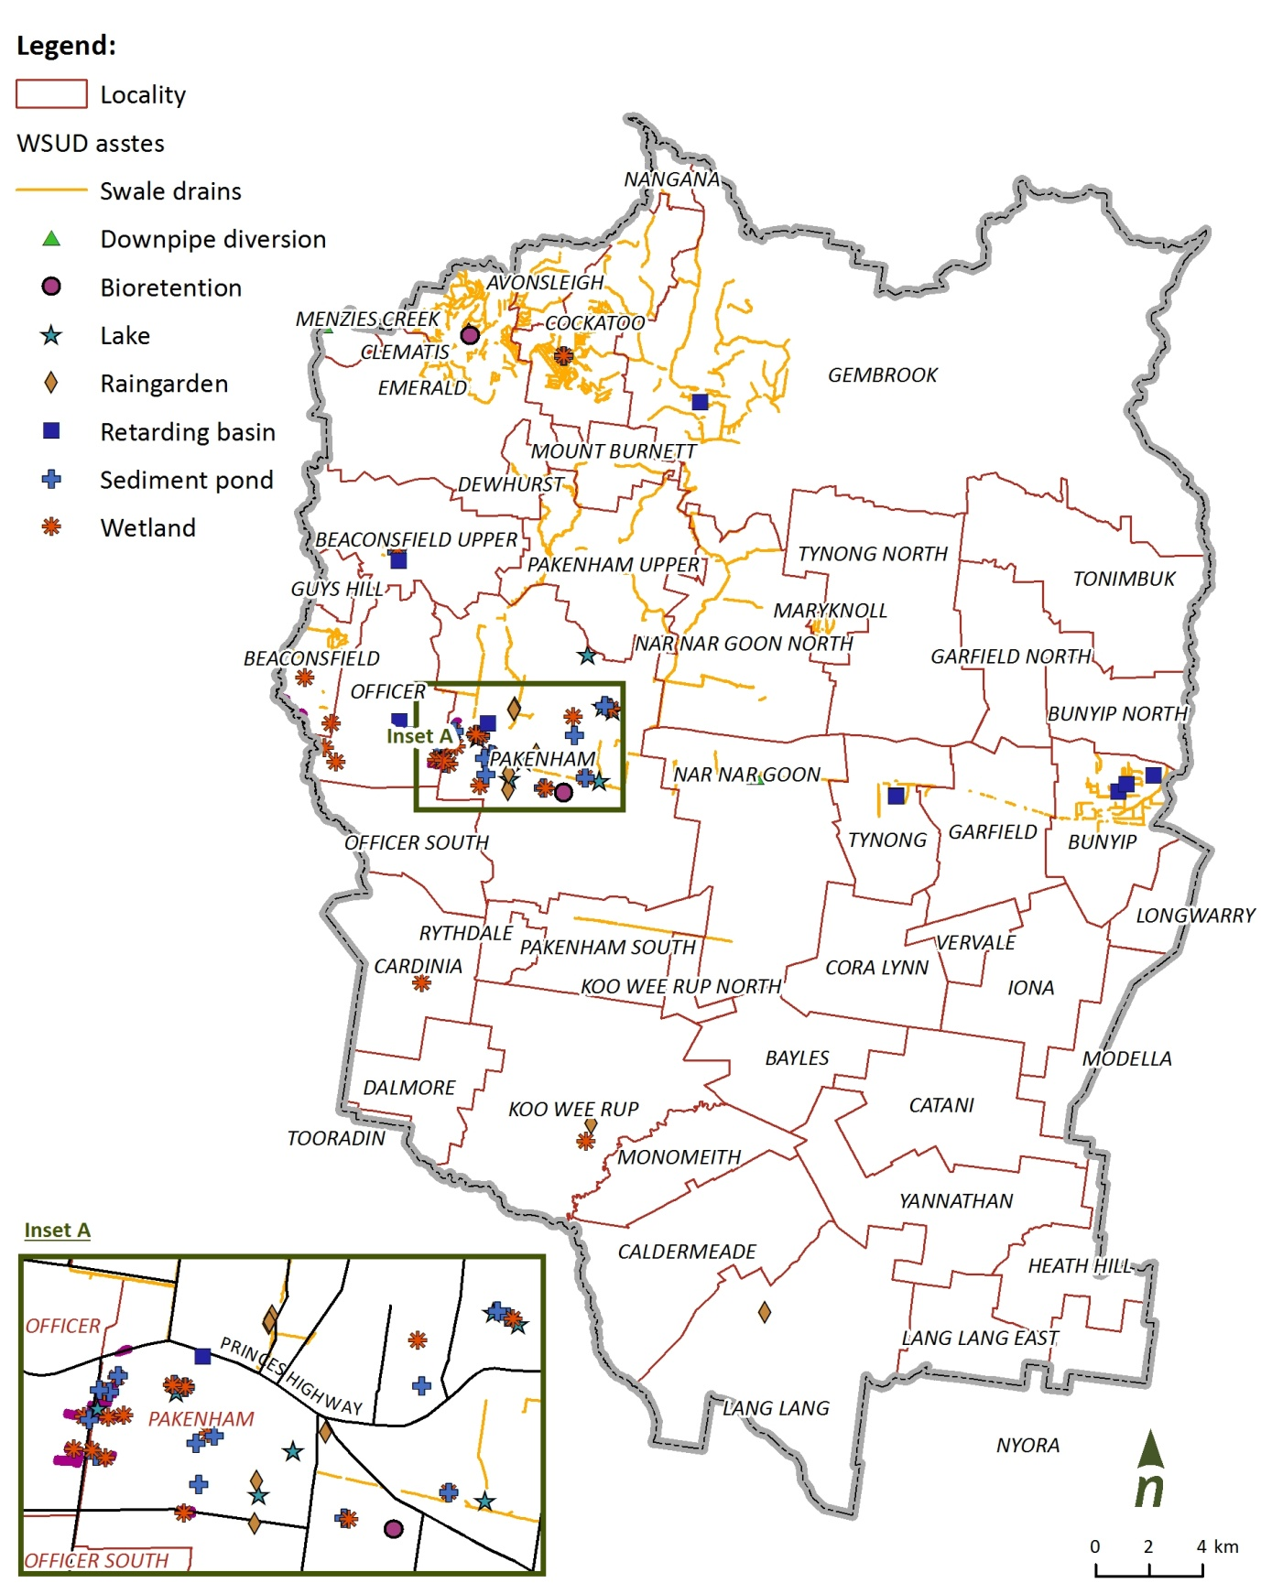

1. Location of WSUD elements across the shire

## Potable water

Potable or drinking water consumed within the shire is stored in Cardinia Reservoir which is sourced from the Thompson and Upper Yarra reservoirs. The Tarago Reservoir and water treatment plant supplies water to the Lang Lang and Koo Wee Rup townships.

The transfer main bringing desalinated water from the Wonthaggi desalination plant meets the existing water network at Berwick before entering Cardinia Reservoir. This transfer main is intended to supply water to both Lang Lang and Koo Wee Rup.

Potable water use was analysed based on five years of water consumption data supplied by SEW and YVW. Figure 18 shows that over two thirds of the total 5.4 gigalitres was consumed by residents while just 1 per cent was consumed by Council’s activities.



1. Water consumption by end use (2012–13)

## Residential water consumption

Water consumption within the shire is measured on a per capita basis to take into account the impacts of population growth (Figure 19). While total residential water use has grown steadily, residential water consumption per capita has remained relatively consistent over the past four years at around 43 kilolitres per person per year. This is however a significant increase from 2008–09 (31 kL/person).

This increase could be explained by Victoria-wide water restrictions which peaked in 2007; a large number of towns were still on Stage 4 restrictions in the latter part of 2009 (DEPI, 2013). Increased water use since then is likely to be associated with higher rainfall and subsequent relaxing of water restrictions.

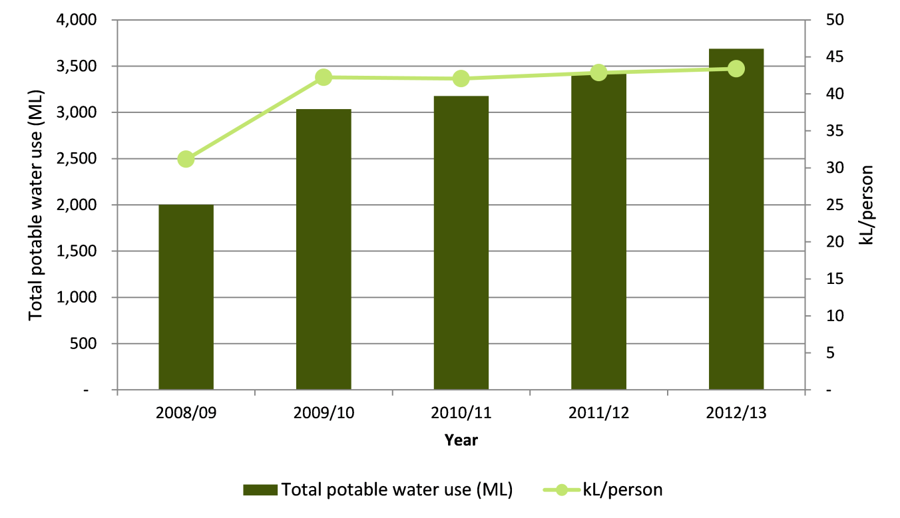

1. Residential potable water consumption (total and per capita)

### Non-residential water consumption

Non-residential water consumption takes into account any industrial and commercial water demands. The past five years of non-residential water use is summarised in Table 2. It shows that potable water consumption has been relatively consistent over that period.

1. Non-residential potable water consumption

|  |  |
| --- | --- |
| Year | Non-residential potable water consumption (ML) |
| 2008‑09 | 1,692 |
| 2009‑10 | 1,557 |
| 2010‑11 | 1,482 |
| 2011‑12 | 1,556 |
| 2012‑13 | 1,692 |

### Potable water use by locality

By breaking down water consumption for the 2012–13 financial year by locality, it is clear that Pakenham is the largest residential and commercial water-using locality. It can be anticipated that water consumption will grow in Pakenham East, Officer and Cardinia Road due to the forecast growth in population. Data from YVW has not been included in Figure 20 due to the small service area that YVW provides.

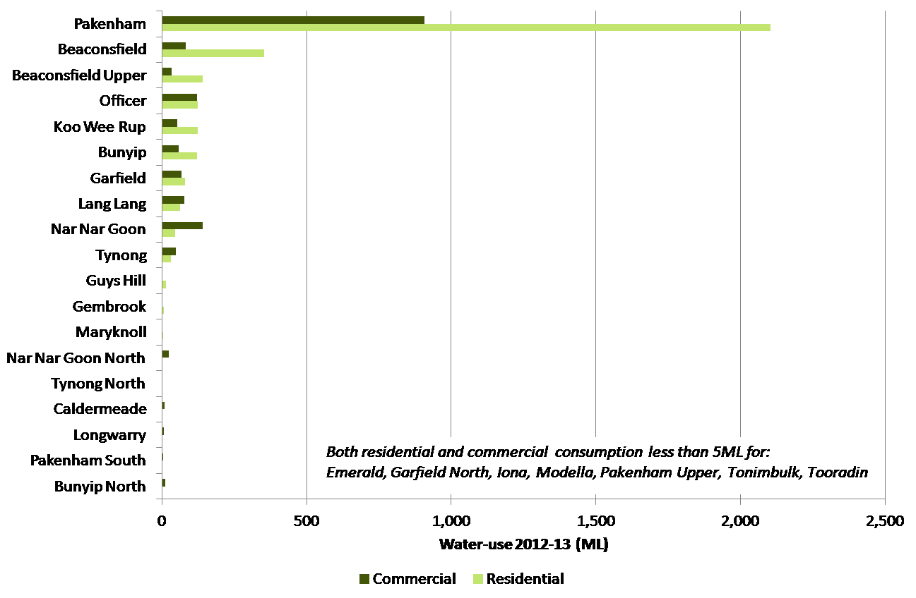

1. Potable water consumption by locality (2012–13)

### Council’s potable water use

Council’s water consumption has been measured on a per community member basis, again to take into account rapid growth in population. The past four years of data (from 2009–10 to 2012–13) are considered a more relevant point of comparison as they are from the same data set, with the first two years from a separate Council water use database.

The data shows a reasonably significant growth in Council water demand on a community per capita basis since 2009‑10. Recalling Council’s 10 per cent community per capita reduction in water consumption target specified in Council’s *Sustainable Water Use Plan* this target is not being met and this trend further suggests that this is unlikely to occur in the future. As previously mentioned, the shire is expecting a large growth in population, therefore a static 10 per cent reduction based on 2009–10 use is unlikely to be achievable. A 1.5 per cent of community use target has been developed as a more reasonable target.

It is likely that the pattern reflects significant growth in high water using services including recreation centres, pools and open spaces. Also, the last two financial years have seen the relaxation of water use restrictions, and therefore there has not been a signal from Victorian Government to reduce water consumption.



1. Council per capita potable water consumption

The breakdown of Council’s water consumption by end-use for the 2012‑13 financial year is shown in Figure 22.

1. Shire water consumption by end-use (2012–13)

The data shows that swimming pools and sporting facilities are the largest users of potable water across the municipality. Significant users of water in this category include Cardinia Life Recreation Centre, Koo Wee Rup outdoor pool and Pakenham regional tennis centre.

Cardinia Life is the largest leisure centre within the shire providing health and fitness facilities as well as three indoor swimming pools. Having identified that swimming pools represent Council’s largest water using category, water use at Cardinia Life was investigated. Cardinia Life consumed approximately 13 megalitres of potable water in 2012–13, representing approximately 23 per cent of Council’s total water use. Rainwater tanks are installed to capture rainwater off the roof at Cardinia Life; however, data on how much rainwater is reused is unavailable.

It should be noted that maintenance of existing facilities uses less water than the construction and establishment of new facilities. A ‘watering in’ period for new initiatives needs to be kept in mind when reviewing Council water use targets and their feasibility long term.



1. Cardinia Life quarterly water consumption (2007–08 to 2012–13)

### Potable water use summary

Residential consumers represent the largest category of potable water consumers within the municipality and this category is expected to grow. It needs to be recognised that Council’s potential to influence potable water consumption is limited; community attitudes are more directly guided by Victorian Government policy implemented by the relevant water retailer.

Council can however support water retailers in delivering water conservation messages and set an example that can lead the community.

A notable omission from the data above is open space. The management of open space (including irrigation requirements) is largely outsourced to voluntary committees of management. These committees manage open space independently and are not required to report water consumption or irrigation behaviours to Council. The water used will be within the non-residential water consumption volumes reported, but currently can’t be quantified separately.

## Recycled water

Recycled water consumed in Cardinia Shire is supplied from the Pakenham Wastewater Recycling Plant (PWRP). This water is often defined by class, with the Class A water produced at the PWRP suitable for residential toilet flushing, irrigation and car washing as well as some industrial uses.

In 2012‑13 Class A water was supplied to approximately 1,300 households within Officer and Pakenham (SEW, 2013). The total recycled water use within the shire between 2011 and 2013 is shown in Figure 24. Recycled water use per household within the shire for 2011–13 is shown in Figure 25.



1. Total recycled water use within shire (2011–12 to 2012–13)



1. Recycled water use per household within shire (2011–12 to 2012–13)

Both of the figures above (Figure 24 and Figure 25) illustrate that the use of recycled water is growing in terms of total and per household basis. Officer has been mandated as a recycled water or ‘third pipe’ area, suggesting that the use of recycled water will increase with urban development over time.

While recycled water provision is managed by SEW, Council can play a role in ensuring that the planning requirements associated with the provision of that service is delivered efficiently and by working with SEW to prepare the community for the appropriate use of recycled water.

## Groundwater

Groundwater is water stored within the aquifers that lie beneath Cardinia Shire. The majority of the shire is located within the Westernport groundwater basin that extends between the Tyabb Fault (on the eastern side of the Mornington Peninsula) and the Heath Hill Fault further to the west (Southern Rural Water, 2013).

The first groundwater bore was sunk for irrigation purposes in 1922. In Cardinia Shire, groundwater is primarily used for crop irrigation. Domestic and stock usage is also significant with approximately 2,000 bores registered for this use. Water levels range from 0.98 metres Australian Height Datum to 71.7 metres Australian Height Datum; the groundwater table is more than 10 metres below ground level in most areas.

The location of groundwater bores across the shire is shown in Figure 26.

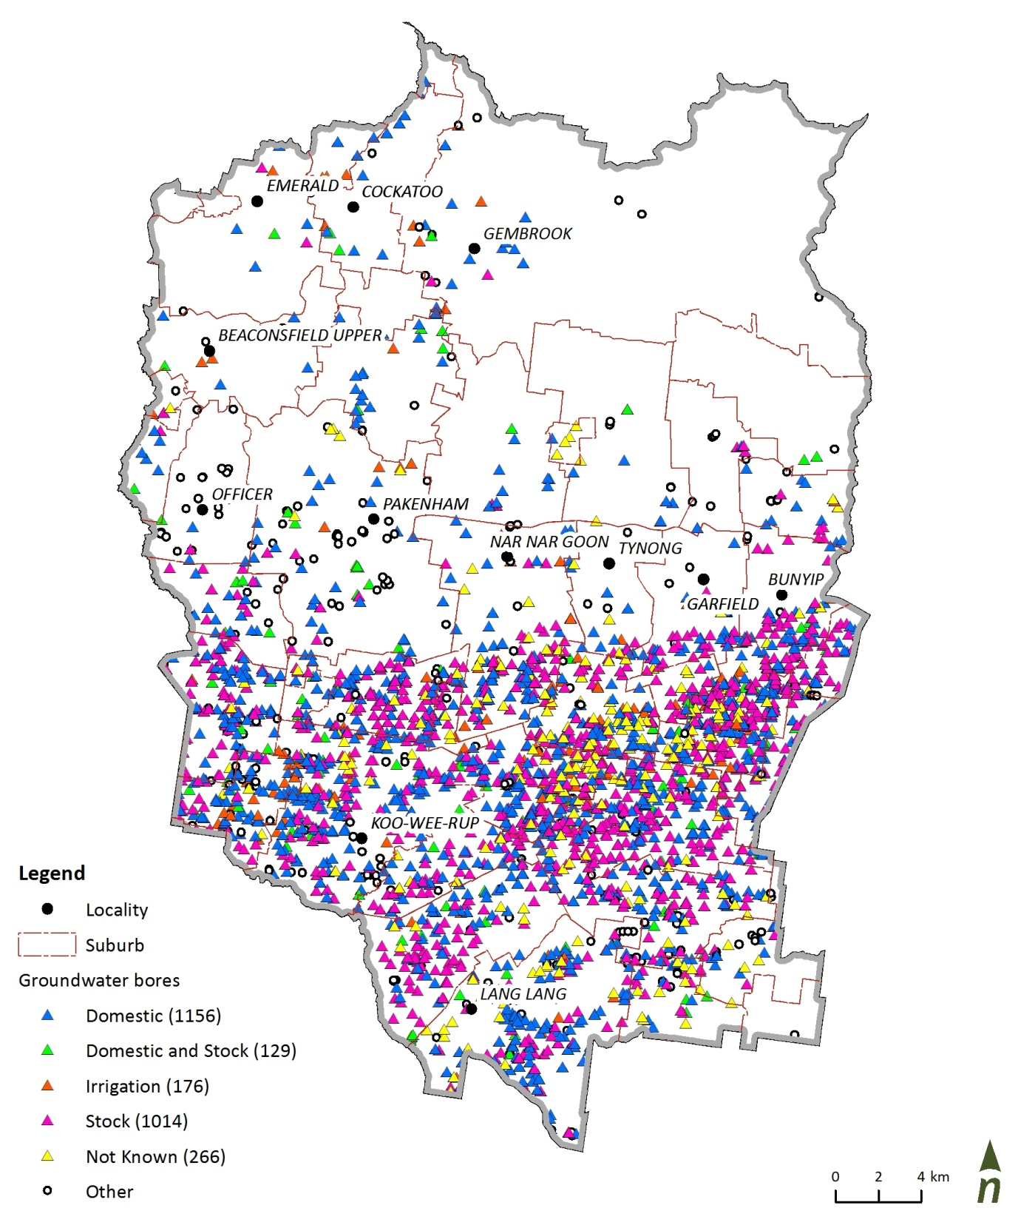

1. Groundwater bores (by type) across the shire

The Koo Wee Rup Groundwater Management Area (that takes in the southern area of the shire) was declared a water supply protection area (WSPA) in 2002 to protect the groundwater or surface water resources through the development of a management plan. The plan defined a permissible consumptive volume (PCV) of 12,915 megalitres per year in 2006. This could be interpreted as the sustainable yield from the aquifer.

Figure 27 illustrates the groundwater balance in the shire today. The first point to note is that licensed allocations well exceed anticipated groundwater recharge. Second, actual usage is significantly below licenced allocations and likely to be below groundwater recharge (or flow in) volumes. This dynamic explains why no new groundwater extraction licences are being allocated; if all allocations were exercised usage would not be sustainable. At current use levels the resource appears to be sustainable.



1. Groundwater balance (adapted from Southern Rural Water, 2013)

## Wastewater

Wastewater services within the shire are predominantly provided by SEW and YVW. SEW business area covers most of the shire; YVW manages the northern region of the shire in the Dandenong Ranges, including Emerald, Cockatoo and Gembrook.

A delineation of their respective service areas is shown in Figure 28. Like potable water, Council doesn’t have direct influence over the generation and management of wastewater particularly within areas with reticulated sewerage infrastructure.

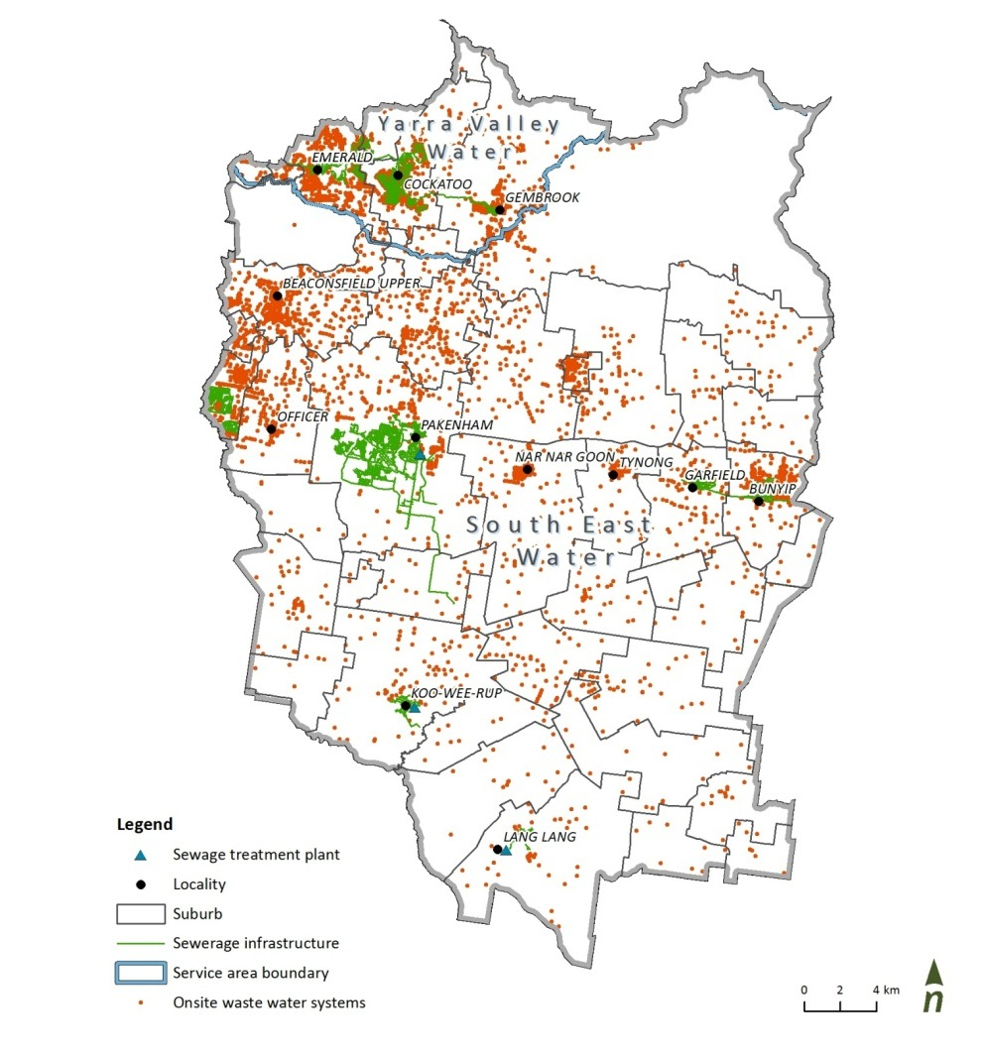

1. Sewerage infrastructure and onsite waste water systems across shire, by suburb

Approximately 10,000 properties have on-site wastewater treatment systems or septic tanks in the shire (Cardinia Shire Council, 2010). Council issues permits for the installation and use of septic tanks on the requirement that the septic tank or other on-site wastewater management system is approved by the Victorian Environmental Protection Authority (EPA).

Properties are included within the YVW or SEW backlog sewerage program if they’re deemed not to be able to contain their wastewater on site. The backlog sewerage program aims to connect these properties to the metropolitan sewerage system.

Consultation with both YVW and SEW indicates that the backlog program has provided reticulated sewerage to more than 1,500 properties in Cardinia Shire. Approximately 1,400 lots are still on the backlog program for connection to sewer between now and 2032–33.

Figure 29 shows the planned backlog sewerage works including the number of lots and proposed timing.

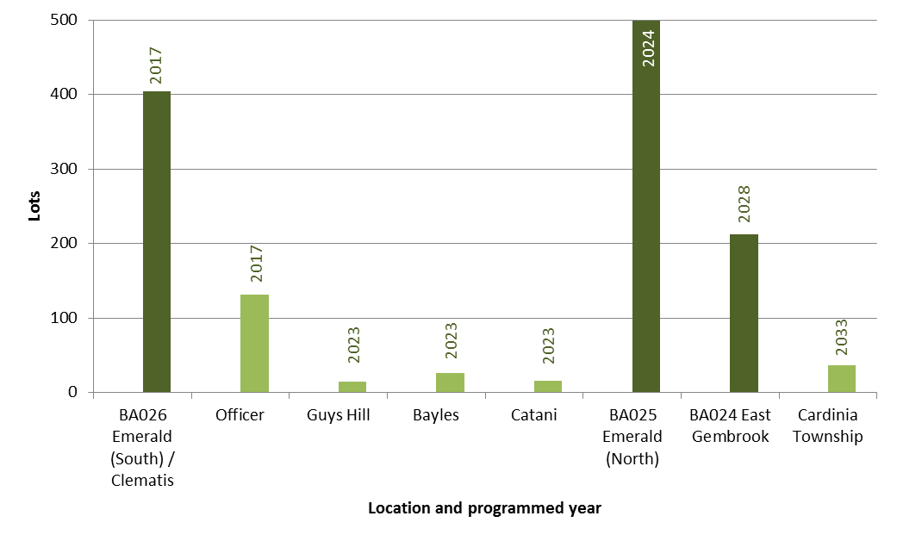

1. Future programmed backlog works by number of lots, location and timing

## Waterways

A number of river systems traverse Cardinia Shire including the Bunyip and Lang Lang rivers and Cardinia Creek. The condition of these river systems reflect historical land use, economic and social decisions that resonate today. It is important to note that while much of the lower waterways have been historically converted to drainage lines, they nonetheless retain many important aspects of natural waterways, such as habitat for endangered species including the Southern Brown Bandicoot and the Australian Greyling.

While Melbourne Water is primarily responsible for managing natural and constructed rivers, creeks and wetlands, Council can influence waterway health, particularly through planning policies and decisions that influence the nature of urban and rural land use within the catchment.

### Cardinia Creek

Cardinia Creek forms part of the shire’s western boundary. The upper reaches of the creek have retained natural vegetation, stream form and good water quality and are home to important environmental values, including fish and frog species and platypus populations. In contrast, and characteristic of a number of waterways in the shire, the lower reaches have been irreversibly modified for flood management, drainage and access. The index of stream condition for this creek in its lower reaches is very poor (Melbourne Water website, May 2013), with particularly poor water quality.

### Bunyip River

The Bunyip River forms part of the eastern boundary of the shire. Much of the upper catchment of the Bunyip River is within state forest with high environmental values and ecologically healthy reaches. The lower reaches (south of the Princes Highway), like Cardinia Creek, are highly modified with the original rivers and creeks now forming agricultural drains. Regardless, the lower reaches still contain priority preservation areas for platypus, bird species and vegetation, noting also that internationally recognised wetland habitats exist where the Bunyip River meets Westernport Bay.

### Lang Lang River

The lower reaches of the Lang Lang River traverse the south-eastern corner of the shire before discharging into Westernport Bay. A significant area of forest and swampland that typified the area prior to settlement has been cleared and drained and the river dredged and channelised. Agricultural land uses are now prominent and stream condition is considered moderate to low.

Figure 30 provides the alignments of these watercourses in the shire, also indicating where future urban development and waterway reaches overlap, creating some risks and opportunities to improve the health of waterways in their lower reaches.

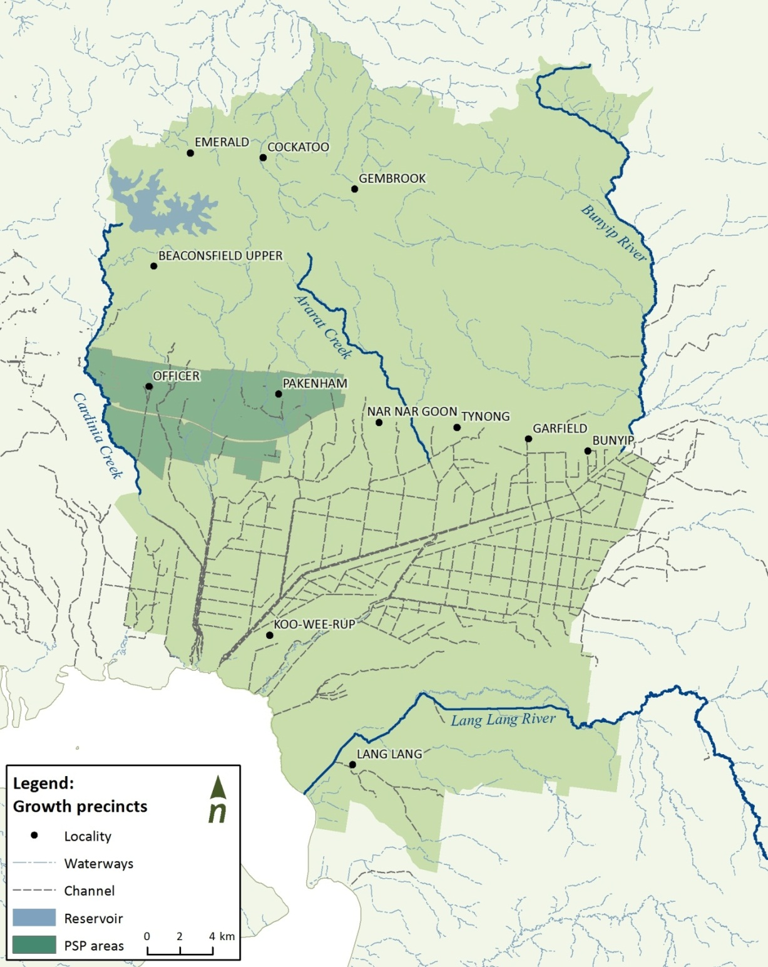

1. Selected waterways and agricultural drains in Cardinia Shire

## Water cycle summary

Taking into account the modelling and references discussed above, some of the key water cycle issues raised are summarised below.

#### Stormwater

* Currently, just over half of the shire’s stormwater comes from agricultural areas. Agricultural land use is also the most significant contributor to pollutant loads to receiving waters.
* Future increases in stormwater will come from the growth region due to urbanisation.

#### Potable water, wastewater and recycled water

* Council’s potable water use is approximately 1 per cent of the shire’s overall water use in 2012‑13.
* Council has significantly exceeded the target (within Council’s SWUP) of a 10 per cent reduction in per capita water use on 2008–09 levels.
* Council has limited direct influence over these streams; however, there is potential for Council to support water authorities in community education and information.
* Council has a more direct relationship with the management of on-site wastewater systems and can assist in the roll out of the backlog sewerage program.

#### Groundwater

* Current groundwater allocations seem to exceed sustainable levels and no further licences are being allocated.
* Current consumption levels seem to be far below licence allocation levels and potentially below estimate recharge volumes, suggesting that current usage rates may be sustainable.

#### Waterways

* Waterways in the shire exhibit a range of conditions. Typically, high ecological and water quality values to the north of Princes Freeway, with poorer conditions to the south.
* The Bunyip and Lang Lang rivers represent the most significant contributors of sediment to Westernport Bay due to bank and bed erosion.
* Melbourne Water is the primary waterway manager. Council has an opportunity to provide support to Melbourne Water to undertake weed control, bank stabilisation and revegetation works.

# Targets and action plan

The targets for Council’s IWMP have been categorised according to elements of the water cycle. They have been designed to take into account the objectives, aspirations, and issues and opportunities identified during consultation. More importantly, they have been designed to take into account where Council is in relation to its IWMP journey and the resources that are available to implement and meet the defined targets.

It needs to be recognised that as a fast-growing municipality, much of Council’s resources are currently dedicated to managing the requirements of growth. In the future, additional resources may be required to achieve some of the actions identified below. With that in mind, the actions have been set out to move the shire toward the targets, while keeping availability of resources over time in mind.

The following section provides targets and actions for the following six key elements of the water cycle:

1. Stormwater
2. Potable water consumption
3. Alternative water supply
4. Groundwater
5. Wastewater
6. Catchments and natural waterways.

## Target and action plan: Stormwater

**Council focus area** Planning and development

**Aspiration** Council will achieve best practice in the adoption and implementation of water sensitive urban design (WSUD)

### Introduction

Urban development will increase impervious surfaces generating approximately 25 gigalitres of additional stormwater per year by 2031, impacting downstream infrastructure, waterways and ultimately Westernport Bay.

It is anticipated that WSUD will be applied to new residential developments in accordance with Clause 56 of the Victorian Planning Provisions. These provisions require targeted reduction in loads of total suspended solids (TSS), total nitrogen (TN) and total phosphorus (TP).

Considering the anticipated rate of development in Cardinia Shire, additional capacity and resources may be required to ensure that the shire can deliver WSUD assets that achieve these reductions.

### Background

An area of approximately 4,000 hectares is planned for residential and employment development within the shire by 2031. Figure 31 shows the anticipated rate of growth by precinct over that period. It shows that the Pakenham precinct is relatively well-established while development within Officer, Cardinia Road and Pakenham East is set to accelerate from 2016, making this a critical time to build capacity in stormwater management and stormwater quality treatment.

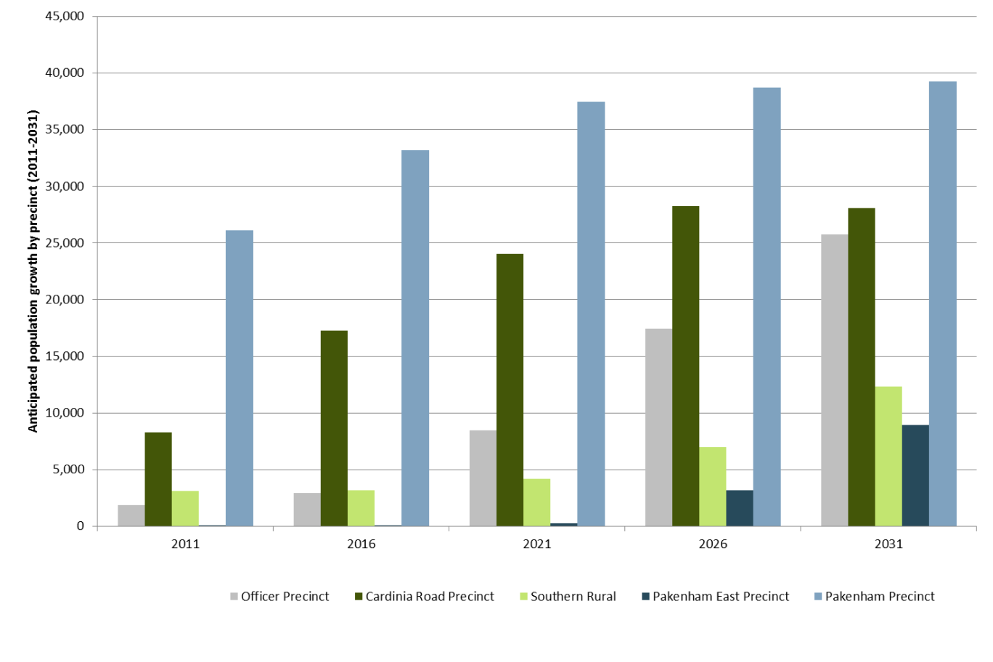

1. Anticipated development of the shire’s residential precincts

Preliminary modelling suggests that of the 182 gigalitres of stormwater currently generated within the shire (in an average rainfall year), 42 gigalitres is from urban areas; this is expected to grow to 67 gigalitres by 2031.

Many municipalities across Melbourne face stormwater volume and quality challenges including how best to implement WSUD. Council is nearer the start of its WSUD journey than some councils and with this in mind, two main challenges have been considered: resourcing and capacity.

Specifically this action aims to guide Council so that:

* staff have the capacity to critically review and evaluate the technical merits of WSUD designs
* assets are constructed to perform as designed
* assets are maintained to achieve optimum performance.

### Opportunity

The opportunity is to build capacity in stormwater management and WSUD so that best practice environmental management (BPEM) targets are achieved across the shire’s development areas.

### Target

**Council:** To build the capacity within Council to implement and maintain WSUD assets to achieve BPEM targets for new developments

**Community:** To educate and inform the community on the benefits of the WSUD assets in their local area and, where possible, engage them in the creation of small scale WSUD initiatives

### Supporting targets

Stormwater quality requirements are specified within the *Best Practice Environmental Management Guidelines* (CSIRO 2006). These targets provide best practice performance objectives designed to meet the Victorian Environment Protection Policy (Waters of Victoria) objectives, particularly relating to beneficial use of waterways. These targets are also required to be met under Melbourne Water’s development services scheme process.

### Stormwater action plan

| Action | | Timing (Financial year) | Responsibility | Estimated cost or resource | Funding or partnership |
| --- | --- | --- | --- | --- | --- |
| 1 | Engage with Melbourne Planning Authority in the 'whole of water cycle assessment' (WOWCA) process for Cardinia Shire’s PSPs to identify optimum water management solutions | 2016‑17 (ongoing) | Strategic Planning (Growth Areas) | Ongoing officer time | MPA, DEWLP, SEW & MWC. |
| 2 | Review and adopt updated WSUD guidelines for Cardinia Shire. Run a lunchtime presentation summarising the content of the guidelines and collate questions to inform training needs | 2016‑17 | Infrastructure Services (Development) | 5 days of officer time | MW |
| 3 | Consult with providers regarding stormwater management and WSUD training options. Agree on training needs, content, numbers of trainees and estimate budget. | 2017‑18 (ongoing) | Infrastructure Services (Development) | Budget TBD following consultation with providers | MW |
| 4 | Identify and complete a community planted raingarden, wetland or similar in a high profile site in a visible location. Engage the local community. | 2018‑19 | Operations (Open Spaces) | $15,000 (based on a 10m2 raingarden) | MW |
| 5 | Identify 2 high profile (i.e. unique, significant due to scale or visible due to high traffic) WSUD sites and install information boards | 2019‑20 to 2020‑21 | Operations (Open Spaces) | $10,000 | MW |
| 6 | Ensure all new WSUD assets being handed over to Council install information boards. | 2016‑17 (ongoing) | Infrastructure Services (Development) | Developer contribution | Internal |
| 7 | Prepare a business case to engage the services of a stormwater management WSUD Officer. | 2017‑18 | Infrastructure Services (Development) | 2 days of officer time | Internal |
| 8 | Review Ecologically Sustainable Development (ESD) Matrix to incorporate stormwater quality and WSUD requirements for new buildings and extension of existing Council facilities. | 2017‑18 | Building and Facilities | 5 days of officer time | Internal |
| 9 | Develop Council specific guidelines identifying the scenarios under which WSUD be incorporated into capital works e.g. taking into account type of capital works, type of WSUD asset, and space. | 2020‑21 | Infrastructure Services (Engineerging) | 20 days of officer time. | Internal |
| 10 | Develop a capital works program to prioritise the installation of sediment pits near key waterways. | 2019‑20 to 2021‑22 | Operations (Operations) | Total project cost $90,000 including  $15,000 for design concept.  $75,000 implementation | MW |
| 11 | Capture ad hoc funding opportunities to carry out WSUD Capital works projects such as design and construct  E.g. Deep Creek wetlands and Henry Road wetlands | 2015‑16  (ongoing) | Infrastructure Services (Engineering) | ongoing officer time | MW |

## Target and action plan: Potable water consumption

**Council focus area:** Water use and alternative water supply

**Aspiration:** Council will use water efficiently within its buildings, recreational facilities and open spaces, sourcing water locally where feasible

### Introduction

Population growth will require Council to develop new facilities and services, some of which will consume significant volumes of water. This action focuses on the efficient use of potable water. It also overlaps with Target 3 by discussing opportunities to use alternative water sources.

### Background

Per capita water consumption has remained relatively steady at approximately 63 kilolitres per person since 2009–10 (based on YVW and SEW data). In 2012–13, Council’s potable water consumption represented approximately 1 per cent of the shire’s overall water consumption. Given that the shire is developing and new infrastructure will be required to cater to population growth, for the duration of this IWMP, a target of 1.5 per cent of community use is deemed to be an achievable target.

Although a relatively small water user, Council can demonstrate leadership in water efficiency and by using alternative water sources when feasible. Council’s water use is dominated by swimming pools and sporting facilities. Reducing reliance on mains water reduces the cost of delivery, operation of the water networks, reduces the size of water treatment infrastructure, and increases savings for Council. When rainwater tanks are included in new residential developments, stormwater infrastructure costs can be reduced.

### Opportunities

* To lead the local community in water conservation.
* To consider reducing potable water consumption in all shire activities where possible.
* To measure and promote water savings made through efficiencies.
* To prepare a prioritised program of water efficiency actions across (see Target 3) key sites.

### Target

**Council:** To stabilise its potable water consumption at 1.5 per cent of shire per capita water consumption

**Community:** To support Victorian Government and water authority programs to reduce residential water consumption

Figure 32 illustrates recent and projected Council water use as a proportion of community use. Based on this data and these trends, stabilising Council’s water use to 1.5 per cent of community water use will be challenging and should be reviewed every two years to understand if the target is still reasonable.

For further information on projected Council water use compared to community use, please see Figure 46 in the appendices.

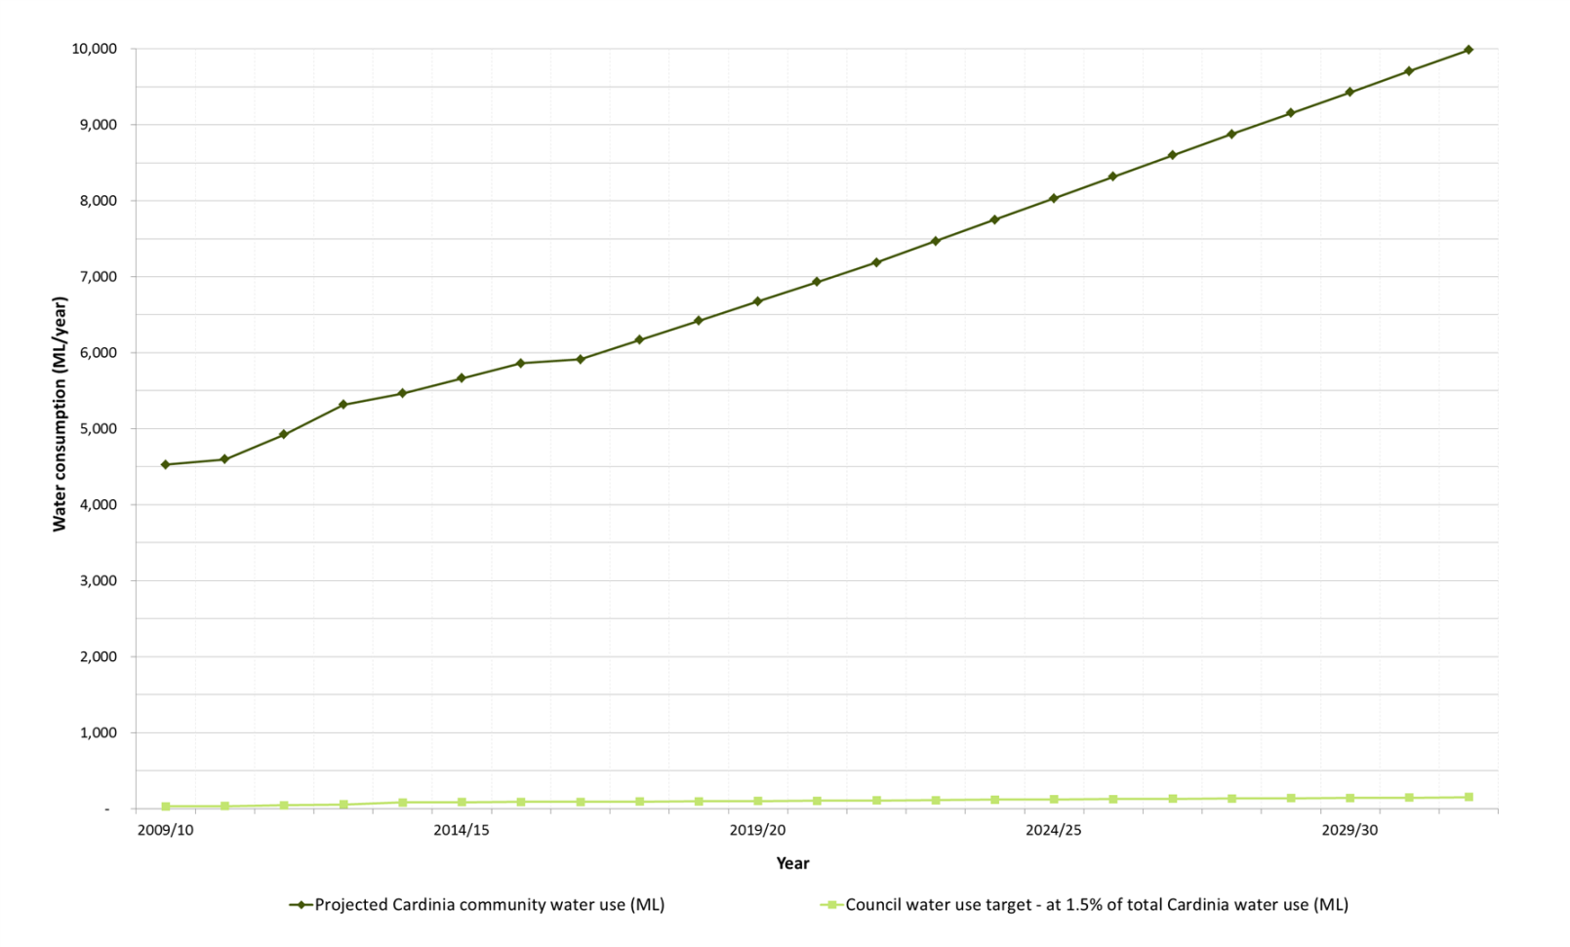

1. Council water consumption target compared to Cardinia Shire consumption (actual and projected)

### Potable water consumption action plan

|  |  |  |  |  |  |
| --- | --- | --- | --- | --- | --- |
| Action | | Timing | Responsibility | Estimated cost or resource | Funding or partnership |
| 1 | Continue to engage with SEW and YVW to ensure that Council and shire water consumption can be received half yearly | 2015‑16 (ongoing) | Environment | ongoing officer time | SEW and YVW |
| 2 | Promote and increase staff knowledge and usage of the ‘sustainable procurement’ column in Finance One when preparing purchase orders. | 2016‑17 (ongoing) | Environment | ongoing officer time | Internal |
| 3 | Complete water efficiency audits at Council’s top three water using sites (including Cardinia Life and Cardinia Cultural Centre). | 2016‑17 | Environment | $150,000 | SEW |
| 4 | Implement the water efficiency saving measures recommended in the water audits at Council’s top three water using sites | 2017‑18 to 2018‑19 | Environment | $576,000 | Internal |
| 6 | For all new recreational facilities, at the planning stage, incorporate a detailed investigation into water re-use opportunities for inclusion in the whole of project scope. | 2019‑20  (ongoing) | Sustainable Communities (Recreation) | ongoing officer time | Internal  MW |

## Target and action plan: Alternative water supply

**Council focus area:** Water use and alternative water supply

**Aspiration:** Council can identify and facilitate the development of feasible alternative water supplies schemes

### Introduction

This target looks at the potential to use alternative water supplies in Cardinia Shire and is applied in two contexts:

1. the potential to harvest and reuse stormwater within new urban developments
2. the potential to develop non-potable water sources to satisfy agricultural demands.

The pressures of population growth and climate change may see the agricultural output from Cardinia Shire become increasingly important, particularly as Australia positions itself as the food bowl of Asia. One critical risk to this may be the reliability of water supplies.

### Background

Agriculture represents the dominant land use and economic activity within the southern rural region of Cardinia Shire. The region has experienced pressures such as urbanisation and variable rainfall. In response to these pressures, the proposed Bunyip Food Belt project examined the potential of transferring 26 gigalitre per year of Class A water approximately 80 kilometres from the Eastern Treatment Plant to irrigate approximately 8,000 hectares across the shire and the adjacent City of Casey.

With the Bunyip Food Belt project, doubts were raised over the timing of the availability of Class A water and, if it was available, the high capital cost of transferring it. This plan proposes investigating an alternative that looks at more local or easier-to-harness sources that can supply Cardinia Shire’s growers. It is hoped that in looking locally, and at a slightly smaller scale, other opportunities may present.

As discussed, it is estimated that new employment and residential areas will generate an additional 25 gigalitre per year of stormwater. Traditionally this would have a negative impact on downstream infrastructure and environments, but may also present as a valuable resource. Add to this additional wastewater being treated at Pakenham STP due to population growth and there may be additional sources that can be harnessed locally.

Figure 33 illustrates the proximity of agricultural precincts in relation to employment precincts in the shire, and therefore potential sources of stormwater.

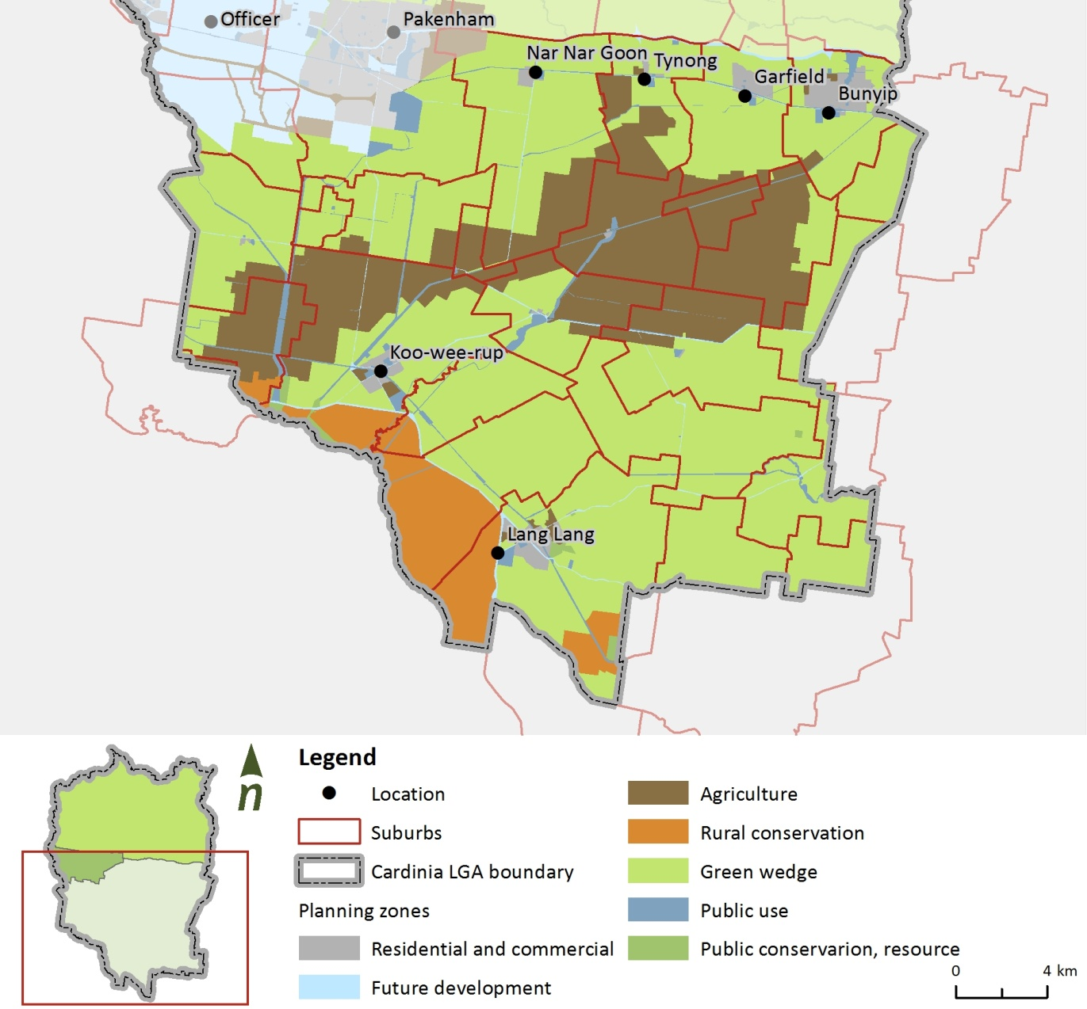

1. Location of agricultural areas in relation to employment precincts

### Opportunity

The opportunity for Council is to identify one or more larger scale, alternative water sources that may present as a lower cost solution to support agricultural activity and productivity in the shire. This scheme would focus only on supplying local producers and aim to identify local water supplies. In this way, it differs from the initial Bunyip Food Belt project that was looking to supply water over two municipalities from one source.

In doing so, Council can utilise background work completed for the Bunyip Food Belt to compare the relative cost and feasibility of other approaches to potentially identify a favourable alternative to transferring future Class A recycled water from ETP.

### Potential alternative water sources

Initial discussions with South East Water and Melbourne Water have identified a number of potential water sources. Some of these may be able to be drawn on, while others may require negotiation with relevant agencies. Possible supply options are summarised in Table 3. It must be noted however, that while surface water flows may be suitable, the environmental flow of each waterway system must be maintained before being considered for irrigation purposes.

1. Potential alternative water sources

|  |  |
| --- | --- |
| Source | Description |
| Surface water (waterways) | Tarago River  Bunyip River |
| Surface water (existing and future retarding basins and wetlands) | Manks Road retarding basin  Browns Road (off Toomuc Creek)  McGregor and Watsons Road (Pakenham)  Deep Creek retarding basin  IYU recreation reserve  New retarding basins related to PSPs |
| Recycled water | Pakenham STP  Koo Wee Rup STP  Lang Lang STP |
| Rainwater | Large roofs e.g. future employment districts |
| Stormwater | Stormwater from progressive urban development within the shire, and particularly employment areas south of Princes Freeway |
| Managed Aquifer Recovery (MAR) | Stormwater injection and recovery using existing infrastructure |

### Target

**Council:** Develop a strategy that identifies potential alternative water sources for Cardinia Shire’s agricultural regions

**Community:** To support Victorian Government programs to use alternative water sources including recycled water and rainwater

### Alternative water supply action plan

|  |  |  |  |  |  |
| --- | --- | --- | --- | --- | --- |
| Action | | Timing | Responsibility | Estimated cost or resource | Funding or partnership |
| 1 | Engage with MPA in the ‘whole of water cycle assessment’ (WOWCA) process that identifies alternative water supply options within new PSPs. | 2016‑17 to 2020‑21 | Strategic Planning (Growth Areas) | ongoing officer time | MPA |
| 2 | Trial the installation of a device such as 'talking Tanks' to manage operation of tanks in Council owned facilities to provide data on rainwater collected and used. | 2018-19 | Building and Facilities | $25,000 assuming internal plumbing | SEW |
| Alternative water supply for Cardinia Shire’s agricultural regions | | | | | |
| 1 | Advocate for alternative water resources for Farmers in the Bunyip Food Belt Area. | 2018‑19 to 2019‑20 | Strategic Planning (Economic development) | 20 days of officer time. | MW and DELWP |
| 2 | Seek in-principle and financial support to progress investigations into a full-feasibility and/or business case of alternative water resource for Bunyip Food Belt | 2018‑19 | Strategic Planning (Economic development) | ongoing officer time | MW, SEW, DEWLP and SRW |

## Target and action plan: Groundwater

**Council focus area:** Water use and alternative water supply

**Aspiration:** Contribute to sustainable groundwater management

### Introduction

The southern portion of the shire overlays the relatively well understood Koo Wee Rup groundwater management area (GMA). As discussed previously, the degree to which groundwater use is sustainable depends on whether measured usage or licenced allocations are being considered. It is evident that licenced allocations exceed likely recharge volumes; however, recent consumption seems to be below recharge volumes and therefore potentially sustainable.

This may be a simplistic reading of the available data and therefore Council and the community may need a clearer understanding of groundwater’s role in the broader water cycle and particularly the conditions under which its use is and isn’t sustainable.

With this information, Council can plan the best way to contribute to sustainable groundwater management.

### Background

Groundwater has four main categories of use in the shire: domestic and stock use; environmental demand; agribusiness; and urban and industrial uses. Most is used for domestic, stock and agribusiness demands. Figure 27above shows the approximate water balance for the Koo Wee Rup GMA, indicating that the licensed allocations outweigh incoming groundwater while current use is likely to be less than inflows.

Council is not a significant groundwater user, although groundwater is critical to local agricultural productivity, being valued at $11.6 million to agribusiness within the Koo Wee Rup GMA. This is approximately half the entire agribusiness value within the Port Phillip and Westernport region.

### Opportunity

The overarching opportunity in relation to groundwater is for Council to better understand its role within the water cycle and therefore how to best use it as a Council, and promote its use and conservation within the Community. The overarching aim will be to contribute to the sustainable use of groundwater over the long term.

Groundwater issues that may be relevant to this understanding include the interaction between surface variations in groundwater quality across the shire (and therefore suitability of end uses), the limits to sustainable use and the potential for allocated volumes to be exercised.

In setting this target, it is recognised that Council does not manage groundwater resources and is limited to having an indirect influencing role.

Managed Aquifer Recharge (MAR) is an opportunity that should be explored because existing infrastructure can be used to supply injected stormwater into the aquifer to the agricultural areas for recovery.

### Target

**Council:** To work with Southern Rural Water to identify groundwater opportunities (use) and impacts (quality) of its use

**Community:** In conjunction with Southern Rural Water, provide information on ground water availability, use, quality and conservation

### Groundwater action plan

|  |  |  |  |  |  |
| --- | --- | --- | --- | --- | --- |
| Action | | Timing | Responsibility | Estimated cost or resource | Funding or partnership |
| 1 | Identify and invite key Southern Rural Water staff to a meeting or series of meetings to discuss groundwater topics that are relevant to the shire including:   * The role of groundwater in the water cycle * The Port Phillip and Westernport groundwater atlas and its implications for groundwater use in Cardinia (including what is sustainable groundwater use in Cardinia Shire?) * The interaction of surface and groundwater and the implications for urbanisation * Groundwater dependent ecosystems in Cardinia * Managed Groundwater Recovery (MGR) opportunities. | 2016 ‑17 to 2017‑18 | Environment | 10 days of officer time | SRW |
| 2 | Engage Southern Rural Water within the MPA’s “whole of water cycle assessment” process to inform groundwater considerations including:   * the impact of development on the surface water / groundwater balance * the role of WSUD and whether this could assist infiltration into the aquifer, * impacts on groundwater dependent ecosystems. | 2016‑17 to 2020‑21 | Strategic Planning (Growth Areas) | ongoing officer time | SRW  MPA |
| 3 | Based on the outcomes of the engagement with Southern Rural Water, prepare Council guidelines that provide a hierarchical use of alternative water sources to groundwater for all Council facilities and reserves (i.e. identifying sensitive areas where groundwater resources are stretched or shouldn’t be used). | 2018‑19 | Environment | 20 days of officer time | SRW |

## Target and action plan: Wastewater

**Council focus area:** Community and public health

**Aspiration:** To reduce the impact of wastewater on the shire’s community and waterways

### Introduction

Reticulated sewerage services are provided by YVW and SEW both of which collect, treat and dispose of (or recycle) wastewater at local sewage treatment plants (STPs), or by transferring flows to Melbourne Water’s Eastern Treatment Plant.

Where reticulated wastewater infrastructure does not exist (i.e. where there is no sewerage main in the street), wastewater is managed by on-site treatment systems (including septic tanks). On-site or lot scale wastewater management is predominantly administered by Council through the permitting of on-site systems and the application of maintenance conditions.

Where properties are assessed as not being able to contain their wastewater within the property boundary (e.g. due to lot size, soil type, rainfall, slope etc.), they are placed on the backlog sewerage program for eventual connection to the reticulated wastewater network.

### Background

While sewerage services are delivered by retail water companies, Council can still play a role in supporting and facilitating the roll out of the backlog sewerage program to ensure that properties that can’t contain their waste within the property boundary are connected to the sewerage system. They can do this by collecting information and data and emphasising the importance of connecting to the sewerage system.

As part of the backlog program, YVW and SEW have sewered over 1,500 properties across the shire. Another 1,400 properties are programmed for connection between now and 2032–33. The locations of completed works and the rate of connection for Yarra Valley Water are provided in Section 6.5.3.

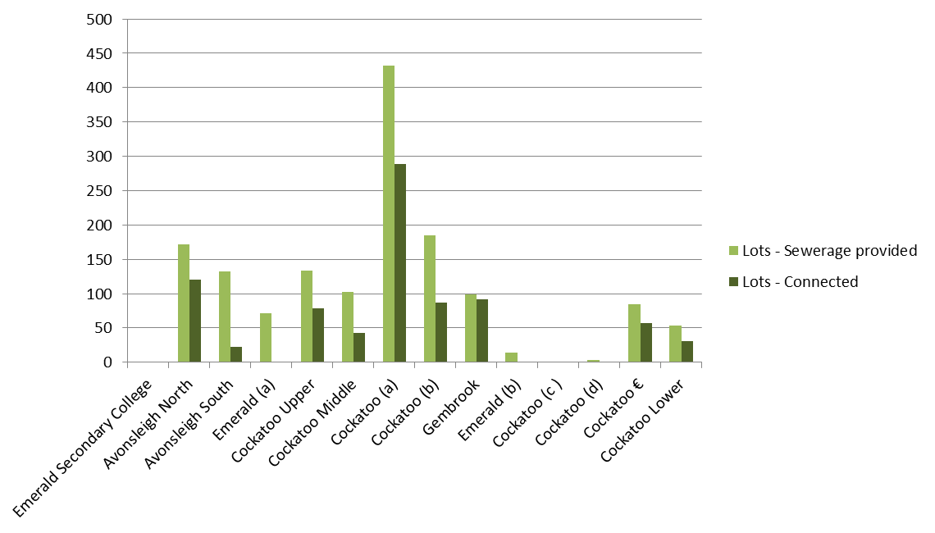

1. Sewerage infrastructure provided and lots connected (YVW area)

### Opportunity

The opportunity for Council is to support the retail water companies as they roll out the backlog sewerage program including in their efforts to engage the relevant communities. Examples of this might include:

* advocating for, where appropriate, the acceleration of the backlog program in certain locations within the shire
* consulting and educating the community regarding the environmental benefits of construction and connection to the reticulated sewerage network
* managing the performance of septic tanks, particularly on lots that are awaiting reticulated sewerage.

### Target

**Council:** Work with Yarra Valley Water and South East Water to ensure as many lots on the backlog program as possible have access to reticulated sewerage by 2031‑32. We acknowledge that this timeframe is outside the scope of the AIWMP; however, these are the water authorities’ timelines for backlog works

**Community:** Support community education programs on the benefits of reticulated sewerage for delivery by the responsible water retailer

### Wastewater action plan

|  |  |  |  |  |  |
| --- | --- | --- | --- | --- | --- |
| Action | | Timing | Responsibility | Estimated cost or resource | Funding or partnership |
| 1 | Meet with YVW and SEW to gain a greater understanding of the prioritisation method for backlog properties and identify any information gaps that could be provided by Council to inform the prioritisation of backlog works. | 2015‑16 | Development and Compliance Services (Health) | 1 day of officer time | YVW SEW and MW |
| 2 | Hold regular meetings with YVW and SEW to discuss the planning and construction of reticulated sewerage works, identifying any local issues that may create barriers or opportunities | 2016‑17 (ongoing) | Development and Compliance Services (Health) | 10 days of officer time | YVW SEW and MW |
| 3 | Work with YVW and SEW to improve connection rates within backlog areas and educate residents regarding the environmental benefits of connection | 2017‑2018 (ongoing) | Development and Compliance Service (Health) | ongoing officer time | YVW SEW and MW |

## Target and action plan: Catchments and natural waterways

**Council focus area:** Waterways

**Aspiration:** To create ‘green and connected corridors’, i.e. open space networks linking waterways, open spaces and the Cardinia community to Westernport Bay.

### Introduction

A number of waterways traverse the shire, exhibiting variable conditions along their reaches. Generally, upper reaches are in good condition while the lower reaches (i.e. south of the Princes Freeway) are typically poor.

Melbourne Water is primarily responsible for the management and condition of rivers, creeks and wetlands. Council can support Melbourne Water’s activities through planning policies and precinct structure plans. Council can also influence the degree to which the community interacts with and values waterways through information and infrastructure.

### Background

Melbourne Water has undertaken many studies on the condition of the shire’s waterways, their environmental values and their impact on the health of Westernport Bay. Identified risks include:

* sediment deposition into Westernport Bay with the Lang Lang River of particular concern due to its high rates of bank and gully erosion that impacts the health of coastal wetland and mangrove environments
* urban development (particularly around Beaconsfield and the Officer employment area) and finding a balance between urbanisation, flood mitigation, habitat protection and community amenity
* segmentation of habitat (particularly that of the southern brown bandicoot).

Melbourne Water’s Community Perceptions of Waterways study (Melbourne Water, 2012) showed that the shire’s resident’s valued and enjoyed the shire’s waterways, felt poorly informed about the health of their waterways and felt conditions were deteriorating. Having said this, there was not a strong recognition between community behaviour and waterway condition.

### Opportunity

Opportunity exists to develop green corridors in the shire. A green corridor is described as having healthy waterway condition, access via walking or bike trails, contributing to habitat connectivity and providing connection to other environmental assets in the shire including Westernport Bay.

In expressing this broad and long-term vision there are opportunities including working with Melbourne Water to assist in the delivery of its Healthy Waterway Strategy.

The target also aims for Council to look forward to the delivery of liveability and health and wellbeing benefits to the community through greater connection with its waterway and bay assets.

### Target

**Council:** Prepare a vision for green and connected corridors, linking the community to the shire’s waterways and natural assets

**Community:** Work with community and environmental groups to develop green and connected corridors

### Catchments and natural waterways action plan

| Action | | Timing | Responsibility | Estimated cost or resource | Funding or partnership |
| --- | --- | --- | --- | --- | --- |
| 1 | Ensure MW's Healthy Waterways Strategy is considered in the preparation of works and activities programs along waterways | 2015‑16 to 2017‑18 | Environment | ongoing officer time | MW |
| 2 | Engage with MPA (and MW) through their whole of water cycle (WOWCA) process to identify how Council can deliver healthy waterways outcomes within the PSPs process. | 2016‑17 to 2020‑21 | Strategic Planning (Growth Areas) | ongoing officer time | MPA  MW |
| 4 | Hold an internal meeting to discuss developing a vision for green and connected corridors in Cardinia.  The meeting will focus on:   * What is the opportunity we are discussing? * What is a green corridor, what does that look like? * Is there a need? If so describe it? * What is the opportunity and has any work been done? (see CEC work on green corridors) * Does this opportunity have one or more internal champions who are prepared to move it forward? If so, what do we plan on producing? | 2015‑16 to 2017‑18 | Strategic Planning (Strategic Planning) | ongoing officer time | Internal |
| 5 | Liaise with external agencies to discuss the green and connected corridors vision and how this might complement existing or proposed projects, plans and strategies, | 2015‑16 to 2017‑18 | Strategic Planning (Strategic Planning) | ongoing officer time | MPA, City of Casey, MW, Westernport and Port Phillip Catchment Management Authority, Parks Victoria, Westernport Biosphere. |
| 6 | With the Stakeholder reference Group and interested community groups, develop a formal vision statement including maps that sets out:   * Existing assets and values (including waterways, trails, walking paths, bike paths, regional parks, environmental values and species and habitat locations) * Planned works including high priority areas identified under the Healthy Waterways Strategy * Council and Melbourne Water land that may be able to incorporated into a longer term vision * Identify potential barriers | 2017‑18 | Strategic Planning (Strategic Planning) | 30 days of officer time | Internal with Melbourne Water and environmental community groups. |
| 7 | Identify opportunities for environmental improvements along key waterways as part of planning for green and connected corridors.  For example, vegetation offset requirements associated with large scale development projects including development of a South Eastern Airport. List possible triggers that may provide funding or access to proceed with all or elements of the vision. | 2017‑18 (ongoing) | Environment | ongoing officer time | Internal Units with developers, MW and Environmental Groups. |

# 

# Conclusions and recommendations

The aspirations and targets outlined in this plan have been identified in relation to the six major elements of the water cycle. The proposed targets and aspirations are summarised in Table 4.

1. Council’s IWMP aspirations and targets

|  |  |  |
| --- | --- | --- |
| Water element | Aspirations | Target |
| Stormwater quantity, quality and WSUD | To achieve best practice in the adoption and implementation of water sensitive urban design | Council: To build the capacity within Council to implement and maintain WSUD assets to achieve BPEM targets for new developments  Community: To educate and inform the community on the benefits of WSUD assets in their local area and where possible, engage them in the creation of small scale WSUD initiatives |
| Potable water consumption | Use water efficiently within Council buildings, recreational facilities and open spaces | Council: to stabilise its potable water consumption at 1.5% of shire per capita water consumption  Community: to support Victorian Government and water authority programs to reduce residential water consumption |
| Alternative water supply | To identify and facilitate the development of feasible alternative water supplies schemes | Council: Develop a strategy to identify potential alternative water sources for Cardinia Shire’s agricultural regions with alternative water  Community: to support Victorian Government and water authority programs to use alternative water sources including recycled water and rainwater tanks |
| Groundwater | To contribute to sustainable groundwater management | Council: to work with Southern Rural Water to investigate groundwater use and quality  Community: to provide information to the Community on groundwater availability, use, quality and conservation |
| Wastewater | To reduce the impact of wastewater on Cardinia Shire’s community and waterways | Council: Work with Yarra Valley Water and South East Water to ensure as many lots on the backlog program as possible have access to reticulated sewerage by 2031‑2  Community: work with the responsible water retailer to educate the community regarding the benefits of reticulated sewerage |
| Waterways | To create ‘’green and connected corridors’ i.e. open space networks linking waterways, open spaces and the Cardinia community to Westernport Bay | Council: Prepare a vision for green and connected corridors, linking the community to the shire’s waterways and natural assets  Community: Work with community and environmental groups to develop green and connected corridors for the shire |

Under each target, a number of actions are proposed. A major consideration in developing the action plan and the timing of those actions is an understanding of the capacity and resources available within Council to implement the plan. It is recognised that resources to deliver the IWMP may be limited; however, the shire is growing rapidly with additional resources likely to be required in future to deliver Council services, including those services and actions described in the IWMP.

The targets and actions described in this plan are a mix of shorter term relationship and capacity building activities and more visionary targets that could ultimately transform how the water cycle is managed in the shire. The action timing was carefully considered and concentrates on early and easy wins that engage people across Council or partner agencies and builds momentum toward more challenging actions.

## Partnerships and relationships

A number of the targets recommend actions that build and grow partnerships and relationships. By its nature, the IWMP covers a range of technical and specialist areas across Council business units and partner organisations and those relationships are critical from the perspective of sharing data, participating in shared actions, engaging the community and being aware of future infrastructure plans.

## Capacity building and training

The actions aim to highlight training and capacity building so that there is technical capability to, for example, review WSUD designs, identify alternative water supply opportunities and understand the impact of development on waterway and environmental health.

## Urban growth and PSPs

The shire’s urban growth and how the water cycle is managed will have a significant bearing on the liveability of new developments and the quality of natural assets downstream. The actions encourage engagement in the whole of water cycle process (or similar) facilitated by the MPA to identify the optimal approach to water cycle management. From Council’s perspective, this plan has highlighted the need to be aware of the impact on Westernport Bay, connecting the community to natural assets and identifying alternative sources of water within PSPs.

## Connecting the community to natural assets

Through the engagement process, a desire to connect the shire community to their waterways and to Westernport Bay was expressed; to raise awareness and appreciation of Westernport’s unique environment and values. This can be partially achieved through the PSP process; however, on a larger and longer term scale *Action 6: Catchments and waterways* focuses on connecting the shire’s urban centres to Westernport. This visionary and long-term target will require strong engagement and support from across partner organisations and community groups.

## Alternative water supply

A range of scales at which to provide alternative water supplies exist, from lot, to PSP to suburb or region. While, again, opportunities can be identified through the PSP and WOWCA process, a broader vision to use the shire’s water resources to support its productive agricultural activities is recommended for investigation. This has the potential to take advantage of additional stormwater and roof water generated from new urban development, upgrades to local treatment plants, flood mitigation works and storage and the delivery of desalinated water that may see the Tarago resource available for use and managed aquifer recharge capabilities.

## Monitoring and review

It is recommended that the Integrated Water Management Plan undergo an internal review mid-way (2019–2020) to ensure that the aspirations, targets and actions are still delivering on Council’s vision and are reasonable considering the resources available. If it is the view of the mid-year review that the actions for the final five years from 2021 to 2025 need to be updated to reflect new situations, this can be done at this time, including reviewing Melbourne Water’s progress on mitigation strategies for the Clyde North development. Capacity and training of the responsible teams should also be reviewed at the same time to ensure the successful implementation of the remaining five years of the IWMP.

In addition to the mid-plan review, the 1.5 per cent potable water use by Council goal should be evaluated every two years to determine if this is still a reasonable target given any climatic or legislative changes not foreseeable at this stage. The suggested timeframes for review are set out in Table 5.

1. Timeline and components of IWMP review

|  |  |
| --- | --- |
| Action | Year of review |
| 1.5% per capita water use Council goal | 2016‑17  2018‑19  2020‑21  2022‑23 |
| Internal midway review of entire IWMP and updates for final 5 year actions | 2019‑20 |
| Responsible team/department review | 2019‑20 |
| Capacity and training review | 2019‑20 |
| Final IWMP review | 2024‑25 |

# References

ABS (2011). *2011 Census Quick Stats,* ABS, 2011. Accessed from the Australian Bureau of Statistics website here <<http://www.censusdata.abs.gov.au/census_services/getproduct/census/2011/quickstat/LGA21450?opendocument&navpos=220>> on 24 March 2014.

BoM (2013a). “About Evapotranspiration”. Accessed from the Bureau of Meteorology website here <<http://www.bom.gov.au/watl/eto/about.shtml>> on 14 April 2014.

Cardinia Shire Council (2014). *Cardinia Shire Community Profile*, Accessed from profile.id website here <http://profile.id.com.au/cardinia/home> on 24 March 2014.

Cardinia Shire Council (2013). *Creating the future - Council Plan 2013 – 17*, Prepared by Cardinia Shire Council, Pakenham.

Cardinia Shire Council (2010). *Sustainable Water Use Plan Review.* Report prepared by Water & Energy Savers (Burwood) for Cardinia Shire Council. Document number 1472, version B, 18 April.

Cardinia Shire Council (2006a). *Sustainable Water Use Plan*, Report prepared by Lorraine Nelson (Consultant) with input from the shire Steering Committee for the Cardinia Shire Council, May.

Cardinia Shire Council (2006b). *Domestic Wastewater Management Plan 2006 – 2009.* Prepared for Cardinia Shire Council and adopted on 21 May 2007.

Cardinia Shire Council (2002). *Stormwater Management Plan: Volume 1,* Report prepared by WBM Oceanics Australia for Cardinia Shire Council, November.

CSIRO (2013). “*Australia’s Future Climate”,* Climate change in Australia. Website created by CSIRO in partnership with Australian Government Department of Climate Change and Energy Efficiency and Bureau of Meteorology. Accessed from here <<http://www.climatechangeinaustralia.com.au/futureclimate.php>> on 28 March.

CSIRO (2006). *Urban Stormwater: Best Practice Environmental Management Guidelines*. Prepared for the Stormwater Committee with assistance from EPA, Melbourne Water, Department of Natural Resources and Environment, and Municipal Association of Victoria: CSIRO Publishing.

Dahlhaus P.G., Heislers D.S., Brewin D., Leonard J.L., Dyson P.R. & Cherry D.P. (2004). *Port Phillip and Westernport Groundwater Flow Systems*. Port Phillip and Westernport Catchment Management Authority, Melbourne, Victoria.

DEPI (2013). *Water resource reporting: Monthly Water Report*. Prepared by Victorian Government, Accessed from here <http://www.depi.vic.gov.au/water/water-resource-reporting/monthly-water-report>, updated 3 December 2013.

Department of Planning and Community Development, Westernport Green Wedge Management Plan, 2011

Department of Sustainability and Environment Melbourne, November, 2011. Policy Paper - Improving management of Victoria’s groundwater resources

Hyder (2009), Southern and Eastern Sustainable Water Strategy Region – Factual Groundwater Report

IPCC, 2013: Summary for Policymakers. In: Climate Change 2013: The Physical Science Basis. Contribution of Working Group I to the Fifth Assessment Report of the Intergovernmental Panel on Climate Change [Stocker, T.F., D. Qin, G.-K. Plattner, M. Tignor, S.K. Allen, J. Boschung, A. Nauels, Y. Xia, V. Bex and P.M. Midgley (eds.)]. Cambridge University Press, Cambridge, United Kingdom and New York, NY, USA.

Melbourne Water (2013). *River health – Westernport catchment*. Accessed from <http://www.melbournewater.com.au/waterdata/riverhealthdata/westernport/Pages/Westernport-catchment.aspx> on 10 April 2014.

Melbourne Water (2010). *MUSIC Guidelines – Recommended input parameters and modelling approaches for MUSIC users.* Prepared by Equest Design for Melbourne Water, December.

Melbourne Water (2009). *Water Sensitive Urban Design Guidelines (South East Growth Councils).* Prepared by Parsons Brinckerhoff for Melbourne Water and the shires of Bass Coast, Cardinia, Mornington Peninsula and South Gippsland, January.

OLV (2013). *Melbourne’s Water Future*. Prepared by the Office of Living Victoria, Accessed from here <http://www.livingvictoria.vic.gov.au/PDFs/MWF/MWF_complete.pdf> on 14 April. East Melbourne: December.

SEW (2013). *2013-18 Water Plan.* Developed by South East Water Corporation, Accessed from here <http://southeastwater.com.au/SiteCollectionDocuments/AboutUs/WaterPlan/20132018WaterPlan.pdf> on 10 April 2014. Heatherton: July.

Southern Rural Water (2013). *Port Phillip & Westernport Groundwater Atlas.* Prepared by Southern Rural Water, Maffra.

Southern Rural Water (2010), Groundwater Management Plan, Koo Wee Rup Water Supply Protection Area

Southern Rural Water (2002), GSPA background report, 2002 (SKM)