9 Appendices

Appendix A Existing policy and legislation framework
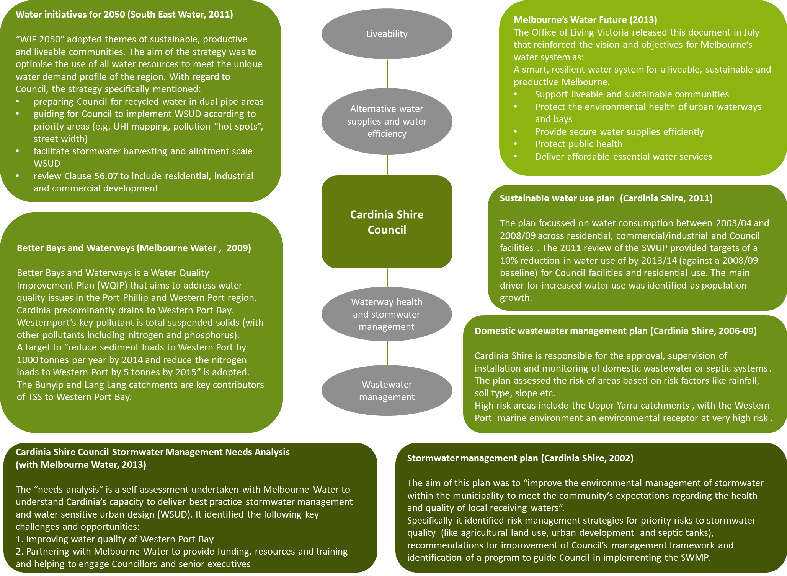
The aim of this legislation and policy review is to set the context for Cardinia Shire’s IWM plan by:
- defining the shire’s role and responsibilities within the water cycle
- describing the operation and relevance of policies, regulations and guidelines; and
- identifying possible IWM partners with shared goals.

Federal
National Water Initiative (NWI) 2004: The NWI is a blueprint for water reform, with all State governments committing to a range of measures to increase the efficiency of Australia’s water use in 2004. The National Water Commission is the independent statutory authority that promotes the objectives of the National Water Initiative (NWI). The ultimate aim of the NMI is to achieve:
- economically efficient water use and related investment to maximise the economic, social and environmental value of Australia’s water resources
- improved environmental water outcomes, including the effective and efficient delivery of water to sustain the health of water-dependent ecosystems of waterways and wetlands.
The NWI encourages water efficiency and the reuse of wastewater and stormwater where cost effective.
Australian guidelines for water recycling (2005-09): produced by the Environment Protection and Heritage Council between 2005 and 2009, the guidelines describe a risk based approach for alternative water supply projects, noting: “it is up to communities as a whole to make decisions on uses of recycled water. The intent of these guidelines is to provide the scientific basis for implementing those decisions in a safe and sustainable manner”.
State
Environment Protection Act 1970 (Victoria): the main objective of the act was to develop a legislative framework for the protection of the environment and the establishment of the Environment Protection Authority (EPA). Regarding water, the EPA has moved toward a risk-based approach to identifying adverse impacts on water bodies and the actions to address those risks. This is consistent with the approach within the Guidelines for water recycling (above), and provides the basis for the environmental quality objectives within the Victorian Environment Protection Policy - Waters of Victoria.
The EPA also provides guidelines for the appropriate use of alternative water supplies.
The Water Act 1989 (Vic): is the core legislation for the Victorian water industry that provides the framework for the allocation and management of Victoria’s water resources. It also defines the functions, rights and obligations of the majority of Victoria’s water businesses. The act aims to encourage:
- the equitable and efficient use of water resources; and
- community involvement in the use, conservation or management of water resources.
Under s 51 of the Act, the Minister is responsible for issuing licences for the use of groundwater. However, the Minister has delegated this power to the three rural water authorities who are responsible for administering the Water Act’s provisions that relate to groundwater. For Cardinia Shire Council, the relevant groundwater authority is Southern Rural Water.
Planning and Environment Act 1987 (Victoria) – Clause 56 (2006): this act provides for the Minister to prepare standard provisions for planning schemes called the Victoria Planning Provisions (VPP). Clause 56.07 (Integrated water management) of the VPP refers to residential subdivisions and is aimed at improving livability and reducing the stress on traditional water sources by supporting recycled water use and meeting stormwater quality objectives set out in the Urban stormwater best practice environmental management guidelines (BPEMG).
Catchment and Land Protection Act 1994 (Victoria): this act applies to the catchment scale and facilitated the establishment of Catchment Management Authorities (CMAs). The aim of CMAs is the protection and restoration of prioritised river systems and reaches (as guided by the Victorian River Health Strategy (VRHS)). Victoria is divided into 10 catchment regions, with Cardinia Shire within the Port Phillip and Westernport CMA.
The Central Region Sustainable Water Strategy (CRSWS): the Central Region incorporates greater Melbourne (including Cardinia Shire). This strategy, released in 2006 (updated in 2007) includes actions and system augmentations to meet the region’s water needs for the next 50 years and was prepared in response to the low rainfall experienced across Victoria at that time and to balance the water needs of urban and rural customers and the environment.
Living Melbourne, Living Victoria (2011): the Living Victoria Advisory Council was established to provide recommendations on reform priorities in the water sector to support the Living Melbourne, Living Victoria policy. The policy supports the consideration of water and urban planning together to enhance urban livability and deliver a more resilient and flexible water services system. The objectives of the policy were to:
- establish Victoria as a world leader in liveable cities and integrated water cycle management
- drive generational change in how Melbourne uses rainwater, stormwater and recycled water
- drive integrated projects and developments in Melbourne and regional cities to use stormwater, rainwater and recycled water to provide Victoria’s next major water augmentation.

This policy statement was followed by the Living Melbourne, Living Victoria, Implementation Plan (2011) that set out the reforms designed to deliver the plan’s objectives to:
- support liveable and sustainable communities
- protect the environmental health of urban waterways and bays
- provide secure water supplies efficiently
- protect public health
- deliver affordable essential water services

Local
Stormwater Management Plan (2002): The aim of the Stormwater Management Plan (2002) or SWMP, was to “improve the environmental management of stormwater within the municipality to meet the community’s expectations regarding the health and quality of local receiving waters”.
Specifically the SWMP included:
- risk management strategies that respond to priority risks in the municipality;
- recommendations for improvement of Council’s management framework to prevent stormwater degradation before it occurs; and
- identification of a program to guide Council in the implementation of the SWMP.
The SWMP adopted a risk based approach to identify the greatest threats stormwater poses to environmental values.
- SWMP risk summary
Risk | Description
Agricultural land | The impact of agricultural land use on stormwater quality due to the transport of soil and nutrients during rainfall events
Residential developments | The impact of the South Eastern growth corridor development on vegetation, sediment and litter generation, both during construction and into the future, including the increased imperviousness of the catchment. Lot scale construction was also identified as having relatively poor controls, contributing litter and sediments to the local stormwater system.
Unsealed roads | Sediment transfer
Septic tanks | Poorly maintained or undersized septic systems can see pathogens, contaminants and nutrients entering waterways and the stormwater system, particularly during storm events
Commercial areas | Commercial land uses within the centre of the township of Pakenham was identified as a stormwater hotspot given the impervious catchment and sediment and litter generated
Major roads | Generating and conveying sediment, litter, hydrocarbons and heavy metals
External and upstream flows | Catchments that are not under Cardinia Shire’s direct control and particularly those where agricultural activities are being undertaken
The SMP also recommended priority management and implementation initiatives such as Council identify specific milestones, objectives enabling benchmarking, and review of the implementation process.
Sustainable water use plan 2011 (Review): The sustainable water use plan 2011 (SWUP) updated the original 2006 document. The plan focussed on water consumption between 2003-04 and 2008-09 across residential, commercial/industrial and Council facilities and the reasons for any changes.
The 2006 plan set a residential and Council water use reduction target of 15 per cent (no commercial/industrial targets were set). Residential and Council water consumption was assessed against a litres per person per day metric to take account of the rapid population growth experienced within Cardinia e.g. there was a 29 per cent increase in properties and 27 per cent increase in population within the municipality between 2003-04 and 2008-09.
The 2011 SWUP review adjusted targets to a 10 per cent reduction in water use of by 2013-14 (against a 2008-09 baseline). This target applied to both Council facilities and residential water consumption and reflected the potential demand reductions identified within the action plan. In summary, the plan identified the following factors that will influence water demand into the future:
- SWUP (review) Risk Summary
Category | Factors | Comment
Residential | Population growth  Property numbers  Water restrictions | Water use bounce back: “If water restrictions continue to be lowered over the coming years, the shire may see a significant increase in residential water consumption due to householders being able to irrigate their lawns and gardens”.
Commercial/Industrial | Increased economic growth associated with increasing population, increased property numbers and increases in production | An increase in residential populations brings an increase in economic and commercial activity. The employment corridor on the southern side of the Pakenham bypass is anticipated to provide jobs for up to 50,000 people bringing an increase in the number of non-residential sites in Cardinia Shire and water demand.
Council activities | Increased property numbers  Increased patrons  Upgrades to newer facilities. | Council facilities achieved a water use reduction of 28% in the plan period. Two sectors that dominate water consumption among council operated facilities are Open Space (35%) and Playing Fields (18%). Water restrictions have a significant impact on consumption associated with these facilities.
Water Initiatives for 2050: an Integrated Water Management Strategy for Melbourne’s South East (2011): South East Water (SEW) released the draft Water Initiatives for 2050 (WIF2050) in September 2011 working with stakeholders Melbourne Water, Southern Rural Water and a 25-member stakeholder reference group. WIF2050 was developed under the themes of sustainable, productive and liveable communities. The aim of the strategy was to optimise the use of all water resources to meet the unique water demand profile of the region, including residential, agriculture and an established and growing commercial and industrial base.
The future of the strategy is unclear; however, the aims and actions within the plan are generally consistent with the objectives of the Living Melbourne Living Victoria implementation plan.
A range of actions were identified within WIF2050. Some specific actions have been identified below that involve Council action and/or engagement.
- WIF20520: Action requiring Council involvement
Action | Description
Preparing for recycled water | Embed nominated recycling areas in Council Municipal Strategic Statements and prepare buildings by regulating the requirement for dual pipe plumbing for new buildings
Facilitating stormwater harvesting | Prioritise the stormwater harvesting opportunities identified within the strategy findings.
Greywater | Support the direct diversion of greywater in areas identified in the strategy findings where the risks are assessed to be minimal by promoting relevant information on risk management
Reducing the impact of stormwater through allotment scale WSUD | “Research has shown that if urban runoff is restricted to an average of no more than 15 additional days per year, compared to pre-urbanised conditions, there is a minimal impact on the health of waterways”.  Undertake a pilot project in a residential greenfield development to demonstrate allotment-scale WSUD within the next 2 years
Improving stormwater quality and liveability through streetscape WSUD | Develop a guide to assist Councils to implement WSUD outlining the relevant criteria such as:  - Identification of priority areas based on UHI mapping  - Identification of pollution “hot spots” 2006-09where WSUD could assist  - Street width and the practicality of implementing streetscape WSUD
Improving rainwater tanks | Encourage the building industry to integrate rainwater tanks within buildings to minimise the aesthetic impact and therefore the liveability in new housing estates.
Existing policy not fulfilling its intent | Review Clause 56.07 within the next 3 years, in conjunction with other regulatory tools such as building standards, to ensure that appropriate Integrated Water Management standards apply to all forms of development including residential, industrial and commercial development.

Better Bays and Waterways: A Water Quality Improvement Plan for Port Phillip Bay and Western Port (EPA and Melbourne Water, 2009) is a Water Quality Improvement Plan that aims to address water quality issues in the Port Phillip and Western Port region. Westernport’s key pollutant is identified as total suspended solids (with other pollutants including nitrogen and phosphorus). The target is to “reduce sediment loads to Western Port by 1000 tonnes per year by 2014 and reduce the nitrogen loads to Western Port by 5 tonnes by 2015”.
The key risks to waterway health in the Western Port catchment are residential growth, major road construction, agricultural run-off and septic tanks. Actions to reduce impacts including planting along the banks of the waterways, improving habitat, removing barriers that hinder native fish migration and protecting threatened flora and fauna (Melbourne Water, 2007c). The report identifies grazing land in the Cardinia Creek catchment contributes high nutrient and sediment loads to Western Port associated with stock access to waterways (Melbourne Water, 2007b)
Bunyip River: The key challenge for Bunyip River is identified as reducing the amount of sediment entering the river by controlling erosion sites in gullies higher in the catchment, as well as along the river itself (Melbourne Water, 2007c). A key water quality issue is high levels of nutrients, organic matter and sediment associated with dairying in the Tarago River catchment (Melbourne Water, 2007b).
Lang Lang: High nutrient loads from grazing land in the Lang Lang River catchment as well as sediment loads to Western Port associated with stock access to waterways and other dry-land grazing practices (Melbourne Water, 2007b). The Lang Lang catchment is identified as the largest generator of contaminants, contributing 29-40 per cent of the total diffuse loads.
Western port catchment: Urban areas make up around 2 per cent of the Western Port catchment, and yet contribute 14 per cent of diffuse nitrogen loads and 15 per cent of diffuse phosphorus loads. Rural land is a significant source of annual diffuse source loads including 76 per cent of nitrogen loads, 76 per cent of phosphorus loads and 85 per cent of sediment loads to Western Port.
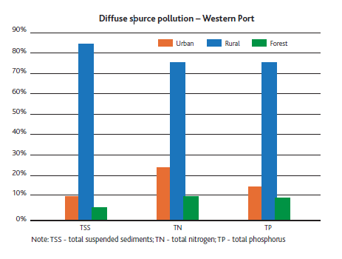
- Source of diffuse pollution (Source: better bays and waterways, Melbourne Water and EPA, 2007)

Sediment: The input of fine sediment to Western Port from tributary catchments has been estimated at 62,000 tonnes /year. The dominant source of fine sediment is identified as subsoil from channel and gully erosion of the Bunyip and Lang Lang catchments (Wallbrink et al., 2003a).
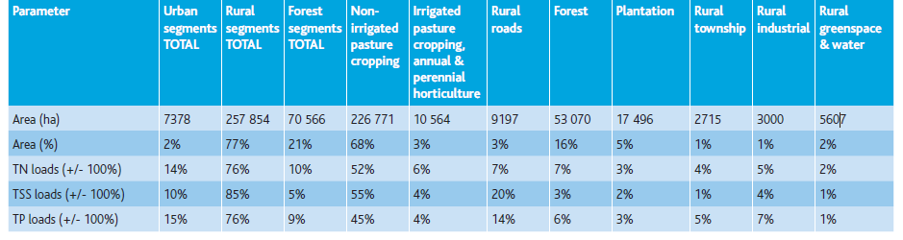
- Source of TSS, TN and TP within Western Port catchments (Source: better bays and waterways, Melbourne Water and EPA, 2007)
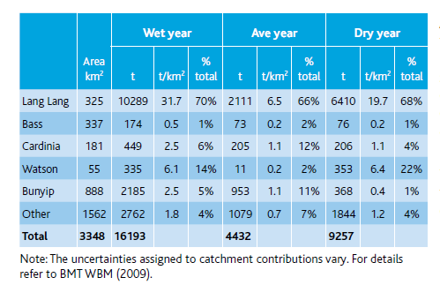
- Total suspended solids loads by catchment (Source: BMT WBM, 2009)
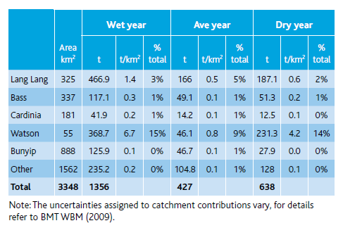
- Total nitrogen loads by catchment (Source: BMT WBM, 2009)

The document identifies urbanisation as impacting waterways and Westernport bay through increased effective imperviousness and “consequent increases in pulse events in waterways”. It is therefore important to apply adequate stormwater treatment infrastructure as parts of new developments
Domestic Wastewater Management Plan (2006-2009): The legislation regulating septic tank systems is the Environment Protection Act 1970 (Victoria). Cardinia Shire Council is responsible for the approval, supervision of installation, and monitoring of septic systems up to 5,000 litres of effluent per day or less i.e. domestic systems. Residents are responsible for the maintenance and performance of those systems. The Health Act 1958 (Victoria) is also relevant but requires more general duties including the prevention of disease, prolonging life and promoting public health.
According to Council’s website there are approximately 10,000 domestic on-site wastewater treatment systems. The public health risks associated with these systems arise when bacterial contamination associated with human waste contaminates drinking water, waters used for recreational purposes or where there is direct human contact with effluent. They also contribute nitrogen and phosphorous to their catchments. Beyond this, there are social implications of poorly maintained onsite systems including odour.
The strategy did assess risk by area based on the following criteria:
Rainfall Risk of flooding Domestic water catchment Soil permeability Depth of water table Distance to water course Slope Soil thickness

- Domestic wastewater risk summary
Area | Risk | Comment
Upper Yarra (Emerald/Avonsleigh, Cockatoo and Gembrook) | Very high | These areas have high rainfall and thin soil profiles. Some systems installed prior to the early 1970’s were permitted to discharge to the stormwater system. Since the time that the management plan was written, wastewater infrastructure has been constructed in this area connecting these areas to the metropolitan wastewater network. The rates of connection to that system however were unknown at the time of writing.
Upper Beaconsfield | High | The area features poor soil permeability, thin soils, relatively steep slopes and high rainfall. Areas with high concentrations of unsewered properties also cause amenity and public health impacts.
Bunyip | High | Poor soil permeability, thin soils and high rainfall.
Nar Nar Goon | High | High rainfall and moderate soil thickness. Flat, with roadside drains tending to pond water. When septic tanks leak to these drains it causes public health issues.

Environmental receptor | Risk | Comment
Westernport estuarine, intertidal and immediate marine environment | Very high | The estuarine, intertidal and immediate marine habitat of Westernport Bay is described as an area of very high environmental value with international geological and geomorphological significance (Cardinia Shire Council, 1999). The saltmarsh and mangrove areas are one of the few remaining examples of this type of landscape in southern Australia (Western Port Regional Planning and Co-ordination Committee, 1992). The impact of septic tanks is associated with the nutrient loads conveyed to these receiving waters.
Westernport Bay | Very high | Westernport Bay is an area with very high environmental values with the bay listed under the Ramsar Convention (Cardinia Shire Council, 1999)
Cardinia Shire, City of Casey and Mornington Peninsula shire: Minimisation of the impact of unsealed roads on stormwater quality, September 2004: The data collected indicates that road surface treatments provide minimal benefits to stormwater quality. Neither wet compaction, dry compaction nor an additional surface layer resulted in a reduction in sediment runoff. As a result, efforts should be focused on improved maintenance of roadside drainage structures and the treatment of drainage water prior to discharge. Focusing on the maintenance of roadside drainage structures and the treatment of drainage water prior to discharge will provide maximum benefits for the environment
Analysis of the road runoff found that unsealed roads generate a large proportion of fine sediment particles. Approximately 60per cent of the sediment collected in runoff was very fine silt and a further 30-40per cent was silt.
During large storms a higher proportion of coarse sediment is produced, most probably because the increased volume and velocity of the stormwater has the capacity to pick-up and transport larger road particles.
An unsealed road network may contribute disproportionate amounts of sediment to the catchment. Only some road sections may have the necessary characteristics to potentially impact on water quality of receiving waters. Identifying these areas is an important step in ensuring cost effective sediment control measures that result in the maximum benefits to the environment.
Cardinia Shire Council Stormwater Management Needs Analysis, “A self-assessment tool to identify stormwater partnership opportunities”, 2013: The Needs Analysis is a self-assessment undertaken with Melbourne Water to understand Cardinia Shire’s capacity to deliver best practice stormwater management and water sensitive urban design (WSUD). The Needs Analysis was undertaken with 38 councils across nine predetermined capacity themes.
- Cardinia Shire Needs Analysis summary
Nine capacity themes | Community  Process Management  Maintenance & Enforcement | Commitment  Interdepartmental Involvement  Champion | Policy & Planning  Implementation Knowledge & Resources
Key drivers and challenges for council | - Improving water quality of Westernport Bay  - Partnering with Melbourne Water to provide funding, resources and training and helping to engage Councilors and senior executives.
Council’s capacity  (summary of a broader list) | - Council committed to undertaking an IWCM Strategy with stormwater targets  - Development of WSUD Guidelines with council specific addenda for internal and external use with the development industry  - Coordinated presentation of residential rain gardens at Koo Wee Rup Water Saving Workshop  - Key council champions regularly attend South East Council Integrated Water Group  - Involvement in Melbourne Water WSUD asset inventory and lifecycle costing programs
Future directions and goals  (summary of a broader list) | - Resource designated officer to drive commitment to water quality and WSUD issues  - Participation at Melbourne Water education programs to increase general awareness  - Include generic media releases or information in Council newsletters or on the website  - Engaging Council management to drive overall commitment  - Improve awareness of and access to available online resources and training opportunities  - Access to a map of locally suitable species for wetlands in order to communicate the information internally, to developers and land owners  - Change Planning Scheme to make WSUD mandatory for Commercial & industrial developments  - Training for new staff on maintenance and lower cost training solution/greater financial assistance.
Opportunities to partner with Melbourne Water | - Directly engage Councilors and senior executives  - Work with Council to develop ideas/ strategies for engaging the community  - Support internal workshops or project design meetings with relevant contacts across council  - Increase capacity across council through co-contributions to strategic and structural projects that deliver multiple community benefits  - Develop an asset register of WSUD assets to aid in monitoring and maintenance  - Enable council Parks and Gardens staff to undertake WSUD maintenance training through Clearwater.

Appendix B – MUSIC modelling details
This appendix discusses the assumptions and details for the MUSIC modelling component of the Council’s IWMP. The approach outlined in Melbourne Water’s MUSIC guidelines has been adopted for the modelling in this project (see Melbourne Water, 2010).
Targets associated with stormwater quality are defined within Best Practice Environmental Management Guidelines (BPEMG) (CSIRO, 2006) as a percentage reduction in loads of typical urban pollutants. These objectives are summarised in Table 6.
- Stormwater management objectives (CSIRO, 2006)
Pollutant | Receiving water objectives | Best practice stormwater management objective
Total Suspended Solids (TSS) | comply with SEPP (e.g. not exceed the 90th percentile of 80 mg/L) | 80% retention of the typical urban annual load
Total Nitrogen (TN) | comply with SEPP (e.g. base ﬂow concentration not to exceed 0.9 mg/L) | 45% retention of the typical urban annual load
Total Phosphorus (TP) | comply with SEPP (e.g. base ﬂow concentration not to exceed 0.08 mg/L) | 45% retention of the typical urban annual load
Litter or gross pollutants | comply with SEPP (e.g. No litter in waterways) | 70% reduction of typical urban annual load
Table 7summarises the MUSIC modelling parameters required for the project.
- Summary of inputs for MUSIC modelling
Parameter | Description
Rainfall and evaporation | Three stations used to account for the distinct rainfall bands across the shire.  Evaporation data for Melbourne will be used for each model as per the MUSIC modelling approach and guidelines.
Time step | A daily time step has been adopted, and is considered suitable for the water and pollutant balance modelling proposed within MUSIC.
Hydrologic routing | No hydrologic routing was employed. Based on discussions with Council staff, this was not deemed necessary for stormwater and pollutant balance modelling.
Soils | The properties of pervious soils specific to Melbourne have been adopted from the MUSIC user manual (Melbourne Water, 2010).
Sub-catchments | The shire had an existing layer with 75 subcatchments, which was considered too fine in scale for this project. A process of reviewing the topography, drainage network, and major tributaries of Dandenong Creek was undertaken to develop a new subcatchment layer. Using local knowledge, Council drainage engineers completed this review and updated the subcatchment layers. These updated subcatchment layers were adopted for this project.
Fraction impervious | Spatial data was acquired from Melbourne Water which identified all impervious surfaces as at 2004. This dataset, which was updated to include minor changes in landuse (and included Eastlink), was used to identify the ‘effective impervious’ fraction. This was achieved by classifying impervious areas that are within a 40 metre buffer from a drainage or waterway.  Fraction impervious values for planning zones in Cardinia were taken from the Melbourne Water MUSIC guidelines. The sub-catchment fraction impervious value was the area weighted average of all planning zones within the sub-catchment which were provided in GIS format by Cardinia Shire Council.

Rainfall and evaporation data
Melbourne Water MUSIC Guidelines (Melbourne Water, 2010) provide contours of rainfall bands for the greater metropolitan Melbourne area and suggest representative sites from which pluviograph data can be sourced. There are three distinct rainfall bands within the shire and this has been taken into account for each within the modelling.
Three interrelated MUSIC models were required to reflect the unique rainfall characteristics of each region. The models were structured so that the outputs can be correlated to each other. For example, a shorter rainfall record, between 1974 and 2010, was adopted. Details of the rainfall inputs for each model are summarised in Figure 5.
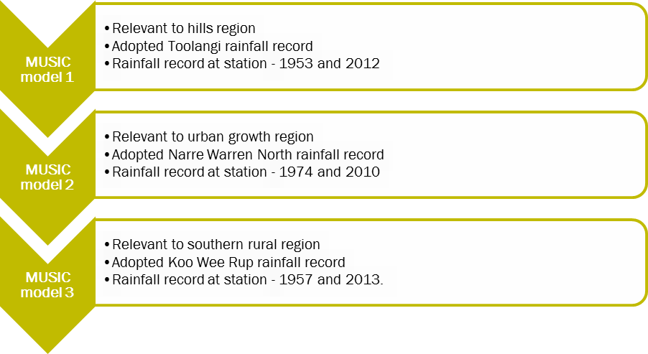
- MUSIC model sequence
Sub-catchments
Sub-catchments within the shire were developed using the following data:
- Primary catchments including: Yarra River, Cardinia Creek, Toomuc Creek, Deep Creek, Bunyip River, Yallock Creek, and Lang Lang River (see Figure 6)
- Catchments being the individual stream catchments developed by Melbourne Water
- Rainfall bands to reflect variations in rainfall data, and
- Major points of interest including: water demand, population growth and infrastructure. These areas included Pakenham, Beaconsfield and Officer townships.
A summary of the MUSIC modelling catchment and sub-catchment details is provided in Figure 6 Error: Reference source not found. Layouts of each of these catchments is provided from Figure 39 to Figure 11 (in these figures, forest nodes are represented as green subcatchments, agriculture nodes are brown, and urban nodes are blue).
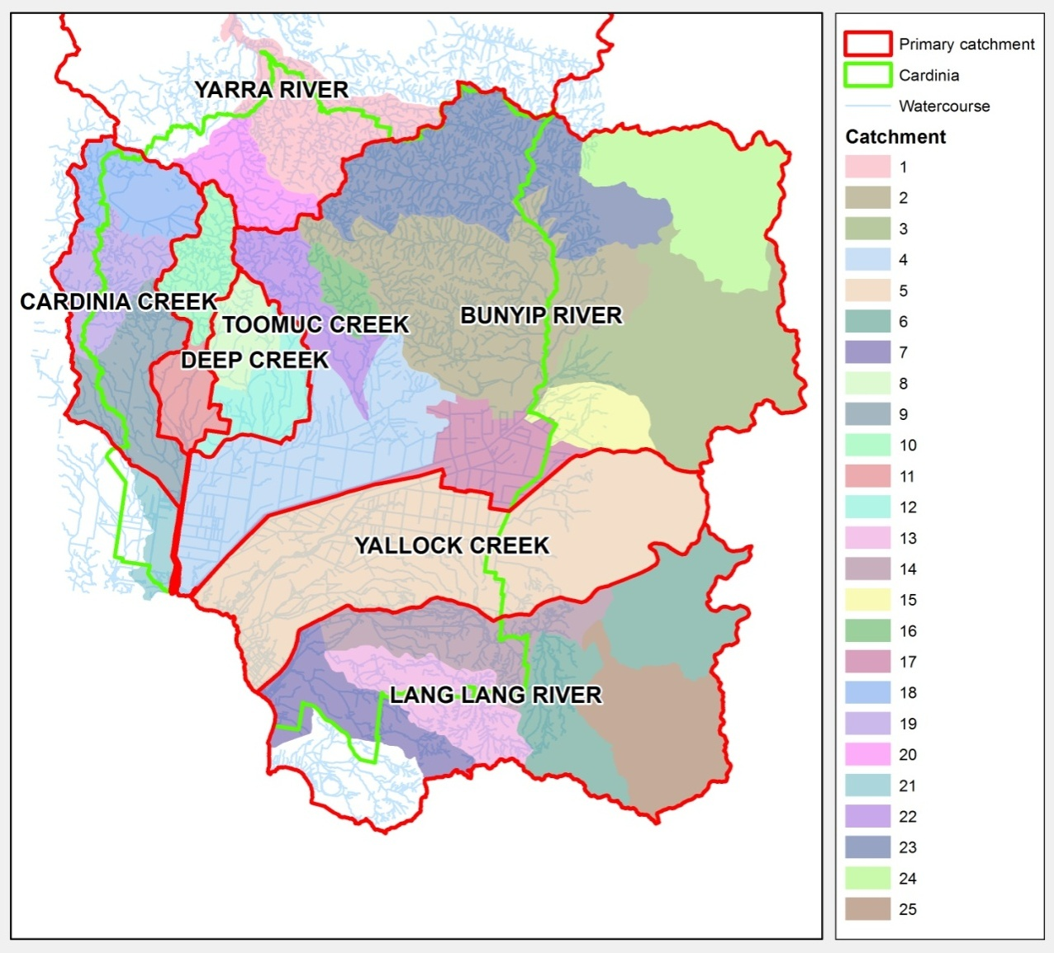
- Primary catchment layers
- MUSIC modelling catchment and sub-catchment details
Catchment | Sub-catchment | Description | Model | Locality of interest | Further details
Bunyip | B-1 | Special use zone – Bunyip food bowl area along Bunyip River to Westernport  Small urban components  Green wedge elsewhere | Agriculture node  Urban node | Part of Garfield (one third of the township)  Tynong  Nar Nar Goon  Part of Koo Wee Rup (not the township)
 | B-2 | Green wedge | Urban node | None
 | B-3 | Small urban component  Green wedge elsewhere | Urban node | Maryknoll
 | B-4 | Special use zone – Bunyip food bowl area along Bunyip River to Westernport  Small urban component  Small farm component  Green wedge elsewhere | Agriculture node  Urban node | Part of Garfield (one third the township)  Part of Bunyip (not the township)
 | B-5 | Small urban components  Small farm zone  Green wedge elsewhere | Agriculture node  Urban node | Part of Gembrook (not the township)  Small part of Maryknoll (not the township)  Part of Garfield (one third of the township)  Bunyip (the township)
 | B-6 | Small farm zone  Green wedge elsewhere | Agriculture node  Urban node | Part of Gembrook (not the township)
 | B-7 | Small urban component  Farm zone elsewhere | Agriculture node  Urban node | Nothing of interest – upstream of Cardinia (township)
 | B-8 | Farm zone  Rural development zone | Agriculture node  Urban node | Nothing of interest – upstream of Cardinia (township)
 | B-9 | Small farm component  Small rural development component  Green wedge elsewhere | Agriculture node  Urban node | None | Reservoir
Cardinia | C-1 | Small urban component  Green wedge elsewhere | Urban node | Small part of Beaconsfield (part of the township)  Part of Officer (not the township)  Small part of Pakenham (not the township) | Future development
 | C-2 | Urban components  Green wedge elsewhere | Urban node | Beaconsfield  Guys Hill  Part of Beaconsfield Upper (the township) | Small future development
 | C-3 | Small urban components  Green wedge elsewhere  Reservoir | Urban node | Part of Emerald (part of township areas)  Part of Menzies Creek  Clematis (township) | Reservoir
Deep | D-1 | Urban components  Farm component  Green wedge elsewhere | Agriculture node  Urban node | Part of Pakenham (part of the township)  Part of Nar Nar Goon (not the township)
 | D-2 | Urban  Green wedge elsewhere | Urban node | Part of Pakenham (part of the township) | Some future urban within existing region (negligible)
Lang Lang | L-1 | Small urban component  Green wedge  Farm zone | Urban node  Agriculture node | Part of Lang Lang (part of the township)
 | L-2 | Green wedge  Farm zone | Urban node  Agriculture node | Part of Lang Lang (not the township)
 | L-3 | Small urban component  Green wedge  Farm zone | Urban node  Agriculture node | Part of Lang Lang (part of the township)
 | L-4 | Farm zone | Agriculture node | None
 | L-5 | Farm zone | Agriculture node | None
 | L-6 | Farm zone | Agriculture node | None
Toomuc | T-1 | Green wedge  Urban zone | Urban node | Part of Pakenham (part of the township) | Future development
 | T-2 | Green wedge | Urban node | Part of Beaconsfield (not the township)  Part of Pakenham (not the township)
Westernport | WP-1 | Small special use zone component – Bunyip food bowl  Green wedge | Urban node  Agriculture node | None
 | WP-2 | Small special use zone component – Bunyip food bowl  Green wedge | Urban node  Agriculture node | None
 |  | Green wedge  Farm zone | Urban node  Agriculture node | None
Yarra | Y-1 | Green wedge | Urban node | Part of Cockatoo (not the township)  Part of Gembrook (part of the township)
 | Y-2 | Urban components  Green wedge | Urban node | Part of Gembrook (part of the township)  Part of Cockatoo (all township)  Part of Emerald (part of the township)  Part of Avonsleigh (part of the township)
 | Y-3 | Urban components  Green wedge | Urban node | Part of Emerald (part of the township)
Yallock | YK-1 | Small urban component  Special use zone component – Bunyip food bowl  Green wedge  Farm zone | Urban node  Agriculture node | Part of Koo Wee Rup (township)

Annual average evaporation and evapotranspiration values across the shire are summarised in Table 9
- Annual average evaporation and evapotranspiration values across shire (BoM, 2013)
Unit | Range (mm) | Description
Average pan evaporation | 1,000 - 1,200 | Applies to an indicative amount of water evaporating from bare ground or open water (i.e. design of local infrastructure)
Areal actual evapotranspiration | 400 – 600 | Applies to a large area of land under existing (mean) rainfall conditions
Areal potential evapotranspiration | 1,000 – 1,200 | Applies to an area so large that the effects of any upwind boundary transitions are negligible and local variations are integrated to an areal average (i.e. greater than one square kilometre)
Point potential evapotranspiration | 1,200 – 1,400 | Applies to an area so small that the local evapotranspiration effects do not alter local air mass properties (i.e. small irrigated fields with a never-ending water inflow, surrounded by unirrigated land)

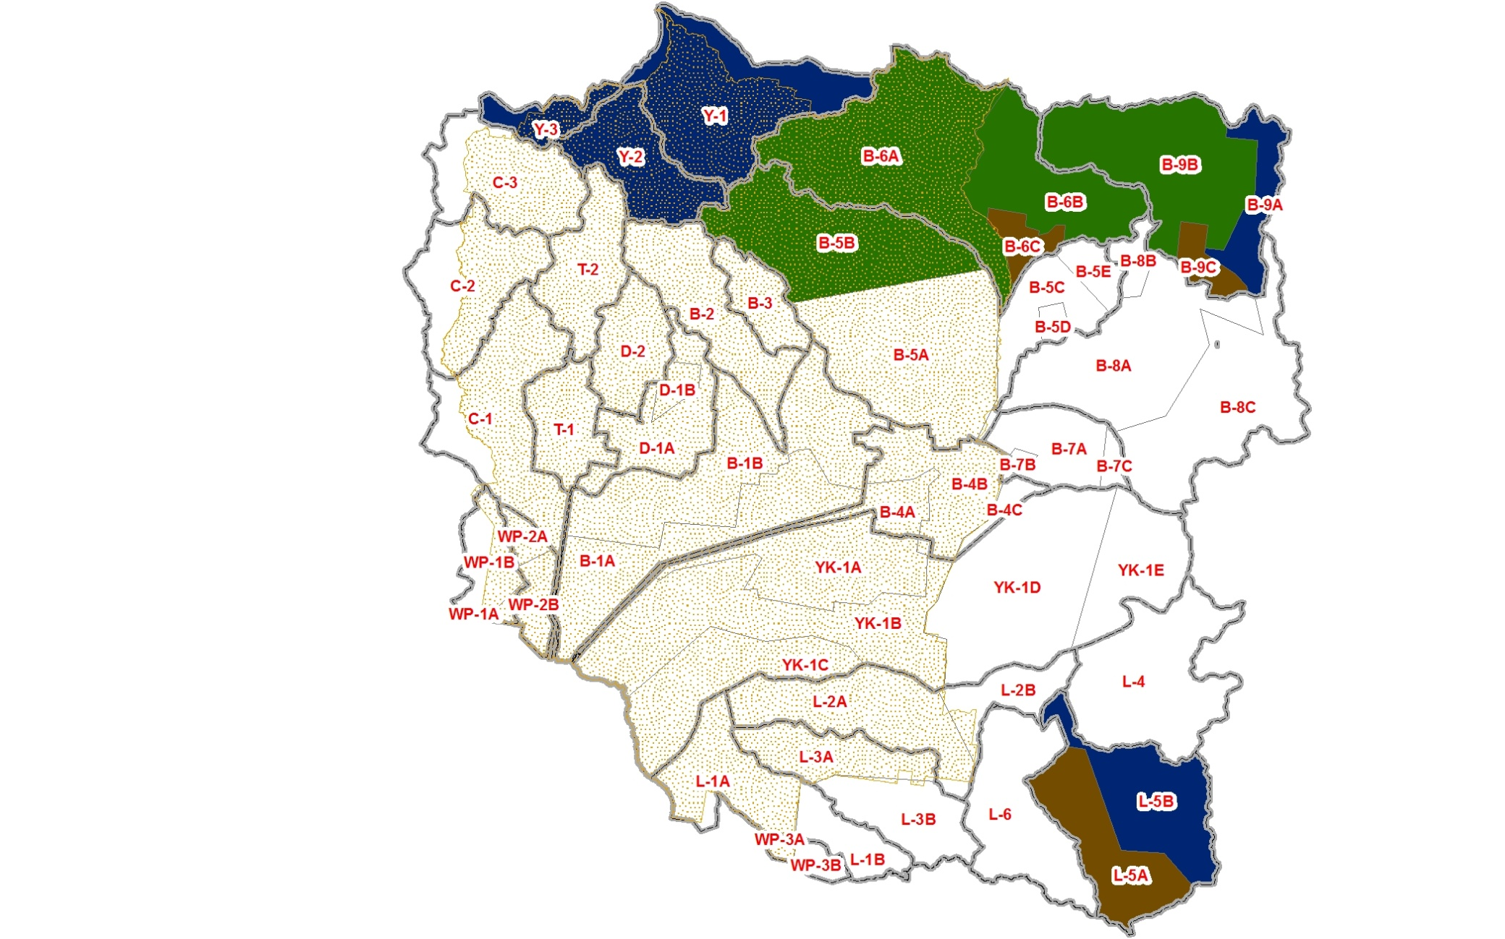
- High rainfall band model (relevant to hills region)
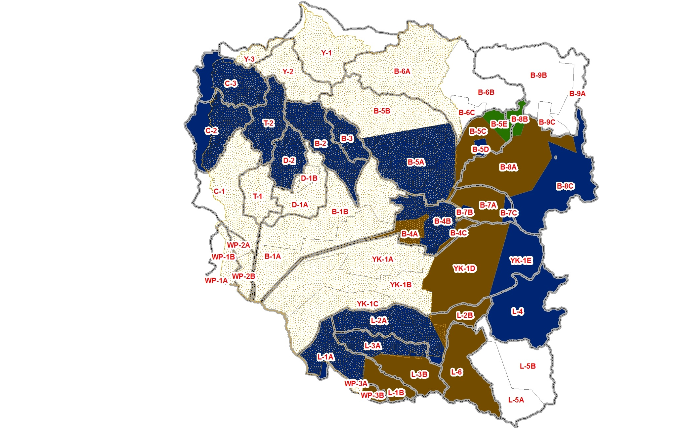
- Moderate rainfall band model (relevant to urban growth region)
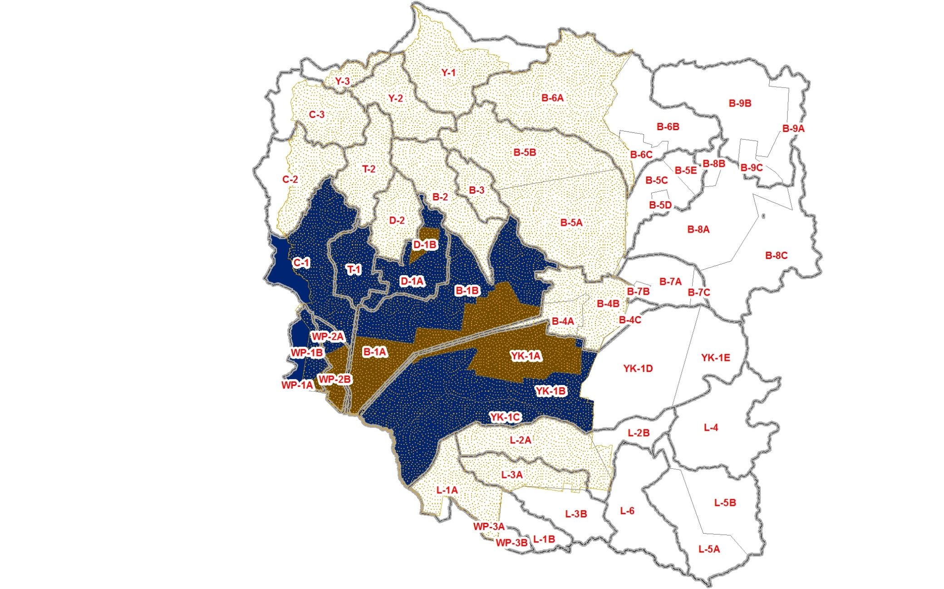
- Low rainfall band model (relevant to southern rural area)
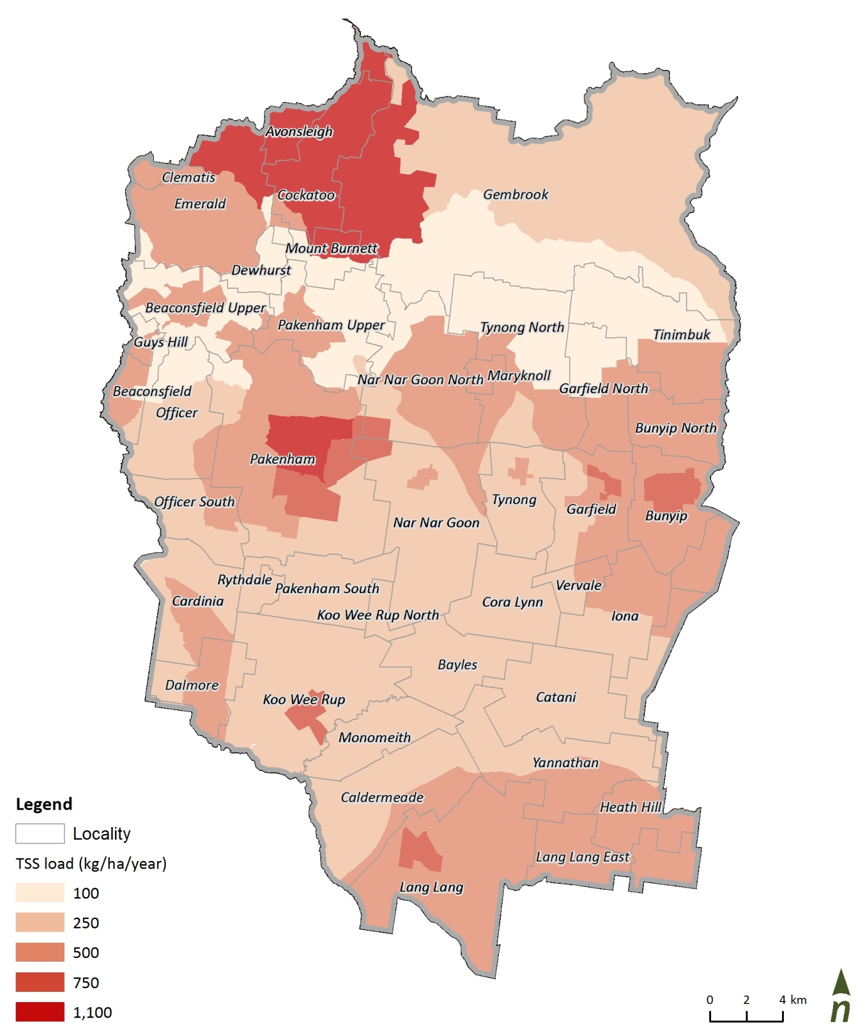
- TSS loads modelled by subcatchment, base case scenario
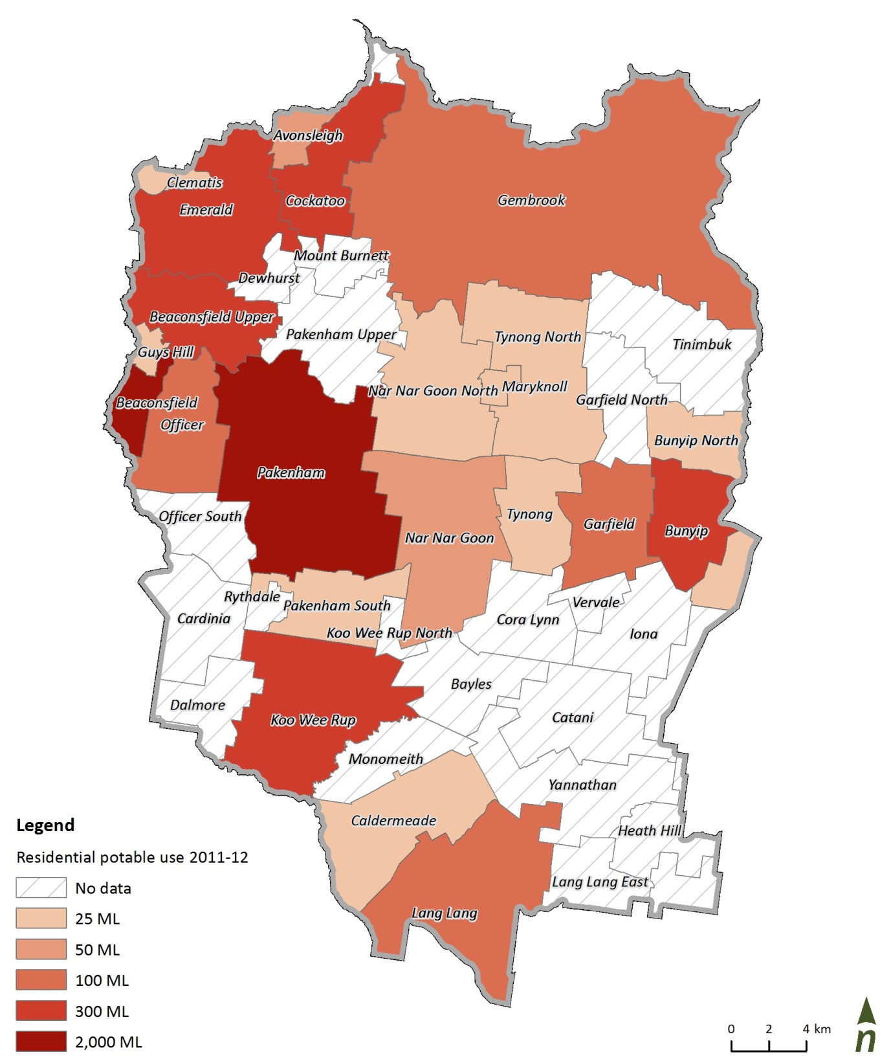
- Residential potable water use 2011-12, by suburb

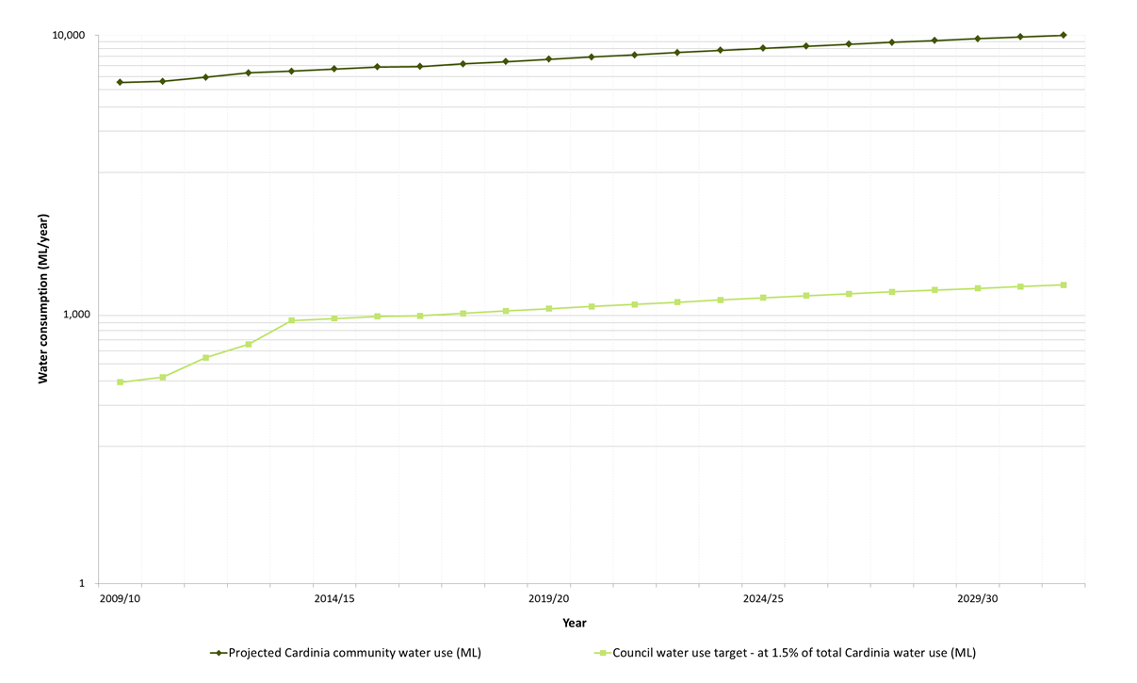

- Council water use projections at 1.5 percent of community use
Appendix C: Vision and aspirations
With an understanding of some of the key flows within the shire’s Water Cycle and some of the current and likely future influencers behind it, an engagement process was undertaken to develop the vision and aspirations for the shire’s water cycle and for the IWMP.
Consultation
Development of the shire’s IWMP was supported by a number of internal (Council) and external stakeholders. Communication with these various stakeholders was undertaken collaboratively and primarily within workshops and one-on-one meetings. A summary of the stakeholders involved in the IWMP process is illustrated in Figure 13.
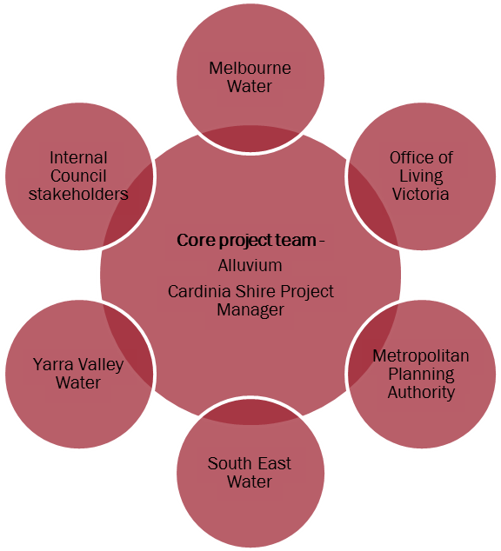
- Summary of project stakeholders
Engagement with these stakeholders can be categorised into three types:
- high degree of engagement (day-to-day discussion and feedback) with the shire’s Project Manager and team
- workshops with both the shire and external agencies.
- meetings and communications with project stakeholders.
Figure 14 shows the process that was undertaken to develop the vision and aspirations for the shire’s IWMP that led to the Targets and Actions that are detailed in Section 5.

- Consultation process for the shire’s IWMP

Vision
Within the first Workshop it was proposed that the vision and objectives for the Council’s IWMP be adapted from the Melbourne’s Water Future document (OLV, 2013). This was agreed upon in an attempt to provide consistency across levels of Government while retaining the flexibility to apply the vision and objectives to Cardinia Shire’s specific requirements.
Accordingly, the vision statement agreed to within Workshop 1 is for Cardinia Shire to be “a shire that is sustainable, productive and liveable”.
The Melbourne’s Water Future objectives that will guide the shire toward that overall vision are shown in Figure 16.
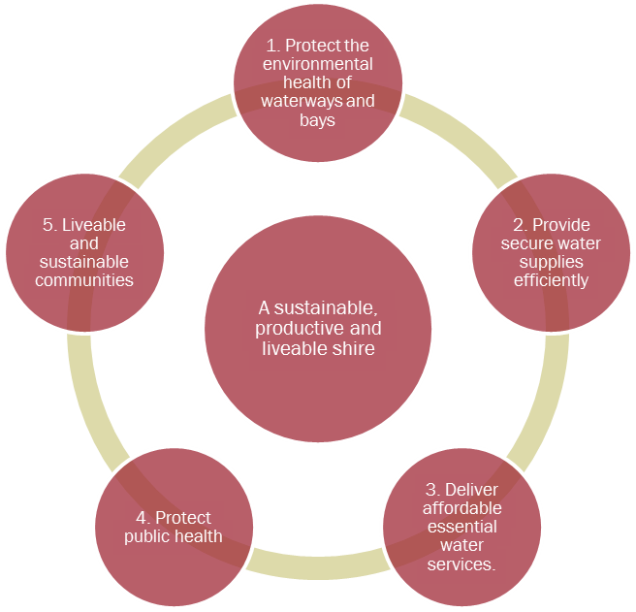
- Vision and objectives for the Council’s IWMP
Workshop 1: the objectives were presented to the group and through discussion adapted as corresponding “focus area” that better reflect Council’s role, issues, drivers and language. Following this, aspirations for each focus area were defined by the group. The aspirations were used as guidance for the identification of related issues and opportunities across the shire.
Workshop 2 presented draft objectives to representatives of external agencies including Office of Living Victoria (OLV), Melbourne Water, South East Water (SEW) and the Metropolitan Planning Authority (MPA). The aim of this workshop was to inform these stakeholder agencies of the plan’s progress to date and specifically the flavour of the issues and opportunities identified. Further, the potential for Council and stakeholders to collaborate on specific issues or opportunities was flagged.
Workshop 3 focussed on identifying and ranking issues and opportunities. These were broadly defined to capture anything that had the potential to influence the water cycle positively or negatively across policy, trends, community, environment, specific hotspots etc.
shire Workshop 1 – Agenda
Meeting | Workshop 1 – Cardinia Shire’s water cycle, issues and opportunities
Meeting held at | Cardinia Cultural Centre, Lakeside Boulevard, Pakenham
Time and date | 9.30 – 12.30, 22 August 2013
Project | Cardinia Shire Council IWMP
Invitees | Council: Janene Vurlow, Desiree Lovell, Ken White, Martin Teplik, John Holland, Hilary Rutledge, Brett Jackson, Kevin Alexander, Heather Callahan, Cory Bixler, Charles Taveira, Steven Hine, Jim Davine, Steven Pomeroy  Alluvium: Dan O’Halloran, Rob Catchlove  Apologies: Stephen Fernee
Time | Item | Responsibility
9.30 – 10.15 | 1. Introduction and the shire today  - Why are you here?  - Why an IWM plan?  - What will we do today?  - Cardinia Shire’s water cycle: literature, data and modelling results | DOH
10.15 – 10.30 | Break
10.30 – 11.20 | 2. Vision and objectives: What does the shire with an integrated water cycle look like? | DOH
10.30 – 11.20 | - Office of Living Victoria’s objectives? Are these relevant and acceptable for Cardinia?  - If not – let’s discuss what our objectives should be? | DOH
10.30 – 11.20 | Breakout 1: Using these objectives let’s discuss the vision for Cardinia  What are the 5 things that will resonate into the future for Cardinia that define it as a place, a region or a community?  Put text and ideas around each objective to “flesh out” what this means for Cardinia and contribute to our vision. | All
11.20 – 11.30 | Break
11.30 - 12.30 | 3. Issues and opportunities | DOH
11.30 - 12.30 | Breakout 2: With the vision and objectives in mind, break up over maps to brainstorm issues and opportunities across the shire  What actions and projects do we want to take forward?  Be general or specific. Write on the plans! | All
12.30 on | Final comments and close | All

Agency workshop 1 – Agenda
Meeting | Agency Workshop 1 – Cardinia integrated water management plan
Meeting held at | Cardinia Cultural Centre, Lakeside Boulevard, Pakenham
Time and date | 4 October 2013
Project | Cardinia Shire Council IWM Plan
Invitees | Council: Janene Vurlow, Ken White, Desiree Lovell, Hilary Rutledge, Ben Weiner  Agency attendees: Alan Watts (SEWL), James Westcott (SEWL), Bridget Weatherall (OLV), Jamie Ewert (MW), Gwenda Kullen (GAA)  Alluvium: Dan O’Halloran
The aim of this meeting was to critically review the IWCM actions that have been developed by Council staff internally, identify complimentary projects and programs at other agencies and identify agency champions that Council can work with to further develop these actions.
Time | Item | Responsibility
10.00 -10.10 | - Project introduction  Scope and timelines | DOH
10.10 - 10.30 | - Activities and progress to date  A brief summary of the literature review, data and modelling undertaken to date  Brief discussion to follow | DOH
10.30 – 11.30 | - Objectives, vision and actions  We’ll review the outcomes of Council’s first internal workshop (summarised within the pdf attached).  Note: The actions are categorised by objective and have been derived from the issues and opportunities identified by workshop attendees.  We will:  - review the actions under each objective  - note those actions that relate to agency projects or programs. Are there existing targets or activities that are complimentary to these actions? How can Cardinia work with your agency to realise or progress these actions?  - Discussion to follow, focussing on:  - Gaps: issues, opportunities and actions that may have been missed  - future development of these actions. | DOH
11.30 | Final comments and close

shire Workshop 2 - Agenda
Meeting | Workshop 2 – Actions and aspirations
Meeting held at | Cardinia Cultural Centre, Lakeside Boulevard, Pakenham
Date | 9.30 – 12.30, 3 December 2013
Project | Cardinia Shire Council IWM Plan
Invitees | Council: Janene Vurlow, Desiree Lovell  Alluvium: Dan O’Halloran, Rob Catchlove, James Fitzgerald
Purpose
This workshop developed targets for prioritised issues and opportunities that were developed within Workshop 1 (within Council) and Workshop 2 (external agencies).
Based on the results of those two workshops we categorised the aspirational statements, issues and opportunities under the following four categories. These correspond to the objectives we adopted within our first workshop.
Waterways and bays
Water efficiency and alternative water sources
Planning and development
Community and public health
Within this workshop we:
- Critically reviewed the outputs to date and identify gaps (e.g. potable water use reduction)
- Prioritised the issues and opportunities
- Proposed targets for high priority issues and opportunities

Time | Item | Responsibility
9.30 -9.45 | Introduction  Where are we up to: data, objectives, issues and opportunities  What are we aiming to achieve today? What do we mean by a target?  What comes after targets? When do we work through the ‘Actions and implementation plan’. | DOH
9.45 – 10.15 | Issues and opportunities review  Break into four groups under the headings below:  - Waterways and bay  - Water efficiency and alternative water sources  - Planning and development  - Community and public health  Review the wording of the issues and opportunities and identify any gaps. Has a key issue or opportunity been missed? | All
10.15-10.30 | Prioritisation  Each participant will be given 10 dots to place against one or more issues or opportunities to emphasise – in their opinion – the importance of that issues or opportunity to the future of Cardinia. | All
10.30-10.45 | Break
10.45 – 11.45 | Targets  Small groups will propose targets for each issue or opportunity. We will tackle these in order of priority. Targets will be expressed to populate the following requirements. | All
  Specific | What do we want to accomplish and why? Who would be involved? Where would it take place?
  Measurable | How much? How many? How will we know when this is accomplished?
  Attainable | Is this possible? How will it be accomplished?
  Relevant: | Is this worthwhile? Does it ‘speak to’ the aspiration statement?
  Time based: | This strategy period goes to 2031? Could this be achieved in the first five, or last ten years of the strategy?
11.45 – 12:15 | Feedback and next steps  - review the data underlying the target statements proposed within the workshop  - refine the target statements and return these to workshop participants for comment,  - develop actions to progress toward those targets, focussing on specific case studies. | All
The following tables illustrate Council’s aspirations, issues and opportunities under each focus area. Having collated the issues and opportunities offered by Workshop 3 participants, the draft summary was forwarded to agency stakeholders (who were present at Workshop 2) for review. Their comments were incorporated into table 16.
- Aspirations, issues and opportunities – Objective 1 and 2

http://nwc.gov.au/nwi/objectives (Accessed 13 May 2013)
Environment Protection and Heritage Council , Australian Guidelines for Water Recycling: Stormwater harvesting and reuse, July 2009
http://www.epa.vic.gov.au/your-environment/water/protecting-victorias-waters/risk-based-approach-protecting-victorias-waters (Accessed 13 may 2013)
Living Melbourne Living Victoria Roadmap, Ministerial Advisory Council for the Living Melbourne Living Victoria Plan for Water, March 2011
Cardinia Shire Council, Stormwater Management Plan, 2002

