**Evacuation Grab Kit - Checklist**

**Items that you can include:**

|  |  |  |
| --- | --- | --- |
| ○ | ○ | ○ |
|  |  |  |
| Emergency plan and important contacts | Important documents and information | Medication and  first-aid kit |
| ○ | ○ | ○ |
|  |  |  |
| Medical aids and equipment | Items for children | Items for pets |
| ○ | ○ | ○ |
|  |  |  |
| Mobile phone  and charger | Miscellaneous  Personal items | Food and water |
| ○ | ○ | ○ |
|  |  |  |
| Radio and torches | Protective clothing and items | Personal clothing and toiletries |

**Evacuation Grab Kit - Checklist**

You may also need to remember...

In addition to the items shown on these pages, think about your household’s special needs and what other items you may require such as items for those with a medical condition or disability, children and pets.



If you have children also pack:

• Any medication (such as asthma puffer or EpiPen)

• Medical records

• Nappies

• Baby formula and bottles

• Carrier

• A familiar item (toys, special blanket, book, game)

to help reduce stress



If you have pets also pack:

• Suitable transport (carrier, cage or leash)

• Food and drinking water

• Food bowl and water bowl

• Any medication

• Veterinary/medical records

• Registration/identification records

• A familiar item (toy, bed, treat) to help reduce stress

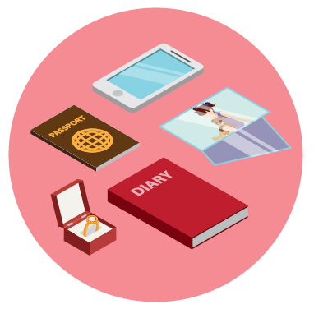

Five things people most regret leaving behind in emergencies**:**

1. A mobile phone

2. Family memorabilia (things you can’t replace)

3. Personal memoirs (personal diaries/ stories)

4. Family photographs

5. Passports and other important documents

For more information:

www.cardinia.vic.gov.au www.emergencyprepare.com.au

