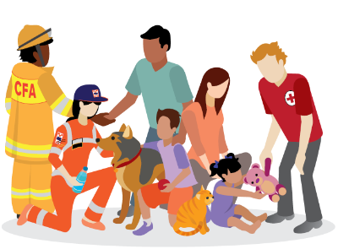
Emergency Preparedness
Booklet

Emergencies can happen at any time.
It is important that you are prepared.

You can do this by:

- Making an emergency plan
- Packing an emergency kit
- Downloading the VicEmergency App
- Building connections within your community

For more information:

- www.cardinia.vic.gov.au
- www.emergencyprepare.com.au
- www.emergency.vic.gov.au

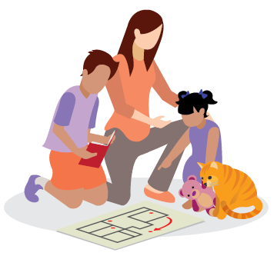
Prepare Early
What you can do now.

Check these off

Write an emergency plan and practice it regularly

If you have animals, make sure they are part of your emergency plan and consider where you will relocate them

Make copies of important documents such as passports, insurance papers and medical scripts

Get insurance and review what it covers

Pack an emergency kit and keep it somewhere easily accessible

Are you prepared?
Emergencies can happen at any time

What you can do now.

Check these off

Download the VicEmergency App on your smart phone and electronic devices

Save important contact numbers into your phone such as family and friends and the VicEmergency Hotline 1800 226 226

Check VicEmergency for information on current incidents

Know if it is a day of Total Fire Ban

Listen to emergency broadcasts

Stay Informed
Stay Connected

Your family Your safety Your Responsibility

What you can do now.

Check these off

Build connections within your local community

Talk to your neighbours about your emergency plans and see if there are ways you can assist each other

Look for local volunteering opportunities or other community groups you can get involved in

Have an agreed meeting place where you will meet if separated

