Important Emergency Contacts
Emergency contacts
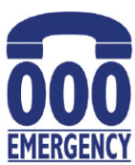 | In an emergency  Call Police, Fire & Ambulance  in a life threatening or time critical situation. |  |  |  |  | CALL 000 | TEXT 106
 | In a flood and storm emergency  Call SES for a flood, storm, landslide and earthquake emergency. |  |  |  |  | 132 500
Emergency information
VicEmergency Hotline
Call to talk to someone about an emergency. 1800 226 226
 | Call if you are deaf, hard of hearing or have a speech impediment  1800 555 677 |  |  |  |  | Call for the Translating and Interpreting Service  131 450
Council customer service
 | Cardinia Shire Council |  |  |  | 1300 787 624
Emergency Information Sources
Mobile |  |  | VicEmergency app  ABC News app  Facebook – Vic Emergency  Twitter @vicemergency
Radio |  |  | ABC 774 AM Local News
Computer |  |  | www.emergency.vic.gov.au
Television |  |  | ABC News

