PUBLIC NOTICE

CARDINIA SHIRE COUNCIL

NOTICE OF INTENTION TO sell land

Cardinia Shire Council (‘Council’) gives notice under section 189 of the Local Government Act 1989 (‘the Act’) of its intention to sell part of 2 Station Street, Officer, being part of the land contained in certificate of title volume 10749 folio 127 and more particularly described as Lot 1 on draft PS824994 (‘Land’). The Land is shown as lot 1 on the plan below.
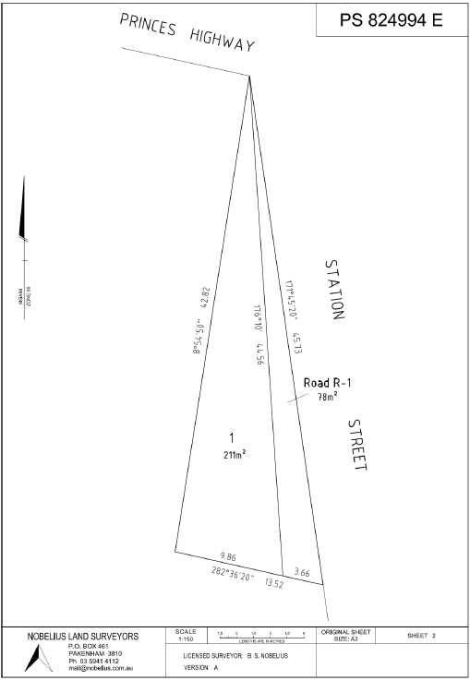
It is proposed that the Land be sold to the abutting owner at market value in accordance with the Road Discontinuance Policy.

In accordance with section 223 of the Act, any person may make a submission on this proposal and all submissions will be considered. Submissions must be received by Thursday 11 July 2019, 5pm.

Submissions can be emailed to mail@cardinia.vic.gov.au, hand delivered to Council’s Customer Service Centre at 20 Siding Avenue, Officer or posted to:

Ms Carol Jeffs
Chief Executive Officer
Cardinia Shire Council
PO Box 7
PAKENHAM VIC 3810

Please include the address of the Land in the subject heading or on the front of the envelope.

Any person requesting to be heard in support of his or her submission is entitled to verbally present their submission to Council (or a Committee established by Council for this purpose), or be represented by a person acting on his or her behalf. They will be notified of the time and date of this meeting.

Following the consideration of any submissions, Council may decide to sell the Land, part of the Land or not sell the Land. For further information, please contact Council’s Property Advisor on 1300 787 624.

Carol Jeffs
CHIEF EXECUTIVE OFFICER

