Outcomes from Cardinia Shire Multicultural community Forum

Report Summary

In November 2018 Cardinia Shire Council held Cardinia Shire’s first Multicultural Community Forum at Pakenham Hall. The forum was hosted by Council’s Culturally and Linguistically Diverse (CALD) Advisory Committee to provide our broader multicultural community with a voice to discuss the opportunities and challenges of settling in Cardinia Shire. Significantly it also provided the community with the chance to meet and get to know members of Council’s CALD Advisory Committee.

Some key themes and issues that emerged included:

The positive aspects of living in Cardinia:
- people identified Cardinia’s clean environment and amenities
- the community is multicultural and generally friendly
- assets including the quality of services and infrastructure
- Council’s efforts to connect to the CALD community

The challenges of settling in a new community:
- not feeling accepted enough by the wider community
- a lack of access to key services and physical infrastructure
- limited local job opportunities
- isolation
- lack of opportunities to connect through events and accessible physical spaces

Ideas for improving people’s experiences of living in the Shire and building connection:
- having events and low cost physical spaces dedicated to helping people build local social networks
- assisting with the cost of participating with sports clubs and venues
- improving communication and outreach methods to help isolated people know about and access local services and events

The following key recommendations will be considered by Council and the Advisory Committee and will inform the development of the new Cultural Diversity Plan:

1. Isolation is a significant challenge experienced by the CALD community - explore ways to create opportunities for connection that may include more targeted events and dedicated spaces. Targeting and working with community members who have strong networks and are recognised as leaders by their own communities (as opposed to the wider community) is suggested

2. Explore ways to increase access for the CALD community to participate in existing recreational spaces, clubs, venues etc.

3. Explore ways to create and increase local employment opportunities and skill development e.g. through training and volunteering

4. Improve communications strategies so the CALD community can be informed about services and events. This could include providing information in a variety of community languages, improving accessibility through the council website and expanding communication mediums

5. Increase awareness and education about the benefits of diversity in Cardinia for the wider community and raise the profile of success stories that celebrate local diversity

If you have any questions, please contact members of the Cultural Diversity team as listed below:

Glenda George  Cultural Diversity Facilitator  59454418  g.george@cardinia.vic.gov.au | Alison Brash  Social Inclusion Officer  5943 4557  A.Brash@cardinia.vic.gov.au

Event Images

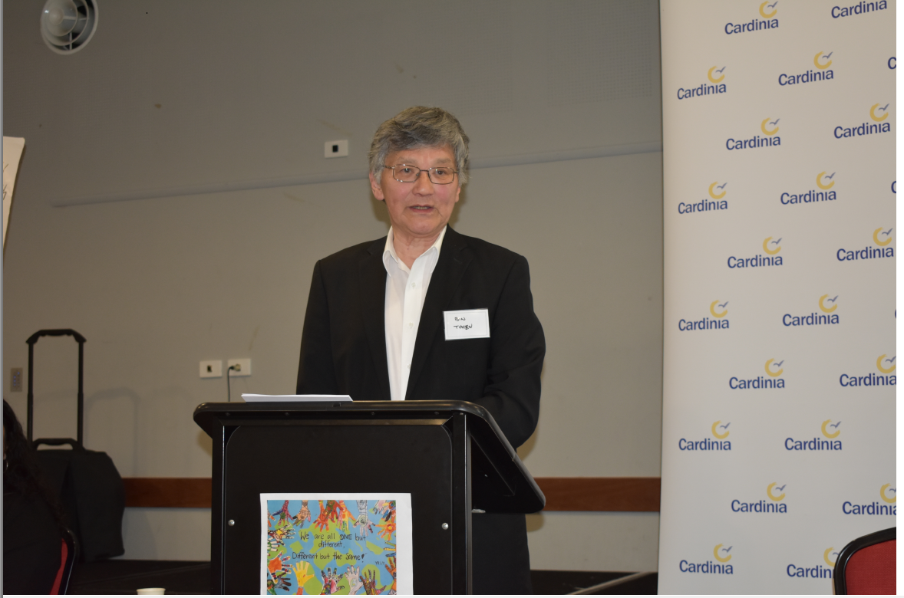 | Victorian Multicultural Commission – Mr. Tsebin Tchen provided the opening address  Image:  Cr. Michael Schilling
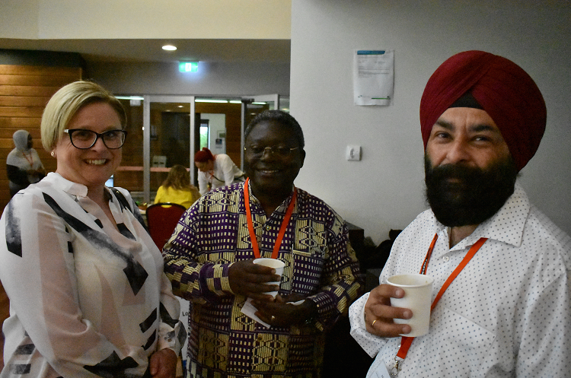 | CALD Advisory Committee members Charles Mphande and Harpreet S Kandra spoke with community members throughout the day  Image:  Cr. Michael Schilling
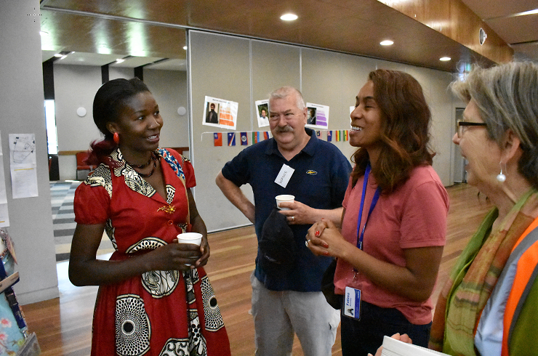 | Cardinia Shire Council staff spoke with community members.  Image:  Cr. Michael Schilling
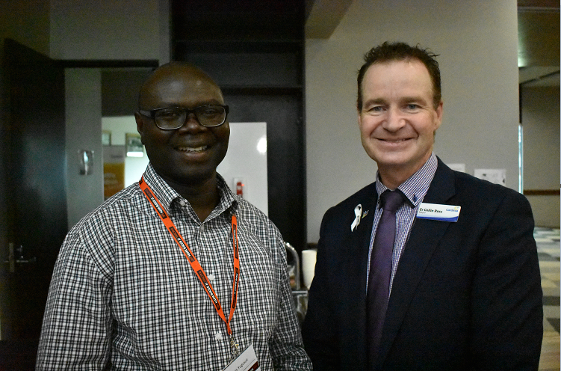 | Deputy Mayor Colin Ross met CALD Advisory Committee member Chris Yugusuk  Image:  Cr. Michael Schilling
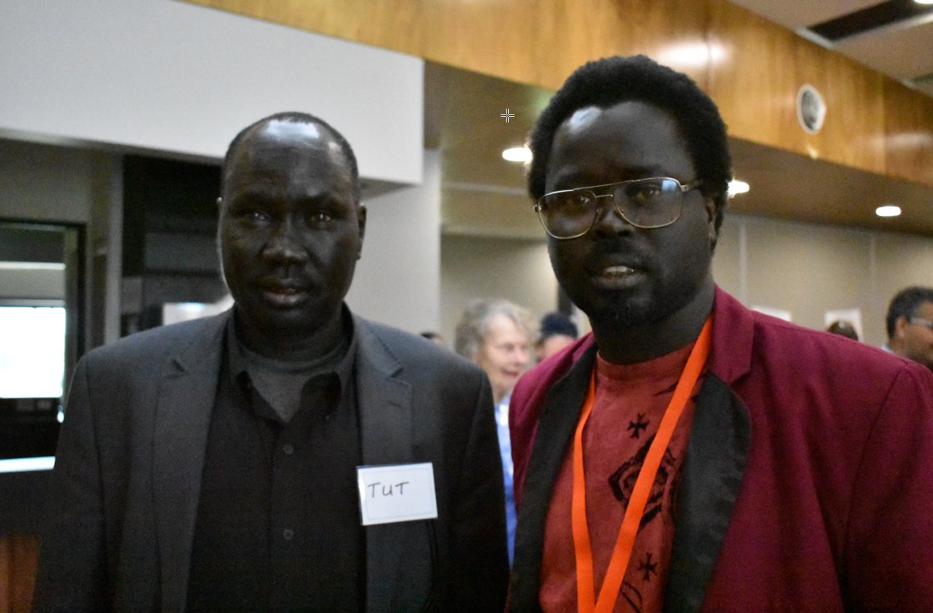 | CALD Advisory Committee member Jeffah Thabach with Tut  Image:  Cr. Michael Schilling
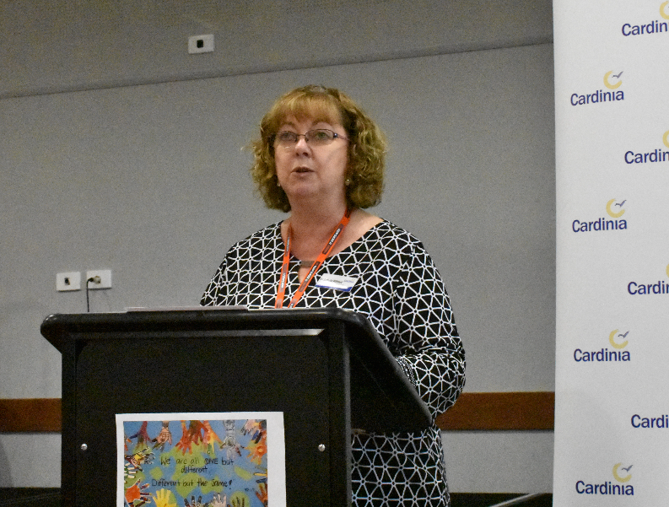 | Cardinia Shire Council CALD Advisory Committee Chairperson Cr. Leticia Wilmot  discussed the Shire’s ongoing commitment to supporting cultural diversity and social inclusion  Image:  Cr. Michael Schilling
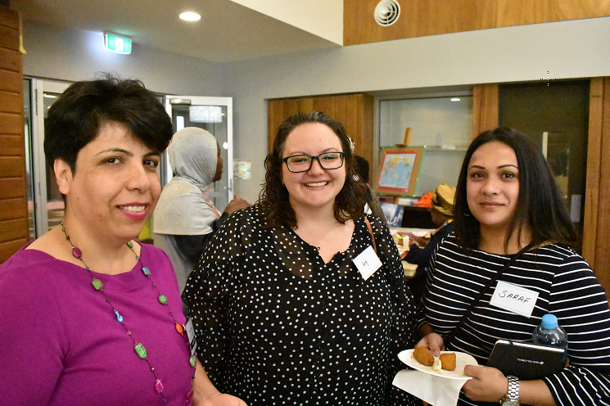 | CALD Advisory Committee member Marzia Wardak with Ivy and Saraf  Image:  Cr. Michael Schilling
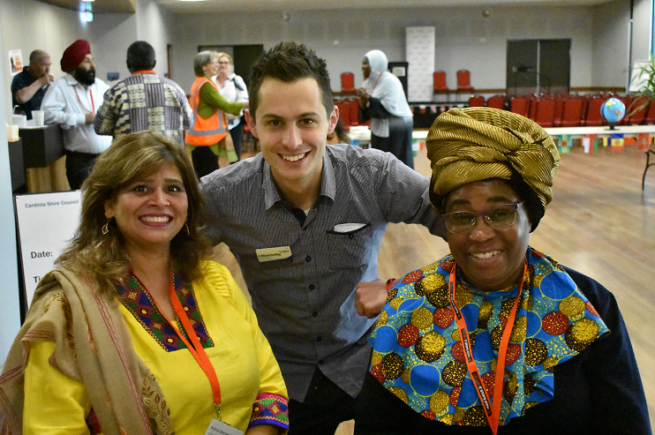 | Councillor Michael Schilling with CALD Advisory Committee members  Rubina Nawabi  and Rabecca Mphande  Image:  Cr. Michael Schilling
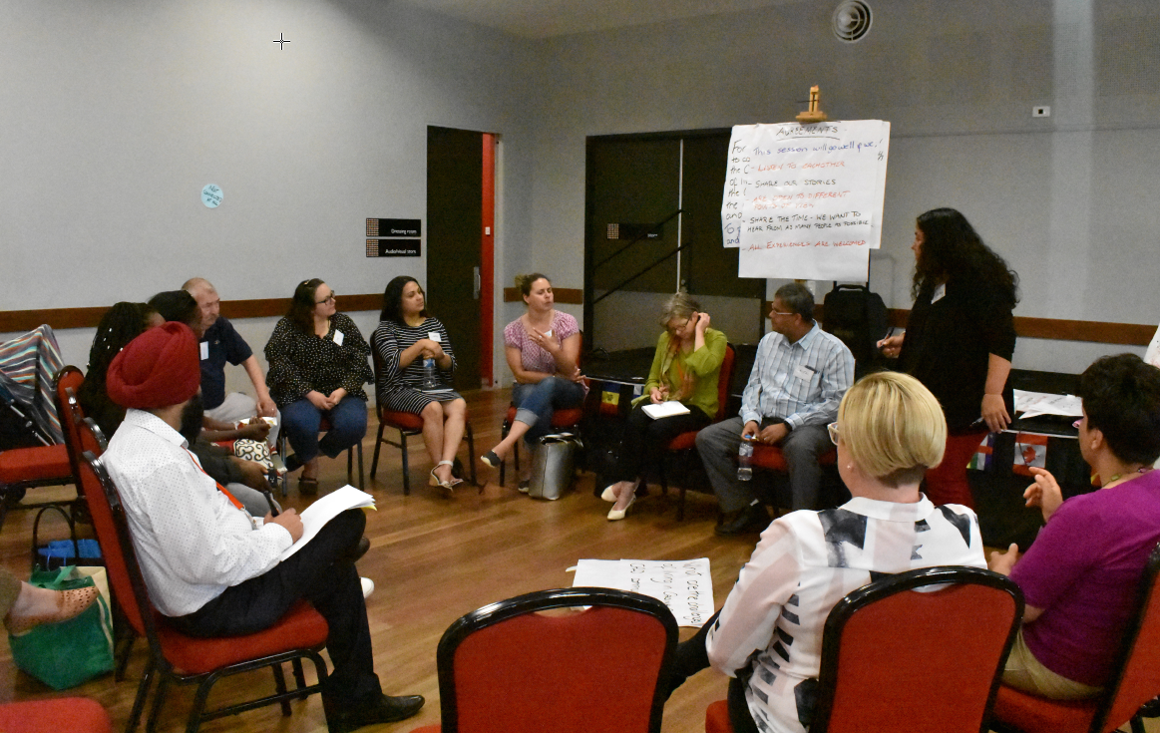 | One of several break out groups who met to identify strengths and issues impacting Cardinia’s CALD community  Image:  Cr. Michael Schilling

