

Housing rights are human rights

Social and Affordable Housing Strategy and  
Action Plan 2018−25

Cardinia Shire Council February 2019

Prepared by:

**Cardinia Shire Council**

Community Strengthening Unit

in association with Affordable Development Outcomes

Council acknowledges the support of the Victorian Government

Published February 2019

© Cardinia Shire Council 2019

ABN: 32 210 906 807

20 Siding Avenue, Officer

PO Box 7, Pakenham Vic 3810

(DX 81006)

Phone: 1300 787 624

Email: mail@cardinia.vic.gov.au

Web: [cardinia.vic.gov.au](http://www.cardinia.vic.gov.au)

Contents

Contents 3

Executive summary i

Cost impact ii

Strategy and Action Plan iii

Recommendations iii

Definitions v

Snapshot of social and affordable housing need in Cardinia Shire vi

Part A: Context 1

Purpose of the strategy 1

Strategy framework 1

Structure of the document 2

Principles 3

Housing affordability, affordable living and affordable housing 4

Why is affordable housing important? 5

Who requires affordable housing? 6

Affordability benchmarks for Cardinia Shire 7

Policy context 8

Global context – United Nations Sustainable Development Goals 8

Australian Government 8

Victorian Government 9

Land use planning policy 10

Local government policy context 12

Role of local government 14

Land use planning role and actions 15

Part B: Social and affordable housing needs assessment 16

Demographics overview 16

Homelessness – demand and service provision 17

Market housing supply 19

Social and affordable housing - supply and demand 20

Affordable rental 21

Affordable purchase 24

Affordability gap analysis 25

Social housing supply gap 27

PART C: Social and affordable housing strategy action plan 29

Strategy framework 29

Strategy rationale 30

Strategic actions 30

Key strategies 30

Strategic focus: value sharing and negotiated planning policy 32

**Action Plan 2018- 25** 35

Part D: Implementation, monitoring and evaluation 40

Attachment 1 41

Attachment 2 42

Attachment 3 45

References 47

List of figures

Figure 1. Estimated social housing supply gap and supply requirement 2016−36 ii

Figure 2. Social and Affordable Housing Strategy 2018−25 framework iv

Figure 3. The Liveability Plan seven priority health and social outcomes 1

Figure 4. The Liveability Plan seven key policy domains 1

Figure 5. Liveability Plan, Housing Domain key objectives 2

Figure 6. Relationship of housing affordability, affordable living and affordable housing. 4

Figure 7. Forms of affordable housing 5

Figure 8. Legislative and policy context 8

Figure 9. Planning Framework 10

Figure 10. Considerations when determining housing appropriateness 12

Figure 11. Summary of key statistics 16

Figure 12. Percentage of homeless in SA2 Regions (ABS 2018) 19

Figure 13. Key social and affordable housing supply and demand figures (2016) 21

Figure 14. Affordable private rentals over time (2 Bedrooms) 23

Figure 15. Affordable private rentals over time (3 Bedrooms) 23

Figure 16. Affordable private rentals over time (All dwellings) 24

Figure 17. Median vacant lot price change over time, 2000-17 25

Figure 18. Change in median prices 1986-2016 25

Figure 19. Social housing supply requirement, number and percentage of forecast dwelling supply, 2016-36 28

Figure 20. Social and Affordable Housing Strategy 2018−25 Framework 29

Figure 21. Living arrangements of households seeking assistance, July 2015 – April 2017 41

Figure 22. Main Presenting Reason to service providers in Cardinia Shire, July 2015 – April 2017 41

Figure 23. Forecast Population, Cardinia Shire 2016-41 42

Figure 24. Estimated population growth distribution 2016-20. 42

Figure 25. Forecast population, 5 year age structure, Cardinia Shire 43

Figure 26. Forecast population, Household Types, Cardinia Shire 43

Figure 27. Number of bedrooms per dwelling, Cardinia Shire, 2016 44

Figure 28. Household Type, Cardinia Shire, 2016 44

List of tables

Table 1. Estimated social housing supply gap and supply requirement 2016−36 ii

Table 2. Principles underpinning Council’s approach. 3

Table 3. Income bands Greater Melbourne, June 2018 6

Table 4. Estimated affordability by household type - Greater Melbourne income band 7

Table 5. Key Council strategies 13

Table 6. Role of Council 14

Table 7. Recipients of Commonwealth allowance, Cardinia Shire, 2016 17

Table 8. Rates of homelessness 2016 – comparison rate and percentage change 19

Table 9. Estimated affordable rent/purchase prices for households in Greater Melbourne 26

Table 10. Median rents and median sale prices (2017) by property type 26

Table 11. Income capacity of household type 26

Table 12. Estimated social housing supply requirement 28

Table 13. Appropriateness considerations and priorities to be applied 34

# Executive summary

Housing is a fundamental human right and a key factor in neighbourhood liveability.

Council recognises affordable housing as a human right and an important link to a liveable neighbourhood; critical to creating a ‘liveable, resilient community where the environment flourishes and residents are healthy, included and connected’.[1]

While Cardinia Shire has had significant housing growth and is relatively more affordable in comparison to many parts of Melbourne to purchase a dwelling, particularly for larger new homes, a significant and growing number of lower income and vulnerable residents lack access to appropriate, secure and affordable housing and over 200 persons are already sleeping rough (ABS homeless counts).

A variety of hidden ongoing living costs, particularly transport costs associated with lower residential densities and limited public transport access introduce further affordability issues, with many residents living in greenfield sites at risk of mortgage and rental stress should petrol prices rise.[2]

This is particularly an issue for younger and older persons, single persons, sole parent families and people with a disability or mental illness. These households can face other disadvantage in the private market that makes accessing appropriate housing challenging.

The evidence confirms that Cardinia Shire lacks sufficient appropriate and affordable housing for lower income residents and that without intervention and investment; the issue will continue to worsen.

**Specifically, the analysis highlights**

* 2,547 households are estimated to have required access to social housing in Cardinia Shire in 2016, representing 7.87 per cent of all households[3]
* 7.21 per cent of all dwellings in Cardinia Shire in 2016 would need to have been available as social housing to address this need
* only 0.9 per cent of all dwellings (317 dwellings) were dedicated social housing in Cardinia Shire in 2016, resulting in a social housing supply gap of 2,230 dwellings
* to meet the 2016 estimated shortfall and projected population demand, an average of 17.03 per cent of all new dwelling supply between 2016 and 2036 is required to be provided as social housing for lower income households. This is an average of 265 dwellings per annum per year for 20 years (Table 1 & Figure 1) [4]
* if 50 per cent of the 1,736 low income households in mortgage stress in 2016 are unable to maintain their housing a further 868 affordable or social rental or ownership options would be required.

1. Estimated social housing supply gap and supply requirement 2016−36

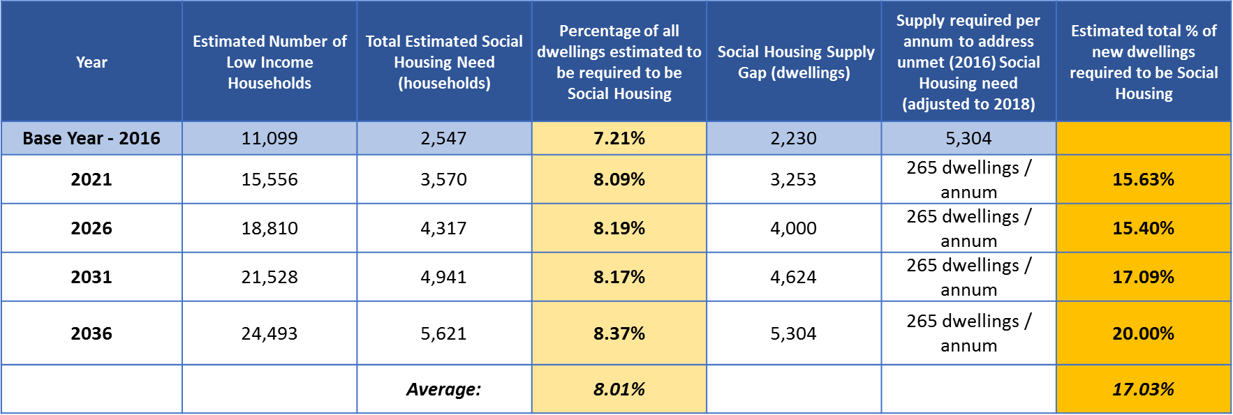

1. Estimated social housing supply gap and supply requirement 2016−36

### Cost impact

Homelessness in Cardinia Shire is estimated to be costing the Victorian Government at least **$5.635m per year**[5]. This cost would be significantly higher if the cost impact of lower income households being in housing stress was also factored.

Without action it is expected that rates of homelessness and housing stress in the Shire will continue to grow, with a range of flow-on impacts, including:

* increased pressure on support services
* increases in mental health presentations, family breakdowns, crime and disengagement of people from their communities, education and employment
* increased food insecurity (and related long-term health implications).

### Strategy and Action Plan

The evidence within this Strategy establishes a clear need for action to:

1. facilitate an increase in the supply of affordable housing (social/community housing and affordable private rental), for very low and low-income households and people with specialised needs
2. increase the diversity of dwelling types to respond to population demographics and needs.

The Strategy cements Council’s commitment to work collectively with key stakeholders to respond to the evidence of need and Council goal to increase access to appropriate and affordable housing.

Targets to respond to this goal that reflect the roles and responsibilities of Council and the objective to work collectively with other stakeholders to address affordable housing need are identified that then drive specific actions and will support reporting and evaluation.

Emphasis is placed on actions that align to Council’s roles as leader and advocate, land use planner, social planner, and community developer.

The Strategy also provides the evidence base and the strategic context and justification to support Council to progress negotiations with landowners to seek a reasonable contribution being made towards affordable rental housing as a result of a rezoning and planning permits in accordance with new Victorian Government legislation and policy.

### Recommendations

1. Strongly advocate to State Government to mandate social and affordable housing for all future residential development
2. Advocate and lead cross-council collaboration to seek an increase in investment by Australian and Victorian governments in social housing and homelessness support services.
3. Strengthen local planning policy to reflect Victorian Government legislative and policy changes in relation to affordable housing facilitation.
4. Seek to secure a minimum 2 per cent affordable housing in every development with an estimated total yield of over 100 lots or dwellings through voluntary negotiations in accordance with the Victorian Government legislation and guidance, with the percentage to gradually increase over time to allow the market to adjust.
5. Undertake a land audit and conduct a feasibility study to determine the potential for Council land to be committed to an affordable housing purpose.
6. Explore opportunities to encourage an increase in smaller dwellings, particularly two-bedroom properties to cater for smaller households.
7. Work with the community to build knowledge and increase support for affordable housing.
8. Establish a Councillor chaired steering committee to oversee the Strategy implementation and support the development of social and affordable housing across the Shire.

The full set of actions is set out in Part C.

1. Social and Affordable Housing Strategy 2018−25 framework

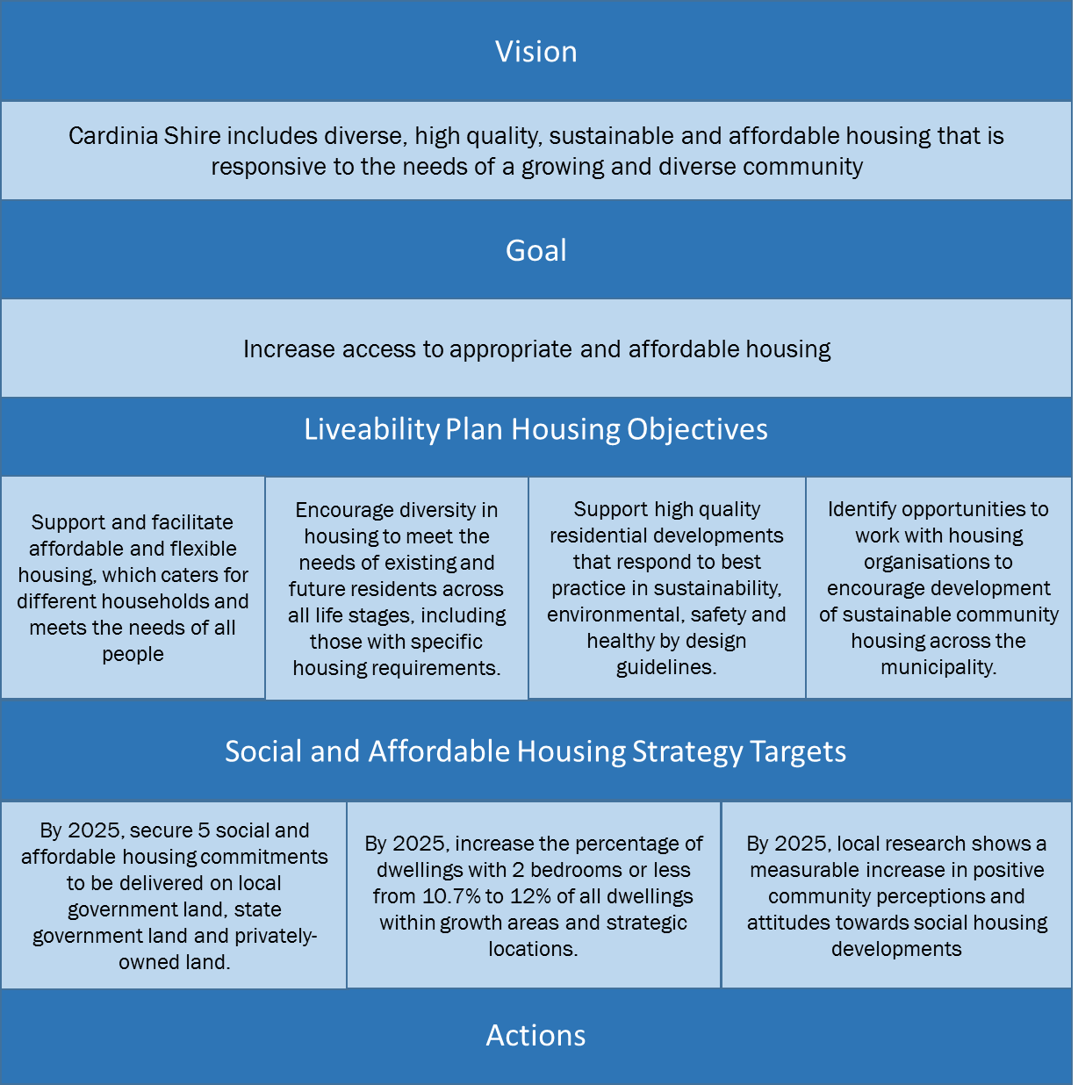

### Definitions

**Housing affordability**

Housing affordability refers to the relationship between expenditure on housing (cost of mortgage payments or rent) and household income.

Housing affordability is particularly an issue for lower income households in the bottom 40 per cent of incomes who have reduced financial resources available to meet housing costs.

**Registered Housing Association / Provider**

A Registered Housing Agency is a not-for-profit organisation registered under the Victorian Housing Act, with a mission to own, control or manage affordable rental housing (community housing).

**Affordable housing**

Affordable housing is housing, including social housing that is appropriate for the housing needs of very low, low and moderate-income households (Planning and Environment Act 1987).

Appropriateness of affordable housing includes consideration of allocation, affordability, tenure, type of housing (form and quality), location, integration and reference to housing need. Affordable housing should be priced (whether mortgage repayments or rent) so households are able to meet their other essential basic living costs.

**Housing stress**

A lower income household (those in the lowest 40 per cent of incomes) is considered to be in ‘housing stress’ when it is paying more than 30 per cent of gross household income on rent (the ‘30/40 rule’).

**Social housing**

Social housing includes:

* [Public housing](http://www8.austlii.edu.au/cgi-bin/viewdoc/au/legis/vic/consol_act/ha1983107/s4.html#public_housing) (owned and managed by the Director of Housing)
* Housing owned, controlled or managed by a partic[ipating](http://www8.austlii.edu.au/cgi-bin/viewdoc/au/legis/vic/consol_act/ha1983107/s4.html#participating_registered_agency) registered [agency](http://www8.austlii.edu.au/cgi-bin/viewdoc/au/legis/vic/consol_act/ha1983107/s4.html#participating_registered_agency) declared by the Director under section 142F(2)(b) of the Housing Act (referred to as an Accredited Housing Association or Provider).

**Community housing**

Refers to housing provided by Accredited Housing Association or Provider.

**Liveability**

Liveable communities are regarded as

safe, attractive, socially cohesive and inclusive, and environmentally sustainable with affordable housing linked via public transport, walking and cycling to employment, education, public open space, local shops, health and community services, and leisure and cultural opportunities (Lowe et al. 2013).

### Snapshot of social and affordable housing need in Cardinia Shire

The following key statistics highlight the pressing social and affordable housing need in Cardinia Shire and the priority areas for collective action.

**There are very low levels of dedicated social and affordable housing for lower income residents to access relative to demand.**

* A minimum 4,086 households require social housing in the Southern Metro (Dandenong) Region[6]
* in 2016 there was an estimated shortfall of 2,230 dwellings that were affordable for lower income households in Cardinia Shire to rent
* only 0.9 per cent of all dwellings is dedicated social rental housing compared to a Greater Melbourne average of 2.6 per cent[7]
* an estimated 17 per cent of all new dwelling supply is required to be affordable for lower income households to rent to begin to meet unmet need as at 2016 and cater for forecast population affordable housing requirements.

**Homelessness is a hidden and significant issue in Cardinia Shire, impacting disproportionately on women, single persons, sole parent families, younger and older residents, people with mental illness and people with a disability.**

* Between 2011 and 2016 the number of persons estimated to be homeless has risen by 52.8 per cent
  + 220 persons were estimated to be homeless in 2016 with a further 207 persons living in marginal housing
  + the rate of homelessness has increased by 20 per cent from 19.4 per 10,000 people in 2011 to 23.4 per 10,000 people in 2016
  + compared to other Victorian interface Councils, Cardinia Shire shows the second highest increase in its rate of homelessness in the last 5 years (after Wyndham)
  + 49.1 per cent of homelessness occurs in Pakenham South[8]
* the main reasons that lead to people seeking support from housing agencies and homeless service providers in Cardinia Shire between 2015 and 2017[9] were
  + financial difficulties (34 per cent)
  + family violence (24.2 per cent)
  + housing crisis (16.2 per cent)
* of the people presenting to homeless service providers between July 2015 and April 2017
  + 34 per cent were people living in a single parent family (425 presentations); 92 per cent of whom were females
  + 31 per cent of presentations were by people with a prior mental illness
  + 28 per cent were by people living on their own
  + 20.7 per cent of services were to young people; 5 per cent of whom were homeless in the 12 months prior.[10]

**The private market is not delivering housing options for everyone, with a lack of smaller dwellings for rent or purchase by single and couple households and a lack of appropriate housing for people with special needs.**

* There has been a significant decline in affordability of private rental dwellings for very low households, from 68.4 per cent of all dwellings available for rent in 2000 to 27.9 per cent in 2017[11]
* only 2, one-bedroom and 25 two-bedroom dwellings that were available for rent in 2017 were aﬀordable for very low income households, with no guarantee these households can access this housing[12]
* the majority of dwellings in the Shire are detached houses comprising three or more bedrooms (82.9 per cent)[13] and only 10.7 per cent of dwellings (3,493) have two bedrooms or less[14]
* 17.7 per cent (5,775 households) have only one person
* 19 per cent of all low income households and 65 per cent of all low income renting households are in rental stress (2,121 households)[15]
* 50.3 per cent of all low income households are in mortgage stress (1,736 households)[16].

# Part A: Context

## Purpose of the strategy

The strategy and action plan reflects Council’s commitment to ensuring all residents in the shire have access to safe, affordable and secure housing that meets their needs. Development of the strategy was a key recommendation arising from a 2016 study commissioned by Council on the nature and extent of homelessness in the shire.

The strategy identifies the social and affordable housing need in Cardinia Shire and provides a strategic justification for Council actions and collective intervention to increase affordable housing supply in the community.

## Strategy framework

The Strategy is underpinned by a human rights framework and local government obligations under the Victorian Charter of Human Rights and Responsibilities Act 2006[17], reflecting that the provision of adequate housing is an essential human need.

The Strategy is framed by and progresses several key Council strategies, in particular, Council’s Liveability Plan 2017-29.

By addressing key liveability factors, Council ultimately aims to address health and social outcomes in the community. Cardinia Shire’s Liveability Plan 2017-29 identified the following housing ‘vision’ in accordance with this objective:

Cardinia Shire encourages diverse, high quality and sustainable housing, affordable for all, in close proximity to employment, education, goods and services and open space, which is connected by active travel infrastructure and meets the needs of a growing and diverse community.

1. The Liveability Plan seven priority health and social outcomes

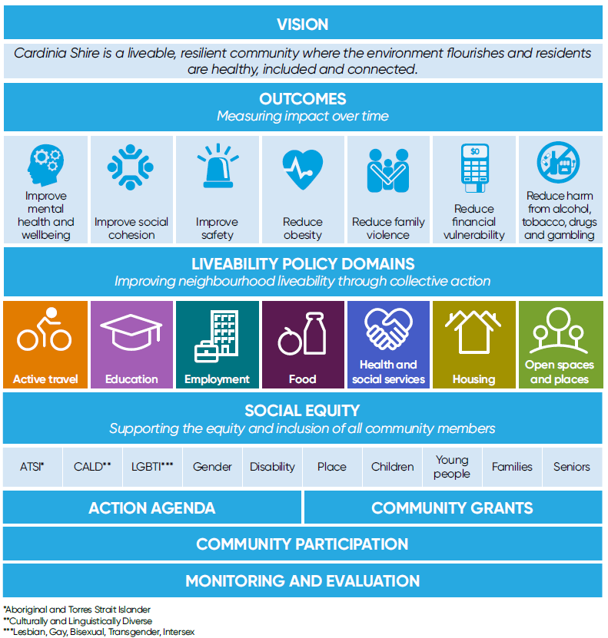

1. The Liveability Plan seven key policy domains



1. Liveability Plan, Housing Domain key objectives

|  |  |
| --- | --- |
| In the medium term we expect to see an increase in access to appropriate and affordable housing. We will do this by: | |
| 6.1 | Supporting and facilitating affordable and flexible housing which caters for different households and meets the needs of all people. |
| 6.2 | Encouraging diversity in housing to meet the needs of existing and future residents across all life stages, including those with specific housing requirements. |
| 6.3 | Supporting high quality residential developments that respond to best practice in sustainability, environmental, safety and healthy by design guidelines. |
| 6.4 | Identifying opportunities to work with housing organisations to encourage development of sustainable community housing across the municipality. |

The strategy aligns and builds on Council’s Housing Strategy 2013−18 which establishes the local housing objectives and strategies in relation to the land use planning role of Council.

The strategy also reflects recent changes to the *Planning and Environment Act 1987* that places clearer emphasis on councils to facilitate the provision of affordable housing as an objective of planning, and provide enhanced support and guidance for voluntary negotiations between councils and land owners to secure affordable housing outcomes.

The vision for this strategy is that

**Cardinia Shire includes diverse, high quality, sustainable and affordable housing that is responsive to the needs of a growing and diverse community.**

This is an aspiration that will depend on collective action as well as Australian and Victorian government investment.

### Structure of the document

The strategy and action plan enhances Council, community and key stakeholders’ collective knowledge of social and affordable housing and establishes the actions Council will take within its remit to work to address this need.

The strategy specifically:

* analyses and estimates unmet and future social and affordable housing need and identifies priority groups to be housed
* contextualises it within the Australian, Victorian and local policy and land use planning policy context and opportunities for actions and investment
* identifies a vision, objectives, targets and actions Council aims to address to respond to the identified need; and a review methodology for Council to monitor success.

## Principles

1. Principles underpinning Council’s approach.

|  |  |
| --- | --- |
| Principle | Approach |
| Human rights | Respect for and upholding of human rights requires adopting a non-judgemental approach to people or groups of people. It involves eliminating discrimination based on age, gender identity, sexuality, race, religious/faith beliefs, political beliefs, ethnicity, physical ability and socio-economic status. |
| Evidence informed | Actions, undertaken to make Cardinia Shire a more affordable region to live need to be informed by the most current data and evidence from Australia and internationally. |
| Partnerships | Cardinia Shire Council recognises the important leadership role it plays in making housing more available, affordable and diverse. Shared responsibility recognises that Council takes a collaborative strategic approach, which involves partnerships with others. Each partnership reflects the requirements of Council and all partners, as well as community needs, funding sources and what each party can bring to the arrangement. |
| Social inclusion | All people, including people experiencing homelessness, have a right to benefit from Council’s services and to participate in public activities and events. People who are homeless have a right to be in public spaces and will be treated as any other member of the public. All community needs will be considered when planning for social and affordable housing. |

## Housing affordability, affordable living and affordable housing

While closely linked, there is a difference between housing affordability and affordable housing. Affordable living is a further concept that requires clarification.

1. Relationship of housing affordability, affordable living and affordable housing.

**Housing affordability** is a complex and critical issue impacting on an areas’ growth and people’s access to housing that is within their financial means:

* affordability is influenced by many factors, including population and demographic trends, land supply, access to and cost of financing, labour and material markets, fiscal policies, planning policy and regulation, industry and community acceptance, design, infrastructure and property trends
* policies and actions taken by all levels of government influence housing affordability, including taxation, income support, planning, land use and funding, and financial decisions
* while actions towards maintaining housing affordability across the market are critical to sustaining lower price points, and thereby reducing the need for dedicated affordable housing, there is no guarantee any lower priced housing in the private market is able to be accessed by lower income households unless a process to allocate is put in place
* dwelling size and diversity of housing types and tenures impact on the cost and affordability of housing.

**Affordable living** is also a broad concept that is linked to affordability and that takes a wider perspective as to the costs of housing, recognising there are a range of associated costs such as cost of transport, cost of a healthy food basket, and running costs that impact on the affordability of a housing outcome for a household.

**Affordable housing** is housing, including social housing that is appropriate for the housing needs of very low, low and moderate-income households[18].

Social/community housing is a form of affordable housing that is either owned by the Victorian Government (public housing) or owned or controlled by a housing agency registered by the government under the Housing Act.

Where references to ‘affordable housing’ are made in this report it includes social/community housing which is a form of affordable housing.

Affordable housing includes:

* supported and transitional housing (housing targeted to very vulnerable households, often people exiting homelessness or with other complex needs that is typically coupled with a range of wrap around personal supports)
* public housing (housing that is owned and managed by the Victorian Government Department of Health and Human Services (DHHS))
* community housing (housing that is owned and/or managed by not-for-profit organisations. Community housing organisations are generally regulated by the Victorian Government)
* social housing (which is the umbrella term to describe public and community housing)
* affordable private rental (housing that is affordable and allocated to very low, low or moderate income households, often through a specific Australian and Victorian government supported program such as the National Rental Affordability Scheme)
* affordable home ownership (dedicated affordable home ownership programs include shared equity arrangements, which are supported by the Australian and Victorian government and not-for-profit organisations.

These housing arrangements are typically provided ‘below-market’ and require subsidy.

1. Forms of affordable housing

### Why is affordable housing important?

Access to an adequate standard of living, including housing, is foremost a human rights issue.[19] Without appropriate shelter, a person’s ability to live and participate in their society to their full potential is significantly decreased.

Affordable housing is also needed to accommodate diversity in a community, to maintain social cohesion, and to support and sustain local economies with a range of services and businesses.[20] A lack of affordable housing therefore has negative impacts from both a social and economic viewpoint.

The provision of sufficient appropriate and adequate affordable housing supply has significant social and economic benefits for individuals, families, the wider community and the economy, with established linkages to households’:

* health and wellbeing
* capacity to participate in education and the workforce
* rates of family violence
* level of reliance on social supports and high cost welfare services
* participation in society.

### Who requires affordable housing?

People across all life stages can find themselves in need of affordable housing at any time, primarily as a result of a limitation on their income generating capacity. This may be a long term constraint (for example, persons who are aged, disabled, face chronic ill health, or are a primary carer and therefore unable to work), or a short term issue (as a result of loss of employment, family violence or family breakdown, or short term illness or disability).

Very low and low-income households are the groups most likely to require affordable housing. Moderate income households are also recognised as potentially requiring affordable housing which could include affordable rental or ownership.

In Greater Melbourne, the Victorian Government has published income bands for households that are deemed to be eligible for affordable housing delivered under the *Planning and Environment Act 1987* (Table 3).

1. Income bands Greater Melbourne, June 2018[21]

|  |  |  |  |  |  |  |
| --- | --- | --- | --- | --- | --- | --- |
| Household type | Very low income | | Low income | | Moderate income | |
| **Annual** | **Weekly** | **Annual** | **Weekly** | **Annual** | **Weekly** |
| One adult | $25,220 | $484 | $40,340 | $774 | $60,510 | $1,160 |
| Two adults, no dependents | $37,820 | $725 | $60,520 | $1,161 | $90,770 | $1,741 |
| Family (1 – 2 adults with children) | $52,940 | $1,015 | $84,720 | $1,625 | $127,080 | $2,437 |

When coupled with other challenges or disadvantage, low income households may be particularly disadvantaged in the housing market and more vulnerable to homelessness.

As outlined in Attachment 1, an analysis undertaken for Council of presentations to local homeless service providers between July 2015 and April 2017 highlights that groups that are disproportionally represented include:

* women
* single-parent families (the majority headed by women)
* young people
* people with a history of mental illness
* people with a disability.

## Affordability benchmarks for Cardinia Shire

A determination of affordability for very low, low and moderate income households has been undertaken using a 30 per cent of household income on housing cost assessment.

This establishes the estimated maximum purchase price or weekly rent that is required for a dwelling to be affordable for the nominated household group, i.e. a very low income single (Table 4).

1. Estimated affordability by household type - Greater Melbourne income band[22]

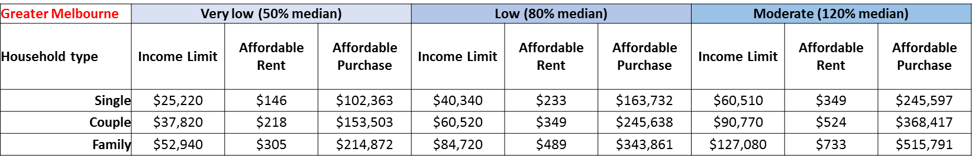

In summary:

* for a very low income single person household living in Greater Melbourne and earning $25,220 per annum, weekly rent must be less than $146 to be considered affordable
* for a low income couple household living in Greater Melbourne and earning $60,520 per annum, weekly rent must be less than $349 per week, and a dwelling less than $245,638 to purchase to be considered affordable
* for a moderate income family household living in Greater Melbourne and earning $127,080 per annum, rent must be less than $733 per week and a dwelling less than $515,791 to purchase to be considered affordable.[23]

An assessment of affordability of the Cardinia Shire market against these income bands and affordable price points is undertaken in Part B.

## Policy context

The strategy is situated within a broader policy framework, summarised in Figure 8.

1. Legislative and policy context

A screenshot of a social media post

Description generated with very high confidence

### Global context – United Nations Sustainable Development Goals

Housing rights are recognised as global human rights. The right to housing is more than simply a right to shelter. It is a right to have somewhere to live that is adequate. Whether housing is adequate depends on a range of factors including security of tenure, affordability, accessibility, location and cultural adequacy.[24]

In 2015 the Member States of the United Nations agreed on the 17 Sustainable Development Goals (SDGs) that are intended to guide global action on sustainable development until 2030.

Whilst all of the SDGs have targets that are directly or indirectly related to the daily work of local and regional governments, the Primary Goal 11: ‘Make cities and human settlements inclusive, safe, resilient and sustainable’ is particularly relevant.

Secondary targets of note include:

* end poverty in all its forms everywhere
* achieve gender equality and empower all women and girls
* reduce inequality within and among cities[25].

### Australian Government

The Australian Government influences housing markets through several policy interventions including in relation to population, employment, transport, taxation and income support.

**Financing and funding**

In relation to property, the Australian Government set and administer policies relating to capital gains tax, negative gearing, Commonwealth Rent Assistance (CRA), and the National Rental Affordability Scheme (NRAS).

Significant investment is made by the Australian Government through the National Affordable Housing Agreement (NAHA), the bi-lateral funding agreement with the Victorian Government, and directly to households in the form of CRA. CRA is not a supply subsidy and households may still be in housing stress despite this additional financial support.

The NAHA sets a range of shared objectives to improve both rental and ownership outcomes particularly for lower income households.

On 1 July 2018 the Australian Government established the National Housing Finance and Investment Corporation which is intended to:

* manage an affordable housing bond aggregator to drive efficiencies and cost savings in the provision of affordable housing by community housing providers
* administer $1 billion National Housing Infrastructure Facility, which will use tailored financing to partner with local governments in funding infrastructure to unlock new housing supply
* support the establishment of Managed Investment Trusts as a vehicle for institutional investment into affordable housing, with tax exemptions and benefits for the investor.

These initiatives will create a new institutional framework for affordable housing investment however subsidy will still be required to be coupled with these tools if significant supply outcomes are to be achieved.

### Victorian Government

The Victorian Government has access to several financial, funding and planning mechanisms that impact on housing affordability and the investment in, and delivery of, affordable housing.

**Financing and funding**

The Victorian Government is responsible for the collection and allocation of a range of taxes and service charges that relate to property development and ownership, including stamp duties, land taxes and infrastructure contributions.

The Victorian Government administers First Home Owner Grants (not tied to incomes) and in 2016 announced a package of housing initiatives intended to increase the supply of social and affordable properties (rent and purchase) for lower to moderate income households.

Specific housing investment strategies were announced in Homes for Victorians in 2017 and include:

* [$1 billion Social Housing Growth Fund](http://chfv.us4.list-manage.com/track/click?u=fbf08072653881a0a959aee4a&id=a00d5118cb&e=470ed7347c) to support new social housing construction or subsidise private rental outcomes
* [$1 billion loan guarantee program](http://chfv.us4.list-manage2.com/track/click?u=fbf08072653881a0a959aee4a&id=66c041843e&e=470ed7347c) to help Housing Associations secure more competitive commercial finance
* [$100 million revolving loan facility](http://chfv.us4.list-manage.com/track/click?u=fbf08072653881a0a959aee4a&id=3a548fa085&e=470ed7347c) which will increase the pool of capital available for Accredited Housing Agencies
* [transfer of the management of 4,000 public housing](http://chfv.us4.list-manage.com/track/click?u=fbf08072653881a0a959aee4a&id=41523fa4da&e=470ed7347c) dwellings to the community housing sector to manage on behalf of the State
* release of surplus government land to the market with an affordable housing requirement through an Inclusionary Housing pilot program
* establishment of a voluntary affordable housing framework to provide greater certainty as to the circumstances and affordable housing outcomes that could be supported on privately owned land
* additional financial support for First Home Buyers including removal of Stamp Duty for properties under $600,000 and an increase in the First Home Owners Grant in regional Victoria
* commitment to shared-equity home ownership programs.[26]

### Land use planning policy

Legislation and policies that establish the context by which a local authority plans for the use of land within its municipality, including for residential purposes are particularly relevant to affordable housing.

The Planning and Environment Act 1987 (the Act) provides the legislative framework under which planning policy is set and delivered in Victoria. Councils and decision makers must have regard to the Objectives of the Act and the matters set out in the Victorian Planning Provisions (VPPs) and State Planning Policy Framework (SPPF) when developing the Local Planning Scheme and Structure Plans and when determining planning matters (Figure 9).

Clause 16 of the SPPF directly deals with Housing.

1. Planning Framework

A close up of a device

Description generated with high confidence

Adapted from the Officer Precinct Structure Plan, September 2011 (amended March 2018)

#### Plan Melbourne

Recent update to the Victorian Planning Policy, Plan Melbourne, set a 35 year blueprint to ensure Melbourne’s growth is more sustainable, productive and liveable. The implementation plan sets out key actions, including actions to increase the supply of social and affordable housing and provide greater choice and diversity of housing.

Direction 2.3 includes a range of actions that the Victorian Government commits to undertake in order to increase affordable housing, including:

* streamlining decision-making processes for social/community housing proposals
* strengthening the role of planning in facilitating and delivering the supply of social and affordable housing
* creating ways to capture and share value uplift from rezonings.

From 1 June 2018 there is a stronger legislative basis and subsequent obligation on Local Councils to give regards to affordable housing when undertaken planning as a result of the incorporation within the Act of a:

* new Objective of Planning “to facilitate the provision of affordable housing in Victoria”
* definition of affordable housing
* statement confirming that a Responsible Authority may enter a Section 173 Agreement with a land owner to secure an affordable housing agreement.[27]

These new provisions are supported by a Governor in Council Order, Ministerial Notice and Departmental Guidance that provides further clarity on the definition of affordable housing and its translation, and a framework to support voluntary negotiations between local councils and land owners.

These legislative changes and associated documents:

* confirm planning has a role in facilitating affordable housing and that “one mechanism to facilitate the supply of affordable housing is through a voluntary agreement between a Responsible Authority and a landowner to deliver affordable housing as part of new developments”[28]
* highlight the importance of Local Governments establishing a strategic evidence base of local affordable housing need, on which to then base policies and negotiations with land owners (addressed by this strategy)
* establish income bands to define ‘very low, low and moderate income households’
* provide guidance as to assumptions on which to establish affordable rent and purchase price points
* establish a set of ‘Matters’ when considering the appropriateness of a proposed built form outcome in relation to the housing needs of very low to moderate income households
* recognise that value is required to be created to support built form costs (rezoning and increased density are two examples of where a value uplift is provided through the planning process that may support affordable housing being delivered)
* highlight planning incentives that Council may adopt, including truncated planning timeframes, rate exemptions, reductions in other planning requirements and reduced developer contributions.

The specific matters that must be given regards to when determining the appropriateness of a planning response to the housing needs of very low, low and moderate income households are set out in the Government Gazette, summarised in Figure 10.

1. Considerations when determining housing appropriateness

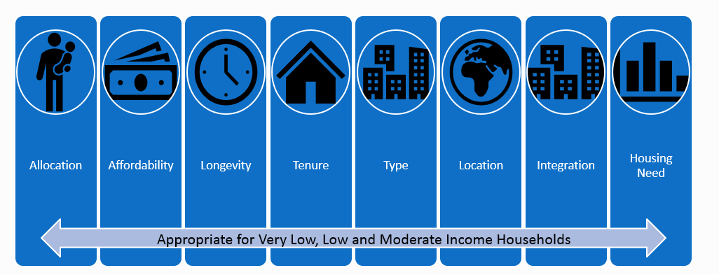

#### Other key policies

Several other policy areas impact on affordability and supply of housing, particularly transport education and health policies. Infrastructure contribution charges and the expenditure of these funds is also a key state policy of influence in Cardinia Shire.

### Local government policy context

The role of Local Government in supporting an increase in affordable housing is informed by legislative policies, powers and obligations.

Cardinia Shire Council’s Vision is that the Shire will be developed in a planned manner to enable present and future generations to live healthy and productive lives and to enjoy the richness of the diverse and distinctive characteristics of the Shire.[29]

**Funding and financing**

Local Governments have limited and constrained means of generating revenue and raising finance. Council revenue typically comprises of revenue from rates, government grants, developer contributions, and from activities such as car parking fees and fine collection.

**Policy**

Cardinia Shire Council has a strong set of planning, housing and community development policies that relate to the delivery of social and affordable housing as highlighted in Table 5.

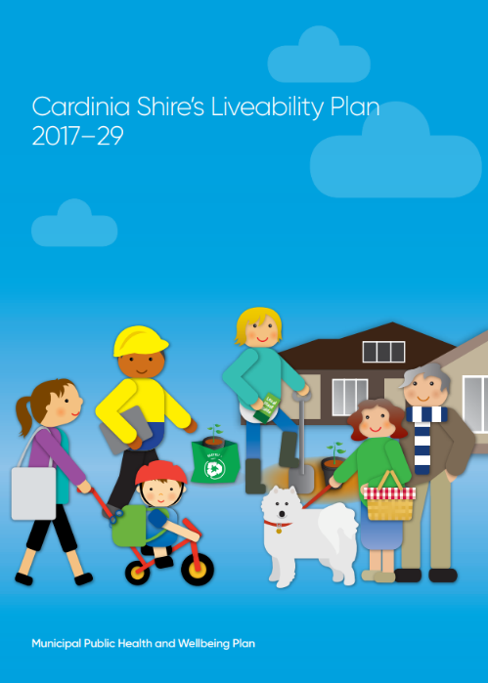Council’s Liveability Plan 2017-29 establishes seven policies domains, one of which is housing.

Four key strategies are identified under the Liveability Plan’s Housing chapter that guide Council action:

* Action 6.1: Supporting and facilitating affordable and flexible housing which caters for different households and meets the needs of all people.
* Action 6.2: Encouraging diversity in housing to meet the needs of existing and future residents across all life stages, including those with specific housing requirements.
* Action 6.3: Supporting high quality residential developments that respond to best practice in sustainability, environmental, safety and healthy by design guidelines.
* Action 6.4: Identifying opportunities to work with housing organisations to encourage development of sustainable community housing across the municipality.

Council’s Housing Strategy and Strategic Action Plan 2013−18 also recognises the importance of affordability in achieving Council’s housing vision.

1. Key Council strategies

|  |  |
| --- | --- |
| Strategy | Points relevant to Social and Affordable Housing Strategy |
| Council Plan, 2017 – 21 | Strategic Objective 2 (Our Community) includes an action to promote access to and encourage, a mix of housing types to cater for the varying needs of people in the Cardinia Shire community.  Emphasis on responding to and reducing family violence has a direct link to affordable housing provision. |
| Liveability Plan, 2017 - 29 | Provides Council with a clear framework that outlines a common agenda for public health planning.  Identifies housing as one of Council’s key Liveability policy domains with the key objective to increase access to appropriate and affordable housing. |
| Liveability Plan Strategic Directions Paper | Provides context and rationale for the development of Council’s Public Health and Wellbeing Plan;  Identifies several related issues surrounding both housing and affordable housing, including financial vulnerability of many lower income households and the need for increased affordable housing to “accommodate diversity in a community, to maintain social cohesion, and to support and sustain local economies with a range of services and businesses". |
| Housing Strategy 2013-18, Strategic Action Plan | Identifies key priorities and develops strategies as a response to the current housing issue within Cardinia Shire.  Recognises that “affordable, accessible and appropriate housing is one of the fundamental prerequisites for a healthy society, [as] it affects nearly every aspect of daily life” (p 3).  Includes specific section on housing affordability and the need for a diverse range of housing types, tenures and costs and a need to Increase the overall supply of developments for affordable houses, especially for households on low to moderate incomes. |
| Cardinia’s Access and Inclusion Policy 2017 | Outlines a strategic direction that improves accessibility and inclusiveness through the implementation of “practices, processes and planning” |
| Cardinia’s Age Friendly Strategy 2015 – 19 | Outlines the strategic direction for Council to create an ‘age friendly’ community  Identifies housing as a priority area with key objectives to:   * support Council’s housing action plan to facilitate development of a diverse, flexible, adaptable range of housing types and tenures for older residents * provide information to older residents about housing options and aged care support services * advocate to land developers for appropriate housing for older people |
| Child, Youth and Family Strategy 2017-21 | Provides the framework which supports the prevention and early intervention approaches that respond to priorities and key focus area identified by community, including by children and young people.  Outcomes of the policy around being safe, healthy and happy, connected, realising potential and economic wellbeing are all linked to the need for safe and secure, appropriate and affordable housing. |

## Role of local government

Council’s Housing Strategy reflects Council’s role and ability to influence the design and development of residential areas and facilitate new housing supply through planning and regulatory functions and via its various other roles set out in in Table 6 with specific consideration given to the potential influence or actions with regards to affordable housing.

1. Role of Council

|  |  |  |
| --- | --- | --- |
| Role | Description | Potential scope of actions |
| Leader and advocate | Take responsibility; present position based on evidence; lobby key stakeholders, such as Victorian and Local Government; Be Accountable; Show the way and consult widely. | Ensuring affordable housing is central to Council policy and planning deliberations.  Represent and advocate on behalf of the community for Australian and Victorian action and funding.  Demonstrate potential solutions through leading by example, e.g. development of Council land.  Lead community in conversation about importance of affordable housing.  Broker partnerships with housing agencies and between housing agencies and property developers.  Lead and work with other Councils in the region and facing similar issues (e.g. Interface Council Network, Homeless network). |
| Land-use planner | Planning for the efficient, orderly and appropriate use of land now and in the future, with consideration to balancing social, economic and environmental needs. | Facilitating the supply of affordable housing through the planning process.  Plan for the delivery of supporting infrastructure, housing diversity and affordable housing to meet the range of community needs, and long term sustainability and affordability. |
| Social planner | Planning the development of social services and facilities based on evidence based practise. | Plan for social infrastructure to support all residents.  Support vulnerable and lower income households with support services that increase social and economic capacity. |
| Community developer | Developing broad and deep collaboration across all levels of government, community service providers, developers and residents. | Capacity building activities by Local Government can come in many forms including:   * building of Council’s own knowledge, resources and capacity to find and deliver solutions * support for other organisations to build their capacity to develop and deliver responses that in turn support capacity building for individuals in the community * support for individuals or community groups to improve their own individual and localised capacity * a range of policy interventions that improve education, training and access to employment are required to support households that face housing stress. Councils can seek to address or influence these areas through policy and investments outside the scope of an affordable housing strategy. |

### Land use planning role and actions

This strategy emphases the role of Council to plan for and administer the use, protection and development of land due to the direct and important influence this role has on the delivery of housing supply and general housing affordability.

Land use planning and administration by Council is undertaken in accordance with the *Planning and Environment Act 1987*, the Victorian Planning Provisions (VPP) and the State Planning Policy Framework (SPPF).

The Cardinia Shire Planning Scheme sets the land use vision and objectives through a Municipal Strategic Statement (MSS) and a Local Planning Policy Framework (LPPF).

Planning Schemes in Victoria must seek to achieve the objectives of planning in Victoria as set out in Section 4(1) of the *Planning and Environment Act 1987*.

The new planning objective *‘t*o facilitate the provision of affordable housing in Victoria*’* is now aspecific objective. Council and decisions makers, including the Minister for Planning, Victorian Civil and Administrative Tribunal (VCAT) and Planning Panels Victoria (PPV) must give regard to the Act when assessing the application of planning policies and provisions.

This objective is reflected in Clause 16.01-1 in the SPPF; *Integrated Housing,* which has a stated Objective; *‘To promote a housing market that meets community needs’,* with strategies to:

* ensure that the planning system supports the appropriate quantity, quality and type of housing, including the provision of aged care facilities, supported accommodation for people with disability, rooming houses, student accommodation and social housing
* facilitate the delivery of high quality social housing to meet the needs of Victorians.

Council is required to ensure the Act and SPPF is responded to and reflected in its MSS, Local Planning Policy, Precinct Structure Plans and any other Council planning documents.

Identification of specific land use planning related actions Council will take to facilitate affordable housing are set out in Part C.

# Part B: Social and affordable housing needs assessment

The analysis of evidence relating to social and affordable housing need has identified several demographic, housing supply and affordability statistics that are of particular relevance as summarised in Figure 11.

1. Summary of key statistics

**A screenshot of a cell phone

Description generated with very high confidence**

Sources referenced within the document

## Demographics overview

The following trends underpin the assessment of supply and demand for social and affordable housing in Cardinia Shire.

* The population as at 2016 was 95,518 persons or 34,465 households, which is estimated to increase to 161,736 persons (59,498 households) by 2031[30]
* the median age is 34
* there is an average between 2.8 and 3.1 people per household[31]
* a significant household growth of 4.8 per cent occurred between 2011 and 2016. Strong rates of population growth are anticipated to continue over the next 20 years with an estimated 25,033 additional households projected from 2016 – 2031[32]
* the median weekly household income is $1,497, with median monthly mortgage repayments at $1,733 and median weekly rent at $320[33]
* 6,041 (21 per cent) of households are very low income (earning less than $494 per week)[34]
* 23.3 per cent of the population owned their dwelling, 46.7 per cent were purchasing their dwelling and 21.8 per cent were renting (compared with 29 per cent, 34.3 per cent and 28.8 per cent respectively for Greater Melbourne)[35]
* 1 per cent of residents live in social housing (decline from 1.3 per cent in 2011), this is less than the Greater Melbourne average of 2.6 per cent[36]
* A total of 14,947 persons (16 per cent of all persons) receive a Commonwealth pension or income allowance[37] (Table 7).

1. Recipients of Commonwealth allowance, Cardinia Shire, 2016

|  |  |
| --- | --- |
| Allowance | Number |
| Aged Pension (including DVA) | 8,435 |
| Carer Pension | 825 |
| Disability Support Pension | 2,274 |
| Newstart Allowance | 2,273 |
| Newstart for more than 365 days | 72 |
| Youth Allowance (full time students) | 746 |
| Youth Allowance (other) | 322 |
| Total allowances (other than Family Tax) | **14,947** |

Attachment 2 summarises key forecast data of relevance.

## Homelessness – demand and service provision

The data in relation to homelessness is singled out in recognition that these persons are highly vulnerable and on a very low income (or have no income) and are the priority groups for housing assistance.

**Homeless definition**

Under the ABS definition, a person is homeless if they do not have suitable accommodation alternatives and their current living arrangement:

* is in a dwelling that is inadequate
* has no tenure, or if their initial tenure is short and not extendable; or
* does not allow them to have control of, and access to space for social relations.[38]

**Homelessness in Cardinia Shire**

In 2016 Council commissioned a detailed study into the causes and impacts of homelessness in the Shire which found:

* significant levels of housing stress and increasing presentations to support services
* financial difficulties, domestic and family violence, and housing crises being the main reasons that led to residents seeking services; and
* over representation of women, sole-parent families, people with a history of mental illness, youth and people with a disability in presentations to support services.[39]

Financial vulnerability and housing insecurity is also noted to be exacerbated by chronic health, disability and family violence.

Of note:

* in 2016 there were 23.4 individuals per 10,000 residents in Cardinia Shire who are classified as homeless. This is up 20 per cent from 19.4 per 10,000 in 2011. Whilst the overall rate is lower than that for the whole state (41.9), the increase has been greater[40]
* between 2011 and 2016 the number of persons estimated to be homeless has risen by 52.8 per cent
  + 220 persons were estimated to be homeless in 2016, with a further 207 persons living in marginal housing[41]
  + compared to other Victorian interface Councils, Cardinia Shire shows the second highest increase in its rate of homelessness in the last 5 years (after Wyndham)
  + 49.1 per cent of homelessness occurs in Pakenham South[42]
* of the 220 estimated homeless people in Cardinia Shire in 2016
  + 57 per cent were living in ‘severely’ crowded dwellings
  + 24 per cent are staying temporarily with other households
  + 18 per cent are in supported accommodation[43]
* a total 507 people sought assistance related to specialist homelessness services between 2015 and 2016, representing a 56 per cent increase in the number of people requiring a specialist homeless service from 2011 to 2016;[44]
* people who are sleeping rough were typically doing so in the house, garage or driveway of someone they know[45]
* of recorded presentations to homeless service providers between 2015 and mid 2017
  + 34 per cent were single parent families
  + 28 per cent were people living on their own
  + 31 per cent of services were to people with a prior mental illness
  + 20.7 per cent of services were to young people (5 per cent of whom were homeless in 12 months prior)[46]
* 31.5 per cent of all presentations were due to domestic and family violence were female[47]
* the number of households accessing services exceeded projections in 2015−16 by 24 per cent[48]
* in 2018, there are four registered boarding houses in Pakenham and an estimated 30 transitional properties across Cardinia Shire[49]
* compared to neighbouring LGAs, Cardinia Shire has the highest percentage increase in the rate per 10,000 population (although the actual number and rate is lower) (Table 8)
* when compared to other interface LGAs, Cardinia Shire has the second highest increase in rate per 10,000 behind Wyndham[50]
* within Cardinia Shire the majority of people classified as homeless are in the Pakenham South and Pakenham North SA2 regions. In the last 5 years there has been a shift in homelessness out of the Pakenham area into Bunyip, Garfield, Beaconsfield and Officer (Figure 12).

1. Rates of homelessness 2016 – comparison rate and percentage change

|  |  |  |  |
| --- | --- | --- | --- |
|  | 2016 number | 2016 rate per 10,000 population | % change by rate  2011-2016 |
| Cardinia | 220 | 23.4 | 20% |
| Casey | 1,280 | 42.8 | 16% |
| Dandenong | 1,942 | 127.7 | 14% |
| Yarra Ranges | 366 | 24.5 | 6% |
| Victoria | 24,828 | 41.9 | 1% |

1. Percentage of homeless in SA2 Regions (ABS 2018)



## Market housing supply

A preliminary analysis of general housing supply data shows that in 2016:

* predominant dwelling type in the Shire is separate house (90.9 per cent) with a significant percentage (86.9 per cent) having three or more bedrooms[51]
* 1.2 per cent of all dwellings had one bedroom, and 9.5 per cent two bedrooms[52]
* an estimated 6.9 per cent of dwellings are unoccupied (2,418 dwellings)[53]
* prices ranged from
  + median vacant house block price of $210,000
  + median house price of $410,000
  + median unit/apartment price of $307,300[54]
* an estimated 6,694 households are in private rental[55]
* median rent of all dwellings made available to rent over the course of 2017 was $352 per week (an increase from $345 in 2016)[56]
* median rents during the September - December 2017 quarter ranged from
  + $290 per week for a two-bedroom unit
  + $320 per week for a two-bedroom house
  + $310 per week for a three-bedroom house[57]
* strong growth in new supply, with 1,938 building approvals in 2016-17 and a forecast average of 1,574 dwellings per annum between 2016 – 2036[58]
* an estimated 60,494 dwellings (total) by 2036, representing an additional 31,480 dwellings from 2016.[59]

The majority of new supply is expected to be concentrated along the Officer – Pakenham growth corridor.

#### Supply of smaller dwellings

10.7 per cent of the Shire’s existing housing stock comprises of 1 or 2 bedrooms, whilst 17 per cent of all households only have one person residing in them.

The figures at Attachment 2 highlight this mismatch.

The lack of affordable smaller dwellings to rent or purchase is expected to make it harder for single person and sole parent households to access appropriate and affordable housing in Cardinia Shire.

For lower income households this is a particular issue as their income limits their capacity to pay for a larger house. This issue is clearly demonstrated by the lack of one and two bedroom private rental dwellings that would be affordable for singles and couples in receipt of a government allowance.

Competition for limited smaller dwellings is expected to further exacerbate this and potentially push up prices at a faster rate than larger dwellings.

## Social and affordable housing - supply and demand

The following snapshot of key social and affordable housing supply and demand figures (Figure 13) supports the case for action.

1. Key social and affordable housing supply and demand figures (2016)

|  |  |
| --- | --- |
| **Supply**  **Home** | 0.9 per cent of all dwellings are dedicated for social housing (317 dwellings), which is very low compared to Greater Melbourne declining average of 2.6 per cent.[60]  Based on Victorian averages, approximately 10 per cent of these households are in inappropriate or overcrowded dwellings and/or want to move to a more suitable location. |
| 2,233 private rental dwellings (31.8 per cent all rentals) that were available for rent during 2016 were affordable for very low-income households,[61] however there is no guarantee of access, with higher income households potentially occupying these dwellings.[62] |
| Estimated up to 30 transitional housing dwellings, with approximately 50 per cent catering for women.[63] |
| Four rooming houses and two caravan parks understood to be providing some short term rental to lower income households.[64] |
| **Demand**  **Family with boy** | 220 persons were estimated to be homeless with a further 207 in marginal housing.[65] |
| Estimated 11,099 low income households (earning less than $650 per week).[66] |
| 11.8 per cent (3,856 households) of Cardinia Shire's households in the lowest 40 per cent of incomes were experiencing housing stress (paying more than 30 per cent of income on rent or mortgage costs) compared to 11.7 per cent in Greater Melbourne.  Proportions range from a low of 3.7 per cent in Beaconsfield Upper and District to a high of 19.2 per cent in Pakenham Central.[67] |
| 2,121 lower income renter households were in rental stress (compared to 1,641 in 2011), representing 29.7 per cent of all households in private rental and 69 per cent of all low income households in private rental.[68] |
| 1,736 lower income households were in mortgage stress and at risk of requiring affordable private rental or social housing (compared to 1591 in 2011).[69] |
| 4,086 households are registered on the Victorian Housing Register for the Southern metropolitan (Dandenong) region which includes Cardinia Shire. 1,592 of these households are assessed as priority for housing.[70] |
| Between July 2015 and April 2017 Housing Establishment Funds were provided to 595 households in the Cardinia Shire.[71] |

### Affordable rental

A detailed assessment of affordable rental supply and demand highlights:

* 8.1 per cent of all renter households are paying more than 30 per cent of income on rent[72]
* 65.1 per cent of all low income renter households are experiencing rental stress (2,121 households). This represents 19.11 per cent of all lower income households residing in Cardinia Shire[73]
* an estimated 2,233 of all new lettings across 2016 (31.8 per cent of all new lettings) were affordable for a household on a statutory income,[74] affordability of private rental does not mean access is provided[75]
* 26.4 per cent (189 dwellings) of all new lettings in the September to December 2017 quarter were affordable for a household on a statutory income, of which the majority had four bedrooms
  + 1BR: 0 per cent (0 dwelling)
  + 2BR: 6.25 per cent (5 dwellings)
  + 3 BR: 13.8 per cent (45 dwellings)
  + 4 BR: 53.1 per cent (139 dwellings)[76]
* the Rental Affordability Index, 2017 2nd quarter analysis[77] highlights
  + affordability for an ‘average rental household’ (defined as households earning less than $80,000 per annum) across the Shire was generally ‘acceptable’ (an index rating of between 120 and 150)
  + some areas of the Shire are ‘moderately unaffordable’ to unaffordable for lower income households including couple pensioners, single part time worker (earning less than $40,000 per annum) (index ratings of between 80 to 120)
  + less than 10 rental lettings during the period across a number of areas, the limited supply of one and two-bedroom dwellings generally partly explains this
* there is no dedicated youth crisis or long-term supported housing option in the Shire
* there are very limited transitional housing options in the Shire and only four registered rooming houses.

#### Affordable private rental dwellings over time (DHHS Rental Report 2017)

There has been a significant decline in affordability of private rental dwellings from 68.4 per cent of all dwellings available for rent in 2000 to 27.9 per cent in 2017.[78]

The following figures highlight the number and percentage of privately owned dwellings that were made available to rent in a given quarter and that would have been affordable for a household on a statutory income to rent (with regards given to household size and dwelling capacity). [79]

1. Affordable private rentals over time (2 Bedrooms) [80]
2. Affordable private rentals over time (3 Bedrooms) [81]
3. Affordable private rentals over time (All dwellings) [82]

The data highlights that despite the significant growth in housing supply in the Shire, the percentage of private rental dwellings that are affordable has significantly declined over time.

This is particularly the case for one and two bedroom dwellings which are notably lower, most likely related to the very small proportion of stock of this size.

Significantly:

* since 2000 there has never been more than three one-bedroom dwellings available for rent in any quarter that were affordable for a single person on a statutory income
* in 2007 an average 64 per cent of all two-bedroom dwellings made available for rent were affordable for a very low income earner (total 119 dwellings), in 2017 this had reduced to an average of 7.7 per cent (25 dwelling)
* in 2007 an average 75 per cent of all three-bedroom dwellings made available for rent were affordable for very low income earner (482 dwellings), in 2017 this had dropped to 17 per cent (61 dwellings)
* there has been a significant decline in affordability of private rental dwellings from 68.4 per cent of all dwellings available for rent in 2000 to 27.9 per cent in 2017.[83]

### Affordable purchase

* Home ownership rates have declined from
  + 25.6 per cent of all households fully owning their property in 2011 to 23.3 per cent in 2016
  + 48.4 per cent purchasing households in 2011 to 46.7 per cent in 2016[84]
* 1,736 lower income mortgage holders (11.4 per cent of all mortgage holders) are paying more than 30 per cent of income on housing, representing 15.64 per cent of all low income households[85]
* land prices increased by 33 per cent between 2000 and 2016 (Figure 17)[86]
* dwelling prices increased by 32 per cent between 2000 and 2016 (Figure 18).[87]

1. Median vacant lot price change over time, 2000-17[88]
2. Change in median prices 1986-2016[89]

## Affordability gap analysis

An assessment of the affordability gap reinforces the issue, with current housing in the Shire assessed as not being affordable for many household groups.

**Methodology**

1. Taking the Victorian Government established income bands under the Planning and Environment Act 1987, and adopting a ‘30 per cent of income on housing costs’ benchmark, the following estimated affordable rent and affordable purchase price points were established for households in Greater Melbourne[90] in Part A.
2. Estimated affordable rent/purchase prices for households in Greater Melbourne



1. Median rents and median sale prices (2017) were then been established for two different housing sizes (1 – 2 bedroom dwellings and 3+ bedroom dwellings)[91].
2. Median rents and median sale prices (2017) by property type

|  |  |  |
| --- | --- | --- |
| Property Type | Median Rent (2017) | Median Sale Price (2016) |
| 1 – 2 bedroom dwelling | $270 per week | $307,000 |
| 3+ bedroom dwelling | $352 per week | $410,000 |

1. This data (income bands, affordability for household groups, and median prices) then enables an assessment of affordability of the Cardinia Shire market for different households. To provide a meaningful analysis the following dwelling types are assessed as being appropriate for each household group:
   * single person: 1 – 2 bedroom dwelling
   * couple: 1 – 2 bedroom dwelling
   * family: 3+ bedroom dwelling
2. The income capacity of these households has then been assessed against the median rent in Cardinia Shire by property type to determine if there is a gap between market prices and household capacity to pay (Table 11).

Red/negative numbers indicate a gap between household capacity (affordable rent or affordable purchase) and median house prices and rent in Cardinia Shire.

Black numbers indicate the household income capacity is higher than median prices and the market is therefore estimated to be generally affordable.

1. Income capacity of household type



The analysis reflects the DHHS Rental Report assessment of affordability of private rental and highlights that:

* very low income singles and couples with household incomes of up to $52,940 are highly unlikely to be able to afford median rents in Cardinia Shire
* low income singles are unable to afford median rents for a 1 - 2 bedroom dwellings
* affordable purchase is out of reach for all very low and low income households and moderate income singles (even when accounting for smaller dwellings)
* purchase price points are only affordable for moderate income couples or families
* the very low percentage of one and two bedroom dwellings means that they are also unlikely to be available and if they are, there is likely to be high competition to access
  + there were only 403 dwellings in the entire Shire with 0 – 1 bedrooms in 2016 and only 3,090 with 2 bedrooms[92]
* only moderate income family households in Greater Melbourne could comfortably afford to rent or purchase a dwelling in Cardinia Shire, reflecting the dominant household mix of the Shire.

## Social housing supply gap

In 2016, 2,547 very low and low income households living in Cardinia Shire were estimated to have required social housing, representing 7.48 per cent of all households and 22.95 per cent of all low income households.

This analysis assumes

* all homeless persons (427 persons)
* 85 per cent of low income households in rental stress (1,803 households)
* all households residing in social housing (317 households) require a social housing response.

To meet this need, 7.21 per cent of all dwellings were required to be affordable and available to rent by very low to low income households in 2016 (2016 Social Housing Need).

In 2016, 317 dwellings were available as social rental housing in Cardinia Shire, representing 0.9 per cent of all dwellings.

There was subsequently an estimated 2016 social housing supply gap of 2,230 dwellings representing 6.31 per cent of all dwellings, being the gap between 2016 social housing need (2,547 dwellings) and 2016 social housing supply (317 dwellings).

By 2036, it is estimated that the social housing need will be for 5,621 dwellings (representing 8.37 per cent of all dwellings forecast for 2036).

To meet this demand an additional 265 dwellings need to be made affordable and available to lower income households per annum between 2016 and 2036 (totalling 5,304 dwellings), assuming there has been no change in 2016 levels of social housing and 2016 rates of demand remain static.

This represents an average of 17.03 per cent of all new dwelling supply forecast to be delivered per annum over the next twenty years that is required to be delivered as social rental housing to meet the needs of lower income households.

1. Estimated social housing supply requirement



1. Social housing supply requirement, number and percentage of forecast dwelling supply, 2016-36

# PART C: Social and affordable housing strategy action plan

## Strategy framework

1. Social and Affordable Housing Strategy 2018−25 Framework



### Strategy rationale

The evidence set out within Part B re-affirms the need for a significant increase in social and affordable housing to cater for unmet household need and respond to forecast population demand.

An analysis of the evidence has established three key areas where action is urgently required:

1. increase the supply of affordable social and community housing), for very low and low-income households and people with specialised needs
2. increase the supply of affordable private rental for very low and low-income households
3. increase the diversity of dwelling types to respond to population demographics and needs.

Three targets have been identified to provide an aspirational intent and a clear and measurable basis for progressing and monitoring actions (Figure 21).

### Strategic actions

The strategic actions establish the actions Council will take towards meeting the Objectives and Targets over the next 7 years.

The actions are in grouped in accordance with Council’s Liveability Plan 2017-29 action areas:

* support and facilitate affordable and flexible housing which caters for different households and meets the needs of all people (6.1)
* encourage diversity in housing to meet the needs of existing and future residents across all life stages, including those with specific housing requirements (6.2)
* support high quality residential developments that respond to best practice in sustainability, environmental, safety and healthy by design guidelines (6.3)
* identify opportunities to work with housing organisations to encourage development of sustainable community housing across the municipality (6.4).

The Actions also reflect the following context:

* key Council strategies, particularly the Housing Strategy 2013-18 and the Liveability Plan 2017-29 and the time period for this later document
* need to support the most vulnerable households to access social and affordable housing or reduce levels of housing stress in accordance with a human rights approach
* new Victorian Government policies, in particular Plan Melbourne and Homes for Victorians and policy and investment opportunities arising from these strategies
* introduced ‘to facilitate the provision of affordable housing’ as an objective of planning in Victoria, a definition of affordable housing, and clearer legislative support for the use of Section 173 Agreements to secure affordable housing outcomes
* Victorian Government support for voluntary affordable housing agreements being negotiated between Responsible Authorities and land owners.

## Key strategies

#### Leader and advocate

1. Continue to partner with, and strongly advocate to, the Victorian Government for an increase in investment in social and affordable housing in the growth areas and to mandate social and affordable housing for all future residential development.
2. Explore the use of Council assets to deliver social and affordable housing development.
3. Lead the community in a discussion on affordable housing.

#### Land use planning

1. Update Council’s MSS and LPPF to reflect recent changes to the Victorian legislation and policy. These changes are proposed to include:
   1. updates to reflect the new objective of planning ‘to facilitate the provision of affordable housing’ and the definition of affordable housing
   2. updates to the Key Issues section (21.01-3) of the MSS to include recognition that dedicated social and affordable housing is required to meet the housing needs of lower income and vulnerable households
   3. strengthening of Objective 1 Strategies (21.03-1) of the MSS to reflect the established need for an increase in one and two-bedroom dwellings
   4. strengthening of Objective 2 Strategies (21.03-1) of the MSS to reflect changes to the Act that introduced a new objective of planning in Victoria ‘to facilitate the provision of affordable housing’ and Council strategy to seek affordable housing outcomes in major rezonings and developments, with an incremental requirement to be put in place
   5. updating of Clause 21-03-1 of the MSS ‘Implementation’ to reflect consideration of social and affordable housing as a consideration with reference to the Social and Affordable Housing Strategy.
2. Pro-actively support development applications and planning scheme amendments by
   1. facilitating the involvement of registered housing agencies through the planning approval process as a priority
   2. considering potential dispensations such as reduction in car parking, improving development yield or considering rate reductions for community housing agencies
   3. supporting community engagement where required to address any community concerns.
3. Explicitly facilitating the provision of affordable rental housing on all developments or subdivisions where the expected total yield will be over 100 lots through seeking a minimum contribution of two per cent affordable housing (rising to 8 per cent by 2025) in the form of gifted built form to be provided to a registered housing agency.

This action is to be progressed via the issuing of a Council Statement of Intent to be provided to potential and current land owners and developers in advance of lodgement of planning applications and which will include the following for developers to refer to and respond to

* 1. reference to Victorian Planning Legislation Objectives and Definitions in relation to affordable housing
  2. a stated minimum baseline contribution of 2 per cent that Council will seek to facilitate and secure through negotiated agreements that occur between 2018 and 2021, rising to 4 per cent for applications considered between 2022 and 2025 and 8 per cent between 2025 and 2029
  3. rationale for the policy, with reference to the Housing Strategy and Social and Affordable Housing Strategy
  4. principles to inform negotiations
  5. considerations Council may take to facilitate the outcome including potential incentives.

1. Explore how Council could achieve an increase in the supply of one and two bedroom dwellings from 10.7 per cent to a minimum 12 per cent of all dwellings by 2025 to reflect household need.

This is estimated to require an additional 6.7 per cent of projected dwelling supply, or 133 dwellings per annum, to be delivered as one or two bedroom dwellings than would otherwise occur if the current dwelling typologies continued to be delivered at existing rates.

1. Undertake an audit of Council owned land to determine potential opportunities for social and affordable housing development.

#### Social planner and community development

1. Investigate with key stakeholders, the potential built form and management arrangements for specialist affordable housing for identified priority vulnerable household groups (such as youth, persons escaping family violence, persons with a disability) and assess opportunities to deliver housing for these households as part of the land audit process.
2. Undertake research to establish community attitudes to social and community housing. Monitor over time to determine whether support changes as a result of Council leadership and community engagement.
3. Undertake communication and engagement activities to increase community knowledge and support for affordable housing development.

## Strategic focus: value sharing and negotiated planning policy

The inclusion of a minimum 2 per cent affordable housing requirement on private land (Strategy 6) rising to 8 per cent from 2025 is a critical policy if a minimum percentage of social housing for very low and low income households is to be achieved.

This section discusses this action in more detail.

In adopting this strategy, Council acknowledges that addressing the overall affordable housing need of 2,547 dwellings (2016 level of need) requires collective government action in partnership with the private and not-for-profit sectors.

A range of investments and actions, particularly by Australian and Victorian governments is required to meet the total supply gap. Planning is identified by the Victorian Government as one tool that can contribute to meeting affordable housing supply requirements and is recognised as an objective of planning.

This strategy reflects the legislative requirement of Council (under the Planning and Environment Act 1987), to facilitate the provision of affordable housing in its municipality.

For the private sector to contribute towards meeting the affordable housing supply requirement it must be viable without costs being passed on to the market or resulting delays to the development progressing. Advanced notification and clarity in relation to requirements is critical to ensure this does not occur.

The expectation is that with sufficient notice the requirement will be factored in to land values, offset by the increase in land value as a result of the rezoning. In turn, the rezoning is creating the value uplift that is proposed to be shared. Council may also consider other incentives to further enhance the viability of the affordable housing component.

Specifically, this strategy seeks that through negotiations with land owners and developers, a minimum 2 per cent of total new residential dwellings is sought between 2018 and 2021 as part of the approval of any large scale subdivision or development where the estimated total yield is expected to be over 100 lots, to increase at the following rates over time:

* 2018−21: 2 per cent
* 2022−25: 4 per cent
* 2025−29: 8 per cent.

These dwellings are to be developed and provided to an accredited housing agency at nil consideration for ownership and use as affordable rental / social housing as a result of the value uplift created by the rezoning and/or other planning incentives or dispensations provided by Council. Gifting of a small percentage of completed stock is proposed as this will ensure delivery, as opposed to a discounted sale arrangement that would depend on third party investment.

Applications for slightly less than 100 dwellings will be carefully considered to ensure that a lower yield is not deliberately being proposed in order to avoid this contribution.

Housing agencies are to be encouraged to further leverage this contribution through securing grants or other funding to further increase the number of dwellings which could occurring through purchasing additional dwellings from the land owner.

The initial contribution rate and the proposed incremental increase has been determined on the basis:

* there is significant and growing affordable housing need, with a requirement for 17.03 per cent of all new housing supply to be delivered as social or affordable housing if current unmet need and forecast population demand is to be met
* the total required affordable housing supply requirement is not the entire responsibility of the market to achieve
* a contribution by the private sector is reasonable on the basis of value creation that is achieved through a rezoning approval or provision of other incentives
* two percent reflects that a number of land sites have already transacted and therefore any higher contribution may be difficult to achieve in the immediate term
* the cost impact of the contribution will over time be factored into land pricing and therefore will not have a negative impact on market pricing
* only 0.9 per cent of all dwellings (317 dwellings) were dedicated social housing in Cardinia Shire in 2016, resulting in a social housing supply gap of 2,230 dwellings.

In developing and applying this policy the Victorian Government published ‘matters’ required to be considered in determining whether affordable housing will be appropriate for the housing needs of very low, low and moderate income households have been considered as set out in Table 13.

1. Appropriateness considerations and priorities to be applied

|  |  |
| --- | --- |
| Housing need | Affordable housing need has been established by Council’s Social and Affordable Housing Strategy. |
| Location | All locations have some demand for affordable housing reflecting that older persons, unemployed persons, people with a disability, singles and sole parent families reside across all geographical areas.  Locations close to transport and services are priority areas for affordable housing.  Locations that are proposed to deliver significant numbers of new housing supply over time are prioritised. |
| Integration | Integration of affordable housing as a principle should be sought.  Advice from a registered housing agency will be sought as to the maximum ‘clustering’ of affordable housing dwellings in any precinct. |
| Tenure | A priority on affordable rental tenure is placed reflecting the affordable housing needs assessment which identifies very low and low income households as most likely to be in housing stress. |
| Type | The type of housing should reflect the household composition and housing needs. With a high need for smaller dwellings, duplexes, townhouses and apartments are to be encouraged.  A diversity of built form is required to address affordable housing need with particular need for smaller one and two bedroom dwellings that can accommodate singles and lower income couples. |
| Allocation | The housing is to be provided to a registered housing agency with the appropriate skills and systems to ensure the allocation of the property to a household in need. |
| Affordability | The housing is to be provided to a registered housing agency with the appropriate skills and systems to ensure the affordability of the property for a household in need. |
| Longevity | The transfer of dwellings at nil consideration to a registered housing agency as a result of the planning process is sufficient comfort that the dwelling will be utilised for affordable housing for an appropriate term. |

A range of actions by which Council will seek to support enhanced development value above that provided by the rezoning, and thereby support the viability of this request are proposed to be considered as part of the planning process. This will include consideration of requests to accommodate increased yield, for example through supported smaller lot subdivisions and considering other planning dispensations or other incentives by which Council could support whilst ensuring integrity of the planning system is maintained.

In exceptional circumstances Council may consider a cash contribution in lieu of on-site delivery where there are appropriate reasons for not providing the dwellings on-site. Any alternative delivery arrangement must be supported by a registered housing agency.

Attachment 3 sets out a draft policy statement as the basis for Council to progress this action.

## 

## **Action Plan 2018- 25**

**Timeframes:**

Short: <2 years

Medium: 2–4 years

Long 4–7 years

**Targets**

**T1:** By 2025, five (5) commitments to deliver affordable housing are secured for local government, state government and/or privately-owned land.

**T2:** By 2025, there is an increase in the diversity of dwellings in the Shire and specifically, an increase in the percentage of dwellings with 2 bedrooms or less within growth areas and strategic locations

**T3:** By 2025, research shows a measurable increase in positive community perceptions and attitudes towards social housing developments.

|  |  |  |  |  |  |  |
| --- | --- | --- | --- | --- | --- | --- |
| Liveability Strategy 6.1: Supporting and facilitating affordable and flexible housing which caters for different households and meets the needs of all people. | | | | | | |
| # | **Social and Affordable Housing Strategy Actions** | **Target** | **Council role** | **Timeframe (years)** | **Business unit lead** | **Business unit support** |
| 6.1.1 | Update and strengthen the Municipal Strategic Statement (MSS) and Local Planning Policy Framework (LPPF) to reflect that the Shire has identified the demand for social housing and will be adopting actions to facilitate the provision of affordable housing through planning. | T1, T2 | Land use planning | 2–4 years | policy design growth area planning | community strengthening |
| 6.1.2 | Review and update the 2013-2018 Council Housing Strategy to strengthen areas to improve housing diversity and affordability and incorporate and reflect the Social and Affordable Housing Strategy and Actions. | T1, T2 | Land use planning | 2–4 years | community strengthening | policy design growth area planning |
| 6.1.3 | Undertake a tour of local and neighbouring affordable housing projects to enhance Councillor and staff knowledge of affordable housing built form, tenancy and property management arrangements. | T3 | Leader and advocate | 2 years | community strengthening | policy design growth area planning and development and compliance services |
| 6.1.4 | Undertake research to ascertain resident understanding and tolerance of social and affordable housing. | T3 | Social planning | 2−4years | community strengthening |  |
| 6.1.5 | Develop and update fact sheets on homelessness, housing stress and social and affordable housing for distribution to agencies and the community. | T3 | Social planning, community development | < 2 years | community strengthening |  |
| 6.1.7 | Work in partnership with Interface Council Network and local community housing sector to develop a cross-Council approach to improve community awareness. | T1, T3 | Leader and advocate, social planning, community development | 2–4 years | community strengthening | communications team |
| 6.1.8 | Engage with local developers to:   * Increase the supply of smaller quality housing options in the housing market (smaller dwellings, not just smaller lots) * Identify how Council could further support smaller dwelling delivery in accordance with Precinct Structure Plan and Structure Plan objectives. | T1, T2 | Land use planning | 2−4 years | policy design growth area planning and development and compliance services | community strengthening |
| 6.1.9 | Engage with local real estate agents and service providers to identify potential affordable housing rental options for vacant properties | T2, T3 | Social planning, community development | 4−7 years | community strengthening | economic development |
| 6.1.10 | Continue to facilitate the Casey Cardinia Homeless Network and Strategic Leadership Group to identify and address local housing needs. |  | Social planning | 2 years | community strengthening |  |
| Liveability Strategy 6.2: Encouraging diversity in housing to meet the needs of existing and future residents across all life stages, including those with specific housing requirements. | | | | | | |
| # | **Social and Affordable Housing Strategy Actions** | **Target** | **Council role** | **Timeframe (years)** | **Business unit lead** | **Business unit support** |
| 6.2.1 | Encourage the provision of a minimum of 2 per cent Social and Affordable Housing (increasing over time to 8 per cent) on all developments or subdivisions over 100 lots through voluntary negotiations and the gifting of completed stock. | T1 | Land use planning | < 2 years then ongoing implementation | policy design growth area planning | community strengthening |
| 6.2.2 | In line with Victorian Government direction, undertake a review for the potential of moveable dwellings, (modular buildings) to increase affordable housing in appropriate and targeted locations. | T3 | Land use planning | 2−4 years | policy design growth area planning | community strengthening |
| 6.2.3 | Consider housing requirements for seniors, youth, people with disabilities and culturally diverse residents and develop checklists for developers and purchasers to consider | T2 | Land use planning, Social planning | 4−7 years | community strengthening |  |
| 6.2.4 | Partner with a senior support service agency to develop and disseminate information regarding dwelling adaptation for older residents wishing to age in place. | T2 | Social planning, community development, | 4−7 years | community strengthening |  |
| Liveability Strategy 6.3 Supporting high quality residential developments that respond to the best practice in sustainability, environmental, safety and healthy by design guidelines. | | | | | | |
| # | **Social and Affordable Housing Strategy Actions** | **Target** | **Council role** | **Timeframe (years)** | **Business unit lead** | **Business unit support** |
| 6.3.1 | Consider housing needs for single persons with regard to current Boarding Houses challenges and identify opportunities to improve safety, quality and access. | T2 | Social planning | 2−4 years | community strengthening | environmental health |
| 6.3.2 | Undertake a feasibility study to assess the specific housing needs of vulnerable residents with consideration to best practice residential development design guidelines and land location. | T1, T2 | Social planning | 2 years | community strengthening | policy design growth area planning |
| Liveability Strategy 6.4: Identifying opportunities to work with housing organisations to encourage development of sustainable community housing across the municipality. | | | | | | |
| # | **Social and Affordable Housing Strategy Actions** | **Target** | **Council role** | **Timeframe (years)** | **Business unit lead** | **Business unit support** |
| 6.4.1 | Host a targeted forum with housing agencies, government representatives and developers to discuss and support social and affordable housing opportunities | T1, T2, T3 | Leader and advocate | <2 years | community strengthening | policy design growth area planning |
| 6.4.2 | Work with DHHS to identify underutilised or ageing public housing stock that may be suitable for redevelopment or increased density | T1 | Land use planning | 4−7 years | community strengthening | policy design growth area planning |
| 6.4.3 | Improve community awareness by hosting events during Homeless week and Poverty Awareness week. | T3 | Leader and advocate | 2−4 years | community strengthening | communications |
| 6.4.4 | Undertake a land audit to identify potential Council owned land that could be sold or leased for social and affordable housing purposes | T1 | Social planning, land use planning, leader and advocate | < 2 years | community strengthening | governance |
| 6.4.5 | Continue to work with existing local service providers to:   * Identify social service gaps to support vulnerable residents * Identify and support service providers to access Australian or Victorian Government and/or private sector funding assistance; * Promote existing and new services to the community; * Support quality data collection and analysis to evaluate outcomes to inform program delivery |  | Social planning | 2−4 years | community strengthening |  |
| 6.4.7 | Advocate to Commonwealth and State Governments for an increase in investment in social and affordable housing supply by:   * Mandating social and affordable housing for all future residential development * Providing current data detailing local needs * Maintaining current contact * Working collaboratively with other interface Councils, housing agencies and providers * Responding to public consultation processes on any new policies to highlight the need in the Shire and opportunities to increase investment and supply. | T1 | Leader and advocate | Ongoing | community strengthening |  |
| 6.4.8 | Facilitate the delivery of social and affordable housing by not-for-profit housing agencies through:   * Prioritising social and affordable housing development applications * Considering planning concessions that may assist facilitation of social housing development. | T1 | Social planning, land use planning, leader and advocate | Ongoing | statutory planning and growth area statutory planning | policy design growth area planning |

# Part D: Implementation, monitoring and evaluation

The Action Plan will be reviewed in 2021 to ensure Council is on track to achieve the targets and to update actions to respond to changing Australian and State policy context, new or emerging issues or opportunities.

|  |  |  |  |  |  |
| --- | --- | --- | --- | --- | --- |
| Liveability Plan medium- term outcome | Indicators | Measures | Source / tool | Frequency | Responsible |
| Increased supply of affordable housing. | Number of commitments secured to deliver affordable housing on privately owned or government owned land | Number of permit conditions or Section 173 Agreements | Council record keeping | 5 years | statutory planning and growth area statutory planning / information services |
| Number and percentage increase in 1 and 2 bedroom dwellings | Increase in percentage of 1 and 2 bedroom dwellings | ABS: Number of social housing dwellings | 5−6 years (Census) | community strengthening |
| Improved community acceptance of affordable housing | Level of community acceptance of social and affordable housing | Increase in positive acceptance or response to affordable housing | Community research | 4 years | community strengthening |

# Attachment 1

Summary data of households seeking support from homeless services (2015/16 – April 2017

1. Living arrangements of households seeking assistance, July 2015 – April 2017[93]



1. Main Presenting Reason to service providers in Cardinia Shire, July 2015 – April 2017[94]



# Attachment 2

**Forecast population growth**

Cardinia Shire’s population is forecast to grow to 198,626 by 2041; a 55 per cent increase between 2018 and 2041.

An annual average growth rate of 4.78 per cent is estimated between 2016 and 2026. The largest increase in persons between 2016 and 2026 is forecast to be in ages 0 to 4, which is expected to increase by 6,430 and account for 9.5 per cent of the total persons.

The largest increase in household types between 2016 and 2026 is forecast to be couple families with dependents, which will increase by 7,441 households and account for 39.9 per cent of all households by 2026.[95]

1. Forecast Population, Cardinia Shire 2016-41

A screenshot of a cell phone

Description generated with very high confidence

Cardinia Shire’s population growth is expected to predominantly be in the growth area, which is expected to increase by about 15,300 people (an increase of 26 per cent) and represent 66 per cent of the total population by 2020 (Figure 24).

1. Estimated population growth distribution 2016-20[96].

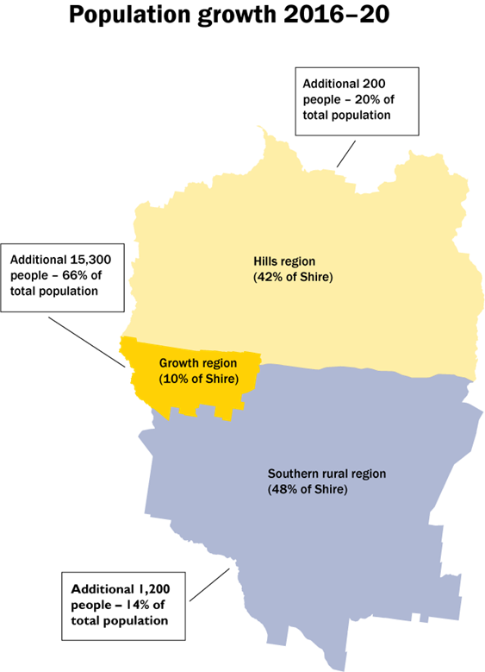

1. Forecast population, 5 year age structure, Cardinia Shire

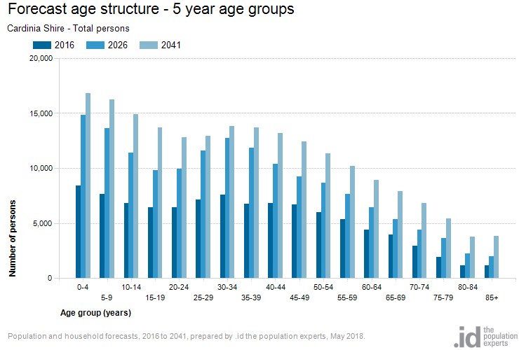

1. Forecast population, Household Types, Cardinia Shire

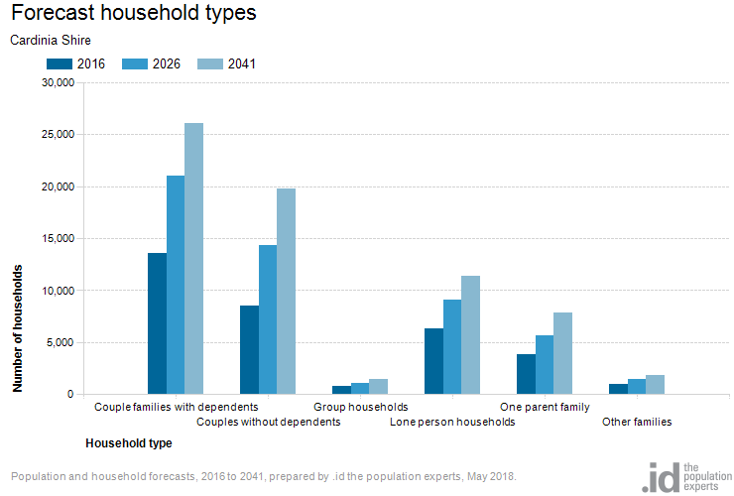

**Dwelling supply versus household types**

1. Number of bedrooms per dwelling, Cardinia Shire, 2016

A screenshot of a cell phone

Description generated with very high confidence

1. Household Type, Cardinia Shire, 2016

A screenshot of a cell phone

Description generated with very high confidence

# Attachment 3

**Draft Statement of Intent to Negotiate Affordable Housing Outcomes on Privately Owned Land**

**Policy Objective:**

Cardinia Shire Council’s Social and Affordable Housing Strategy 2018-25 identified that at 2016 there is an estimated shortfall of 2,230 social housing dwellings in the Shire. To meet this shortfall and to address projected demand, an estimated 17.03 per cent of all new housing supply forecast to be delivered per year between 2016 and 2036 is required to be delivered as affordable rental housing, representing an estimated 265 dwelling per annum.

In accordance with the objectives of the *Planning and Environment Act 1987*, Cardinia Shire Council’s intention is to facilitate the provision of affordable housing through a number of actions, including through agreement with land owners and developers of all developments over 100 dwellings (proposed yield) the transfer of completed dwellings to a registered housing agency for the purposes of affordable rental housing at the following rates:

* Between 2018 and 2021: 2 per cent of total proposed residential yield;
* Between 2022 and 2025: 4 per cent of total proposed residential yield; and
* Between 2025 and 2029: 8 per cent of total proposed residential yield.

**Planning Negotiated Outcomes**

Council will work with land owners and developers in accordance with the State Government supported voluntary negotiation policy guidance (available at <https://www.planning.vic.gov.au/policy-and-strategy/affordable-housing>) and the concept of value sharing to secure a percentage of the overall affordable housing supply requirement in the form of a contribution towards affordable housing.

It is Council’s intention to work with land owners and/or developers in the pre-planning approval stage to secure a commitment to a minimum total new residential dwellings in any large scale subdivision or development over 100 lots to be built and provided to an Accredited Housing Agency at nil consideration. The rate will increase from 2 per cent for applications made between 2018 and 2021, increasing to 8 per cent by 2025.

Proposals that deliver more than the minimum requirement are also encouraged. Council encourages Housing Agencies to leverage this contribution through securing grants or other funding to further increase the number of dwellings and response to affordable housing need in the Shire.

**Additional Council support**

A range of actions by which Council may support enhanced development value and thereby enhance the viability of this policy have been identified and include consideration of requests to accommodate increased density within an area, for example through supported smaller lot subdivisions and considering other planning or other incentives by which Council could support delivery.

Council will also support developers to connect to and partner with community housing agencies.

Information on community housing agencies, including contact details, can be found at <https://chiavic.com.au/developers/>.

In exceptional circumstances Council may consider a cash contributions in lieu of on site delivery where there are appropriate reasons for not providing the dwellings on-site. Any alternative delivery arrangement must be supported by a registered housing agency.

**Process of negotiation and agreement**

The following process will guide the approach to implementation of this policy:

1. Promotion and provision of this Statement of Intent will be provided by Council to land owners and potential developers that may be considering a rezoning and developing in the Shire.
2. Pre-lodgement discussions between Council and the land owner will be held to confirm Council position and to discuss the potential affordable housing outcome that could be achieved on a site. This discussion will include Council:
   1. Reaffirming the basis of their request and the proposed affordable housing outcome they are seeking as a minimum outcome;
   2. Providing a copy of these State Government’s Guidance and other information in relation to the translation of the affordable housing definition in particular, in regards to the criteria of ‘appropriateness’;
   3. Referring the land owner to information on the community housing sector and specific agencies that have been identified as having an interest in the area.
3. Discussions with other parties (potential End Recipients) by the land owner as to these organisation’s requirements in relation to the minimum dwellings to be transferred and to an Agency capacity to support and enhance the outcome to achieve any additional affordable housing above the base contribution.
4. Documentation of the Agreement including in a Section 173 Agreement, with regards given to:
   1. Number or percentage of dwellings to be transferred;
   2. Timeframe for delivery;
   3. Sunset clause once transfer has occurred.

# References

1. Cardinia Shire Council Liveability Plan 2017 – 2029, page 5
2. Cardinia Shire Council (2017) Strategic Directions Paper, For development of the Municipal Public Health and Wellbeing Plan, October 2017
3. Figure based on 19.1 per cent of all low income households that were estimated to be in housing stress in 2016 (ID Profile). 2016 figure adjusted to include estimated number of homeless in 2016 (ABS 2018).
4. 2016 unmet affordable housing need (2,548 dwellings) divided by 20 years to determine number of dwellings required to be delivered per annum to meet current need (127 dwellings).
5. Witte, E. 2017 ‘The case for investing in last resort housing’, MSSI Issues Paper No. 10, Melbourne Sustainable Society Institute, The University of Melbourne. Calculation based on 220 persons defined as homeless in Cardinia Shire as at 2016 Census
6. Department of Health and Human Services (2018) Victorian Housing Register, Total number of social housing applicants on the Victorian Housing Register - March 2018
7. ID Consulting – ID Profile (2018) <https://profile.id.com/Cardinia/>
8. ABS (2018) 2049.0 - Census of Population and Housing: Estimating homelessness, 2016, <http://www.abs.gov.au/AUSSTATS/abs@.nsf/DetailsPage/2049.02016?OpenDocument>, Accessed 27 May 2018
9. Judith Stubbs and Associates (2017), The Nature and Extent of Homelessness, Risk of homelessness and Financial Vulnerability: Cardinia Shire,
10. Judith Stubbs and Associates (2017), ibid
11. DHHS Rental Report (2018) Affordability over time, Author’s analysis of time series
12. DHHS Rental Report
13. ID Consulting – ID Profile (2018), Percentage of dwellings comprising of three, four and five or more bedrooms as at 2016 <https://profile.id.com/Cardinia/>
14. ID Consulting - ID Profile (2018), Percentage of dwellings comprising of one and two bedrooms as at 2016 <https://profile.id.com/Cardinia/>
15. ID Consulting – Social Atlas, (2018), Households in bottom 40 per cent of incomes in Rental Stress as at 2016, Cardinia Shire, <https://atlas.id.com.au/cardinia>
16. ID Consulting – Social Atlas, (2018), Households in bottom 40 per cent of incomes Mortgage Stress as at 2016, Cardinia Shire <https://atlas.id.com.au/cardinia>
17. <http://www.humanrights.gov.au/our-work/rights-and-freedoms/projects/housing-homelessness-and-human-rights>

    Judith Stubbs and Associates (2017), The Nature and Extent of Homelessness, Risk of homelessness and Financial Vulnerability: Cardinia Shire, June 2017 page 1
18. Victorian Planning and Environment Act 1987
19. ICESCR, Article 11 quoted in statement from <http://www.humanrights.gov.au/our-work/rights-and-freedoms/projects/housing-homelessness-and-human-rights>
20. Cardinia Shire Council (2017) Liveability Plan 2017-29, referencing Melbourne School of Design - Transforming Housing. Affordable Housing for All. Melbourne: Faculty of Architecture, Building and Planning, University of Melbourne; 2016.
21. Government of Victoria, Government Gazette, 31 May 2018
22. Calculations as to affordable purchase is based on the following assumptions:

    10 per cent deposit

    25 year term

    6.69 per cent interest rate (Reserve Bank Standard Variable Rate average over 10 years)

    30 per cent income on mortgage repayments

    fortnightly repayments.
23. Note that these affordability measures are based on the upper income band for each household type. Actual affordability will vary depending on individual household income.
24. <https://www.humanrightscommission.vic.gov.au/human-rights/the-charter-and-local-government/charter-obligations>
25. United Cities and Local Government ‘The Sustainable Development Goals, What Local Government’s Need to Now, <https://www.uclg.org/sites/default/files/the_sdgs_what_localgov_need_to_know_0.pdf>
26. Victorian Government (2017), ibid
27. Parliament of Victoria (2017) Planning and Building Legislation Amendment (Housing Affordability and Other Matters) Act 2017, Assented to 26 September 2017
28. Department of Environment, Land, Water and Planning, (2018) Planning Mechanisms for Affordable Housing, <https://www.planning.vic.gov.au/policy-and-strategy/affordable-housing>
29. Cardinia Shire Council (2018) Draft Council Plan 2018, March 2018
30. Victoria in Future (2018) Households by Household Type, Local Government ARea
31. Victorian Government policy is to use 2.86 persons per household, which is the ABS reportable figure. Based on discussions with demographers from Victorian Planning Authority (VPA) and Council the size of the household has been supported as 3.1 persons per household, based on peak population and ultimate population figures experienced in Cardinia Shire and elsewhere in other growth corridors. The range is therefore reflected in this report, noting that other statistics referenced relate to the ABS Census 2016 figure of 2.8 persons.
32. Victoria in Future (2018)
33. ABS
34. ID Consulting – ID Profile
35. ID Consulting – ID Profile <https://profile.id.com/Cardinia/>
36. ID Consulting – ID Forecast and ID profile <https://profile.id.com/Cardinia/> and <https://forecast.id.com.au/cardinia>
37. # ABS (2018) Cardinia (S) (LGA) (21450) Quick Stats

    <http://stat.abs.gov.au/itt/r.jsp?RegionSummary&region=21450&dataset=ABS_REGIONAL_LGA&geoconcept=REGION&datasetASGS=ABS_REGIONAL_ASGS&datasetLGA=ABS_NRP9_LGA&regionLGA=REGION&regionASGS=REGION>
38. <http://www.abs.gov.au/ausstats/abs@.nsf/mf/2049.0>
39. Judith Stubbs and Associates (2017) ibid
40. ABS (2018) 2049.0 - Census of Population and Housing: Estimating homelessness, 2016, <http://www.abs.gov.au/AUSSTATS/abs@.nsf/DetailsPage/2049.02016?OpenDocument>, Accessed 27 May 2018
41. ‘Homeless’ is defined by the ABS as persons living in tents, improvised dwellings, sleeping out, living in supported accommodation for the homeless, temporarily staying with someone else, living in a boarding house or temporary lodgings and people living in ‘severely overcrowded’ dwellings. Marginal housing includes people living in other crowded or improvised dwellings and people marginally housed in caravan parks
42. ABS (2018) 2049.0 - Census of Population and Housing: Estimating homelessness, 2016, <http://www.abs.gov.au/AUSSTATS/abs@.nsf/DetailsPage/2049.02016?OpenDocument>, Accessed 27 May 2018
43. ABS (2018) 2049.0 - Census of Population and Housing: Estimating homelessness, 2016, <http://www.abs.gov.au/AUSSTATS/abs@.nsf/DetailsPage/2049.02016?OpenDocument>, Accessed 27 May 2018
44. Judith Stubbs and Associates (2017) ibid
45. Judith Stubbs and Associates (2017) ibid
46. Judith Stubbs and Associates (2017) ibid
47. Judith Stubbs and Associates (2017) ibid
48. Judith Stubbs and Associates (2017) ibid
49. Judith Stubbs and Associates (2017) ibid and Consumer Affairs Victoria Public Register of Rooming Houses, accessed 27 May 2018,
50. ABS (2018) 2049.0 - Census of Population and Housing: Estimating homelessness, 2016, <http://www.abs.gov.au/AUSSTATS/abs@.nsf/DetailsPage/2049.02016?OpenDocument>, Accessed 27 May 2018
51. ID Consulting – ID Profile
52. ID Consulting – ID Profile
53. ID Consulting – ID Profile
54. Guide to Property Values 2017
55. ID Consulting - ID Profile
56. DHHS (2018) Rental Report Time Series, Author’s analysis
57. DHHS, (2018) Rental Report December 2017 quarter
58. ID Consulting – ID Profile
59. ID Consulting - ID Forecast
60. ID Consulting – ID Profile
61. Affordable Development Outcomes, analysis of ID Consulting
62. DHHS (2018) Rental Report
63. Judith Stubbs and Associates (2017) ibid
64. Consumer Affairs Victoria (2018) Public Register of Rooming Houses, accessed 27 May 2018; and Judith Stubbs and Associates (2017) ibid
65. ABS (2018) Catalogue 2049.0 - Census of Population and Housing: Estimating homelessness, 2016,
66. ID Consulting – ID Profile, with additional advice provided by ID Consulting via correspondence 28/6/18
67. ID Consulting – ID Profile
68. ID Consulting – ID Profile and ABS
69. ID Consulting – ID Profile and ABS
70. DHHS (2018) Victorian Housing Register, Total number of social housing applicants on the Victorian Housing Register - March 2018
71. Judith Stubbs and Associates (2017) ibid
72. Australian Bureau of Statistics (ABS) (2018) Census 2016 Quick Stats, Cardinia Shire Local Government Area
73. ID Consulting – ID Profile, with additional advice provided by ID Consulting via correspondence 28/6/18
74. DHHS Rental Report (2017) Author’s analysis of time series
75. AHURI
76. DHHS Rental Report (2018)
77. Rental Affordability Index (2018)
78. DHHS Rental Report (2018) Author’s analysis of time series
79. DHHS Rental Report (2018) Affordability over time, Author’s analysis of time series
80. DHHS Rental Report (2018) Affordability over time, Author’s analysis of time series
81. DHHS Rental Report (2018) Affordability over time, Author’s analysis of time series
82. DHHS Rental Report (2018) Affordability over time, Author’s analysis of time series
83. DHHS Rental Report (2018) Affordability over time, Author’s analysis of time series
84. ID Consulting – ID Profile
85. ABS (2018) Census 2016 Quick Stats, Cardinia Shire <http://www.censusdata.abs.gov.au/census_services/getproduct/census/2016/quickstat/LGA22310>
86. Victorian Valuer General (2017) Guide to Property Values 2016
87. Victorian Valuer General (2017) Guide to Property Values 2016
88. Victorian Valuer General (2017) Guide to Property Values 2016
89. Victorian Valuer General (2017) Guide to Property Values 2016
90. The affordability of an area is assessed using wider geographical income bands (Greater Melbourne) reflecting that households not already residing in an area may require access to housing but are already locked out of the local market. This approach also reduces distortions from applying local income bands which reflect the incomes of households who have been able to access housing in the area.
91. Victorian Guide to Property Values (2017) and DHHS Rental Report, time series, (author’s analysis)
92. ID Consulting - ID Profile
93. Judith Stubbs and Associates (2017) Figure 6.7: Living Arrangements at Presentation for WAYSS Cardinia Shire Clients 2015-April 2017 (Source: JSA 2017, WAYSS 2017)
94. Judith Stubbs and Associates (2017) Figure 9.15: Main presenting reasons of Cardinia Shire clients, 2015-16 and 2016-17 - Source: WAYSS, Support Period List Data, 2015-2017. Financial year 2016-17 data is based on data relating to activities occurring between 1 July 2016 and 27 April 2017
95. ID Consulting – ID Forecast <https://forecast.id.com.au/cardinia>
96. Cardinia Shire Council Draft Council Plan 2018