Cardinia Shire Council

Biodiversity Conservation Strategy 2019−29

June 2019

Prepared by:

Cardinia Shire Council
Environment and Heritage Unit
Published February 2019

© Cardinia Shire Council 2019
ABN: 32 210 906 807
20 Siding Avenue, Officer

PO Box 7, Pakenham Vic 3810
(DX 81006)

Phone: 1300 787 624
Email: mail@cardinia.vic.gov.au
Web: www.cardinia.vic.gov.au

Contents
1 Executive summary 5
2 Why is our natural environment important? 6
2.1 Cultural and settlement history 6
3 Vision 8
4 Goals and objectives 9
5 Legislative and policy context 10
5.1 Australian Government legislation and policies 10
5.2 Victorian Government legislation and policies 10
5.3 Local policies, strategies and plans 10
6 Our biodiversity 12
6.1 Flora 16
6.2 Fauna 16
6.3 Community values 17
7 Challenges for our biodiversity 18
8 Roles and responsibilities 22
8.1 Victorian Government 22
8.2 Council’s role 22
8.3 Residents 25
8.4 Community volunteers 25
9 Community engagement 26
10 Monitoring and review 27
11 Glossary 28
12 References 30
13 Action plan 31
14 Appendices 40

Figures
Figure 1. Biodiversity outcomes with the successful implementation of the strategy vision 8
Figure 2. Land managed by Cardinia Shire Council 13
Figure 3. Biodiversity hot spots in Cardinia Shire 15
Figure 4. Council’s diverse role to protect and enhance our natural environment 24

Tables
Table 1. Goals and objectives 9
Table 2. Number of known animal species (excluding invertebrates) within Cardinia Shire 16
Table 3. Biodiversity challenges and opportunities 19

Abbreviations
ABCS | Australian Biodiversity Conservation Strategy
CaLP | Catchment and Land Protection Act 1994
CAMBA | China−Australia Migratory Bird Agreement
CEC | Cardinia Environment Coalition
DEDJTR | Department of Economic Development, Jobs Transport and Resources
DELWP | Department of Environment, Land, Water and Planning
EVC | Ecological Vegetation Class
EPBC Act | Environment Protection and Biodiversity Conservation Act 1999
FFG | Flora and Fauna Guarantee Act 1988
GIS | Geographic Information System
JAMBA | Japan−Australia Migratory Bird Agreement
ROKAMBA | Republic of Korea-Australian Migratory Bird Agreement
SEP | Sustainable Environment Policy 2018-2028
SDGs | Sustainable Development Goals
VBA | Victorian Biodiversity Atlas
VCT | Victorian Conservation Trust Act 1972

- Executive summary
This strategy provides a strategic and planned approach to sustainably manage Cardinia Shire’s natural environment so that it is resilient, healthy and valued by the community.

Cardinia Shire’s native plants and animals have an intrinsic right to exist, as a consequence all public and private land managers are custodians of approximately 1,739 native plant and animal species that make up the local natural environment. Working together to protect our local environment provides the community with an important sense of identity. Living with healthy populations of native plants and animals is important to our quality of life; providing us with shade, improved water and air quality, places for recreation, mental health and spiritual benefits, while also helping mitigate climate change. Working together to protect our environment also helps achieve altruistic goals and economic benefits such as supporting healthy waterways and pastures and sheltering stock and pastures from climate extremes.

Since European settlement of Australia, the natural environment has deteriorated incrementally through vegetation removal for agriculture and development, altered fire regimes and also from the invasion of weeds and pest animals. More than four legislative acts provide direction for Council to protect native flora and fauna against threats that contribute to species decline.

Compounding this decline are low levels of understanding of the factors affecting our environment in the community. The natural environment, which is our natural heritage, may not be sufficiently in the forefront of the community’s decision making and values and is often not reflected in community land management.

The need to take action now is clear: 94 of our native plants and 63 of our native animal species are ‘rare’ or ‘threatened’ and 33 per cent of our native vegetation communities are listed as ‘endangered’. Private properties make up approximately 83 per cent of the shire, however vegetation only covers 14 per cent of these properties.

This strategy has been developed based on data collected in 2017 by Council in a review and audit of biodiversity health and on scientific reporting of the threats to biodiversity in Cardinia Shire. Community questionnaires and workshops have also informed priorities set out in this strategy.

The strategy identifies goals and objectives to address threats to our natural environment and meet our legislative obligations to protect native flora and fauna. A detailed 10-year action plan is included to deliver on these goals and promote a shared purpose with the community on the importance of the natural environment and its link to our quality of life.

Why is our natural environment important?
Native plants and animals have an intrinsic right to exist. Cardinia Shire is home to 1,325 native plants and 414 native animals. Unfortunately however, 94 native plants are listed on the state advisory list as ‘rare’ or ‘threatened’ and 63 native animals are recorded as ‘rare’ or ‘threatened’. We have responsibilities as custodians of the land and under national and state legislation to protect our remaining native species and ensure that threatened species do not become locally extinct.

Our quality of life is also linked to a healthy natural environment and the ‘ecosystem services’ that the environment provides. Ecosystem services are defined as ‘the benefits provided to humans through the transformations of resources (or environmental assets, including land, water, vegetation and atmosphere) into a flow of essential goods and services, for example clean air, water, and food’ (Constanza et al., 1997). In Cardinia Shire our native animals, plants and micro-organisms are the engine room of ecosystem services and include physical benefits such as shade, improved air and water quality, places for recreation and also spiritual and mental health benefits. These ecosystem services help to regulate climate change, protect soil and cycle nutrients and water.

Ecosystem services also provide extensive economic benefits, such as providing native shelter belts which protect stock and pastures from erosion and weather events. Native species can also assist in improving pasture health and controlling pests that impact crops. Environmental−economic accounting has the potential to drastically change the value placed on natural assets when we calculate the potential economic cost of losing them and replacing the services they provide. This cost−benefit analysis helps to strengthen advocacy for the conservation of our natural environment.

The local environment provides our community in part with its local identify. From Emerald and Gembrook to Koo Wee Rup and Lang Lang, 53 different plant communities can be found. Each of these vegetation types have their own unique suite of native plants and animals which provide Cardinia Shire’s residents with a tangible sense of place and pride. Working together to enhance our natural environment provides us with social opportunities and the satisfaction and happiness of achieving altruistic goals.

Cultural and settlement history
The Yarra and Western Port catchments are part of the traditional country of the Mayone buluk and Yallock balug clans of the Bun Wurrung people and the Bulug willam clan of the Woi Wurrung (Canning et al. 2010). Each have strong connections to the land through their ancestral history and spiritual relationships, as custodians of the land for over 40,000 years.

The Boon Wurrung and the Woi Wurrung people are part of the broader alliance of the Kulin Nation which also includes the Watha Wurrung, the Djaja Wurrung and the Taung Wurrung peoples, who all shared a common language (Rhodes et al. 2004). The Boon Wurrung and the Woi Wurrung peoples intermarried and traded, moving freely (in accordance with mutually understood protocols) across each other’s territories. According to some observers, their contact was so frequent and so amicable, that boundaries between them may not necessarily have been rigidly defined.

Their movements were seasonal; during summer months they travelled along major streams, fishing for eels, and hunting and snaring game such as kangaroos, wallabies, possums, wombats and emus. They gathered plant foods, ate swamp-dwelling plants like the roots of rushes, and collected wild honey. In the cooler months, the Boon Wurrung people moved inland seeking shelter and gathering the pith of tree ferns and fishing Cardinia Creek.

The land was well-watered and was managed to provide plentiful food resources and shelter for its numerous inhabitants. In common with the practice of Aboriginal people throughout Australia, they skilfully used fire to clear forest areas into patchwork patterns to foster new plant growth, particularly grasses, to attract game and promote the growth of herbs, tubers, native fruits and nuts to balance their diet and to forestall bushfires. These land use practices have shaped the natural environment, creating the diverse legacy of native plants and animals now found in Cardinia Shire.

Council values the traditional owners’ knowledge and land management practices which can guide current land management.

From the earliest times of European settlement, Cardinia Shire’s natural environment has been detrimentally impacted. Cardinia Shire’s grasslands were rapidly colonised in this period. By the mid-19th century, most of the forested land in Cardinia Shire had been taken up by pastoral leases, part of the condition was that the land had to be ‘improved’ and cleared for agriculture. By 1900, the Koo Wee Rup swamp had been drained to expand agriculture, which impacted approximately 40,000 hectares of wetland ecosystems.

The natural environment is under increased threat and has continued to decline. Vegetation loss continues to incrementally create fragmented landscapes. Many species and communities suffer from the cumulative impacts of land cleared for development, minimising real or perceived fire threat and competition from introduced weeds and pest animals.

- Vision
Vision: Cardinia Shire’s natural environment is protected, valued and enhanced in partnership with the community to improve our quality of life

- Biodiversity outcomes with the successful implementation of the strategy vision

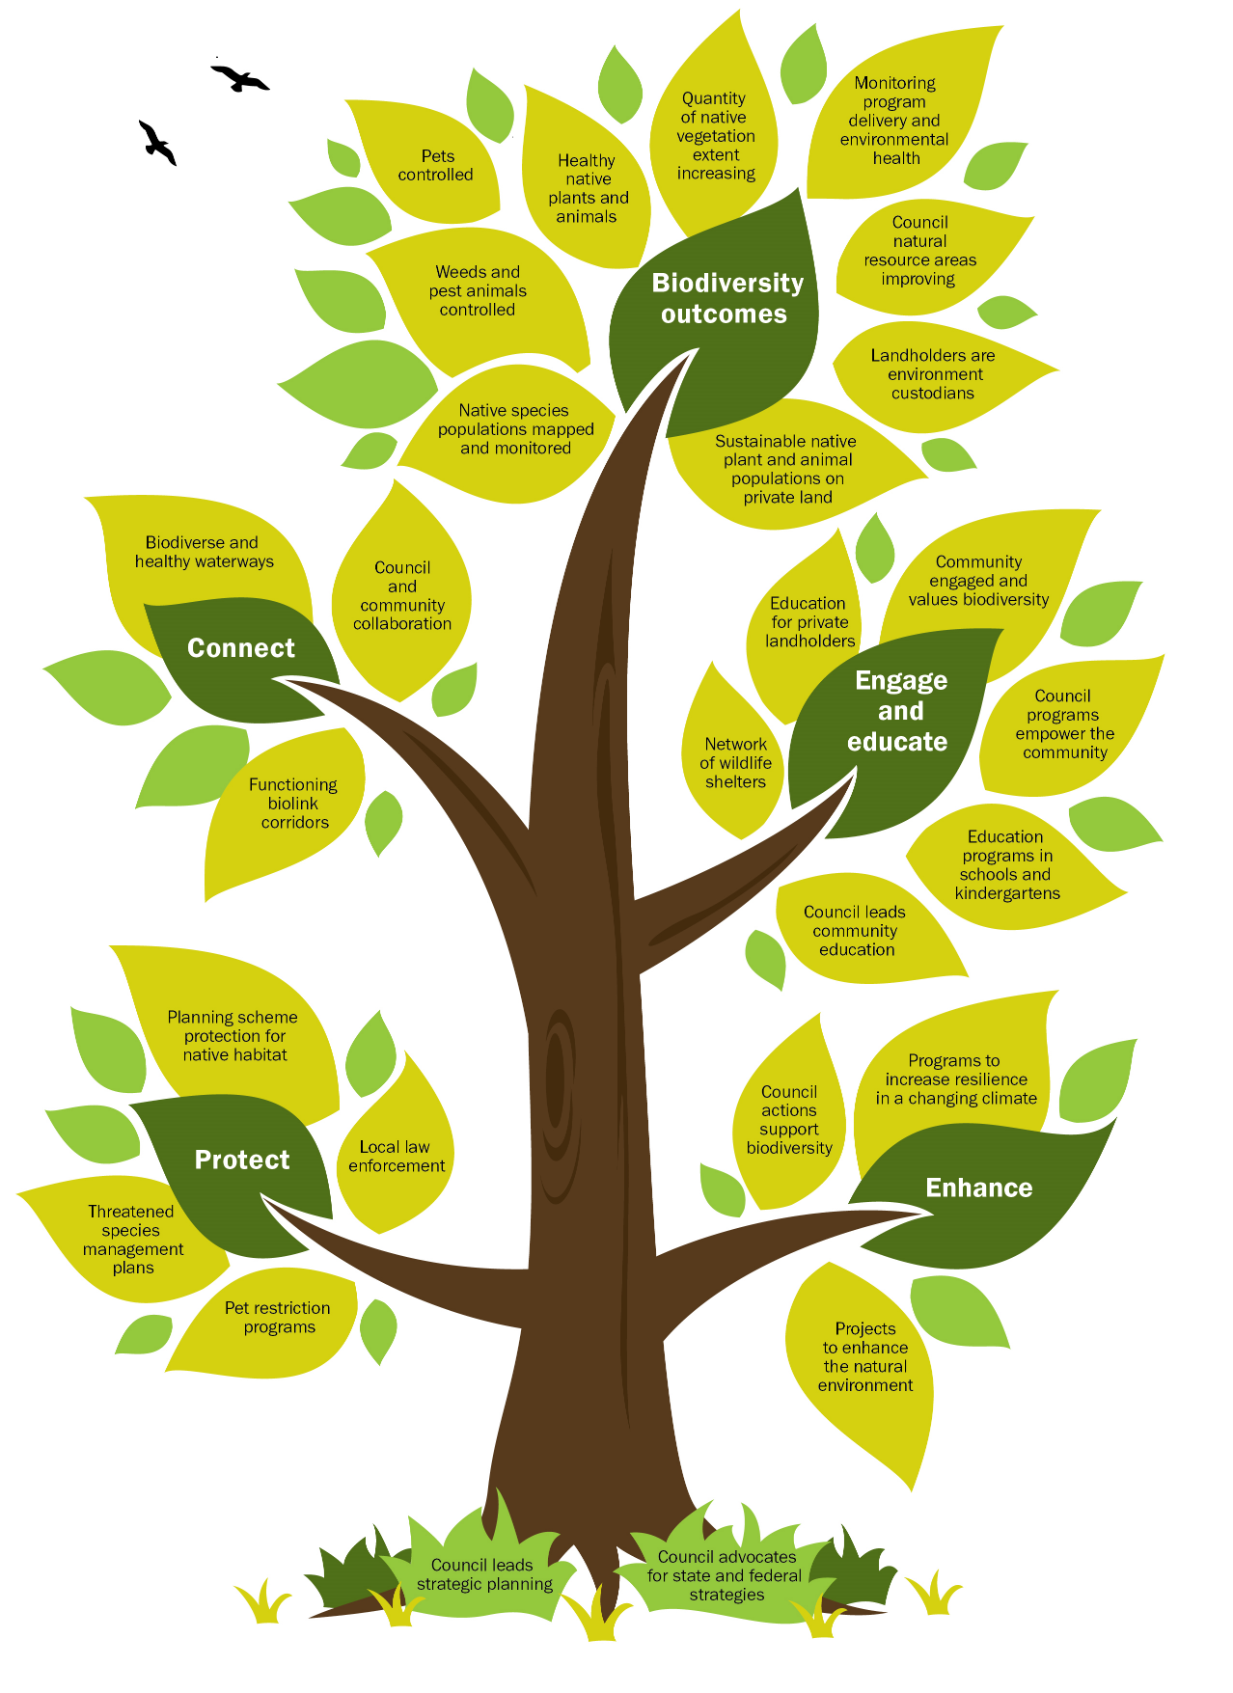
- Goals and objectives
This strategy’s goals have been divided into four distinct themes. To successfully reverse the decline of native plants and animals across the municipality, it is fundamental that Council implement programs that achieve the following outcomes:
- Protect – native flora and fauna
- Enhance – species health
- Connect – native flora and fauna across the landscape
- Engage and educate – the community on the value of our natural environment.

- Goals and objectives
Goal 1: Protect – we achieve a net gain of the overall extent and condition of habitat across land and waterway environments
Objective 1.1 Biodiversity conservation is considered in line with the Sustainable Development Goals (SDGs) in Council’s policies, strategies and plans, and is incorporated into the planning scheme
Objective 1.2 The health and extent of key threatened species has improved and increased over the life of the strategy
Goal 2: Enhance –the quantity and quality of indigenous flora and fauna is improved on private and public land
Objective 2.1 Our natural resource areas have improved in quantity and quality by 2024 and 2029 (refer Appendix E)
Objective 2.2 By 2029, Council has revegetated 230,000 indigenous plants to enhance native habitat
Objective 2.3 Biodiversity indicators in Council’s biodiversity monitoring program show progressive improvement in 2024 and 2029 (review periods)
Objective 2.4 Pest animal programs are implemented in defined catchments to protect threatened species by 2029
Goal 3: Connect – Council has mapped bio-link corridors that will enhance biodiversity connectivity across the region
Objective 3.1 In partnership with the community, priority bio-link corridors are mapped by 2024
Objective 3.2 Implement regional initiatives and connectivity plans to control weeds and pest animals and enhance biodiversity.
Goal 4: Engage and educate – the number of community members actively participating in natural environment programs has increased
Objective 4.1 Community participation in environmental programs has increased by 2024
Objective 4.2 Opportunities for the community to connect with nature are provided
Objective 4.3 Community environment groups are supported and empowered to enhance biodiversity (or deliver programs) on public and private land

- Legislative and policy context
Appendix J outlines the Australian and Victorian government legislation, policies and strategies that provide important guiding principles, directions and laws which impact the way Council manages biodiversity. Section 8 Roles and responsibilities further explores the impact that these legislation, polices and strategies have on Council and other land managers.
  - Australian Government legislation and policies
The Australian Biodiversity Conservation Strategy (ABCS) is a call to action for all levels governments to achieve the strategy vision, to ensure biodiversity is healthy, resilient to climate change and valued for its essential contribution to our existence. The strategy lists six priorities for change that must be made urgently to achieve the vision:
- building ecosystem resilience
- mainstreaming biodiversity
- reducing pressures on biodiversity and promoting sustainability
- enhancing benefits of biodiversity to the community including ecosystem services
- involving Indigenous people and the broader community
- measuring success.

The Environment Protection and Biodiversity Conservation Act 1999 (EPBC Act) is the Australian Government’s centrepiece of environmental legislation. It provides Commonwealth protection to nationally important flora, fauna, wetlands of international importance, migratory species and ecological communities. In Cardinia Shire this includes 44 species and plant communities (including Western Port Bay which are listed under the act (refer Appendix A and B).

Cardinia Shire’s 16 kilometres of coastline is part of a Ramsar listed wetland of international importance. Australian migratory birds are also protected within the EPBC Act, being listed under international JAMBA, CAMBA and ROKAMBA agreements. At a national level, the Australian Government has made a commitment to appropriately manage the Western Port coastline and implement land-use recommendations that conserve these wetlands.
  - Victorian Government legislation and policies
Protecting Victoria's Environment – Victoria’s Biodiversity Plan 2037 is the Victorian Government’s plan to stop the decline of biodiversity and achieve an overall improvement over the next 20 years. The plan identifies the need for an increased effort using strategic management actions and a cost−benefit analysis to most efficiently protect the maximum number of species. The plan relies heavily on needing to work with agencies and communities to capture environmental data out in the field to feed into the Victorian Biodiversity Atlas. This work will inform Victorian investment modelling software for future government funding, including the ‘Native Vegetation Information Management’ tool and the Victorian Government conservation prioritisation matrix (called the ‘Strategic Management Prospects’ tool). Data for the Cardinia Shire region is significantly under-recorded which reduces the perceived significance of flora and fauna in the Victorian Government modelling software.

The plan places equal weighting on biodiversity conservation and the need to for the community to value nature through increased interaction and connectivity.

  - Local policies, strategies and plans
Council has a strong focus on protecting and enhancing biodiversity which is outlined in the Council Plan 2018−22 action to ‘protect and enhance biodiversity by increasing the area of natural ecosystems across the shire’.

The Sustainable Environment Policy 2018−28 (SEP) is the roadmap for the future direction of Council's environmental sustainability and incorporates the international Sustainable Development Goals (SDG). The 17 SDGs are intrinsically linked and aim to end poverty, fight inequality and injustice, and tackle climate change by 2030 (refer Appendix K). The SEP shows the link between the everyday work of Council, and highlights opportunities for Council to become a leader in the whole-of-organisational approach to solving the big issues outlined in the SDGs. Sustainable land management practises complement these SDGs by advocating for multiple land management outcomes in Council strategies and programs.

Other Council policies, strategies and plans that help provide long-term guidance and action for biodiversity conservation include:
- Weed Management Plan 2019−29
- Aspirational Energy Transition Plan 2014−24
- Integrated Water Management Plan 2015−25
- The Liveability Plan 2017–29
- Reconciliation Action Plan

- Our biodiversity
Cardinia Shire has an area of 128,244 hectares. Ninety two per cent of the shire falls within the Western Port catchment while the northern 8 per cent of the shire falls into the Yarra catchment. Eight per cent is within the growth corridor or located within a township, while the remainder is rural. More than five new families move into the shire each day, this rapid growth and development provides a major challenge to our natural environment.

The vegetation of Cardinia Shire is highly diverse with 53 different ecological vegetation communities, including 19 different eucalypt species. The shire falls within two distinctly different ‘bioregions’ (Appendix I) located along the ‘break of slope’, approximately delineated by the Princes Highway
- The ‘highlands southern fall bioregion’ to the north is characterised by mountainous forests and woodlands with higher rainfall. The soil types are many millions of years old. A total of 25 different ecological vegetation communities can be found in this bioregion, ranging from wet forests in the northern hills, to woodlands and heathland vegetation types in the foothills, of which orchids can make up to 20 per cent of the plant flora. Four of the ecological vegetation communities in this bioregion are listed as ‘endangered’ and support iconic species such as powerful owls, lyrebirds, greater gliders (possums) and lace monitors.
- The ‘Gippsland plain bioregion to the south’ is dominated by the former Koo Wee Rup swamp complex; soils are thousands of years old. Native vegetation exists in only three per cent of the landscape and is made up of diverse swamp scrub and similar vegetation types. Twenty eight ecological vegetation communities of which 13 are listed as ‘endangered’ by the Victorian Government. This includes treeless grasslands which are our most threatened plant community and are nationally listed as ‘endangered’. The Gippsland plain bioregion supports habitat for iconic species such as the southern brown bandicoot, growling grass frog, Latham’s snipe and dwarf galaxias.

Western Port Bay extends for 17 kilometres along the Cardinia Shire coastline. The bay is listed under the Ramsar Convention and is also listed as a matter of national significance under the EPBC Act. The bay is furthermore recognised as an internationally significant biosphere reserve by the United Nations Educational, Scientific and Cultural Organisation (UNESCO) and is represented by the Biosphere Foundation of which Council is a partner.

Western Port is characterised by seagrass meadows which act as the forests of the ocean, mangroves, mudflats, saltmarsh, melaleuca thickets and deep waterway channels. It supports a large number of marine invertebrates and about 65 per cent of Victoria’s bird species (NRE, 1999). Twenty-two species of migratory wader birds that use the mudflats are listed under international agreements, including JAMBA, CAMBA , ROKAMBA and the Bonn Agreement (Australian Wetlands Database, 1982). Seagrass and mangrove communities support broader marine ecosystems including fish nurseries which support the recreational fishing industry.

Cardinia Shire has 19 significant waterways and tributaries, which Melbourne Water’s index of stream condition rate from ‘poor’ in the lower catchment around Koo Wee Rup, through to ‘moderate’ to ‘good’ higher up in the catchment. The health of our seagrass communities are dependent on the health of our waterways.

Council manages more than 77 bushland reserves over an area of 840 hectares and 950 kilometres of very high to low quality roadside vegetation. Figure 2 shows that Council is well placed to influence the goals and objectives in the strategy and play a leadership role for land management in the community. Bunyip State Park and Cardinia Reservoir represent significant core areas for biodiversity to migrate out into the shire.
- Land managed by Cardinia Shire Council
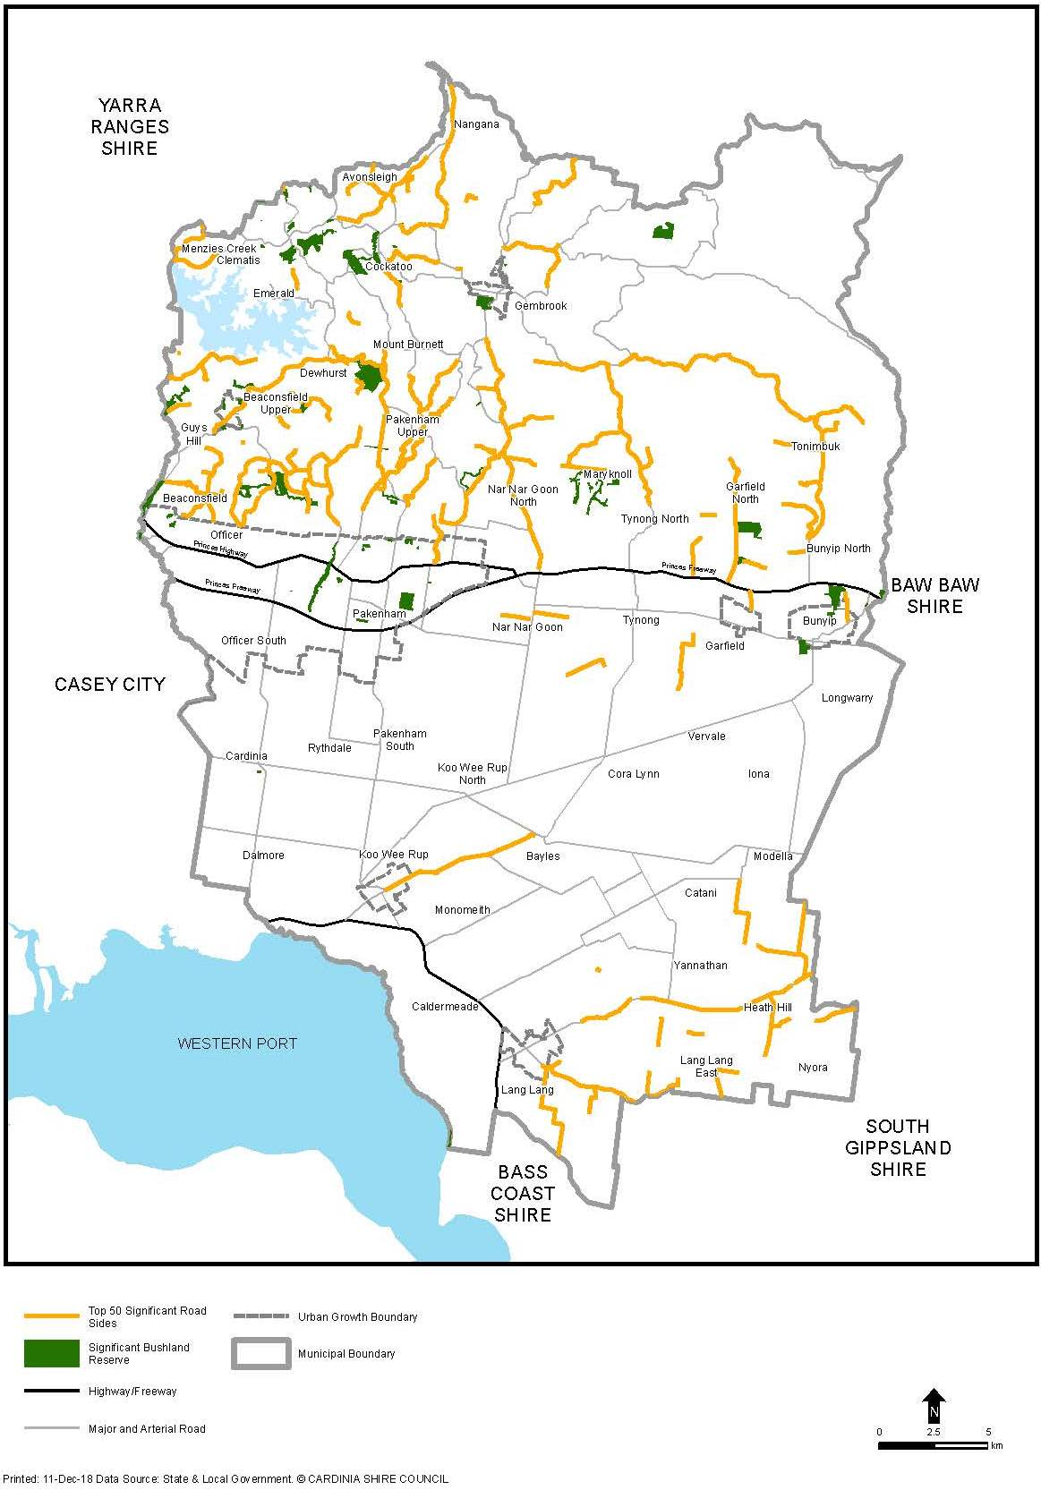
Every property in Cardinia Shire whether large rural acreages (supporting species such as owls and goannas) or small urban blocks (which may glimpse blue wrens visiting the backyard) have the potential to act as a home for our native plants and animals. Figure 3 represents the biodiversity hotspots that are not Council-managed where large groups of native plants and animals exist in sustainable populations. These hotspots act as essential breeding grounds for biodiversity to thrive and migrate out along corridors and into new environments.

- Biodiversity hot spots in Cardinia Shire

  - Flora
The Victorian Biodiversity Atlas (VBA) contains records of 1,325 indigenous flora species occurring in Cardinia Shire. The diversity of our native species is vast and ranges from mountain ash eucalypts (which at over 80 metres in height are the tallest flowering plants in the world) to the Emerald star bush (with less than 6,000 known plants existing in the world) and 55 species of orchids found in Mt Cannibal Reserve. Of the 94 rare or threatened plants listed by the Victorian Government, five species are of national significance being listed under the Environment Protection and Biodiversity Conservation (EPBC) Act 1999. This includes the green-striped greenhood, maroon leek-orchid, matted flax-lily, tall astelia and clover glycine.

The 2017 Cardinia Shire vegetation mapping project (Abzeco, 2017) demonstrated the deteriorating state of the shire’s natural environment. The mapping project identified:
- native vegetation is now limited to 29 per cent of the shire
- extent of native tree canopy cover on private land is 14 per cent
- 69 per cent of private properties surveyed north of the Princess Highway were found to have half of the native understorey lifeforms (groups of species) missing.
  - Fauna
The VBA contains records of approximately 414 indigenous fauna species in Cardinia Shire. An additional 17 animal species are likely to be locally extinct. These include iconic animals such as the eastern quoll, long-nosed potoroo and brush-tailed phascogale.

Thirty six fauna species considered present or with potential to remain in Cardinia Shire are listed under the federal EPBC Act. This includes species such as the helmeted honeyeater, southern brown bandicoot, dwarf galaxias, growling grass frog and eastern curlew.

Sixty-three species recorded in Cardinia Shire are listed as rare or threatened on the Department of Environment, Land, Water and Planning (DELWP) threatened species list. Thirty six of these species are listed under Victoria’s Flora and Fauna Guarantee Act.

Western Port Bay is an internationally listed wetland under the Ramsar convention. Cardinia Shire is home to twenty five migratory wader bird species which annually travel approximately 12,000 kilometres to breeding sites in the Siberian Tundra.

- Number of known animal species (excluding invertebrates) within Cardinia Shire
 | Birds | Mammals | Reptiles | Frogs | Fish | Total
Native species | 232 | 36 | 27 | 17 | 23 | 335
Threatened species | 59 | 11 | 4 | 3 | 3 | 80

Cardinia Shire’s native plants and animals have evolved to coexist in complex ecological partnerships and are interdependent on each other for their survival. An example is in our large old trees which provide habitat hollows for 20 per cent of our native birds and many species of possums and micro-bats. Larger birds require larger hollows, such that a eucalypt may be 70−100 years old before it can provide suitable habitat. Eucalypt trees are also a vital link in the start of the food web. Scientists have counted hundreds of insect species (a species distinguished from others by its form or shape) on just two trees (Yen et al, 2002).

  - Community values
The link between a healthy natural environment and community quality of life is not always clearly visible. It is also challenging for the community to value and experience elements of the natural environment when many of our native species are hard to detect, being discrete, small or nocturnal in their movements.

Programs designed to engage and educate the community to more highly value the natural environment and become environmental custodians also compete with other lifestyle demands, including limited time and availability of finances.

Council undertook a community survey of 247 people in 2018 (survey results are in Appendix F and G). The survey found that:
- 46 per cent of respondents did not identify that native plants and animals lived in their backyard
- an average of 34 per cent of respondents were not aware that climate change, water pollution and community indifference were a threat to the natural environment.

Notwithstanding these results, there is clear support from the community to improve the natural environment. In the community biodiversity survey respondents identified the following environmental initiatives:
- 58 per cent suggested improved communication to raise awareness of the challenges and opportunities to improve our natural environment
- 84 per cent said they would consider participating in a citizen science project to collect environmental data for projects such as monitoring our natural environment
- 28 per cent suggested environmental programs required additional resources.

Council also ran community workshops involving 83 participants, to inform the development of the strategy goals and objectives (Appendix H provides a summary of community workshop issues and priorities).

The community workshops identified:
- that an uninformed person sees a tree as dispensable and an informed person sees it as a living environment
- an informed population is a proactive population
- a fundamental component to a healthy environment is knowledge sharing.

Challenges for our biodiversity
The health of native plants and animals have been in continual decline since European settlement. This has historically been the result of an accumulation of factors such as uncontrolled land clearing for agriculture and development, and increasing competition from weeds and pest animals. Competing land management priorities, such as vegetation removal for economic gain or to increase the perceived safety of people and property, result in the further deterioration of the natural environment. Cardinia Shire’s large old trees are at particular risk from these threats. Where these factors are combined it has led to the widespread deterioration of our natural environment.

Competition from plants and animals that are not native to Australia has historically, and continues to have, a profound detrimental impact on our native flora and fauna. Council’s Weed Management Strategy (2019−29) provides the detail of the impact of weeds and sets out the long-term plan to manage these species. Key invasive animals in Cardinia Shire include the fox, feral cat, deer, rabbit, Indian myna, starlings and honey bees.

These species impact native animals in a range of ways including:
- occupying niches that crowd and outcompete
- destroying native habitat
- eating and hunting (predating on) native species.

The mobile nature of pest animals makes these species extraordinarily difficult to control. At a minimum, pest animal control programs must be implemented on a ‘whole of catchment’ scale to ensure effective control. Programs that are only conducted at the property scale reveal that the pest species quickly reinvade the control area, thereby negating the usefulness of the program. The effectiveness of a pest control program can therefore be impaired due to landholder apathy or constrained time and resources. Active education and awareness programs are of critical importance to gain support from the majority of landholders in these pest control areas. This is of particular relevance in the management of domestic cats which, if not restricted within the property (indoors or in outdoor cat ‘runs’), will hunt and kill native wildlife. This threat is not widely acknowledged in the community.

The consequential fragmented landscapes and disruption to plant populations, while still providing habitat for some species resilient to disturbance, can lead to entire suites of plants and animals that are sensitive to change ‘crashing’ and disappearing completely from an area. A study in Victoria of woodland bird populations revealed that populations are more likely to crash when tree canopy cover reduces to less than 30 per cent (Bennett et al, 2005). Species decline is reflected in Council native flora and fauna records which show that, notwithstanding our native vegetation cover extends to 29 per cent of the shire, 94 native plants and 63 native animals species are listed as ‘rare’ or ‘threatened’.

Climate change is predicted to be one of the greatest long-term threats to biodiversity and the uncertainty it brings will need to be considered in all biodiversity conservation decisions.

The most vulnerable ecosystems include coastal ecosystems, forests, fragmented terrestrial ecosystems and areas vulnerable to fire or low freshwater availability. Species that could become endangered or extinct include those living near the upper limit of their temperature range, those with constrained climatic niches, and those that cannot migrate to new habitats due to habitat fragmentation or lack of suitable alternatives. Addressing the impacts of climate change on biodiversity will require a long-term effort and new ways of thinking.

Four key priorities are:
- Enhancing our understanding of the likely responses of biodiversity to climate change and readjusting management programs where necessary.
- Protecting a range of habitats and ecosystems.
- Increasing opportunities for species to move across the landscape by working with partners and the community to protect habitat and create the necessary connections across landscapes.
- Assessing adaptation options and supporting the resilience of climate-threatened ecosystems and species.

This strategy has identified a climate change adaptation policy, which will take an ecosystem-based approach to support the shire’s biodiversity in adapting to a changing climate. Community groups and partners will play a key role in providing input on conservation land management activities and monitoring the impacts of climate change on indigenous species. Council will address the impacts of climate change by enhancing the resilience of habitats and ecosystems to support suitable alternatives, create connections across landscapes and reduce habitat fragmentation. Climate-ready revegetation: A guide for natural resource managers (Hancock, 2016) is a useful resource for natural resource managers when planning revegetation activities.

The variety of rural land use in Cardinia Shire also presents a challenge. These land uses can be generalised into two areas, broadly following the two bioregions (Cardinia Shire bioregions are mapped in Appendix I). Environmental programs must take into account each landholder area. The northern hills are generally made up of smaller rural hobby farms, while the southern flats are generally made up of larger more productive agricultural farms. As a consequence, land management programs such as installing a habitat corridor can be more costly in the southern flats than an equivalent program in the northern hills, due to the perceived loss of farm productivity.

In Cardinia Shire other significant threats to our natural environment include:
- grazing native vegetation from stock
- dieback caused by the root-rot fungus (Phytophthora cinnamomi)
- inappropriate fire regimes causing disruption to sustainable ecosystem processes and resultant loss of biodiversity
- rubbish dumping
- salinity
- coastal erosion
- loss of seagrass in Western Port (approximately 30% of sediment entering Western Port comes from eroding coastline in Cardinia Shire. The sediment reduces light reaching the seafloor and thus seagrass coverage (Wilkinson, 2016)).

Table 3 identifies the goals and opportunities in which Council will address the 11 priority challenges, incorporating multiple goals to achieve success.

- Biodiversity challenges and opportunities
 | Challenge | Strategy goal | Opportunity
 | Bio-links have not been identified or protected across the municipality | Protect, connect | Prioritise the development of a bio-links plan to identify the strategic corridors across the landscape. This will inform other conservation initiatives such as the location of statutory planning overlays and threatened species management actions.
 | The community experience competing goals and priorities which challenge their ability to experience and value nature | Engage and educate | Utilising the Deep Creek Ecocentre as a focal point, to expand revegetation, weed control and threatened species programs in addition to increasing support for ‘friends groups’ and Gardens for Wildlife program. Advocate for an environmental education officer which will expand schools and kinder education and the future citizen science program.
 | Biodiversity on private properties is incrementally deteriorating through a variety of threatening processes | Enhance, engage and educate | Support the Weed Management Strategy actions and advocate for a future Pest Animal Strategy. Fencing remnant vegetation and revegetation works will be delivered in collaboration with Landcare groups activities to improve the natural environment, soil and water health and farm productivity.
 | Native plants and animals in Council natural resource areas are under threat from weed invasion, pressure from pest animals and altered fire regimes. | Protect, enhance | Identify programs and additional resources to appropriately manage Council reserves. The bio-links plan will identify strategic conservation priorities that will influence external grants. This will complement the weed management, revegetation program and future Pest Animal Strategy and Ecological burn program to allocate funds strategically to most efficiently and effectively conserve our threatened species.
 | To protect our native species a coordinated program is required to control pest animals and provide education on responsible pet ownership | Enhance, engage and educate | Collaborate with the Eastern Region Pest Animal Network to develop a regional pest animal strategy and implement across the Shire. Utilise this as a catalyst for community conversations regarding the shared responsibility to manage pest animals. This work will complement the existing pest animal projects, future bio-links plan and threatened species management actions.
 | Native vegetation is limited to 29% of the Shire | Enhance, engage and educate | Identify a range of regeneration and revegetation initiatives on public and private land to meet objective to revegetate 226,000 indigenous plants over the strategy’s life. Increasing the existing weed grant and the Gardens for Wildlife program will compliment this objective.
 | To monitor programs to understand effectiveness | Enhance, engage and educate | Assess vegetation health in 20 priority bushland reserves and 120 random private properties. The presence of key indicator species that could be monitored include; southern brown bandicoot, platypus, growling grass frog, emerald star bush, lyrebirds, lizard diversity and powerful owls.
 | Environmental community groups require support from Council | Protect, enhance,  engage and educated | Develop action plans with ‘friends groups’ and provide increased support to community catchment based conservation projects.
 | Council requires a consistent approach to roadside conservation planning and management. | Protect, enhance, connect, engage and educate | A roadside management strategy to be developed including other complimentary works to commence in 2022.
 | Council requires a strategic planned approach to mitigate the impacts of climate change on biodiversity | Protect, enhance | Develop a climate change adaptation policy which will consider the impacts on climate vulnerable species.
 | Biodiversity conservation values are not always considered in Council decision making. | Protect,  enhance,  engage and educate | Raise awareness on the threats to our natural environment and seeks incorporation of the vision, goals and objectives by considering biodiversity in all organisational plans, strategies and polices. Projects such as the cross department awareness raising, and incorporation of the Sustainable Environment Policy will improve the collaborative opportunities within Council and identify shared opportunities to realise sustainable land management outcomes.

Roles and responsibilities
  - Victorian Government
The Victorian Government plays a broad role in setting legislation, policies and strategies to provide direction for Council. The government leads the development of specific policies and programs to conserve threatened species. A significant environmental policy document is the Victorian Biodiversity 2037 strategy.

Victorian Government land managers such DELWP, DEDJTR, Parks Victoria, VicTrack, VicRoads and authorities such as Melbourne Water and Puffing Billy Railway manage Crown land that have high conservation values. All Council regional weed or pest animal control programs by necessity must collaborate with these government stakeholders to maximise program success.
  - Council’s role
Council has statutory responsibilities to protect or enhance native flora and fauna from threatening processes on land managed or owned by Council. Council manages 840 hectares of natural resource areas including bushland reserves and 940 kilometres of roadsides that contain remnant native vegetation and threatened species. Council annually takes on responsibility for new bushland reserves as an outcome of urban development associated with the Planning and Environment Act 1987.

Where Council is the delegated land manager of a natural resource area, there are not less than four state and federal acts that direct Council to protect, care and enhance all native flora and fauna found in our reserves. These include:
- the Flora and Fauna Guarantee Act 1988 − directs the land manager to ensure native flora and fauna must survive and flourish by managing threatening processes
- the Environment Protection and Biodiversity Conservation Act 1999 (EPBC) − applies to 44 listed species and plant communities in Cardinia Shire (including Western Port Bay), providing the management direction that there must not be a significant (detrimental) impact to these listed species
- the Victorian Conservation Trust Act 1972 − applies to two Council reserves which directs that all native wildlife and plants must be conserved
- the Conservation and Land Protection Act 1994 −identifies that the land manager must manage and control regionally controlled and prohibited weeds and also control restricted pest animals.

Council plays a strategic leadership role through the development of plans and community programs to protect and enhance the natural environment and avoid and minimise native vegetation removal.
This role extends to implementing regional plans to manage threatened species and coordinate and empower community conservation projects (community engagement is covered in Section 9) which consider sustainable development goals within the project objectives. This is reflected in the proposed development of a bio-link corridors plan for threatened species and roadside management strategy. These projects compliment the Melbourne Strategic Assessment which provides specific management directions for the EPBC listed southern brown bandicoot and growling grass frog.

Council carries out a critical role to provide statutory environmental information to residents through the Planning and Environment Act 1987. Utilising planning zones, overlays and DELWP guidelines this involves educating residential planning applicants on the natural environmental features that are protected on their property. This presents a unique opportunity to undertake broader education on the conservation opportunities for our residents. Where possible Council capture these conservation actions within environmental permit conditions.

To compliment ‘goal 1, achieve a net gain in native vegetation,’ local revegetation policy guides will be developed to ensure that compensatory vegetation offsets are directed into the Shire. These will identify appropriate vegetation specifications including species types and numbers. Policy guides will include the development of an over the counter offset scheme, local native vegetation planting policy and environment planting guidelines.

Council utilises Ecological Vegetation Classes (EVC’s) as the standard unit for classifying vegetation types within Cardinia. EVC’s define the characteristic lifeforms, species, canopy and percentage large tree density by which Council makes statutory vegetation assessments. Ecologists assess the quality of vegetation for net gain offset calculations and Council plan revegetation projects and monitor the health of the natural environment using EVC benchmarks.

Council’s ‘Gardens for Wildlife’ program complements this education initiative by engaging knowledgeable community members to provide environmental assessments and educate land owners on the value of their environmental assets. Figure 4 show the diversity of Council’s environmental roles.

To stimulate the natural ecology that takes place as a result of fire, Council is working towards implementing a scheduled program to undertake ecological controlled burns in Cardinia Shire’s bushland reserves. This also complements Council’s Municipal Fire Management Planning role to create safer communities.

Monitoring the outcomes of conservation projects and the broader health of the natural environment provides a critical component of natural resource management because it enables Council to evaluate the effectiveness of a program and understand whether we are sustainably managing natural environmental assets. Where monitoring identifies deteriorating species health, intervention strategies can be put in place. Council programs for the community to participate in citizen science projects are important in monitoring our natural environment.

To reverse the trend of species extinction, Council is challenged in the delivery of a multitude of competing conservation projects while working within a finite budget. Council prioritises conservation planning with criteria such as the following:
- presence of threatened species
- bioregion conservation significance of vegetation communities
- DELWP’s strategic priority setting
- community project support
- quality and quantity of vegetation onsite and it’s connectivity role and ability to offer refuge for native species
- outcomes from the ‘Open Standards for the Practise of Conservation’ planning framework

The ‘Open Standards for the Practise of Conservation’ is an adaptive planning framework that helps land mangers systematically plan, implement and monitor conservation initiatives. This provides a more effective and efficient conservation management planning by analysing what works and what does not and continually making improvements to on ground works. This approach will provide an important tool in the delivery of programs from this strategy and to lobby for external government funding.

- Council’s diverse role to protect and enhance our natural environment
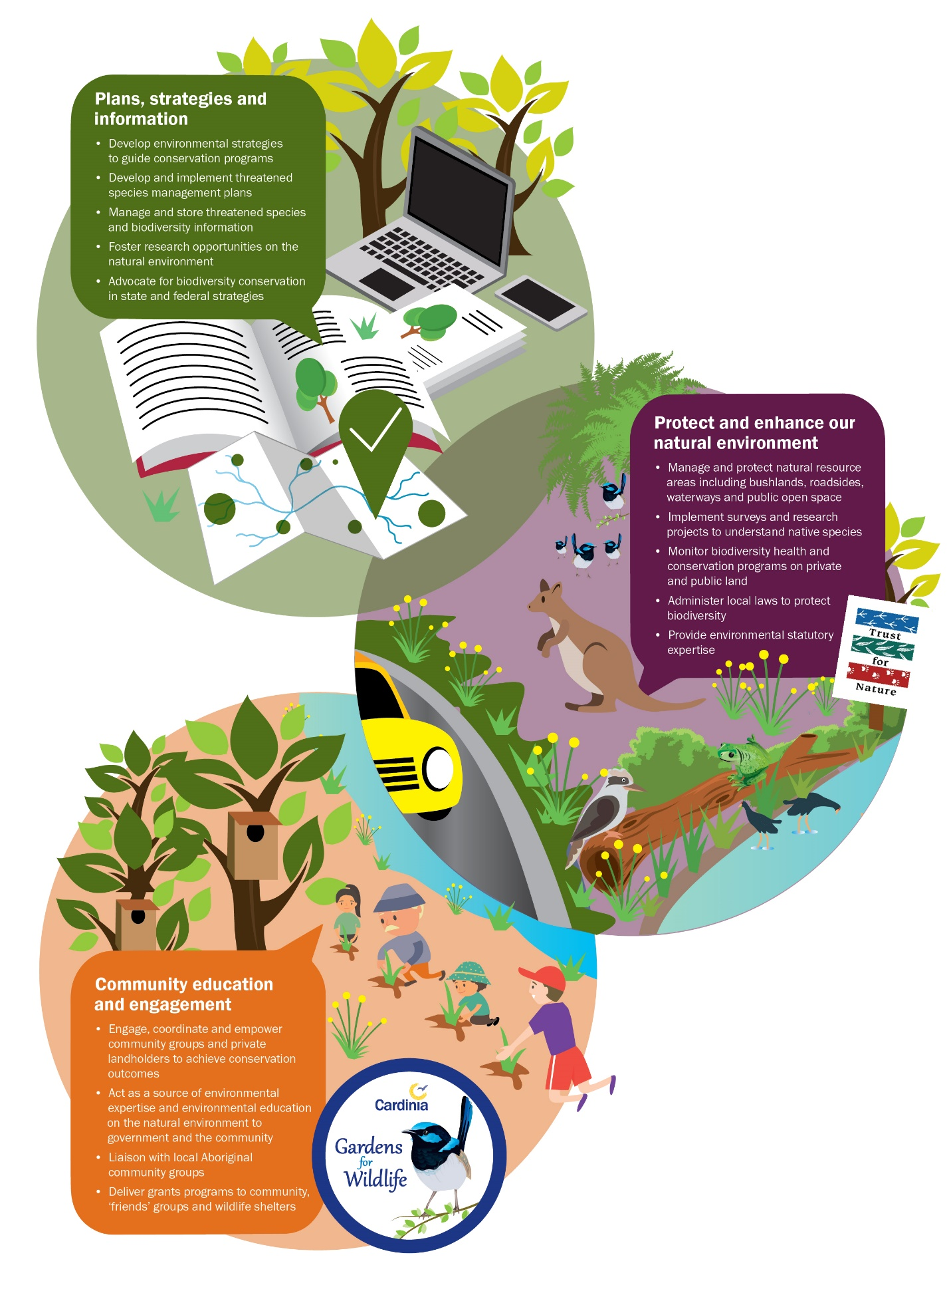

  - Residents
Cardinia Shire residents represent the majority of landholders in the shire and as such are custodians of the land. Their management actions directly influence the condition of soil, water and vegetation and, in turn, the condition of those assets influences their livelihoods, wellbeing and productivity.

Under the CaLP Act landowners are responsible for the management of regionally controlled and regionally prohibited weeds and to prevent the spread of (and as far as possible eradicate) established pest animals.

To support residents to undertake their role in biodiversity conservation, Council provides education and support.
  - Community volunteers
Cardinia Shire has more than 15 ‘friends’ groups, three indigenous plant nurseries, wildlife shelters and 10 Landcare groups who volunteer to protect and enhance the natural environment. The Cardinia Environment Coalition (CEC), Western Port Catchment Landcare Network, Southern Ranges Environment Alliance, Cannibal Creek Catchment Biodiversity group and Port Phillip to Healesville Nature Links are important network groups with which Council partners to engage with the community.

Volunteerism to enhance our natural environment conservatively reaches over 2,000 hours annually. The environmental volunteers in Cardinia Shire play a fundamental role in contributing to landscape change and community education and engagement to benefit the natural environment. The length and breadth of the work they undertake shows a profound dedication to improving the natural environment.

Volunteers currently work in 10 Council bushland reserves undertaking weed control and tree planting. Significant works also extend to liaison with neighbours and the local community on appropriate environmental land management. These groups provide an important surveillance role to monitor the health of the reserve, including reporting reserve hazards and monitoring for threatened species. The groups acquire grants for the reserves and assist in the development of strategic conservation plans and tour guiding activities to further improve the reserves. Their knowledge on the ground also provides Council with a valuable local expertise to guide in reserve management.

Wildlife shelters provide an invaluable community service to assist community members who encounter injured wildlife. After an incident, both wildlife and community member can be highly traumatised and distressed. One shelter can care for many hundred injured wildlife each year.

- Community engagement
To achieve this strategy’s goals, Council requires the entire community, including individual landholders in a whole of catchment approach to value the local biodiversity in and around their properties.

Past studies, including the project partnership report ‘Why don’t they manage their weeds?’ developed with Johns Hill Landcare Group and Cardinia Shire Council, identified the three primary factors that inhibited residents from implementing conservation (weed) programs was one or all of the following:
- lack of knowledge
- lack of time
- lack of resources.

The project found that the greater the number of these inhibitors that could be addressed in a community conservation project, the better the success of achieving support from new landholders.

Other important behaviour change theory includes the ‘Psychology of Sustainable Behaviour Change’ (Christie Manning, 2009) which provides a guide on how it is possible to motivate and empower sustainable actions. This strategic behaviour-change approach forms the basis of future community conservation initiatives. For this reason, Council will continue to strengthen work with the community in collaborative conservation projects. These partnerships have proven to be the most effective method of achieving biodiversity outcomes on private and public land because they address these inhibiting factors.

Council−community collaborative partnerships contribute a combination of scientific knowledge, funding and resources to a given project which, when coupled with the community’s contacts and knowledge of the local environment, can tailor programs that meet local community needs. These programs often increase in size over time as additional landholders join the project as a result of advocacy from trusted neighbours. Council also has programs to cater for landholders who prefer to implement solitary projects. The key to achieving this strategy’s goals is to offer a range of conservation initiatives that suit individual landholders’ needs.

Revegetation programs identified must be coordinated with weed management initiatives, if we are to ensure environmental gains onsite are sustained. Coordinated revegetation programs also provide continued community enthusiasm for conservation projects.

Deep Creek Ecocentre is intended to become a focal point for the delivery of Council’s conservation initiatives. This includes Council revegetation and ‘Gardens for Wildlife’ programs. Educational programs to schools, kindergartens and the community will be integrated with the indigenous nursery on site. Programs to be delivered range from managing our waterways through to building possum boxes and protecting native vegetation through to controlling weeds and pest animals.

Council’s website is another key tool providing the community with information on biodiversity assets, current projects, community groups, protected species in the planning scheme and web-based tools for planning applications. Due to the dynamic and changing nature of the conservation sector, it is important that resources are continually allocated to website updates to ensure information is accurate and relevant to the community.

By implementing the identified community-based conservation actions, Cardinia Shire Council will meet its goal to annually increase the number of community members actively participating in conservation initiatives on private and public land.

Case study – Cannibal Creek catchment biodiversity project
The Cannibal Creek catchment biodiversity project is a collaboration program and has been running for five years from 2013. The project has grown from original engagement of 10 properties to now involving 12 different stakeholder groups, extending over an area of 45 square kilometres along 12 kilometres of Cannibal Creek.

Using the core biodiversity assets of Mount Cannibal Reserve and Cannibal Creek, the group includes numerous government and community stakeholders. Members have collaborated to pool their vast local knowledge and resources to incrementally role out an integrated conservation management program to improve biodiversity values in the entire catchment. Council supplied expertise, funding, mapping and resources to assist in the project.

On-ground initiatives have included pest animal and weed control, revegetation, monitoring of flora and fauna, cultural heritage awareness and educational field days. The project has increased over its life by 45 times, accruing more than 2,000 volunteer hours managing weeds and tree planting and controlling 279 foxes. Up to 2020, the project will have secured funding of more than $470,000.

Monitoring and review
Progress of the action plan for this strategy will be reviewed in 2024. A more detail review of the entire strategy, including progress towards the objectives outlined under each of the four goals, will take place at its conclusion in 2029.

Contained within the review, is a biodiversity monitoring program in 2020 and 2024 to inform the progress towards the strategy objectives.

Glossary
Biodiversity | This is the variety of all life forms; the different plants, animals and microorganisms, the genes they contain and the ecosystems of which they form a part. For the purposes of this strategy, biodiversity refers to all plants and animals indigenous to Cardinia Shire
Bioregion | Biogeographic areas that capture the patterns of ecological characteristics in the landscape or seascape, providing a natural framework for recognising and responding to biodiversity value.
Bioregional conservation status | An assessment of the conservation status of the native vegetation type in the context of a particular bioregion, taking account of how commonly it originally occurred, the current level of depletion due to clearing, and the level of degradation of condition typical of remaining stands. Six categories of bioregional conservation status exist: presumed extinct, endangered, vulnerable, depleted, rare and least concern.
Bonn | The Bonn Convention identifies migratory bird taxa at and below the species level, as well as some whole families.
Bushland reserve | Council-owned reserves which contain native or indigenous flora and fauna. Vegetation is usually remnant and has never been cleared, although some bushland reserves have arisen from revegetation using indigenous species. Bushland reserves form part of the broader natural resource area system of environmental assets that Council manages.
Citizen science | The collection and analysis of data relating to the natural world by members of the general public
Ecological Vegetation Class (EVC) | A type of native vegetation classification that is described through a combination of its floristic, life form and ecological characteristics. Each EVC includes a collection of floristic communities. In 2006, approximately 300 EVCs have been defined and mapped in Victoria with around 53 of these being located in Cardinia Shire
Ecosystem | All the organisms (including plants and animals) present in a particular area together with the physical environment with which they interact.
Habitat corridor | Pathways of natural or created habitat within larger areas that have been developed by humans, either farmed or urban development. Habitat corridors attract wildlife and act as safe passages for wildlife between neighbouring natural areas. Corridors often occur along creek riparian zones that run through urban areas, however can also encompass road reserves, railway lines and other linear easements.
Indigenous vegetation/animals | Plants (including trees, shrubs, herbs, and grasses) or animals (including mammals, birds and insects) that occur naturally in the local area, a local native plant/animal.
Lifeforms | Scientific ecological vegetation classes (EVCs) can be generalised and expressed into 15 separate vegetation groups or ‘lifeforms’ including; three types of tree, four types of shrub, six types of ground storey vegetation and two other vegetation components.
Miradi management system | A system to design conservation projects where the project is conceptualised, actions are planned, analysed, evaluated and reported on.
Native vegetation | Plants (including trees, shrubs, herbs, and grasses) that are indigenous to a particular site.
Natural environment | All plants and animals including the locations they are found that are indigenous to Cardinia Shire.
Natural resource areas | The term used to refer to the collective of all Council assets where native plants and animals can be found. These areas include bushland reserves, roadside reserves and waterways and include any location where threatened flora and fauna may exist including weedy vegetation.
Niche | Natural home or environment of species, the physical environment in which a species lives including the energy flow the species occupies in the ecosystem
Open space reserve | Council reserve that is used for a wide variety of recreational purposes, where conservation values are shared with other recreational values. Typically sparsely vegetated with no critical habitat located onsite.
Ramsar | An intergovernmental treaty that provides the framework for national action and international cooperation for the conservation and wise use of wetlands and their resources
Rehabilitation | Any attempt to restore elements of structure or function to an ecological system without necessarily attempting complete restoration to any specific prior condition.
Restoration | The return of a community to its pre-disturbance or natural state in terms of abiotic (non-living) conditions, community structure and species composition.
Revegetation | Replanting indigenous vegetation in either restoration or rehabilitation.
Understorey vegetation | Any vegetation lifeform under 5 metres in height. The 14 different lifeforms which generally make up an EVC which range from immature trees down to the smallest herbs and ferns. Where less than half of these lifeforms exist, Council is defining the vegetation quality as significantly disturbed.
Victorian Biodiversity Atlas | State Government tool to collate species presence with observations from registered users, which acts as the foundation dataset to inform environmental decision making by the State Government.

References
Abzeco. (2017). Cardinia Shire Council Vegetation Mapping Project 2017. Abzeco.
Australian Wetlands Database. (1982, December 15). Retrieved from Australian Department of Environment and Energy: https://www.environment.gov.au/cgi-bin/wetlands/ramsardetails.pl?refcode=19#
Bennett et al, 2. (2005). Landscape level thresholds of habitat cover for woodland dependant birds. Biological Conservation.
Cardinia. (2018).
Constanza et al. (1997).
Hancock, N. H. (2016). Climate-ready revegetation. A guide for natural resource managers. Sydney: Macquarie University.
Mitchell, Y. &. (2005). Vegetation mapping of the Koo Wee Rup swamp and adjacent grasslands.
NRE. (1999). Ramsar Information sheet: Western Port site. Retrieved from Department of Natural Resources and Environment, Victoria. : http://www.nre.vic.gov.au
Wilkinson, S. A. (2016). Western Port Sediment supply, seagrass interactions and remote sensing. Melbourne Water.
Yen et al. (2002). A Preliminary Survey of the Arboreal Invertebrate Fauna of Two River Red Gum Trees near the Murry River. Field Naturalist , 180-186.

- Action plan
Council is committed to reversing the decline in native plants and animals by implementing the action plan. The action plan has been developed through a strategic approach to achieve the most cost-effective outcomes to protect the maximum number of species. Protection of remaining remnant vegetation is prioritised over revegetation of native landscapes.

Over the next 10 years, the actions will meet Council’s statutory obligations and protect native flora and fauna.

Appendices
Appendix A: Indigenous flora list for Cardinia Shire post 1988
Appendix B: Indigenous fauna list for Cardinia Shire post 1988
Appendix C: Cardinia Shire ecological vegetation classes
Appendix D: Cardinia Bushland Reserves at November 2018
Appendix E: Tree canopy cover in Cardinia Shire
Appendix F: Community consultation survey 1 (Pakenham show)
Appendix G: Community consultation survey 2 (open internet survey)
Appendix H: Summary of community workshop issues and priorities
Appendix I: Cardinia Shire bioregions
Appendix J: Legislation, policy and strategies for biodiversity conservation
Appendix K: Sustainable development goals

