Cardinia Youth Survey

2018 Analysis Report

1 Background and methodology 2
2 Key findings 4
3 Respondent profile 8
4 Analysis 9
4.1 Things that are important 9
4.2 Issues of concern 12
4.3 Stressful situations 15
4.4 Perceptions of safety 17
4.5 Sources of information, advice or help with a problem 19
4.6 Barriers to accessing services 21
4.7 Community perceptions of young people 22
4.8 Facilities and services for young people 23
4.9 Other ideas 26
5 Appendices 28
5.1 Questionnaire changes 28
5.2 Distribution 34
5.3 Sample counts 36
5.4 Notes on analysis 38

Background and methodology

Background
Council acknowledges that youth is a crucial period for establishing positive health and social behaviours and it is during this period young people acquire a range of skills and behaviours, face a range of life events, and make decisions that can influence their physical and psychological health, their social development, and their educational and employment opportunities (WHO 2010).
To ensure that programs, services, strategies and advocacy continues to meet the needs of young people who live and spend time in the municipality, Council undertakes regular consultations with young people. This document presents the findings from the 2018 Youth Survey. This survey aims to assist Council in understanding the needs of young people, as well as the points of stress that are experienced and barriers to accessing services so that appropriate support can be provided. Results will be used to inform Council planning, strategy implementation, advocacy on behalf of youth, and service refinement.
Council encourages youth service providers in the region, peek bodies and government departments to use the information contained within to enhance their service provision, planning and advocacy to meet the needs of young people in Cardinia Shire.

Methodology and distribution
Dates in field: | 22 March - 8 May 2018
Number of responses: | n=722
The 2018 Youth Survey is the continuation of a series of surveys Council has run with young people in 2009, 2011, 2013 and 2015. In 2018 a range of changes were made to the Youth Survey questionnaire to ensure relevance to the changing experiences of young people and to fine tune the usefulness of findings to inform planning for young people in Cardinia. A schedule of changes can be found in the Appendices.
The ethical management of respondents aged 14 years or under was introduced in 2018. This involved active consent for the general online survey (if the respondent said they were under 14 a question appeared requiring their parent or guardian to provide consent) or an opt-out option for surveys conducted in schools (parents were notified of the survey by the school and given the opportunity to advise if they didn’t want their child to complete the survey. There was a consent check question in the schools survey for those under 14).
The distribution methodology in 2018 differed slightly in that there were fewer in-school surveys conducted, thereby resulting in a greater representation of respondents aged 15 and over and those in employment or looking for work. This also resulted in a higher proportion of respondents who are residents of Cardinia and a greater gender disparity (higher proportion of females, which is common for online surveys).

Age range:  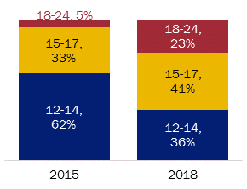 | Employment / study type (includes multiples)  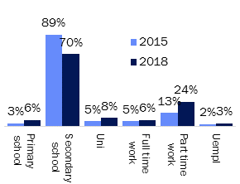
Gender:  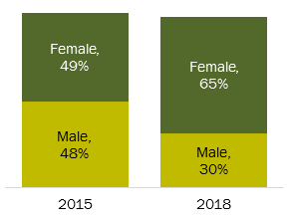 | Ward:  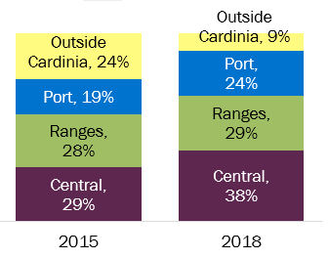
Seven individual distribution links were provided so that the number of respondents from different distribution channels could be tracked. How each link was used is outlined in the distribution list appendix.
Distribution link | Number sent / views | Number received | % of sample
Schools | 11 Schools | 299 |  | 41%
Youth services Facebook | 5,881 reach, 28 likes, 19 comments, 13 shares, 45 link clicks. | 203 |  | 28%
Face to face | Includes email to SRS distribution list with 208 contacts and My Place distribution list with 24 contacts. | 94 |  | 13%
Other | 5 organisations | 54 |  | 8%
Council website | Xx Page views | 36 |  | 5%
Council Facebook | 6 likes, 3 comments, 23 shares. | 23 |  | 3%
Youth Service providers | Facebook: 220 reach, 1 link click  Email to 255 contacts on Youth Network distribution list and 36 contacts through the Youth Strategy Group. | 13 |  | 2%
Please note that the ‘face to face’ link gives an inaccurate count of face to face interviews as the link to track these was also sent to a range of youth settings for distribution, therefore not all were necessarily face to face.

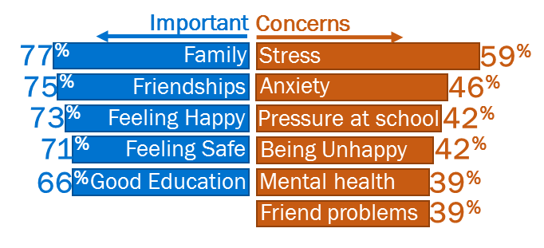
Key findings
In 2018 the survey results are characterised by a continuation of the finding that young people have strong ties to family and friends, whilst also highlighting their need for safety, mental health, jobs, and being respected.
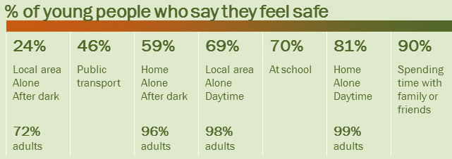
Stress remains the key concern for young people. A new question this year resulted in being able to identify that the frequency of stress for young people is higher relating to school, with key components of school related stress being homework and peer/family pressure. For young people who have left school, family and social media emerge as more frequent points of stress.
On average, young people less often feel safe than adults when alone at home or in their local area, however most feel safe when with family or friends.

Around a third (35%) believe that the community views young people in a negative light. Written comments from these people shed some further light into misperceptions, with the top explanations being:
- Some set a bad example and then everyone is judged by that, but we are not all the same. The good ones don’t get recognised.
- Perception that young people are disobedient, thugs, criminals, troublemakers, ratbags, and violent.
Young people mostly turn to family (that they live with) and friends for help. Lack of confidence, lack of awareness and lack of affordability are the key barriers for using health and community services. The key services young people want within their local community are cinemas, places to hang out, job opportunities, mental health services and services in general being more welcoming to youth.
The last question of the survey gave respondents the opportunity to share their ideas for making Cardinia a better place for young people to live. The most common ideas put forth were improved public transport, youth events/centres, support services and places to hang out.

The following pages provide an overview of the findings for some of the key segments within the community.

Females (n=468)
Either more likely to experience a wider range of issues, or they are inclined to undertake a more detailed completion of the survey than males.
- More frequently indicated concerns with anxiety, negative body image and friendship problems.
- Higher frequency of experiencing stress across all presented scenarios.
- On average, selected a greater number from the list of issues as something they had experienced in the year prior to interview.
- Higher incidence of feeling unsafe in most scenarios, particularly those after dark or outside of the house.
Those born overseas (n=80)
Want equality and are often very family orientated (rather than friendships), even though for some the family environment is stressful.
- Showed a much higher incidence of selecting equality as important.
- Higher frequency of feeling stressed around family.
- Higher instances of indicating suicide as a concern.
- Lower instances of turning to family for help (including both family they do and don’t live with).
18-24 year olds (n=166)
When they leave school they switch from a focus on sports and exercise, to work and money. This age group is in the process of learning how to juggle work commitments whilst maintaining a healthy lifestyle and are starting to seek resources outside of the family network for support, although finances and awareness can be a barrier to use.
- Less often select being active and playing sport as important.
- More commonly indicated a concern about being overweight / obesity.
- Amongst Cardinia residents, this age group more commonly selected mental health as an issue.
- Those in this age group more frequently experience stress: when around immediate family; based on things in the media and/or on social media; and/or regarding the threat of bushfires.
- More commonly turn to a doctor or health professional for help.
- Higher incidence of stating lack of awareness and finances as barriers to accessing services.
- This age group are more commonly seeking local job opportunities, local study opportunities, counselling services and support groups.
- Highest incidence of expressing an interest in forums/committees for young people to have a voice.
15-17 year olds (n=294)
Young people in this age group are experiencing greater levels of stress due to school commitments.
- Cardinia residents in this age group more frequently experience stress when at school.
- This is the age group where being mentally well really kicks in as important (in younger people it is a lot less prominent).

12-14 year olds (n=262)
Need things to do outside of school times and place more importance on being physically active than older youth. This age group are experiencing fewer issues as most still have strong ties to family support structures and face fewer barriers to accessing services.
- More commonly select being active / playing sport as important.
- Cyber/online bullying is an issue for a greater proportion of 12-14 year olds than those aged 15-24.
- Show a higher incidence of turning to family they live with and/or a telephone helpline for help.
- Higher instance of wanting shopping centres, places to hang out, sport, and skate parks in their area.
- Higher instances of indicating that there are no barriers to accessing services.
Ranges ward (n=189)
Young people in this ward don’t exhibit many significantly different traits to the overall findings within the report, although they may be a little more focused on money and due to their geographic location the stress of bushfires is more common.
- Lower levels of assigning importance to family and/or feeling safe at home. Higher instance of assigning importance to having money. (weighted data).
- More frequently experience stress regarding the threat of bushfires.
Central ward (n=249)
In this ward priorities are more money-focussed, perhaps due to the large component of 18-24 year olds in the sample. There is a stronger call for a cinema and/or TAFE in this region.
- This category has a higher instance of 18-24 year olds within the sample, which may influence findings.
- Higher levels of assigning importance to family, feeling safe, having a job, and/or sexual health.
- Higher proportion of residents calling for a cinema and/or TAFE.
- Higher instance of respondents calling for a drug and alcohol rehabilitation centre.
Port ward (n=159)
There are fewer 18-24 year olds in the Port ward sample, resulting in there being a greater interest in sport (which appeals more to the younger age groups). People in this area also deem access to youth services as important. Due to the geographic location of this ward, bushfires are a less frequent concern.
- Higher incidence of wanting a sport in the local area.
- Higher instance of feeling safe when walking alone in the local area at night.
- Higher incidence of assigning importance to access to local youth services.
Unemployed (n=90)
Unemployed people had a wide range of employment support needs, but they also need to have places to hang out.
- High incidence of assigning importance to sexual health (more likely a function of these respondents being older).
- Expectedly, issues more common amongst this group are trouble finding employment, getting a license, getting a job, financial / money challenges and mental health.
- Higher instance of wanting places to hang out.

Cardinia residents (n=597)
Young people who live in Cardinia face work/money and transport challenges more frequently than those outside of the region. Although it should be noted that the resident sample did have a higher proportion of 18-24 year olds (26%, 10% non-resident) which could be skewing the findings.
- Higher proportion selecting getting out and about in nature as important.
- Higher incidence of selecting trouble finding employment and/or difficulty finding transport to get around as an issue.
Non-binary or ‘other identity’ gender identity (n=11)
Whilst the sample for this category was very small there were some statistically significant variations that suggest that further exploration of the needs of this category would be required.
- Higher incidence of indicating issues with suicidal thoughts, being unhappy, and/or isolation.
- Higher incidences of saying they would use an online help service if they needed help.
- Having permission is a significant barrier for this group to access services, along with finances.
- Greater proportions of this group want youth centres, support groups and/or social groups in their area.

Respondent profile
The profile of survey respondents differs to the demographics of young people in Cardinia as per the 2016 Census, characterised by a higher proportion of females, 15-17 year olds (and therefore those in secondary school), and people living in the Port ward.
Gender:  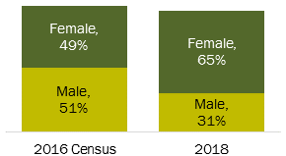 | Age:  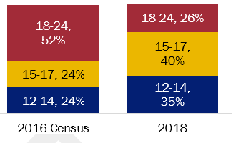
Locality:  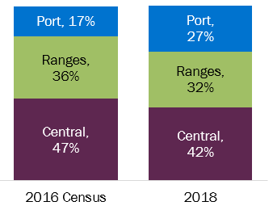 | Birthplace:  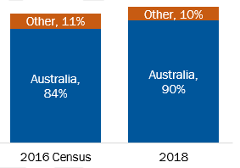
Given these variations, respondents who live in Cardinia have been weighted to align with Census data based on a combination of gender, age and locality (ward). We have also calculated a weight based on gender alone, for specific types of gender-based analysis. Where appropriate, the data will be analysed with these weights active and if the weighted data provides notably different results these have been referenced in the analysis. Unless otherwise specified unweighted data has been used.
Small counts for 18-24 year old males in the Port and Ranges wards (n=6 for each) may result in a mis-representation the opinions of young males in these areas.
The sample contains an over-representation of those in secondary school and unemployed people, and a lower representation of those in full time work.
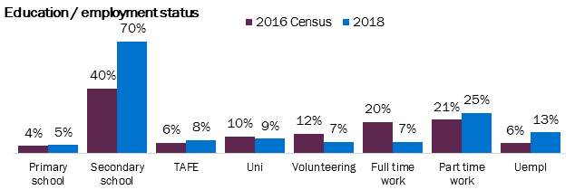

Analysis

Things that are important
Respondents were presented with a list of 26 items and asked which were the most important to them. They could chose as many as they liked and the items appeared in a different randomised order for each respondent (to avoid order bias). An average of 13.5 options were chosen per respondent.
Relationships with family and friends, happiness and safety are the three key things that are important to young people.
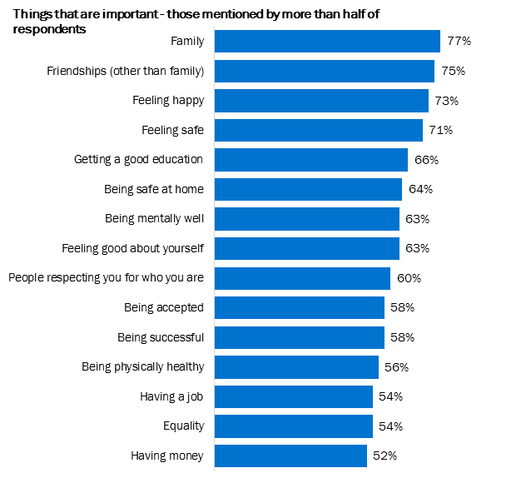
The top 10 items of importance was fairly consistent across gender, age, location of birth, location of residence and employment/study status. Exceptions have been noted in the key statistical variations section on the following page.
Respondents were also provided with a comment box in case there were items of importance to them that did not appear on the list. This comment box was used by 7% of respondents and were mostly single-instance statements with the exception of a couple of topics which were mentioned by 2-3 people each: Computer / console / online games (3 mentions); Netball (2 mentions); LGBTIQ inclusivity and support (2 mentions); and God / church (2 mentions).

Key statistical variations
 | When comparing Cardinia residents to non-residents (weighted by age/gender/ward), having a job features more prominently (60%, 46% non-residents), as does getting out and about in nature (43%, 29% non-residents) and access to local youth services (27%, 17% non-residents).
 | Females showed a higher incidence of selecting almost all variables.
 | Being successful was in the top 5 most commonly selected options for males (4th), pushing getting a good education out of the top 5 (drops to 7th).
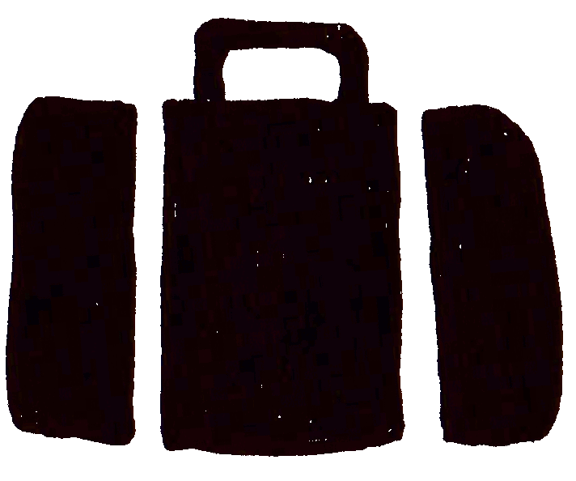 | Understandably, having a job is the most commonly selected item amongst those who are employed, and hence comes 3rd amongst 18-24 year olds; it is much further down the list for those aged 12-14 (19th) and 15-17 (15th), and those still at school (16th). Having money also makes it to the top 10 for those who are employed (10th), and males (6th).
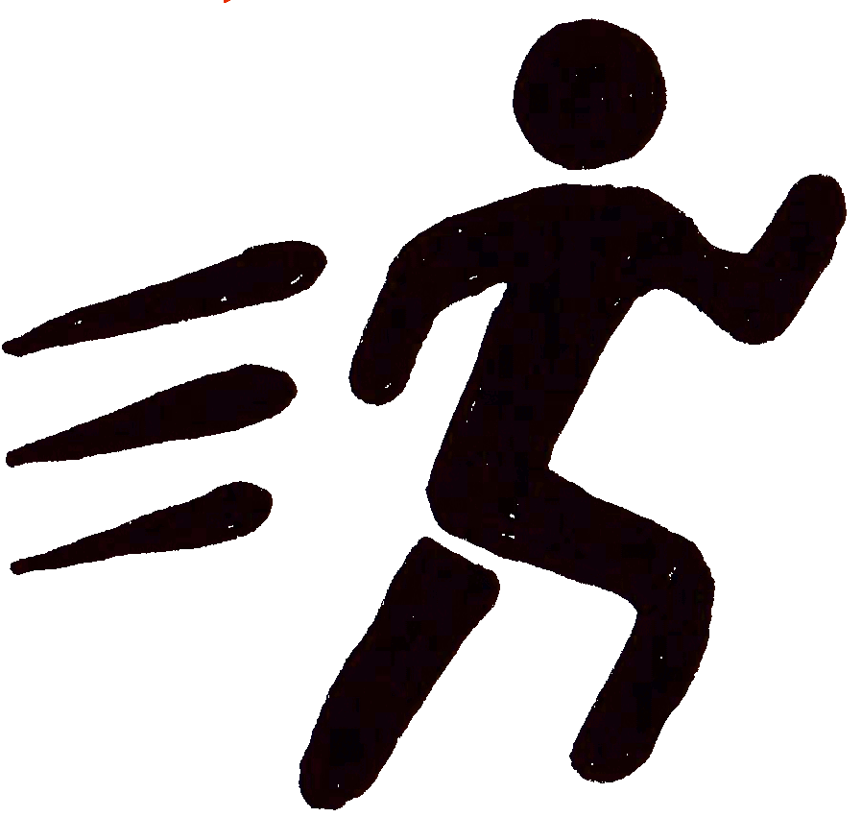 | Being active / playing sport is more commonly important to younger age groups, at around half of 12-17 year olds (55% 12-14, 51% 15-17), then this drops to just a third amongst 18-24 year olds (33%).
 | Being mentally well becomes more common as an item of importance when young people reach the age of 15-17 (53% 12-14, 68% 15-24). It also factors into the top 5 most commonly selected items of importance amongst 18-24 year olds (5th) and unemployed (5th).
 | Friendships (other than family) was more commonly selected as important amongst those aged 12-17 (78%, 66% 18-24 year olds) and consequently those at school (78%).
 | Equality was more often selected as important by those born overseas (68%, 53% Australian born). Those born overseas were the only category where equality made the top 5 (4th).
 | Being physically healthy is more commonly important amongst those who volunteer (73%, ranked 2nd), particularly when compared to those who are studying at Uni or TAFE (49%).
 | Being accepted was selected as important by higher proportions of those who are unemployed (66%, compared to 48% employed people), those at school (62%), 12-14 year olds (61%, compared to 49% 18-24 year olds) and females (62%, 49% males).
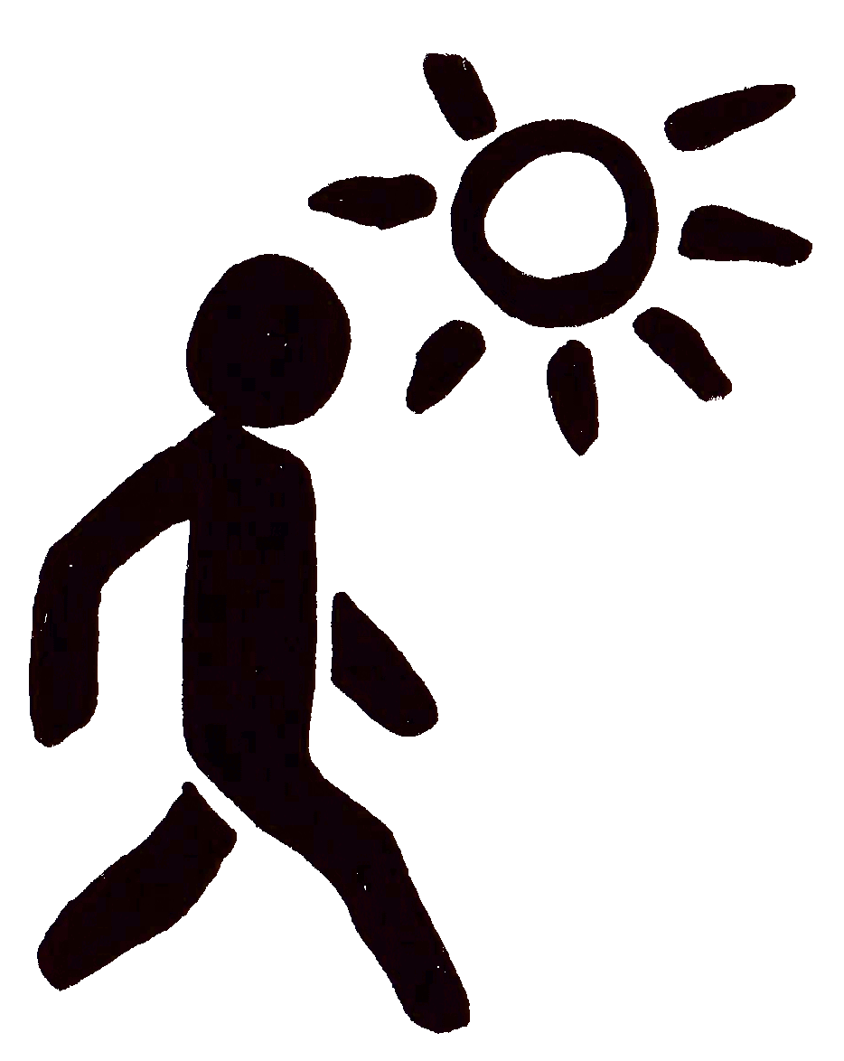 | When people reach the 18-24 age group there is a shift in a priorities. The data shows a drop in the incidence of assigning importance to being active and playing sport (33%, 51-55% in younger age groups), being accepted (49%, 61% 12-17 year olds) and Music/art (31%, 43-46% in younger age groups), coupled by an increase in the incidence of assigning importance to getting out and about in nature (51%, 37% 12-14 year olds), sexual health (35%, 15-27% in younger age groups) and having a job (72%, up from 53% and lower in lower age groups).
 | Those still in school show higher incidences than employed people of selecting music/art (45%, 34% employed), being accepted (62%, 48% employed), having places to hang out (45%, 35% employed) and/or being active/playing sport (53%, 41% employed).
 | Those who live in the Central ward more often selected family (82%, 72% Ranges ward), feeling safe (77%, 66% Ranges ward) and/or having a job (60%, 45% Port ward).

Weighted Cardinia residents (age/gender/ward weight)
The previously observed higher incidence of females choosing most options continues to be the case, however there are some additional observations by age group and location:
- Safety is of more prominent importance amongst those living in the Central ward, with higher instances of selecting being safe at home (69%, 50% Ranges ward) and/or Feeling safe (78%, 56% Ranges ward).
- Younger residents more commonly assign importance to family (80% 12-17 year olds, 63% 18-24 year olds).
- Being respected for who you are is important for 65% of 15-17 year olds, but only 47% of 18-24 year olds.
- Sexual health kicks in as being important when Cardinia residents reach the 15-17 age range (27%, 31% 18-24, compared to 17% 12-14 year olds).

Comparison to 2015
A range of changes were made to the answer text for this question in 2018 that results in some findings not being directly comparable (see appendices). However, when comparing the results more generally to 2015 it is clear that family, friendships, and feeling happy continue to be the most important things for young people.
2018 top 10 | 2018  % | Rank | Corresponding 2015 code | 2015  % | Rank
Family | 77% | 1 | Family | 65% | 2
Friendships (other than family) | 75% | 2 | Friends | 68% | 1
Feeling happy | 73% | 3 | Feeling happy | 53% | 3
Feeling safe | 71% | 4 | Safety | 31% | 10
Getting a good education | 66% | 5 | Education | 48% | 6
Being safe at home | 64% | 6 | Being safe at home | 39% | 8
Being mentally well | 63% | 7 | Mental health | 21% | 15
Feeling good about yourself | 63% | 8 | New code
People respecting you for who you are | 60% | 9 | New code
Being successful | 58% | 10 | Being successful | 48% | 5
Being accepted | 58% | 11 | Being accepted | 35% | 9
Being physically healthy | 56% | 12 | Being healthy | 51% | 4
Being active / playing sport | 48% | 16 | Sport | 41% | 7
In 2015, respondents selected an average of 7.5 of the 23 answer options for this question; this compares to an average of 12.9 selections from the list of 26 options in 2018. This increase in the number of options selected could be a function of question positioning (Q1 in 2018, Q5 in 2015 = more response fatigue in 2015) or due to the revised answer options being more relevant/specific (or a combination of both). This increase in the number of answers selected has resulted in higher percentages recorded across the board in 2018.
Some of the survey changes have allowed for a deeper level of understanding about priorities for young people. Specifically:
- Using the term ‘feeling safe’ appears to be more meaningful for young people than ‘safety’ and has resulted in the 2018 research revealing this as a critical item of importance for young people (in the top 5, whereas in previous years the extent of the importance of ‘safety’ was somewhat lost).
- Likewise, the re-framing of the mental health code so that it is more personalised (‘feeling mentally well’) has resulted in an increase in the incidence of respondents indicating mental health is important.

Issues of concern
When asked to tick which of a list of 38 issues had been of a concern to them in the year prior to interview, respondents selected an average of 7.3 answers each. Stress and anxiety are the main issues of concern for young people.
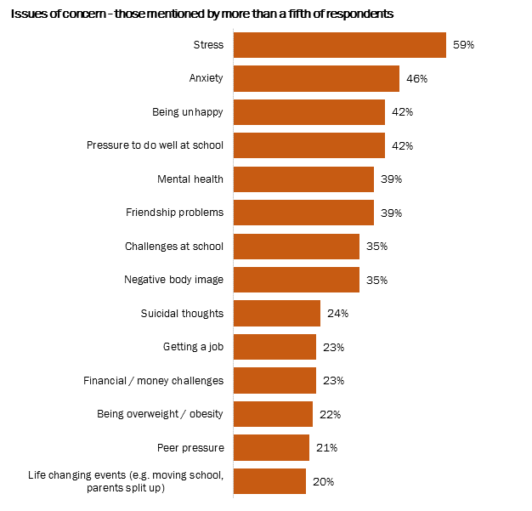
Those who indicated that they identify as non-binary or other gender selected on average 12.55 of these issues, compared to an average of 8.2 for females and 5.9 for males.
The main concerns in this survey are fairly in line with the 2017 Mission Australia Youth Survey which shows that the top areas of concern for young people statewide (Victoria) are coping with stress, school or study problems, body image, depression and family conflict. The Mission Australia research approaches this topic in a different way to the Cardinia Youth Survey in terms of question structure, codeframe, and sample (15-19 year olds only), however it clearly supports the findings that stress (including school stress), and mental health are the key challenges for young people.

Key statistical variations
Cardinia residents (weighted for gender) more frequently indicate issues relating to finding transport to get around (15%, 6% outside of the region).
Those living outside the region show a higher incidence of selecting problem gambling as an issue (4%, 1% in Cardinia).
 | As with things that are important, females showed a higher incidence of selecting almost all variables. The issues of concern with the biggest gap between males and females were negative body image (44% females, 15% males), friendship problems (47% females, 21% males) and anxiety (55% females, 26% males).
 | Cyberbullying / bullying online was selected far more commonly as an issue of concern amongst 12-17 year olds (21%, dropping to 12% amongst 18-24 year olds).
 | A notably higher incidence of those born outside Australia said they were concerned about suicidal thoughts (34%, compared to 22% of those born in Australia).
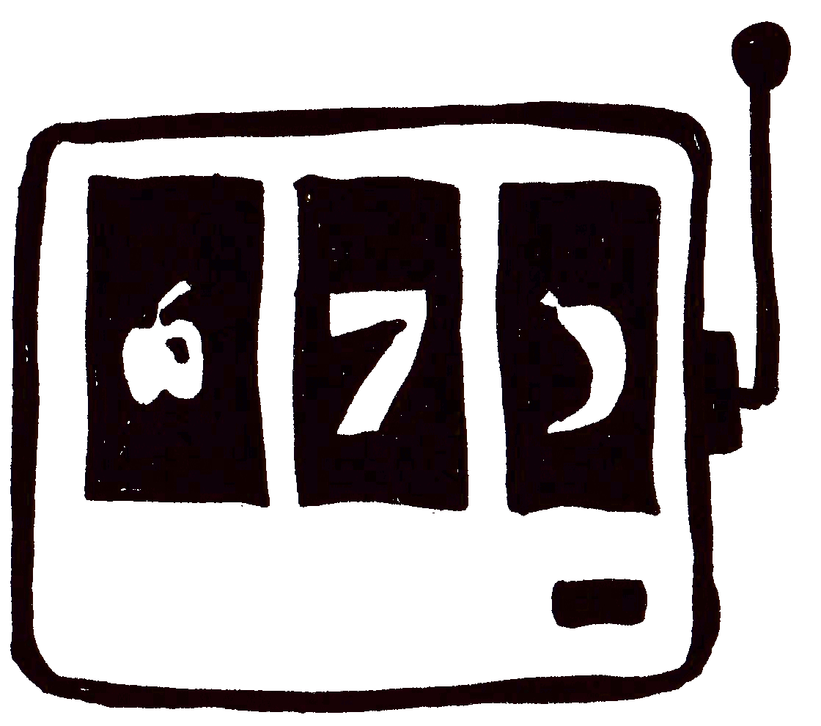 | Problem gambling was also selected by those who were born outside of Australia (6%) more commonly than those born in Australia (1%).
 | Stating mental health as an issue of concern is more common amongst those in higher education (54%), those aged 18-24 (53%), and those who are unemployed (51%, compared to 36% of those in primary/secondary school).
 | Being overweight is more commonly cited as an issue of concern for those who are employed (30%) than those in school (20%), in line with the incidence of indicating this concern being high amongst 18-24 year olds (28%, 17% 12-14 year olds).
 | Although based on a small sample size, those who identify as non-binary or ‘other identify’ for gender (n=11) show a significantly high incidence of indicating issues with suicidal thoughts (73%), being unhappy (82%), and/or isolation (45%).

Weighted Cardinia residents (age/gender/ward weight)
- 18-24 year old Cardinia residents show a significantly higher incidence of indicating mental health as an issue (49%) than those aged 12-14 (24%). Although the 18-24 age category did have higher assigned weights than other age groups (due to lower sample numbers) so this could be skewed by a few respondents.
- Those living in the Central ward also show a higher incidence of selecting a range of issues:
  - Suicidal thoughts/attempts (28%/10%, 16%/3% Ranges ward)
  - Isolation (19%, 10% Ranges ward) Port ward also showed a higher incidence of selecting isolation (21%)
  - Cyber/online bullying (19%, 11% Ranges ward)
  - Being underweight (10%, 3% Ranges ward)
  - Physical violence (12%, 3% Ranges ward)

Time series
In 2018 this question changed slightly to make it more focussed on the topic at hand (issues of concern), and to ensure the question was easier to decipher. There were also additional codes added to the list to reflect the changing nature of experiences for young people: further detail regarding these changes can be found in the appendices.
2015 wording | 2018 wording
If you have experienced any of the following problems in the last year, please tick in the boxes the issues that were of concern to you. | Thinking about the last year, which issues were of concern to you?
For improved accuracy of comparison with previous data, the order of issues for 2018 has been run with a gender weighting assigned to the data (as the unweighted 2018 data had significantly higher proportion of females than previous years). It should also be borne in mind that the 2015 data had a lower proportion of 18-24 year olds in the sample.
The key themes in 2015: stress, anxiety, school pressure, being unhappy and body image all continue to be in the top 10 issues for young people.
 | 2009 | 2011 | 2013 | 2015 | 2018
1 | Bullying | Bullying | Stress | School/Work stress | Stress
2 | Drugs | Alcohol | School/Work stress | Stress | Anxiety
3 | Activities | Drugs | Bullying | Being Unhappy | Pressure to do well at school*
4 | Transport | Violence | Being unhappy | Anxiety | Being unhappy
5 | Boredom | Smoking | Body image | Body Image | Mental health
6 | Vandalism | Transport | Life changing event | Life Changing events | Friendship problems*
7 | Alcohol | Boredom | Being overweight | Bullying | Challenges at school*
8 | Smoking | Vandalism | Peer pressure | Financial/money | Negative body image
9 | Safety | Activities | Mental health/ wellbeing | Being Overweight | Getting a job
10 | Skate parks | Shopping | Transport | Peer Pressure | Suicidal thoughts*
* New codes in 2018
There were four new codes added in 2018 that immediately made it to the top 10: pressure to do well at school (replaces “school/work stress”), friendship problems, challenges at school (replaces “school/work stress”), and suicidal thoughts. These and a number of other new codes have pushed some of the previous top 10 issues to further down the list: bullying (in person 15th, cyber 16th), being overweight (13th) and life changing events (14th).

Stressful situations
Respondents were asked to indicate how often they felt stressed in a number of scenarios. The ‘perceived stress’ scale was used: Very often (4) – fairly often (3) – sometimes (2) – almost never (1) – never (0) and not relevant (not included in analysis). (The number in the brackets shows the assigned scoring to calculate a mean).
Of the scenarios put forward, the situation where young people are more frequently stressed is school.
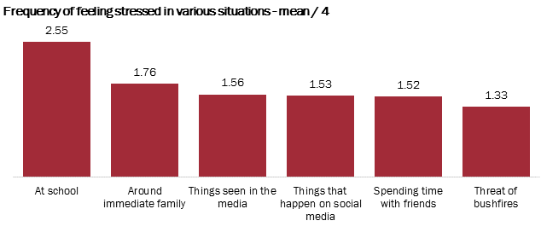

Other causes of stress
180 Respondents wrote in another item that causes them stress. These have been grouped into themes for analysis, with the top mentions as follows:
Theme | Mentions | Details
School, Study and university | 32 | 10 mentions of there being too much homework.  Tests are also mentioned as quite stressful.  Some find it stressful to juggle study and family commitments.
Work | 19 | Many mentions just typed in the word ‘work’ (6).  Key points of stress are changing roles at work, finding a job, performing well and job stability.
Pressure from peers and parents, including people being judgemental or developing incorrect perceptions. | 15 | Points of stress arise when young people feel they are being unfairly judged by family and their peers. This extends to worry about what people are going to think about personal behaviours.  Some mentioned being pressured by their parents to do well.
Life in general / everything | 7 | No additional insights
Transport | 6 | Challenges arise when needing to use public transport to get around, specific to delays and lack of options.
Financial pressure | 6 | Includes not having money to pay for expenses / buy food, as well as stress about rising cost of living.
Mental health | 5 | Includes personal mental health as well as seeing friends with mental health problems and not being able to help.
Other | 27 | Includes bullying, lack of time, isolation, people not caring about the environment, illegal drug use, discrimination, corruption, medical, and safety at night.

Key statistical variations
As with previous questions, females again show notable differences to males, with consistently higher average stress frequencies recorded.
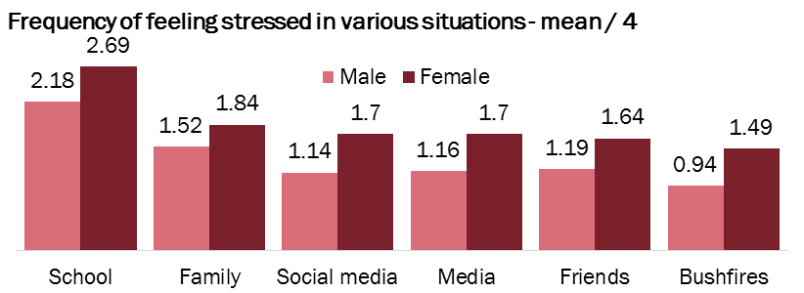
With regards to family, social media, and media, the frequency of experiencing stress increases with age.
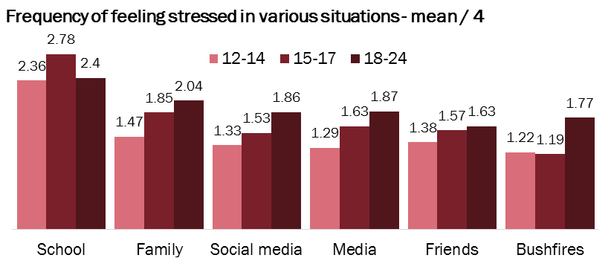
Those born overseas show higher mean frequency of feeling stress when around immediate family (2.13, compared to 1.69 for those born in Australia) and based on things they see in the media (1.97, compared to 1.5 for those born in Australia)
Those who are employed show higher mean frequency of stress than those at school to a range of scenarios including when around immediate family (2.01 employed, 1.7 school), based on things in the media (1.78 employed, 1.45 school), based on things on social media (1.78 employed, 1.45 school), and bushfires (1.53 employed, 1.26 school). This closely correlates with age.

Weighted Cardinia residents (age/gender/ward weight)
- The frequency of feeling stressed around immediate family is higher amongst 18-24 year olds (2.02, 1.43 12-14 year olds)
- Those in the Central ward show higher average frequency of stress based on things that happen in social media (1.7, compared to 1.2 Port ward)
- Those in the Ranges ward show higher average frequency of stress regarding bushfires (1.7, 1.21-1.27 in other wards).

Perceptions of safety
Given the significant differences in perceptions between males and females, the following data has been run using a gender weight to adjust for the over-representation of females.
Most young people feel safe when spending time with friends and/or family, but many don’t feel safe in their local area alone after dark.
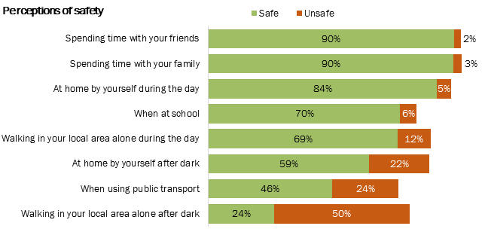
For comparison, research conducted with the broader Cardinia community (2011 Vic Health indicator survey, ages 18 and over) shows that young people have notably lower perceptions of safety both when at home and also walking alone in their local area when compared to adults.
Feel safe or very safe… | 2018 Youth Survey | 2011 Vichealth indicator survey
Home alone during the day | 84% | 99.3%
Home alone at night | 59% | 95.9%
Walking alone in local area during the day | 69% | 97.5%
Walking alone in local area at night | 24% | 71.7%

Reasons for feeling unsafe
Those who said that they felt unsafe in one or more of these scenarios were asked to write in why they feel unsafe. The table below summarises the written responses of the 140 respondents who wrote in an answer.
Theme | Mentions | Details
Strangers or dangerous people | 33 | Many comments included some mention of people perceived to be dangerous, usually strangers.
Violence, crime | 31 | Many mentioned violence or crime without any further elaboration. The top mentions of specific crimes were house breaking, robberies and physical assault.
Dark, poor lighting | 23 | Mentions include being afraid of the dark, or not trusting dark places. Others mentioned there being insufficient lighting to be outside in their area at night.
Scary, anxiety | 11 | This theme was selected when the respondent used the word scary or anxiety. No further details were given.
Gender (female) | 11 | There is a perception that it is unsafe for a female in these environments.
Pakenham | 8 | There is a perception that Pakenham is an unsafe area.
People on drugs or drunk | 7 | No further detail
Gangs | 7 | No further detail
Something bad may happen | 4 | No further detail
Media portrayal of it being dangerous | 3 | No further detail
Fear of the unknown | 3 | No further detail
Other | 10 | Including social climate, parent behaviour, bullying, and isolation.

Key statistical variations
Females show higher incidences of feeling unsafe in many of these situations.
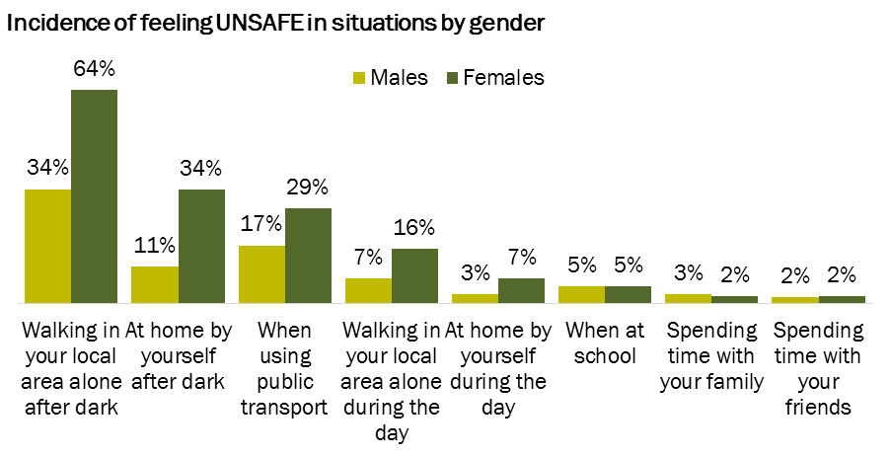
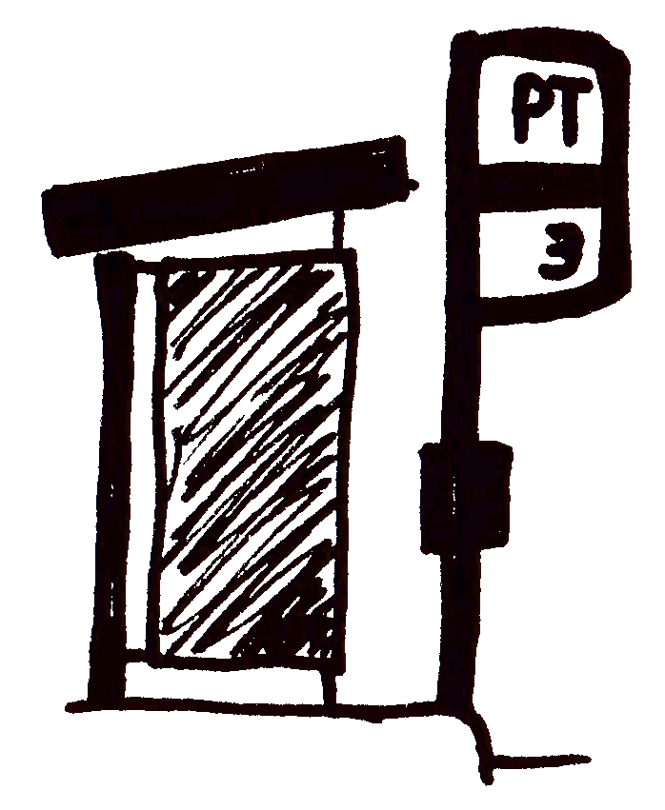 | Public transport is perceived as very safe/safe by a higher proportion of 12-17 year olds (49%) than 18-24 year olds (32%).
 | Those in the Port ward show a higher incidence of feeling safe when walking in their local area at night.

Sources of information, advice or help with a problem
Respondents were presented with a list of potential sources of information and support (order randomised for each individual) and asked to select which ones they would turn to (multiple responses allowed).
Friends and family that they live with are the primary people that young people would turn to for information, advice or help about a problem.
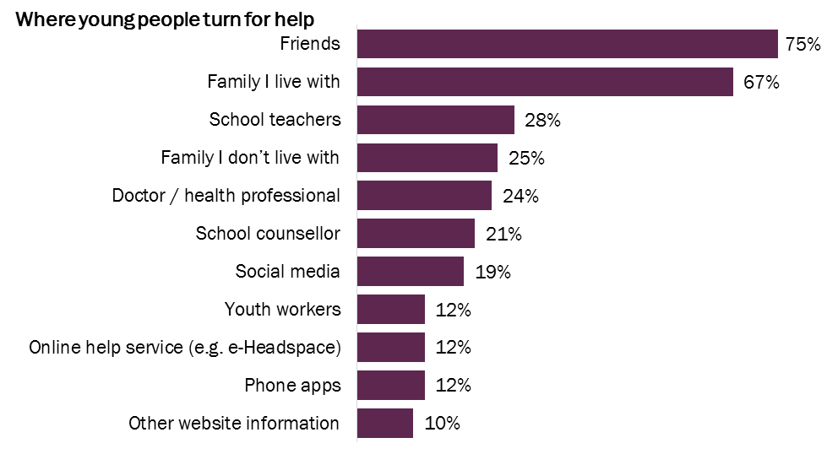
A small number (4%) wrote a response in ‘other’, which were primarily to specify their partner / boyfriend / girlfriend (10 mentions) or themselves / not turn to anyone else (7 mentions).

Key statistical variations
Despite a small sample size (n=11), those who indicated that they identify as non-binary or ‘other’ gender show notably higher incidences of saying they would use an online help service (36%), and a much lower instance of saying they would talk to family they live with (27%).
12-14 year olds more often selected family I live with (75%, compared to 61-64% 15-24 year olds) and/or telephone hotline (12%, 3-6% 15-24 year olds).
18-24 year olds more commonly indicated they would seek help or advice from a doctor or health professional (47%, 13-21% 12-17 year olds), which translates into higher instances of those at University/TAFE (48%) and in employment (37%) indicating they would use this resource. 18-24 year olds also show notably high instances of indicating they would turn to family they don’t live with (33%, 19% 15-27 year olds).
Those born in Australia show notably higher instances of indicating they would turn to family they live with (70%, 53% born outside Australia) and/or family they don’t live with (26%, 14% born outside Australia).
Cardinia residents more commonly indicate that they would turn to youth workers (13%, compared to 4% of those who live outside of Cardinia).

Time series
There were two key changes in the design of this question in 2018. The first was to re-frame the family components of the question from defining the family member type (immediate or extended) to defining whether they would turn to family they live with or didn’t live with. This provides a greater understanding of young peoples’ immediate support structures. The ‘Doctor’ option was also expanded to incorporate other healthcare professionals.
2018 top 5 | 2018  % | Rank | Corresponding 2015 code | 2015  % | Rank
Friends | 75% | 1 | Friends | 62% | 1
Family I live with | 67% | 2 | Immediate family | 45% | 2
School teachers | 28% | 3 | School teachers | 20% | 4
Family I don’t live with | 25% | 4 | Extended family | 25% | 3
Doctor / health professional | 24% | 5 | Doctor | 7% | 6
 |  |  | Adult outside the family | 14% | 5
In 2018 there is a notably higher incidence of respondents naming doctor than was recorded in 2015, most likely due to the inclusion of ‘health care professional’ in the code, and the higher proportion of 18-24 year olds in the sample (who more often turn to this resource).
In total, 73% of respondents in 2018 said that they could turn to a family member that they either live with or otherwise, compared to 52% in 2015. Given the questions were asked in a similar way, findings suggest either an increase in the incidence of young people being able to turn to family for help, or an increase in respondents understanding the answer code terminology. Future research will identify if there is a trend.

Barriers to accessing services
In 2018 a new question was included to help understand the barriers to accessing health or community services in Cardinia. Respondents were presented with a set of potential barriers (in a randomized order for each respondent) and asked to tick all that apply.
Almost half indicated that they didn’t experience any barriers to attending local health or community services. The primary barriers are personal (confidence and finances), lack of promotion (awareness), and structural (transport and distance). Encouragingly, few cited barriers relating to the perceived quality of the services (wait times, perceptions).
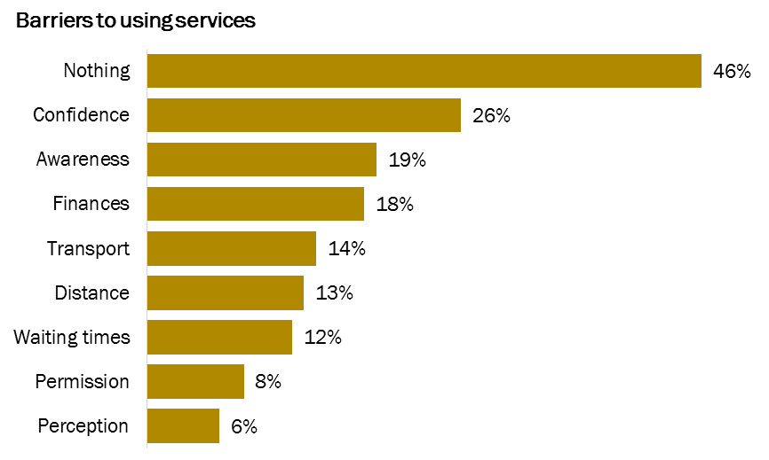
I have heard local services aren’t very good
Not allowed to attend services
Services are too far away
Too difficult to travel to services
Can’t afford to use services
I don’t know what services are available
I don’t feel comfortable going on my own
A small number (4%) specified an ‘other’ barrier, mostly indicating that they don’t like talking to people they don’t know, or are too scared to access services (6 mentions) or that they need their parent’s permission (2 mentions).

Key statistical variations
Males more often selected nothing (58%) than females (42%), whereas confidence and awareness were named by greater proportions of females (28% and 22% respectively).
Although a small sample size (n=11), the two primary barriers for those who indicated they identify as non-binary or ‘other’ identify were finances and permission (each selected by 45%).
Those in the 12-14 age group show higher instances of indicating that there are no barriers (62%, dropping to 44% 15-17 year olds and only 26% of 18-24 year olds). For the 18-24 year olds the primary barriers are finances (31%) and awareness (33%).
Those at school show higher instances of having no barriers (52%), while those at University face financial barriers (28%), and employed people face both financial (24%) and awareness (30%) barriers.

Community perceptions of young people
Just over a third (36%) think that the community thinks negatively about young people. The perception that the community thinks negatively about young people is significantly higher amongst those aged 18-24 years (60%) and consequently those who are employed (49%) or studying at University or TAFE (57%). Cardinia residents also show a higher incidence of saying that they think the community thinks negatively about young people (38%, 25% non-residents), as driven by those living in the Central (41%) and Ranges (44%) wards (26% Port ward).
Those who indicated that ‘yes’ the community thinks negatively about young people were asked to write in why. These comments can be grouped under the following themes:
Generalisation - some set a bad example and then everyone is judged by that, but we are not all the same. The good ones don’t get recognised.
(43 mentions)
Disobedient, Thugs, Criminals, Troublemakers, Ratbags, Graffiti, Violent
(38 mentions)

There is a large stigma that is related to young people, especially in this area, to be thief’s, break into homes and involved in large amounts of crime, so the community generalises one incident and puts it onto the whole lot of the younger people.
Nobody takes the time to look and appreciate all the good things that we do and partake in and are always quick to judge us for our mistakes.
They think millennials are no good children. They expect us to be able to buy houses and be able to afford things when in reality we will never be able to do that because everything is too expensive, but they made it too expensive. The past generations baby boomers, gen X, sure they had it hard but now the government from those generation has made it almost impossible to live.
They’re perceived as ‘thugs’ and when one person does something wrong, they assume all teenagers are rude and criminals.
They all think we are drop kicks based on the perception the media has of young people.
Ignorant, Fools, Stupid, Reckless, Silly.
(10 mentions)
Intimidating, dangerous (4 mentions)
No drive for success, don’t work hard (3 mentions)
Soft, oversensitive (3 mentions)
No respect, trust or compassion for young people, dismissive.
(11 mentions)
Media, social media perpetuating stereotypes (12 mentions)
Take drugs, get drunk (11 mentions)
Lazy, Dropkicks.
(12 mentions)
Destructive, Disrespectful, Rude, Bad attitude, Untrustworthy
(14 mentions)
Older generations expect too much from us, expect us to follow their formula. They don’t understand us, we want different things.
(13 mentions)

Facilities and services for young people
Respondents were asked to select from a list which services, activities, programs, events or other opportunities they would like to see in their home town/area. Answer options were presented in a random order for each respondent to avoid order bias and they could choose as many options as they liked.
Places to go and being able to find work were called for by more young people than community services or groups.
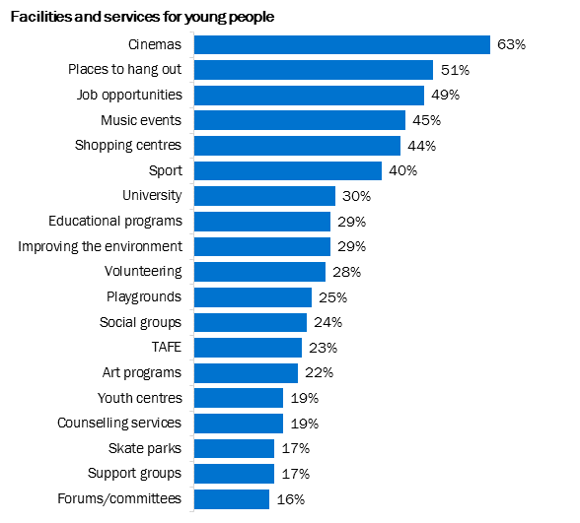
The top 5 facilities and services per ward are:
Central ward (n=249) |  | Ranges ward (n=189) |  | Port ward (n==159) |  | Outside Cardinia (n=57)
Cinemas | 76% | Places to hang out | 60% | Cinemas | 57% | Places to hang out | 54%
Places to hang out | 51% | Cinemas | 59% | Shopping centres | 54% | Cinemas | 51%
Music festivals/gigs/concerts | 49% | Job opportunities | 56% | Job opportunities | 50% | Job opportunities | 47%
Job opportunities | 45% | Music festivals/gigs/ concerts | 50% | Places to hang out | 49% | Music festivals/gigs/concerts | 44%
Shopping centres | 44% | Shopping centres | 41% | Sport | 48% | Sport | 39%

Key statistical variations
 | As has been observed across most questions, females show consistently higher instances of selecting most options, with the exception of sport, TAFE and skate parks.
 | Although based on a small sample size (n=11), those who identify as non-binary or ‘other’ gender show significantly high incidences of indicating they would like youth centres, support groups and social groups in their area (each selected by 64%).
 | There are some variations by age, with more 12-14 year olds selecting shopping centres (50%), sport (50%), places to hang out (54%) and skate parks (21%). At the other end of the youth spectrum, higher proportions of 18-24 year olds want to see job opportunities (64%), University (44%), educational programs (41%), counselling services (31%), youth centres (24%), support groups (25%) in their area.
 | Those born outside of Australia more commonly selected volunteering (45%, compared to 26% of those born in Australia).
 | Greater proportions of those in Central ward were calling for cinemas (76%, compared to 58% in the other wards) and/or TAFE (31%, 18-24% in other wards). Port ward respondents show a notably high incidence of selecting sport (48%).
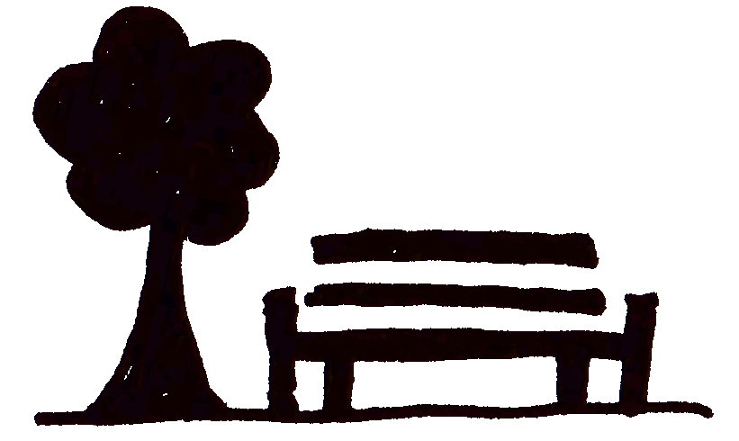 | Places to hang out were of interest to a significantly high proportion of unemployed people (73%) and those at school (57%), whereas many of those studying at University/TAFE or employed called for job opportunities (62% and 59% respectively) and / or university (46% University, 39% employed).
 | 18-24 year olds and employed people show the highest incidence of interest in forums/committees for young people to have a voice (each 22%).

A new question was included in 2018 to identify whether young people think particular services or programs would help with the issues they face. A list of services and programs was presented (in randomised order) from which they could select as many as they like, or they could type in their own response.
Findings suggest that the priority areas of focus for Council to assist young people would be through job creation and mental health services.
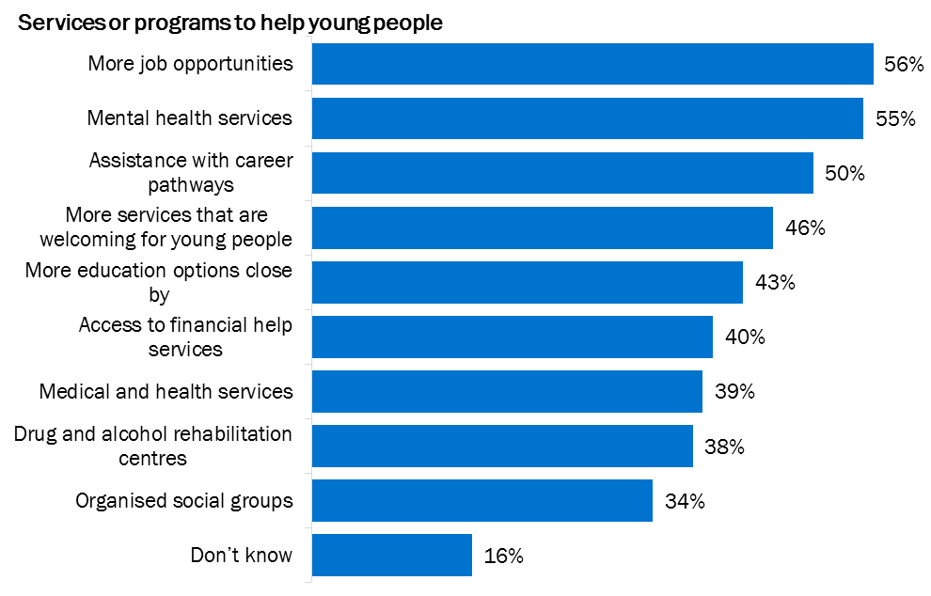
Very few typed in their own response to this question (3%), with answers too varied for any further meaningful groupings.

Key statistical variations
Again, females show consistently higher instances of selecting each of the options.
12-14 year olds show a higher incidence of indicating that they don’t know (24%), with this dropping to 14% amongst 15-27 year olds. The 18-24 year old age group is clearly the most engaged with the question, showing significantly higher instances of selecting each option than younger respondents.
Services that are welcoming for young people was of appeal to greater proportions of young people in Central (51%) and Ranges (54%) wards(compared to 36% Port ward). Central also shows a higher incidence of young people wanting a drug and alcohol rehabilitation centre (45%, compared to 30% Port ward).
Expectedly, unemployed respondents more commonly selected more job opportunities (69%) and/or assistance with career pathways (66%).

Other ideas
At the end of the survey respondents were asked to type in their ideas for what could make Cardinia a better place to live. 208 respondents provided an answer to this question. Comments have been grouped into a number of themes as outlined in the following table.
Theme | Mentions | Details
Transport | 31 | There were a few key issues put forth with regards to transport:  - Difficulty getting places on public transport (particularly in the more regional areas) – poor connections or no transport close to home.  - Need more public transport (routes and frequency).  - Safety of public transport stops and stations  - Unsafe road crossings  - Footpaths unsafe or inappropriate
Youth events / centres | 23 | Suggestions include:  - Youth conference  - Talks at schools  - Youth centres close to home  - Youth centre that offers free support services  - Workshops/events: sustainable living (3 mentions), health, finances, nutrition, environment, arts and crafts, sport, markets, festivals, concerts, fun run, competitions, volunteering, mural, sculpture, social events, film festival, study group, boxing classes.
Support services | 21 | This is a separate code to ‘mental health’ specific support. This theme captures those who mention ‘support services’ without defining these further. Some mention particular needs that require support such as financial issues, family issues, help finding jobs, LGBTIQ services, and general help. Some mention that this would need to be coupled with adequate advertising so that young people know the services are available.
Places to hang out | 20 | In particular, people are looking for places they can go that are close to home (as public transport is limited for many).
Improve safety / policing | 20 | Ideas range from the provision of safer places to hang out through to an increase in police presence to manage deviant behaviour.  Areas where safety is a particular concern include public transport and roads.
Outdoor activity | 19 | A number of ideas were put forth for specific outdoor activities:  - Skate park (4 mentions)  - Mountain bike trail network (3 mentions)  - Basketball courts (3 mentions)  - Parks (including those suitable for teenagers) (3 mentions)  - Waterslides  - Places to ride bike  - Dog park  - Music (www.caravanmusicrecords.com)  - Community garden  - Bike/hiking trail Nar Nar Goon – Pakenham – Officer – Berwick  - Volleyball  - Baseball grounds
Drugs / alcohol | 13 | Comments revolved around reducing drug use in the region (7 mentions), reducing cigarettes (2 mentions) and educating young people on the dangers of alcohol use.
Local jobs | 13 | Generate more jobs for young people in their local area.
Shopping centre / cinema | 12 | No further detail other than requests for shopping centres and cinemas.
Environmental protection | 11 | A number of respondents suggested the introduction of programs to protect the environment, whist others called for no more littering.
Improve schools | 9 | Emerald Secondary School was the most commonly mentioned (3 mentions). Comments suggest making schools a less stressful environment, as well as updating buildings.
Mental health services / information | 8 | A range of suggestions were made on how to help young people with their mental health, including talks at schools and cheaper/free counselling. Mostly comments simply referred to ‘mental health services’.
Cheap / free activities | 8 | Provide more activities that are accessible for those facing financial hardship.
Consult youth | 7 | A range of comments suggested that youth need to be consulted when planning infrastructure and services for youth.
Local education opportunities | 5 | Including University, TAFE and schools
Other suggestions |  | - Diversity awareness education (3 mentions)  - Don’t give up on troubled youth (3 mentions)  - McDonalds / fast food (2 mentions)

Things that Council could do to help make these ideas reality are:
- Advocate for better public transport;
- Ensure adequate and safe footpaths and road crossings;
- Run youth events and activities (preferably free or cheap);
- Provide youth centres in places that mean youth don't have to travel long distances;
- Support and help advertise local support services;
- Facilitate the provision of affordable mental health services for youth;
- Include spaces for youth in infrastructure plans, including places to safely hang out, skate parks, mountain bike trails, basketball courts etc.;
- Help bring local jobs and education opportunities to the region so that young people don't have to travel long distances for work/study;
- Encourage environmental protection through litter reduction and programs to educate young people on sustainable living; and
- Consult with young people when designing infrastructure or services for them.

Appendices

Questionnaire changes
The following section summarises the changes to the 2018 survey. Many of these changes remove the ability to analyse trends over time, however it was identified that an update was needed to enhance the accuracy and relevance of future tracking surveys.

Things of importance
In 2018 this question was moved to the start of the survey so that respondents could ease into the survey by sharing what is important to them, instead of jumping straight into concerns.
A number of answer codes were altered to enhance their relevance to both young people and Council, as outlined in the following table.
2018 response code | Status / change compared to 2015
Access to local youth services | Access to support services – updated to be specific to youth services
Being successful | unchanged
Equality | unchanged
Being mentally well | Mental health – re-framed the comment
Getting out and about in nature | Recreational activities – reworded to be specific about what sort of recreational activities
Being active / playing sport | Sport – expanded it to include being active
Friendships (other than family) | Friends – reframed the comment to make it distinguishable from family
Knowing what is going on in the world | World affairs – reframed the comment
Indoor activities/non-competitive sports/youth programs | New code
Feeling safe | Safety – reframed the comment
Being accepted | unchanged
Music / art | unchanged
Family | unchanged
Having money | Money – reframed the comment
Sexual health | unchanged
Having a job | Work – reframed the comment
Being safe at home | unchanged
Support people at school | New code
Taking care of the environment | Environment – reframed the comment
Being physically healthy | Being healthy – made it specific to physical health (there is a different option specific to mental health)
Eating healthy food | New code
Getting a good education | Education – reframed the comment
Feeling happy | unchanged
Having places to hang out | Place to hang out – reframed the comment
Feeling good about yourself | New code
People respecting you for who you are | New code
 | Body image not included in 2018
 | Relationships not included in 2018

Issues of concern
In 2018 the wording of this question was updated so that it was clearer that the question was seeking the respondent to specify issues of concern. In 2015 some may have read just the first half of the question and ticked those they had experienced, yet it was reported as issues of concern not experiences. In 2018 an explanation for how the question will be used, and a link to beyond blue was also included in case the question itself proved to be a trigger.
2018 wording / display:
Q2. Thinking about the last year, which issues were of concern to you?
This will help us understand which aspects of everyday life we need to help young people with.
Please tick all that apply, and remember, your response is completely anonymous.
If you feel sad or anxious, please contact www.beyondblue.org.au, 1300 22 4636
2015 wording/display:
Question 1
If you have experienced any of the following problems in the last year, please tick in the boxes the issues that were of concern to you.
This question also had a number of the answer codes updated to allow for changes in youth experiences. The following table outlines the changes to the response codes.
2018 response code | Status / change compared to 2015
Financial / money challenges | ‘Financial/money’ – updated in 2018 to include the word ‘challenges’
Negative body image | ‘Body image’ – updated in 2018 to specify that this means a problem with body image (body building could also be considered ‘body image’
Discrimination | unchanged
Questioning gender identity | ‘Gender identity’ – updated in 2018 to be more specific to LGBTIQ identity
Mental health | ‘Mental health issue’ – doesn’t necessarily have to be an ‘issue’ to be of concern
Challenges at school  Pressure to do well at school | ‘School / work stress’ – removed ‘work’ aspect as it was referring to 2 separate concepts that we couldn’t individually identify. Should have had a separate code for ‘work challenges’ but missed that – to be included in the future.
Stress | unchanged
Access to TAFE or University | New code
Smoking cigarettes | ‘Smoking’ – updated in 2018 to be specific to cigarettes
Getting a job | New code
Smoking vapes | New code
Difficulty finding transport to get around | ‘Transport’ – updated in 2018 to be more specific about what the code means.
People with a disability being able to access services and recreation facilities | ‘Disability’ – updated in 2018 to be more specific to the issue

2018 response code | Status / change compared to 2015
Alcohol related illness / binge drinking | ‘Alcohol’ – updated in 2018 to specify what is meant by this code
Cyber bullying | Unchanged. But merged with ‘Bullying – online’ for analysis.
Being unhappy | unchanged
Suicidal thoughts | New code
Suicide attempts | New code
Anxiety | unchanged
Bullying – online  Bullying – in person | ‘Bullying – split it up between online and in-person
Use of illegal drugs | ‘Drugs’ – switch it to referring specifically to illegal drugs (‘Drugs’ could be construed as referring to prescription drugs as well).
Getting a license | New code
Friendship problems | New code
Unapproved graffiti pieces / tagging  Finding opportunities to do legal public art (pieces, pasteups etc.) | ‘Graffiti’ – split into 2 codes to make it clearer about whether their concern was related to not liking graffiti or wanting to do pieces.
Isolation | unchanged
Problem gambling | New code
Trouble finding employment | New code
Peer pressure | unchanged
Physical violence  Emotional abuse | ‘Victim of violence’ – changed to split out physical and emotional and removed the personalisation of it (ethical reasons).
Being overweight / obesity | ‘Being overweight’ – added ‘obesity’ in 2018
Being underweight | New code
Acceptance of those with a non-binary sexuality | ‘Sexuality’ – changed to be more specific as to the issue.
Life changing events (e.g. moving school, parents split up) | unchanged
Housing / having somewhere to live | New code
 | No issues not included in 2018 (not sure why). Only 2 people said ‘nothing’ in the other comment box.
 | ‘Not attending school’ removed in 2018
 | ‘Sexual health issues’ removed in 2018
 | ‘Family violence’ removed in 2018
 | ‘Violence in public spaces’ removed in 2018
 | ‘School disengagement’ removed in 2018

Information, advice or help
In 2018 the text of this question was altered slightly.
2018 wording / display:
Q5 If you need some information, advice or help with a problem who are the people or places you turn to? Please tick all that apply
2015 wording/display:
Question 4
If you need some information, advice or help with a problem who are the people or places you turn to? (please tick all that apply)
Minimal alterations were made to the response codes. The primary change was to reframe how information about family support was collected to make it more strategically relevant.
2018 response code | Status / change compared to 2015
Family I live with  Family I don’t live with | Changed from the following codes as it was decided that the important distinction was whether they are family in the same household or a different household.  - Adult outside the family  - Extended family (e.g. aunty, uncle, grandma)  - Immediate family (e.g. mum, dad, brother, sister)
School teachers | unchanged
Case Manager | unchanged
Doctor / health professional | Doctor – expanded to include other health professionals
Phone apps | unchanged
Council website information | unchanged
Other website information | unchanged
Social media | unchanged
Online help service (e.g. e-Headspace) | HeadSpace (centre or online)
School counsellor | unchanged
My Place Youth Facility | unchanged
Youth workers | unchanged
Friends | unchanged
Telephone hotline (e.g. Kids helpline) | unchanged

Services in area
The question text did not change in 2018, however some of the answer codes were adjusted, as shown in the following table.
Q8. Which of the following services, activities, programs, events or other opportunities you would like to have in your home town/area? Please tick all that apply
2018 response code | Status / change compared to 2015
Art programs | unchanged
TAFE | unchanged
Places to hang out | unchanged
University | unchanged
Support groups | Support groups (Same sex attracted/mental health)
Social groups | New code
Sport | unchanged
Skate parks | unchanged
Cinemas | unchanged
Music festivals/gigs/concerts | unchanged
Playgrounds | unchanged
Volunteering | unchanged
Educational programs/courses | unchanged
Improving the environment | unchanged
Counselling services | unchanged
Job opportunities | unchanged
Shopping centres | unchanged
Youth centres | unchanged
Forums/committees for young people to have a voice | Forums/committees for you to have a voice
 | ‘Hitchhike’ removed
 | ‘Skate / soccer’ removed

New questions
A range of new questions were added in 2018, as follows:
Q3. To help us understand the issue of stress for young people, please let us know in the last 12 months, how often have you felt stressed…
Q4 How safe or unsafe do you feel when you are in the following situations?
Q6 Is there anything stopping you from accessing health or community services in your area? Please tick all that apply
Q7 Do you think the community thinks negatively about young people?
Q9. What kinds of services or programs do you think might help young people with the issues they face? Please tick all that apply
Q10. Please share any ideas you have that could make Cardinia a better place to live for young people?

Questions not asked in 2018
The following questions were asked in 2015 but not 2018:
Question 2
If you have experienced stress, what are the things that make you feel stressed? (please tick all that apply)
Question 3
What are the things that stop you from participating in or attending activities/school/work? (please tick all that apply)
Question 6
Please tick what activities you do in your spare time
Question 7
Please tick the ways you get to your daily activities.
Question 8
Please tick the ways that you would like to receive or find out information from Council about youth programs, services and events?
Question 9
If you could change one thing for young people in Cardinia Shire, what would it be?
Question 10
Do you have any other comments to add?

Distribution
Type | Details | Date of first contact | Distribution link used
Education / youth settings | 11 Schools (see list below) | 23-26/3/2018 | Schools
 | Youth Strategy network | 23/03/2018 | Youth Service providers
 | Youth Network | 23/03/2018 | Youth Service providers
 | Scouts | 26/03/2018 | Other
 | Sports clubs | 26/03/2018 | Other
 | Aligned Leisure | 26/03/2018 | Other
 | Associated churches | 13/04/2018 | Other
 | Lakeside residents group | 13/04/2018 | Face to face
 | VicPol | 13/04/2018 | Face to face
 | Chisholm teachers | 4/04/2018 | Face to face
 | SRS Youth services | 9/05/2018 | Face to face
 | 13 Sports clubs (see list below) | 9/05/2018 | Face to face
 | Cardinia Youth Theatre | 9/05/2018 | Face to face
Online | Council website | 22/03/2018 (xx date posted) | Council website
 | Headspace Facebook | 23/03/2018 (xx date posted) | Face to face
 | Youth Services Facebook | 23/03/2018 | Youth services Facebook
 | Scouts Facebook | 13/04/2018 | Face to face
 | internet café computer landing page | 23/03/2018 | Face to face
 | Council Facebook | 23/03/2018 (xx date posted) | Council Facebook
 | Glenda George (xx what was this for / how was it distributed?) | 26/03/2018 | Other
Face-to-face | My Place youth facility | 23/03/18 | Face to face
 | Yakerboo festival | 22/04/18 | Face to face
 | Together with Me event at Pakenham Library | 16/04/18 | Face to face
 | My Place after school and in-school programs | 23/03/18 | Face to face
 | Good Choice awards | 20/04/18 | Face to face
 | Teenage School Holiday program | 3/04/18 – 13/04/18 | Face to face
 | Internet Café | 23/03/18 | Face to face
 | Gumbuya Park day – VicPol | 19/04/18 | Face to face
Mailing list / newsletter distribution | Youth services distribution list | 9/05/2018 | Youth Service providers
 | Enliven newsletter | 9/04/2018 | Youth Service providers

List of schools:
- Yvette Sangster (Pakenham Sec)
- Felicity Wooden (Emerald Sec)
- Leonie McGinley (KWR Sec)
- Jackie Bonis (Officer Sec)
- Helen Kusters (Oakwood)
- Beaconhills Secondary
- Chairo Christian College
- Heritage College
- Glenvale School
- Saint Francis Xavier
- Lakeside College
List of sports clubs:
- Pakenham FNC
- Beaconsfield FNC
- Koo Wee Rup FNC
- Bunyip FNC
- Bunyip Women's FC
- Garfield FNC
- Emerald FNC
- Gembrook/Cockatoo FNC
- Nar Nar Goon FNC
- Lang Lang FNC
- ROC FNC
- Cora Lynn FNC
- Pakenham Baseball Club

Sample counts
The following section shows the count of respondents in each demographic group (prior to weighting).
Gender | TOTAL | Cardinia Resident | Outside Cardinia
Male | 218 | 185 | 33
Female | 468 | 388 | 80
Non-binary | 7 | 5 | <5
Other identity | <5 | - | <5
I’d prefer not to say | 25 | 19 | 6

Age group | TOTAL | Cardinia Resident | Outside Cardinia
12-14 years | 262 | 204 | 53
15-17 years | 294 | 223 | 58
18-24 years | 166 | 147 | 13

Country of birth | TOTAL | Cardinia Resident | Outside Cardinia
Australia | 628 | 536 | 92
Other | 80 | 58 | 22
Id prefer not to say | 14 | 3 | 11

Other Country of birth | Count
United Kingdom | 11
New Zealand & Pacific | 10
America (North and South) | <5
Europe | 5
Southeast Asia | 7
East Asia | 6
South Asia | 14
Middle East | 6
African continent | 8
Joke answers (planet etc.) | 7

Ward | TOTAL
Central | 249
Ranges | 189
Port | 159
Outside Cardinia | 57
Undetermined | 68

Suburb | Count |  | Count |  | Count
Avonsleigh | 11 | Gembrook | 16 | Nyora | <5
Bayles | 7 | Guys Hill | - | Officer | 31
Beaconsfield | 28 | Heath Hill | - | Officer South | -
Beaconsfield Upper | 6 | Iona | <5 | Pakenham | 249
Bunyip | 8 | Koo Wee Rup | 47 | Pakenham South | <5
Bunyip North | <5 | Koo Wee Rup North | - | Pakenham Upper | 13
Caldermeade | <5 | Lang Lang | 17 | Rythdale | -
Cardinia | 26 | Lang Lang East | <5 | Tenby Point | -
Catani | <5 | Longwarry | <5 | Tonimbuk | -
Clematis | <5 | Maryknoll | <5 | Tooradin | 13
Cockatoo | 46 | Menzies Creek | <5 | Tynong | -
Cora Lynn | <5 | Modella | - | Tynong North | <5
Dalmore | <5 | Monomeith | - | Vervale/ Yannathan | -
Dewhurst | - | Mount Burnett | <5 | Other | 57
Emerald | 30 | Nangana | <5 | I’d prefer not to say | 25
Garfield | 6 | Nar Nar Goon | 8 | No answer | 43
Garfield North | - | Nar Nar Goon North | <5

Of the 82 respondents who indicated they live in a suburb outside of Cardinia, Most said that they attend school, visit family or go shopping in the region (chart includes multiple responses).
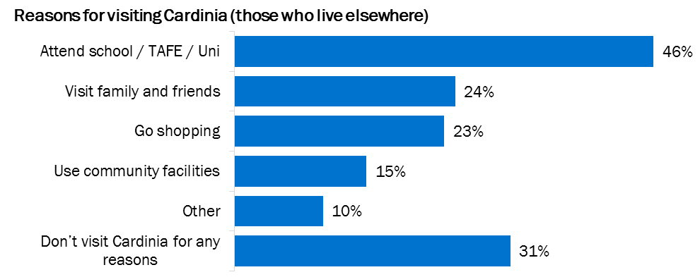

Education / employment  includes multiple responses | TOTAL | Cardinia Resident | Outside Cardinia
Primary school | 40 | 32 | 8
Secondary school | 507 | 415 | 92
VCAL, CGEA, Oakwood school | 25 | 22 | 3
Apprenticeship / traineeship | 15 | 12 | 3
TAFE | 52 | 47 | 5
University | 60 | 53 | 7
Volunteering | 51 | 43 | 8
Full time employment | 43 | 39 | 4
Part time/casual employment | 170 | 149 | 21
Unemployed and not looking for work | 20 | 16 | 4
Unemployed and looking for work | 75 | 66 | 9
Unemployed (grouped) | 90 | 79 | 11
Other | 20 | 19 | 1
I’d prefer not to say | 30 | 10 | 18

School | TOTAL
Beaconhills College | 13
Berwick Grammar School | <5
Chairo Christian School | 7
Community College of Gippsland (ECG) | -
Drouin Secondary | 7
Emerald Secondary | 113
Heritage College | <5
Koo Wee Rup Secondary | 164
Lakeside College | 5
Maranatha Christian College | <5
Merinda Park | -
Minaret College | -
Oakwood | <5
Officer Secondary | 57
Pakenham Secondary College | 70
St Francis Xavier | 16
Other | 28
Nossal High School | 40
Kambrya College | 11
Berwick Secondary College | 7

Notes on analysis
A weighting by age, gender and ward was conducted to bring the Cardinia resident results in line with the 2016 Census. However, there was an under-representation of males aged 18-24 in the sample, resulting in very high proportional weights being assigned to these responses (with weights of 400-800%). Initial analysis of the results with this weight active revealed significant changes in the findings that could be attributed to some unique traits amongst these 18-24 year old males, and therefore given the low sample sizes the decision was made not to use the age + gender + ward weight unless it clearly resulted in more meaningful findings. Where it looked as though the large representation of female responses was likely to be skewing the data, a gender-only weight was assigned.
Variations by demographics have only been mentioned in this report if statistical analysis shows that the differences are statistically significant. To identify statistically significant variations a comparison of column proportions was used, assigning a significance level of 0.05 (5%).

https://www.missionaustralia.com.au/what-we-do/research-evaluation/youth-survey

