PUBLIC NOTICE

CARDINIA SHIRE COUNCIL

NOTICE OF INTENTION TO sell land

Cardinia Shire Council (‘Council’) gives notice under section 189 of the Local Government Act 1989 (‘the Act’) of its intention to sell the land known as Reserve 3 Cumberland Drive, Pakenham, being the land contained in certificate of title volume 11609 folio 913 and more particularly described as Lot Reserve 3 on PS638885 (‘Land’). The Land is shown hatched on the plan below.

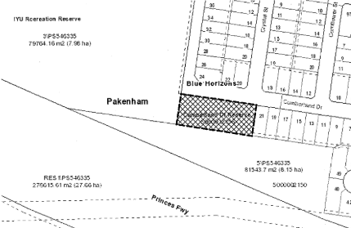

It is proposed that the Land be sold to a registered housing provider or a registered housing association under the Housing Act 1983 (Vic) for development and use as community housing, pursuant to a public procurement process. It is proposed that the Land will be sold for a value taking account of the community benefit provided by the development and use of the Land. It is also proposed that a planning process will be carried out to consider the removal of the reserve status from the Land.

In accordance with section 223 of the Act, any person may make a submission on this proposal and all submissions will be considered. Submissions must be received by 5pm, Thursday 4th October 2018.

Submissions can be emailed to mail@cardinia.vic.gov.au, hand delivered to Council’s Customer Service Centre at 20 Siding Avenue, Officer or posted to:

Mr Garry McQuillan
Chief Executive Officer
Cardinia Shire Council
PO Box 7
PAKENHAM VIC 3810

Please include the address of the Land in the subject heading or on the front of the envelope.

Any person requesting to be heard in support of his or her submission is entitled to verbally present their submission to Council (or a Committee established by Council for this purpose), or be represented by a person acting on his or her behalf. They will be notified of the time and date of this meeting.

Following the consideration of any submissions, Council may decide to sell the Land, part of the Land or not sell the Land. For further information, please contact Council’s Property Officer on 1300 787 624.

Garry McQuillan
CHIEF EXECUTIVE OFFICER

