PUBLIC NOTICE
Cardinia Shire Council
Notice of intention to change use of land

Cardinia Shire Council (“Council”) gives notice under section 192 of the Local Government Act 1989 (“the Act”) of its intention to change the use of land abutting Army Road, Pakenham (“Land”). The Land is known as part of Reserve 3 on PS339370 and held in Certificate of Title Volume 10239 Folio 886. It is proposed that the Land status be changed from reserve to a road. The land is shown below

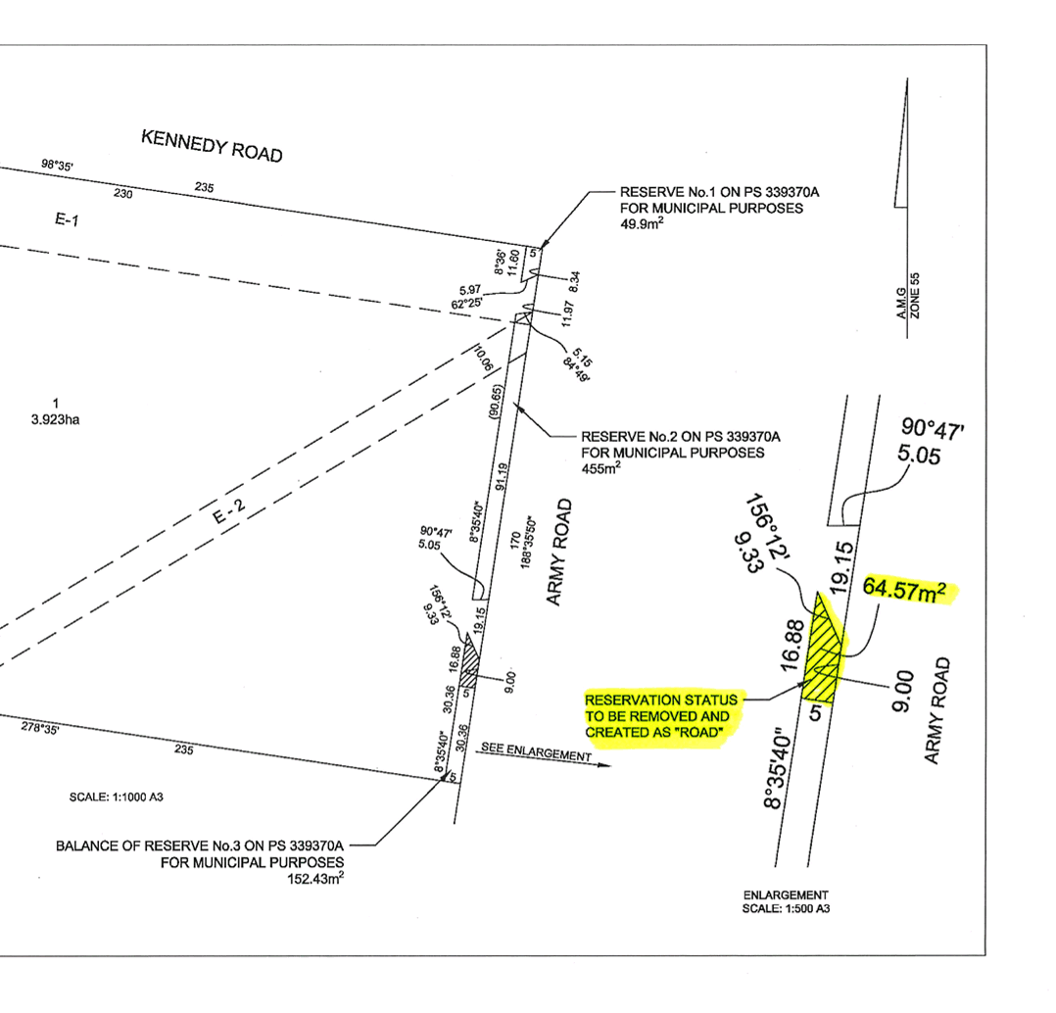

In accordance with section 223 of the Act, any person may make a submission on this proposal and all submissions will be considered. Submissions must be received by 5pm, Thursday 30 August 2018.

Submissions can be emailed to mail@cardinia.vic.gov.au, hand delivered to Council’s Customer Service Centre at 20 Siding Avenue, Officer or posted to:

Mr Garry McQuillan
Chief Executive Officer
Cardinia Shire Council
PO Box 7
PAKENHAM VIC 3810

Any person requesting to be heard in support of his or her submission is entitled to verbally present their submission to Council (or a Committee established by Council for this purpose), or be represented by a person acting on his or her behalf. They will be notified of the time and date of this meeting.

Following the consideration of any submissions, Council may decide to change the use of the Land, or leave the Land as a reserve. For further information, please contact Council’s Property Officer on 1300 787 624.

Garry McQuillan
CHIEF EXECUTIVE OFFICER

