Sustainable Environment Policy 2018–28

June 2018

Prepared by:

Cardinia Shire Council
Environment and Heritage Unit
Published June 2018

© Cardinia Shire Council 2018
ABN: 32 210 906 807
20 Siding Avenue, Officer

PO Box 7, Pakenham Vic 3810
(DX 81006)

Phone: 1300 787 624
Email: mail@cardinia.vic.gov.au
Web: cardinia.vic.gov.au

Contents
1 Executive summary 5
2 Introduction 6
3 Policy context 7
4 Sustainable Development Goals 8
4.1 SDGs and a sustainable environment at Cardinia Shire Council 9
5 Climate change 10
5.1 The Aspirational Energy Transition Plan 2014–24 10
5.2 Community-based adaptation 10
6 Water 13
6.1 Integrated Water Management Plan 2015–25 13
7 Biodiversity 14
7.1 The Biodiversity Conservation Strategy 15
8 Waste 16
8.1 Waste and resource recovery strategy 2017–26 16
9 Human settlements 18
9.1 Green spaces and urban forests 18
10 Council leadership 20
10.1 Related Council strategies, plans, policies and projects 20
11 Conclusion 22
12 References 23

Figures
Figure 1. Policy umbrella 7
Figure 2. Sustainable Development Goals 8
Figure 3. Australia’s Sustainable Development Goals performance 2017 9
Figure 4. Community-based adaptation process (CARE International, 2014) 12
Figure 5. Sustainable environment initiatives undertaken by Cardinia Shire Council 20

Tables
Table 1. Elements of the IWMP 13
Table 2. Examples of current Cardinia policies and activities that support the SDGs 21

Abbreviations
AETP | Aspirational Energy Transition Plan
CBA | Community-based Adaptation
CED | Community Economic Development
CSIRO | Commonwealth Scientific and Industrial Research Organisation
CSR | Corporate Social Responsibility
DDR | Disaster Risk Reduction
DPSIR | Drivers, Pressures, State, Impact, Response
EPA | Environmental Protection Agency
ICLEI | International Council for Local Environmental Initiatives
IWMP | Integrated Water Management Plan 2015–25
LA21 | Local Agenda 21
LGA | Local Government Area
MWRRG | Metropolitan Waste and Resource Recovery Group
OECD | Organization Economic for Cooperation and Development
PWRP | Pakenham Wastewater Recycling Plant
SDGs | Sustainable Development Goals
SES | Sustainable Environment Strategy
SEW | South East Water
SoE | State of the Environment
UN | United Nations
WCED | The World Commission on Environment, Development.
WRRS | Waste and Resource Recovery Strategy 2018–27
WSPA | Water supply protection area
WSUD | Water sensitive urban design
YVW | Yarra Valley Water

Executive summary
The Sustainable Environment Policy 2018–28 is the roadmap for the future direction of Council’s environmental and sustainability strategies, plans and activities. It identifies the challenges facing the municipality in these areas, and outlines the plans and strategies already in place and those required to address them to ensure Cardinia Shire continues to be a place in which people want to live, work, and play.

Traditionally, environmental policy at local government level is developed in isolation from other local government policies, plans and strategies. Cardinia Shire Council is taking a more global view of our environment and recognising that our unique natural environment influences our communities in myriad ways, building a sense of place and belonging, contributing to our economic development, and affecting our health and wellbeing. Similarly, we recognise that every action that our community and Council undertake has an influence on our environment, and wish to make that influence as positive as possible. To this end, the Sustainable Environment Policy 2018–28 has been developed to demonstrate our commitment to protecting and enhancing our natural environment so that we may continue to enjoy this wonderful place to live and work, and that those who come after us have the same opportunities.

Introduction
The challenges to sustainability and a healthy future for our communities are immense. Global health threats, more frequent and intense natural disasters, and spiralling conflict threaten to reverse much of the development progress made in the past few decades. Natural resource depletion and adverse impacts of environmental degradation, drought and loss of biodiversity add to and exacerbate the list of challenges which humanity faces. Climate change is one of the greatest challenges of our time and its adverse impacts undermine the ability of all countries to achieve sustainable development. Increases in global temperature, sea level rise, ocean acidification and other climate change impacts are seriously affecting coastal areas. The survival of many societies, and of the biological support systems of the planet, is at risk.

It is also, however, a time of immense opportunity. Many sustainability challenges have seen significant progress. On 25 September 2015, the Member States of the United Nations (UN) agreed on the 17 Sustainable Development Goals (SDGs) of the Post-2015 Development Agenda. These goals will guide global action on sustainable development until 2030. All of the SDGs have targets that are directly related to the daily work of local governments. Local governments are not mere implementers of the agenda but the policy makers, catalysts of change and the level of government best placed to link these global goals with local communities. The Sustainable Development Goals are a direct acknowledgement that the ‘triple bottom line’ of environment, society and economy can no longer be considered as separate entities and that all will have direct and lasting flow-on effects in our communities. If we wish to create liveable and resilient communities, we will need to consider the interrelations and effects of all of our actions.

To this end, Cardinia Shire Council has taken these overarching global goals and translated them into our local context, to help build a more equitable, secure and environmentally sustainable place for our current community and for those who come after.

Policy context
The Sustainable Environment Policy provides a narrative to enhance understanding of the complexity and inter-relatedness of our environment and how it is affected by, and affects in turn, all aspects of community life in Cardinia Shire. It is intended to be a guiding framework for all areas of sustainability decision-making for the next 10 years.

The Council Plan 2017 identifies some major challenges for the coming years, the first two of which are managing population growth and managing the natural environment. It acknowledges that the quality of our natural and built environments affects our communities and that they must be developed and managed in a way that contributes to the health and safety of present and future generations.
- Policy umbrella
2

Adopted plan/strategy
Draft policy/strategy
Future plan/strategy
Environmental topic

Sustainable Development Goals
Realisation of the worldwide environmental problems that were developing in the late 1960s compelled the international community to establish the United Nations (UN) Environment Programme in 1972. The Organisation for Economic Cooperation and Development (OECD) (2002) recognised that only governments with clear commitment and leadership could generate the institutional, policy and regulatory impetus for environmentally sustainable reforms. International support for the role of local government in environmental sustainability followed this process, through Chapter 28 of Agenda 21, commonly referred to as Local Agenda 21 (LA21).
At the United Nations Sustainable Development Summit in 2015, world leaders adopted the 2030 Agenda for Sustainable Development, a set of 17 Sustainable Development Goals (SDGs) to end poverty, fight inequality and injustice, and tackle climate change by 2030 (see Figure 2).

- Sustainable Development Goals
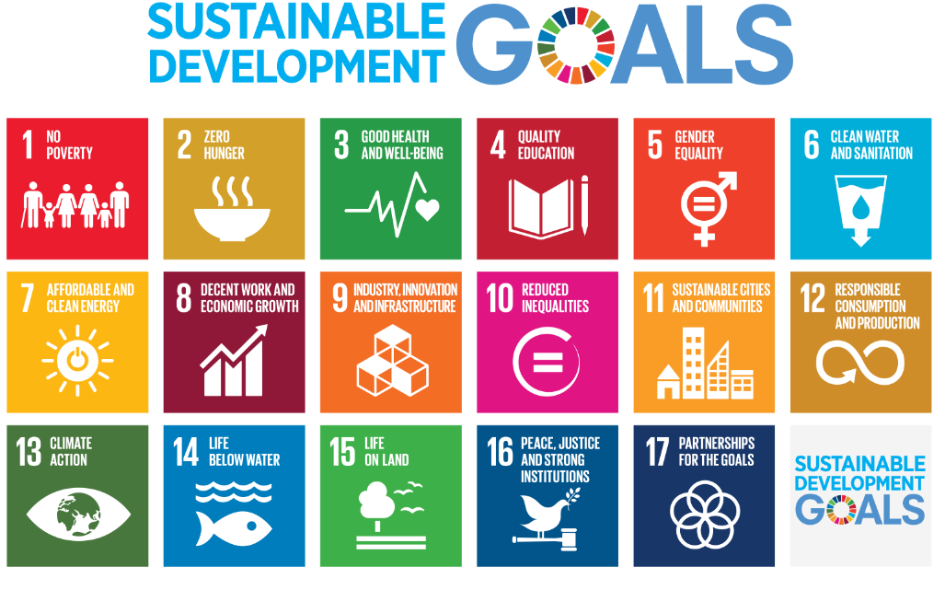

Translating these international concerns, or ‘localising’ the SDGs, is the process of taking into account subnational contexts in the work towards achieving the 2030 Agenda (United Nations Development Programme, 2015). This can range from the setting of goals and targets, to determining the implementation, and using local indicators to measure and monitor progress. Localisation relates to how local governments can support the achievement of the SDGs through action from the bottom up and how the SDGs can provide a framework for local policy development. While the SDGs are global, their achievement will depend on making them a reality in cities and regions. All of the goals have targets directly related to the responsibilities of local governments, particularly in their role in delivering basic services. As stressed in the Synthesis Report of the UN Secretary General “many of the investments to achieve the sustainable development goals will take place at the subnational level and be led by local authorities” (Ban, 2015). Similarly, the Report of the High-Level Panel of Eminent Persons on the Post-2015 Development Agenda (United Nations, 2013 p.10) states that “local authorities form a vital bridge between national governments, communities and citizens and will have a critical role in a new global partnership”.

SDGs and a sustainable environment at Cardinia Shire Council
The UN 2017 SDG Index and Dashboards Report is designed to assist countries in identifying gaps that require attention in order to achieve the goals by 2030 and to identify priorities for action. This assessment ranks Australia as 26 out of 157 countries against different nations’ performance on the 17 SDGs. As demonstrated in Figure 3, Australia performs well on the UN’s Human Development Index, which focuses on social and economic development. In contrast, Australia, which has some of the world’s highest carbon emissions per person, rates poorly on clean energy (SDG 7), climate change (SDG 13) and biodiversity loss (SDGs 14 and 15) as land clearing remains an area of concern (Sachs, 2017). This analysis demonstrates that Australia needs to act urgently to address climate and environmental goals, thus is particularly relevant to this policy.

- Australia’s Sustainable Development Goals performance 2017
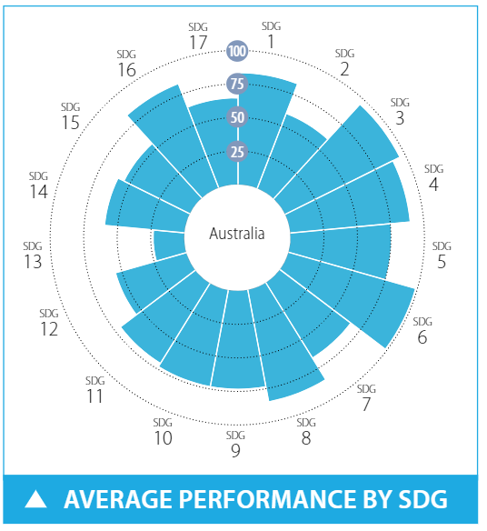

In an effort to localise the SDGs, local government bodies and other organisations are beginning to recognise the need to align their internal strategies with the goals. Indeed, some Victorian local government organisations have begun this process. Nevertheless, for many local governments, transitioning away from traditional, siloed ways of enacting sustainability may require a large shift in the contemporary institutions and/or ‘ways-of-working’. The very nature of the Sustainable Development Goals are transactional and each goal is not meant to be taken in isolation, but the linkages and overlaps are intended to be part of the process of progressing towards realising them.

Figure 1 outlines how the environmental issues of biodiversity, climate change, waste and water sit under this policy. By relating the Sustainable Development Goals to these local environmental concerns, we can see how they do not sit in isolation of all of the other actions and plans of Council. By improving our natural environment and addressing climate concerns, we can positively affect all of the areas of the SDGs and in turn, all of the areas in which Council works.

At the end of each section of this policy, the Sustainable Development Goals that affect, and are affected by, Council’s actions are displayed to demonstrate the interrelated aspects of the overarching global goals and the work that Council does in this space.

Climate change
Climate change is the greatest environmental challenge facing Australia. It is disrupting national economies around the world and affecting lives, costing people, communities and countries dearly today, and even more tomorrow. Australia experienced its third hottest year on record in 2017. The ‘Angry Summer’ of 2016–17 broke more than 205 climate records across the nation, and included several intense heatwaves in January and February (Steffen, 2018).

Solid scientific evidence supports the position that climate change is occurring now, caused by elevated concentrations of greenhouse gases in the atmosphere. Climate change in Australia has been reported by pre-eminent climate science scholars (CSIRO, 2013, DELWP, 2015). This research shows that temperatures, sea levels and sea-surface temperatures are all rising in Australia.

Such changes will lead to significant ecosystem changes and biodiversity impacts, and will expose our community to increased droughts, fires, large storm events and coastal inundation. Responding to climate change will require fundamental and sweeping long-term changes in how we organise our lives and our communities. We do not need to wait for industry and government to act on our behalf to combat climate change. Citizens and their communities can and should take the lead, and Cardinia Shire Council has an ambitious plan in our Aspirational Energy Transition Plan (AETP).

The Aspirational Energy Transition Plan 2014–24
Climate change and peak oil are dual threats that mean we need to change the way we generate and use energy. Council adopted the Aspirational Energy Transition Plan in October 2014. It investigates the dual challenges of climate change and energy security.

Council’s Energy Transition Plan has set aspirational targets of achieving zero net emissions for its operations and a 36 per cent reduction in community emissions on a per capita basis by 2024. Meeting these targets will benefit the environment and provide significant financial benefits, through savings in energy costs for Council and the community. The plan outlines steps to achieve these goals. Some major actions include the following:
- environmental upgrades of Council facilities and improving energy efficiency of decorative street lighting throughout the shire
- installing solar electricity systems for Council facilities and purchasing grid-supplied green power
- initiatives to support solar electricity systems and energy efficiency for the community.

Cardinia Shire Council and its residents are dependent on electricity and fuel; however, rising energy costs and potential shortages leaves Council and the public vulnerable. Improving energy efficiency and promoting fuel switching, are key measures towards limiting the impacts of climate change and improving energy security for the wider community. Council has a unique opportunity to make a difference in these areas and is committed to ensuring that the challenges presented by these global issues are addressed at the local level.

Community-based adaptation
Adaptation involves anticipating the adverse effects of climate change and taking appropriate action to prevent or minimise the damage it may cause. Well-planned early adaptation actions have been shown to save lives and money.

Local governments play a critical role in helping their communities adapt to climate change. They are often the first to respond to localised impacts, and their strong connections to the community and local knowledge mean they are often best placed to recognise the need for adaptation on a local scale. The responsibilities of local governments are closely linked in areas such as land-use planning, infrastructure, health, emergency management, community services and environmental management. For local communities to effectively manage the impacts of climate change, local governments need to be able to manage their own risks as well as helping the community to adapt.

To date, action on climate change at Council has focussed on mitigation. However, lacking a climate change adaptation strategy, adaptation initiatives have been infrequently implemented resulting in gaps in climate adaptation actions and knowledge throughout the shire. The goal is to develop a Council adaptation strategy towards embedding climate change adaptation within the community and into the function of Council.

Why a community-based approach to adaptation
The realisation that most climate change impacts are felt at the local level has shaped the way in which local governments are beginning to address changing climatic conditions and patterns. Community-based adaptation (CBA) to climate change is defined as a “community-led process, based on communities’ needs, priorities, knowledge and capacities”. CBA aims to empower people to plan for and cope with the adverse effects of climate change. At a local government level CBA would operate under an overarching Council Climate Change Adaptation Strategy.

A community-based approach to climate change adaptation is based on cooperation between local stakeholder groups and Council, towards collaboratively developing adaptation initiatives. Community inclusion in decision-making improves the uptake and sustainability of the process; this can directly meet community priorities and develop a strong sense of community ownership in the strategic outcomes Proactively addressing climate change risks and embedding new knowledge will promote the strengthening and growth of existing community structures and institutional mechanisms at a local government level. Climate change adaptation is a cross-sectoral issue and the integration of climate risk must be included across all sectors within local government.

How – pathways to adaptation
The CBA framework describes a range of enabling factors that need to be in place for effective community-based adaptation to occur. These factors include climate resilient livelihoods, disaster risk reduction (DRR), local adaptive and organisational capacity development, an enabling national policy environment, a good knowledge of climate change and addressing underlying causes of vulnerability.

These enabling factors can be achieved through four interrelated strategies:
- promoting climate resilient livelihoods
- reducing disaster risk to minimise the impacts of hazards on vulnerable households
- developing capacity for local government, community groups and organisations
- addressing the underlying causes of vulnerability through advocacy and social mobilisation.

- Community-based adaptation process (CARE International, 2014)
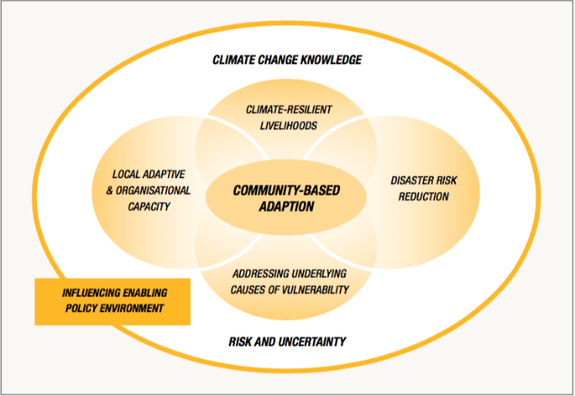

Model used with permission, CARE International, accessed May 2018,
https://careclimatechange.org/tool-kits/cba-framework/’

Relevant SDGs

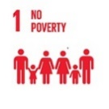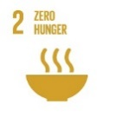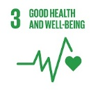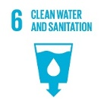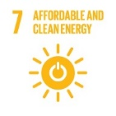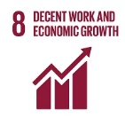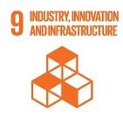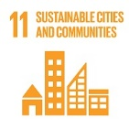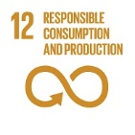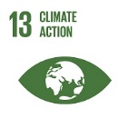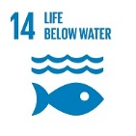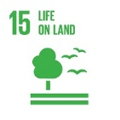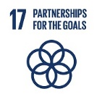

Water
Cardinia Shire Council is planning for a future with less water as we respond to the impacts of climate change and a growing population. Climate change modelling undertaken by CSIRO indicates a 10 per cent reduction in annual rainfall may be anticipated by the year 2050 under a high emissions scenario (CSIRO, 2013). In response to the combined pressures of climate change, urbanisation and population growth and the changing demographic profiles of our community, Cardinia Shire Council was one of the first local governments in Victoria to consolidate the management of water issues under the banner of integrated water management and is a leader in this area.

Integrated Water Management Plan 2015–25
In December 2015, Council adopted the Integrated Water Management Plan (IWMP). The IWMP is a framework that guides Council towards a more sustainable approach to water management. It does this by establishing aspirations, targets and actions for each aspect of the water cycle. Table 1 demonstrates the six elements that make up integrated water management.

- Elements of the IWMP
Stormwater | To quantify and minimise stormwater flows and pollutant loads to the shire’s creeks, rivers and Westernport Bay
Potable water | To ensure efficient potable water use within our facilities and encourage the community to reduce potable water consumption
Alternative water | To reduce our reliance on potable water by identifying and using alternative water sources
Groundwater | To contribute to sustainable groundwater management, including exploring the option of alternative water sources for agriculture
Wastewater | To reduce the impact of wastewater on the environment
Catchments and natural waterway | To protect the shire’s waterway values and open these assets up to the community

The IWMP reframes Council’s approach to water management within the context of a water cycle that considers the role, benefits, issues and relationships between each element of the water cycle. Some of the major actions that will assist Council are:
- developing a capital works program to prioritise the installation of sediment pits near key waterways
- capturing funding opportunities to carry out WSUD projects
- completing water efficiency audits at Council’s top water-using sites and implement recommended water-saving measures
- investigating alternative water sources for use in the Bunyip Food Belt area
- developing a vision and identifying opportunities for the creation of Green and Connected Corridors in Cardinia Shire.

Relevant SDGs

Biodiversity
The value of Australia’s biodiversity is difficult to measure but biodiversity is a key part of Australia’s national identity and is fundamentally important to environmental services that support human health and wellbeing, and economically important to a wide range of industries. The national State of the Environment Report 2016 (Jackson et al., 2017) demonstrates that Australia’s biodiversity is under increased threat and has continued to decline. Many species and communities suffer from the cumulative impacts of multiple pressures. Invasive species, particularly feral animals, are unequivocally increasing the pressure they exert on Australia’s biodiversity, and habitat fragmentation and degradation continue in many areas.

RMIT University undertook research to identify priority areas for greening in local government areas (Amati et al., 2017). This research discovered that over the past four years no local government areas had significant increases in total vegetation cover in the period studied and that the majority have lost vegetation.

Council undertook its own, much more detailed vegetation mapping in 2017 in order to create a baseline of information and determine coverage losses or gains into the future. This mapping demonstrated that total tree cover in the shire is 29 per cent, 26 per cent of which occurs north of the Princes Highway with the remaining three per cent occurring south of the highway. The mapping also determined that woody weeds cover 0.5 per cent of the shire.

A significant finding of the mapping is that 17 of the 55 different ecological vegetation communities found within the shire are listed as endangered, which means according to the Environment Protection and Biodiversity Conservation Act 1999, they are facing a very high risk of extinction in the wild, in the medium-term future. These results demonstrate the importance of a dedicated biodiversity conservation strategy, which Council is developing at the time of writing this policy. In this way, Council is actively working towards the conservation of our unique and precious ecological communities and the biodiversity they support.

The Biodiversity Conservation Strategy
At the time of publishing this Sustainable Environment Policy, the Biodiversity Conservation Strategy was under development.

Relevant SDGs
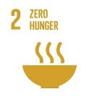

Waste
Council provides many waste services including residential kerbside services, commercial business services, public place litter services, processing services and more. Emphasis is placed on waste and resource recovery education relating to services, regional and local issues. In addition, significant input is made into the advocacy, development and implementation of key strategies and policies.

Many of the challenges outlined earlier in this strategy are also pertinent for waste, including population growth pressures. In 2017, Council was providing waste services to approximately 37,500 properties weekly, which is expected to increase to more than 53,000 by 2028. Household size is decreasing. Social research identified financial hardship as a significant social and personal issue for residents. These factors will impact on how services are planned and delivered. The rapid population growth, along with sparsely populated rural areas and some difficult access areas will continue to put pressure on the delivery and cost of Council’s services. Council will need to continue to advocate to and engage with industry, other councils and the Metropolitan Waste and Resource Recovery Group (MWRRG) to facilitate and keep abreast of the fast changing developments occurring in the industry, particularly in the area of technology. This will enable Council to be informed to take up new opportunities as they arise and achieve the best outcome for the community.

A full list of challenges facing Council is discussed in detail in the Waste and Resource Recovery Strategy 2017–26. Many of these challenges also bring opportunities and exciting solutions. As Cardinia Shire’s population grows, economies of scale are achieved with services and this allows Council to look at implementing service improvements or additional resource recovery opportunities without considerable price increases. The requirement to address the issue of landfill availability allows us to look at higher technology options and achieve better environmental outcomes over time.

Waste and resource recovery strategy 2017–26
Council’s Waste and resource recovery strategy (WWRS) was adopted in 2017 and is a roadmap for the future direction and actions of Council’s waste and resource recovery services, waste-related education policy and advocacy activities. It identifies the issues facing the municipality and sets out a plan for how we can keep services efficient and effective, minimise waste to landfill and other impacts on the environment, as well as keeping costs low.

Council’s work and role in this area is also partly determined by relevant Victorian and Australian government policies, many of which have also been updated in recent years. The Victorian Government policy Getting Full Value has turned the focus to thinking of waste as a resource to be extracted and reused or recycled where possible, bringing not just environmental benefits, but also financial and social. This policy recognises that to achieve this there needs to be more value placed on, and investment in regional infrastructure, which Council recognises and supports. Council’s WRRS builds on the work outlined to be achieved in the region within the MWRRG’s Implementation Plan.

The top priorities are:
- increased resource recovery with a particular focus on hard waste service, food within garbage waste, additional kerbside programs and e-waste
- achieving long-term secure landfill arrangements by reducing landfill and seeking alternative landfill treatment options
- addressing increasing issues of illegal dumping through improved services and compliance activities
- continuing to drive value for money in services
- appropriate consideration of waste provision in developments including increased higher density development, infill development and new Council facilities
- supporting the local community to be responsible and accountable for their waste generation and disposal practices.

Council’s waste and resource recovery services are funded through the garbage charge which is an annual charge set each year under the Local Government Act 1989 as part of Council’s budget process. This charge is set on a fee for service basis. As many of the waste and resource recovery services are contracted services, costs are in many cases related to market forces and contract rates, and to a degree outside of Council’s control. This puts ongoing challenges to Council to seek efficiency opportunities and more effective ways of working to ensure the garbage charge increases are kept to a minimum.

Relevant SDGs

Human settlements
In the last century, the world has been rapidly urbanised. In 2008, for the first time in history, urban populations outnumbered rural populations, and by 2050, two-thirds of the world’s population are expected to be living in urban areas. Communities are now beginning to realise that they do not live separately to their environment but are a part of it. Similarly, human settlements are places that encompass many elements of nature within them. For any environmental plans, policies or actions to be truly effective, human settlements, and human interactions with the natural environment must be considered. Biodiversity, water, waste, and responses to climate change all need to be considered when any local government action is enacted, as human settlements impact, and are impacted by, all of the four elements with which this policy is concerned.

Human settlements are hubs for ideas, commerce, culture, science, productivity, social, human and economic development. Urban planning, transport systems, water, sanitation, waste management, disaster risk reduction, access to information, education and capacity building are all relevant issues to sustainable urban development. As part of the unprecedented expansion of Melbourne’s growth corridor, Cardinia Shire has an opportunity to create urban areas that can be a powerful tool for sustainable development.

Cardinia Shire Council already has many policies, plans and strategies in place that plan for our increased population and for our already existing communities (see Section 10.1). Good planning can ensure that each action has multiple benefits for our communities. An example of an increasingly popular solution to some of the most pressing issues of climate change, population growth, biodiversity loss and urban heating is the development of urban forests and increased access to green spaces.

Green spaces and urban forests
Much research has been conducted in the past few years on the benefits of green spaces in urban areas. Some of these benefits include improving air quality, reducing urban heat island effects and the positive effects on mental health, physical activity, and children’s development when they have access to green spaces. Many cities and towns around the world are now coming to regard trees and other vegetation as critical components of urban infrastructure. Urban green space can be considered as important to how a human settlement functions as roads or public transport, and particularly vital to the health and wellbeing of communities. Some of the ways that urban forests provide value to our communities are outlined below.

Economic benefits
- Reducing energy costs
- Increasing property values
- Avoiding costs of infrastructure damage and renewal
- Decreasing health costs
- Marketing the townships
- Nature attracts business

Environmental benefits
- Providing shade and cooling our urban areas
- Reducing stormwater flows and nutrient loads
- Reducing air pollution and air-borne particulates
- Storing and sequestering carbon
- Providing habitat for biodiversity

Community benefits
- Providing a sense of place and creation of local identity
- Improving community cohesion
- Encouraging outdoor activity
- Reconnecting children with nature
- Reducing people’s exposure to sun
- Reducing heat-related illnesses
- Improving mental wellbeing

For example, a recent study by Harvard University (Bezold et al.) found that exposure to greenery can be a factor in reducing symptoms of depression in teenagers living in the United States. Overall, adjusting for family and economic factors, the research found that young people living near the highest quality green space were 11 per cent less likely than their peers with the poorest quality green space to be in the high depression group. This demonstrates that far from being effective in only one area, such as increased biodiversity, increased urban green spaces can have far-reaching beneficial effects such as addressing mental health issues, connecting communities and increasing resilience to climate impacts. These outcomes are directly related to other Council policies, such as the Liveability Plan 2017–29, which has specific goals around improving mental health and wellbeing for Cardinia Shire residents and encouraging active travel.

When integrated with other Council initiatives, such as the Liveability Plan, Pedestrian and Cycling Strategy and the upcoming Biodiversity Conservation Strategy, the cumulative benefits of creating more green spaces and more walkable urban areas has been shown to have great impacts on long-term health outcomes (Sarkar et al.). Given the pressure on local government to plan for greater populations, increased urban density and climate change adaptation, there is a clear opportunity for urban forests to help create resilient, sustainable communities that improve health and provide enjoyable places for people to live and work. Sustainable urban development relates to all 17 of the Sustainable Development Goals.

Relevant SDGs
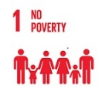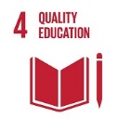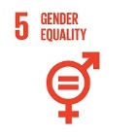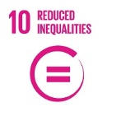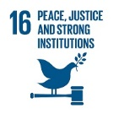

Council leadership

Related Council strategies, plans, policies and projects
Table 2 is a snapshot of some of Council’s current policies, plans and strategies and demonstrates that Council already works across all of the SDGs. This shows a direct link between the everyday work of Council and the global Sustainable Development Goals. However, for the SDGs to be truly successful on a global scale, local governments need to become champions of sustainable development and play a leading role in implementing them (Global Taskforce of Local and Regional Governments, 2016). Cardinia Shire Council has an opportunity to become a leader in a whole-of-organisational approach to solving the big issues outlined in the SDGs.

- Sustainable environment initiatives undertaken by Cardinia Shire Council
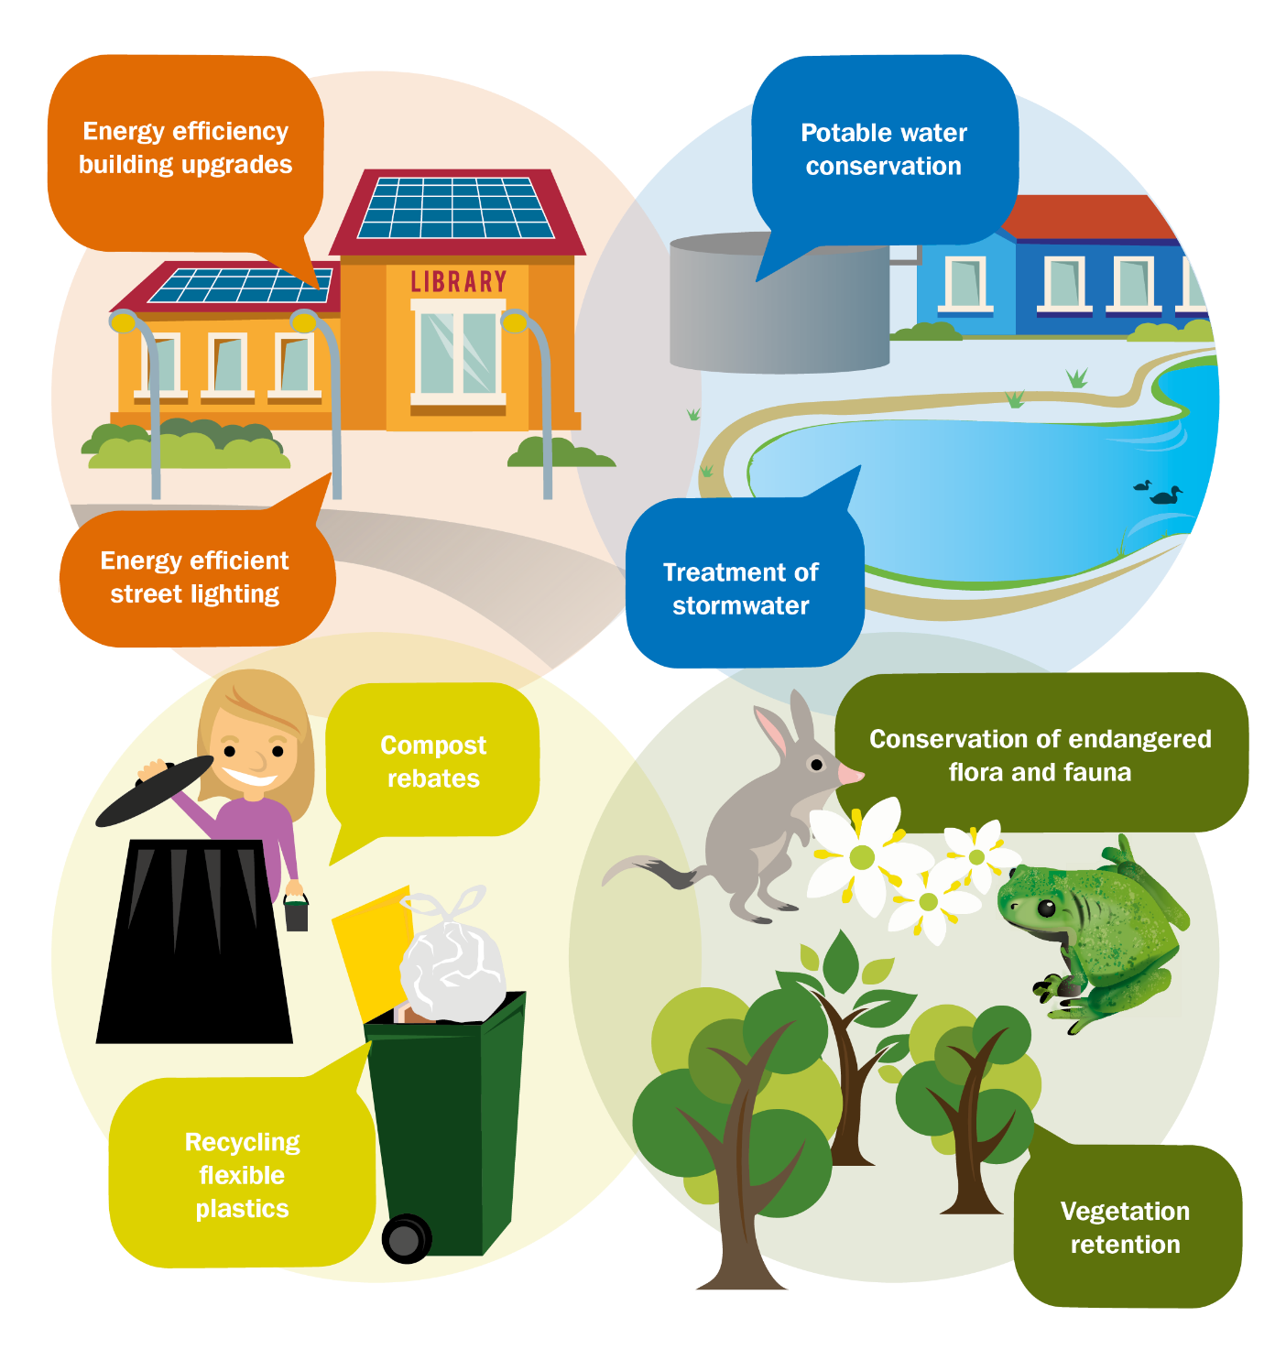

- Examples of current Cardinia policies and activities that support the SDGs
Goal | Examples of policies, plans, strategies and actions
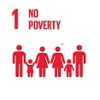 | - Environmental Planning Controls  - Ecological Sustainable Design requirements  - Continuity of operation of community spaces
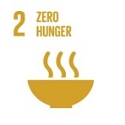 | - Food Circles Project  - Green Wedge Management Plan  - Planning Scheme  - Liveability Plan
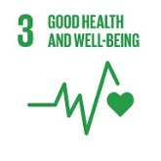 | - Pedestrian and Cycling Strategy  - Health and Wellbeing Plan  - Heathy by Design  - Child, youth and family strategy  - Liveability Plan
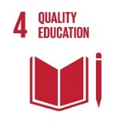 | - Council Plan  - Provision of tailored facilities for delivery of educational programs  - Precinct structure plans  - Provision of kindergarten facilities
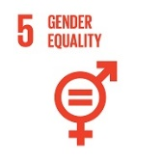 | - White Ribbon Accreditation  - Education for all community-facing staff in domestic violence awareness
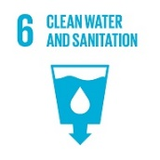 | - Integrated Water Management Plan  - Ecological Sustainable Design requirements  - Green Wedge Management Plan  - Planning Scheme
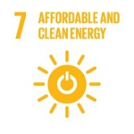 | - Aspirational Energy Transition Plan  - Solar Savers program (assisting community groups to access affordable energy)  - Ecological Sustainable Design requirements
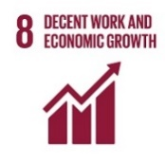 | - Operation of Youth and Training Centres  - Precinct structure plans  - Township strategies  - Casey Cardinia visitation strategy
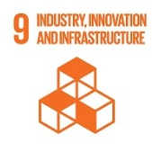 | - Council Plan  - Precinct structure plans  - Township strategies  - Planning Scheme
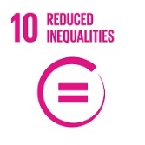 | - Universal Access Design on all Council facilities  - Mandatory requirement for all contracts to employ at least two local, disadvantaged people  - Gaming policy  - Age-friendly Strategy
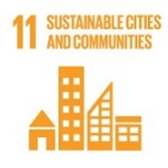 | - Council Plan  - All Cardinia Shire policies, plans and strategies align with this SDG as it specifically relevant to local government concerns.
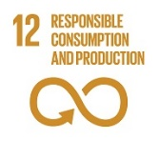 | - Ecological Sustainable Design requirements  - Ensure the use of sustainable building materials and consumables  - Integrated Water Management Plan  - Aspirational Energy Transition Plan
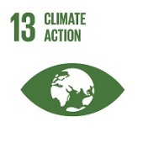 | - Aspirational Energy Transition Plan  - Integrated Water Management Plan  - Ecological Sustainable Design requirements  - Green Wedge Management Plan  - Planning Scheme
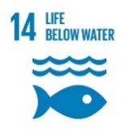 | - Integrated Water Management Plan  - Green Wedge Management Plan  - Planning Scheme  - Precinct structure plans  - Ecological Sustainable Design requirements
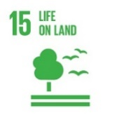 | - Biodiversity and Conservation Plan (in progress)  - Green Wedge Management Plan  - Planning Scheme  - Precinct structure plans  - Ecological Sustainable Design requirements  - Liveability Plan
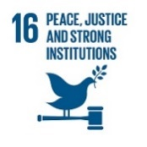 | - Council Plan  - Crime prevention through environmental design  - Planning and Environment Act (State)  - Actively supporting transparency and inclusivity in all planning schemes
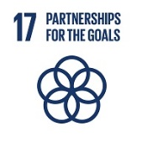 | - Adherence to all Victorian and Australian government legislation and actively working with outside organisations  - Every business unit has too many external bodies that it works with to progress goals to name individually

Conclusion
The shift of focus from stand-alone environmental policies to examining the interactions of our natural environment with sustainable development is an opportunity for Cardinia Shire Council to create a more inclusive, economically successful, and environmentally sustainable community. Council is set to experience a massive increase in population over the coming years. Planning for and building the infrastructure required to support this, using the SDGs framework, offers an opportunity to improve the quality of life for local residents as well as protecting the natural environment.

This policy describes how the interactions between our responses to the environmental issues of climate change, water, biodiversity, waste, and the way we plan our human settlements, impact and are impacted by, all facets of Council plans, policies and actions. None of these elements should be taken in isolation and best practice management means we have the opportunity to create co-benefits for our communities by integrating our actions across the sphere of Council influence. In this way, we can contribute to an increasing recognition in all levels of government to bring about the realisation of the Sustainable Development Goals in an uncertain and rapidly changing world.

References

AMATI, M., BORUFF, B., CACCETTA, P., DEVEREUX, D., KASPAR, J., PHELAN, K. & SAUNDERS, A. 2017. Where should all the trees go? Investigating the impact of tree canopy cover on socio-economic status and wellbeing in LGA's prepared for Horticulture Innovation Australia Limited. Centre for Urban Research, RMIT University.
BAN, K.-M. 2015. The road to dignity by 2030: ending poverty, transforming all lives and protecting the planet. . Synthesis report of the Secretary-General on the post-2015 sustainable development agenda.
BEZOLD, C. P., BANAY, R. F., COULL, B. A., HART, J. E., JAMES, P., KUBZANSKY, L. D., MISSMER, S. A. & LADEN, F. The Association Between Natural Environments and Depressive Symptoms in Adolescents Living in the United States. Journal of Adolescent Health.
CARE INTERNATIONAL 2014. Community-Based Adaptation in Practice: A global overview of CARE International's practice of Community-Based Adaptation (CBA) to climate change.
CSIRO. 2013. Australia's Future Climate: Climate Change in Australia [Online]. Available: http://www.climatechangeinaustralia.com.au/futureclimate.php [Accessed 28 March 2017].
DELWP. 2015. Climate-ready Victoria: Greater Melbourne [Online]. Available: http://www.climatechange.vic.gov.au/__data/assets/pdf_file/0004/323455/Greater-Melbourne.pdf on 15.02.2017 [Accessed 15 February 2017].
GLOBAL TASKFORCE OF LOCAL AND REGIONAL GOVERNMENTS 2016. Roadmap for Localizing the SDGs: Implementation and Monitoring at Subnational Level. United Nations General Assembly.
JACKSON, W., ARGENT, R., BAX, N., CLARK, G., COLEMAN, S., CRESSWELL, I., EMMERSON, K., EVANS, K., HIBBERD, M., JOHNSTON, E., KEYWOOD, M., KLEKOCIUK, A., MACKAY, R., METCALFE, D., MURPHY, H., RANKIN, A., SMITH, D. & & WIENECKE, B. 2017. Australia's state of the environment 2016: overview. In: ENERGY, A. D. O. E. A. (ed.). Canberra: Australian Government.
ORGANISATION FOR ECONOMIC, C.-O. & DEVELOPMENT 2002. Improving policy coherence and integration for sustainable development : a checklist.
SACHS, J., SCHMIDT-TRAUB, G., KROLL, C., DURAND-DELACRE, D. AND TEKSOZ, K. 2017. SDG Index and Dashboards Report 2017. New York: Bertelsmann Stiftung and Sustainable Development Solutions Network (SDSN).
SARKAR, C., WEBSTER, C. & GALLACHER, J. Neighbourhood walkability and incidence of hypertension: Findings from the study of 429,334 UK Biobank participants. International Journal of Hygiene and Environmental Health.
STEFFEN, W., RICE, M., ALEXANDER, D., 2018. 2017: Another record-breaking year for heat and extreme weather. The Climate Council of Australia.
UNITED NATIONS 2013. A New Global Partnership: The Report of the High-Level Panel of Eminent Persons on the Post-2015 Development Agenda.
UNITED NATIONS DEVELOPMENT PROGRAMME 2015. Localizing the Post-2015 Development Agenda: Dialogues on Implementation.

