Cardinia Shire Council

Expression of Interest

Public Art Commission

Hills Hub

Submissions close 5pm, Sunday 27th May

Contents
INTRODUCTION 2
1 SELECTION PROCESS 2
2 PROJECT BUDGET 3
3 PROJECT TIMELINES 3
4 TARGET AUDIENCE 3
5 SITE DETAILS 3
6 INTERPRETIVE VALUES AND THEMES 4
7 MATERIAL SELECTION 4
8 EOI SELECTION CRITERIA 4
9 REQUIREMENTS OF THE ARTIST’S EOI PROPOSAL 5
10 SUPPORTING DOCUMENTS 5
11 FURTHER INFORMATION 5
12 SITE IMAGES 5

INTRODUCTION

Cardinia Shire Council

Cardinia Shire is diverse across all of its communities. From the hills to the plains, Cardinia Shire has a wide range of natural and built environments. Comprising 1,280 square kilometres of land, Cardinia Shire is situated 50 kilometres south-east of Melbourne and is one of eight ‘interface councils’ forming the perimeter of metropolitan Melbourne and providing a transition between urban and rural areas. Cardinia Shire is experiencing some of the fastest population growth in Australia. The population is located in three distinct areas: the hills, southern rural sub-regions, and the growth area (which encompasses Pakenham).

In 2012, Council adopted the reviewed Cardinia Shire Council Public Art Policy, outlining Council’s commitment to the ongoing provision of public art within the Shire through:
- incorporating public art into the urban and natural landscape through adopting a ‘whole of Council’ approach to planning, selection and maintenance of public art
- developing a high quality, progressive and varied public art collection through best practice Artist commissioning and selection processes
- encouraging community connection and belonging, through the development of public art that is relevant to the community.

Public art commission
Cardinia Shire Council is extending an invitation to suitably experienced artists who may wish to be shortlisted for the development of an internal suspended art work to the value of $65,500 including all costs. The suspended work will be located inside the Hills Hub above the community lounge.

This document will provide a broad outline of the project and conditions to be met, and advise applicants of the information required for an Expression of Interest (EOI) submission to be considered for short-listing.

SELECTION PROCESS
A shortlist of artists responding to the project brief will be compiled from those artists best meeting the evaluation criteria set out in this document. It is anticipated that there will be 1-3 artists shortlisted at this stage. Following the EOI submission, each of the shortlisted candidates will be paid a concept development fee of $1,500.00 and will be required to fully develop their concepts. Artists will be required to consult with Council’s Conservator prior to submitting their concepts (at Council’s expense). A final concept with a marquette/s (or equivalent) will then be presented at a meeting with Council’s Public Art Selection Committee.
The selection committee will select its preferred artist/s using the selection criteria detailed in Section 8 of this brief.

The selection panel’s decision is final and no correspondence will be entered into.

PROJECT BUDGET
Each shortlisted artist will receive a concept development fee of $1,500 to undertake concept development.

The successful artist will then be commissioned to implement their project proposal to the value of $65,500

This amount is in addition to the concept development fee and is to cover all costs associated with the project from concept approval through to the handing over of the work (commission acceptance), including all applicable costs relating to: materials, labour, fabrication, artists’ fee, agents fee, insurance and lighting etc.

PROJECT TIMELINES
Indicative project timelines (milestones to be negotiated with selected Artist/s):

- Expressions of Interest April 27- May 27
- Appoint short-listed Artists June 4
- Concept development June 4- June 30
- Final concept presentation July 23
- Appoint artist/s August
- Fabrication August 2018- March 2019
- Installation April- May 2019
- Official Launch To coincide with building opening

* Please note installation of work must be completed within the 2018/19 financial year.

TARGET AUDIENCE
The residents of Emerald, and the community users of the Hills Hub including the permanent user groups: Emerald Men’s Shed, Emerald U3A, Emerald Toy Library and the Eastern Dandenong Ranges Community Group. The Hub has also been designed to attract artists with multi purpose rooms for exhibition and workshops.

5 SITE DETAILS

Site specific work
The project seeks a site specific work, meaning that the concepts proposed and the successfully selected public art work will have a direct relationship with, and be in response to, the physical, symbolic, cultural, ecological, psychological, social and political environment in and around the location of the artwork.

The site
The Hills Hub will deliver an integrated and collaborative community facility where local community can engage in educational and skills based learning, access local business information, engage with the arts and receive allied health services. The Hub will facilitate sustainable community employment and strengthen local community connections whilst addressing critical social, health and economic needs of the east-west corridor of the Hills region.
The project will also enhance existing community activities delivered by the Emerald Mechanics Institute, establishing a long term base for Emerald U3A, Men’s Shed, 3MDR Community Radio station and other existing and emerging local needs, including skill development, training, health services, counselling services, employment creation, an arts display space and support for tourism.

The work is to be suspended internally in an area above the community lounge (see pictures).
The weight of the suspended art piece can be up to 200kg and the infrastructure includes power and data so that the art installation has the potential to include lighting and sound.

6 INTERPRETIVE VALUES AND THEMES
The strength, success and longevity of this project lies in establishing meaningful connections with local residents and visitors. The aim is that this site specific work will increase the vitality and richness of community experience in the area.
Artists are encouraged to devise relevant thematic approaches and to consider how they would meaningfully engage the community (target audience) in the concept development phase if shortlisted.

Emerald has a rich and diverse history that artists can research and draw on during the concept development phase. In addition to this some general themes suggested by the community are:

“Community”- This would recognise the cohesion and associated integrated community engagement and strengthening resulting from this and other projects to the local communities in and surrounding Emerald.

“Hub”, i.e. being an important centre in the life of our community

NB: The artist is not bound or limited to these themes

7 MATERIAL SELECTION
Artists are requested to identify their preferred medium/s and materials for the project. The materials selected must be durable given that ephemeral projects are outside the scope of this project and final work will become part of Council’s public art collection. Digital and sound based works will be considered.

8 EOI SELECTION CRITERIA
Artists’ proposals will be measured against the following criteria:
- appropriateness of the thematic approach
- Originality and suitability of the initial concept
- ability to deliver the project

The ‘ability to deliver the project’ will encompass:
- proven experience and evidence of past projects
- a clear and feasible project plan and demonstrated success in meeting agreed project timelines
- a clear and feasible project budget and proven success in working within agreed budgets
- material selection.

9 REQUIREMENTS OF THE ARTIST’S EOI PROPOSAL
You must provide the following in your proposal:
- well articulated thematic approach
- initial concept drawings
- evidence that the site has been researched
- indication of the preferred materials
- outline of the method of approach from research to resolution
- estimated time schedule for making and installing the work with key dates to facilitate progress payments.
- images of past work
- an estimated budget or example of a budget from a previous work

10 SUPPORTING DOCUMENTS
- 3D render of space
- Architectural drawings and 3D images

11 FURTHER INFORMATION
For any further information please contact the Project Manager:

Jadah Pleiter, Cultural Development Officer
Cardinia Shire Council, PO Box 7, Pakenham VIC 3810
Telephone: 03 5945 0414
Email: arts@cardinia.vic.gov.au

Suspended Art Work Location:
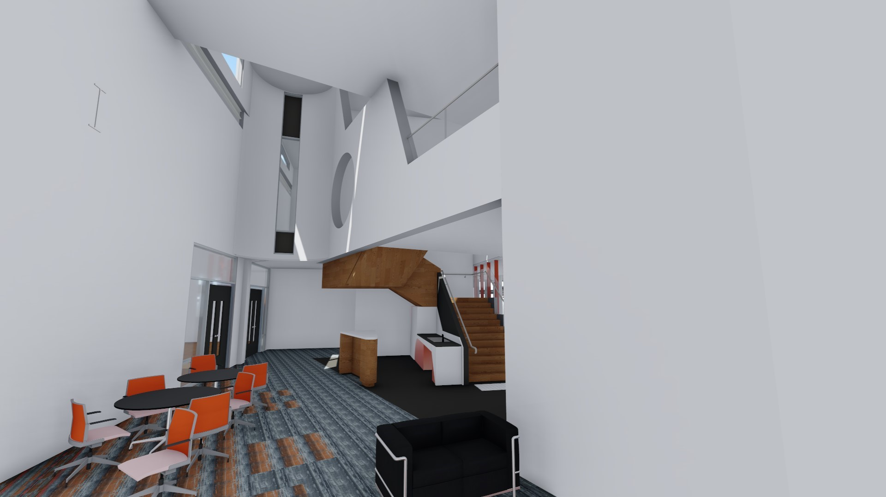

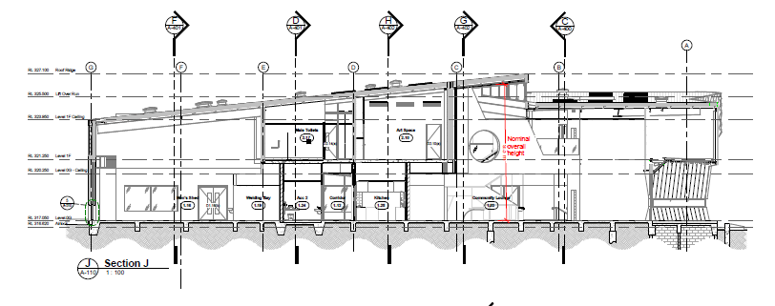

Public Art Location
