Notice No. Asset Property (4420) – 2017/2018
Country Fire Authority Regulations 2014

SCHEDULE 15
Regulation 112(1)
FIRE PREVENTION NOTICE
I direct: Josiah Hughes
of: 145 Wells Street
South Melbourne VIC 3205

The owner or occupier of: 5000024051, Fifth Avenue, Cockatoo

To do the work specified below:
- Cut/slash all grass for the entire property.
- Remove all ground cover to a height of 50 centimetres for the entire property.

All work must be completed no later than 12 March 2018

Date: 20 February 2018
Name of Authorised Officer: Janette Schimleck
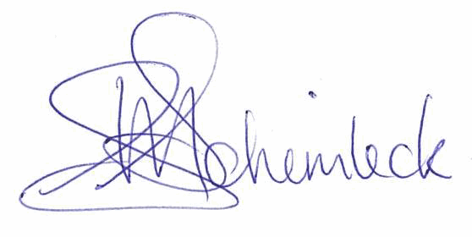
Position: Emergency Management Coordinator
Phone: 1300 787 624

Signature of Authorised Officer:……………………………………………..

Fire Prevention Officer for Cardinia Shire Council
You may lodge an objection to this notice under section 41B of the Country Fire Authority Act 1958 and appeal the outcome of that objection under section 41C of that Act.
PLEASE DO NOT IGNORE THIS NOTICE

You must maintain your property to the level described in this notice throughout the Fire Danger Period. In order to avoid fines and clearance costs you must organise the specified work to be undertaken by the due date. If you do nothing you may be fined or prosecuted (see the following page).

Further Inspections of properties may be undertaken.

Note: If a Covenant, Agreement or Enforcement Order concerning native vegetation or environmental assets relates to your land, you must contact Council immediately in writing. DO NOT conduct the works detailed in this Fire Prevention Notice until such time as you have discussed this with Council.

CONDITIONS OF THIS NOTICE

This Fire Prevention Notice has been issued under Section 41 of the Country Fire Authority Act 1958. The Fire Prevention Officer or an Assistant Fire Prevention Officer has formed the opinion that the specified works are necessary, or will become necessary, to protect life or property from fire.

The specified works on this Fire Prevention Notice are to be undertaken by the specified date.

Recommended contractors
Council is unable to recommend any specific contractors to undertake the specified works. The responsibility for compliance is on the person specified on the notice rather than any contractor. It is recommended that should a contractor be engaged, you verify that the works have been completed.

Failure to comply with the directions of this Fire Prevention Notice
The specified works must be undertaken by the date specified on the front of this notice.
Failure to comply will result in ‑
• Automatic forced clearance

Automatic ‘forced clearance’
The works specified on the Fire Prevention Notice will be automatically undertaken within 7 days of issuing a Fire Prevention Infringement Notice. This is referred to as a ‘forced clearance and is an automatic process. Forced clearance will occur irrespective of whether any works have been arranged or undertaken after the date that a Fire Prevention Infringement Notice was issued.

