Appendix 3: Additional data

Below is further information regarding population, Cardinia Shire’s data comparable with other councils, costs and e-waste.

Population data

- Cardinia annual changes in Estimated Resident Population. Source: Australia Bureau of Statics provided by Forecast id
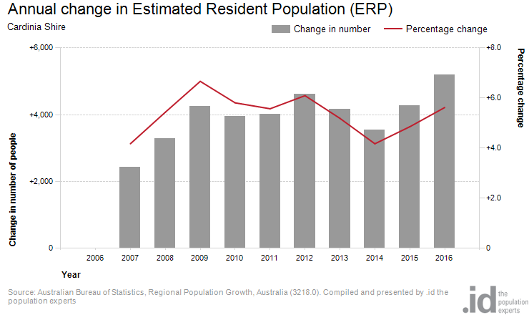

In Cardinia shire, parents and homebuilders aged 35−49 account for one fifth of the population (20.8%) reflecting the pattern of families relocating to the urban fringe seeking affordable housing. Figure 2 present’s Cardinia’s population breakdown as of 2017, by service age group.

- Estimated age structure, service age groups, Cardinia Shire, 2017
Cardinia Shire − total persons | 2017
Age group (years) | Number | %
Babies and preschoolers (0 to 4) | 8,160 | 8.2
Primary schoolers (5 to 11) | 10,888 | 11.0
Secondary schoolers (12 to 17) | 8,024 | 8.1
Tertiary education and independents (18 to 24) | 9,312 | 9.4
Young workforce (25 to 34) | 14,741 | 14.9
Parents and homebuilders (35 to 49) | 20,617 | 20.8
Older workers and pre-retirees (50 to 59) | 11,228 | 11.3
Empty nesters and retirees (60 to 69) | 8,468 | 8.5
Seniors (70 to 84) | 6,426 | 6.5
Elderly aged (85 and over) | 1,327 | 1.3
Total persons | 99,192 | 100.0

Know your Council data
Council reports annually on established measures which are made available to the community at www.knowyourcouncil.vic.gov.au. This reporting has been in place since 2014-15, and provides a good comparison to Average Councils and similar Councils.

- Cost of kerbside recyclables collection service per bin
Direct cost to Council of the kerbside recyclables collection service per kerbside recyclables collection bin | 2014−15 | 2015−16
Cardinia Shire | $22.63 | $22.02
Similar to Cardinia Shire Council average | $25.37 | $24.38
All council average | $37.28 | $38.04

- Cost of kerbside garbage bin collection service per bin
Direct cost to Council of the kerbside garbage bin collection service per kerbside garbage collection bin | 2014−15 | 2015−16
Cardinia Shire | $122.06 | $119.29
Similar to Cardinia Shire Council average | $88.57 | $95.51
All council average | $100.52 | $100.59

- Kerbside collection bins missed per 10,000 households
Number of kerbside collection bins missed per 10,000 scheduled kerbside collection bin lifts | 2014−15 | 2015−16
Cardinia Shire | 6.34 | 10.23
Similar to Cardinia Shire Council average | 6.69 | 6.63
All council average | 5.02 | 4.16

- Kerbside collection waste diverted from landfill
Percentage of garbage, recyclables and green organics collected from kerbside bins that is diverted from landfill | 2014−15 | 2015−16
Cardinia Shire | 46.00% | 46.05%
Similar to Cardinia Shire Council average | 46.89% | 46.22%
All council average | 40.86% | 42.92%

Comparisons between the measures for Cardinia Shire, compared with ‘All councils’ and ‘Councils similar to Cardinia Shire show’ that our recycling service is delivered at a lower cost than all councils and similar councils (Table 1), however our garbage service is more expensive than average and similar councils (Table 2). Providing waste collection services for a large shire combined with the long travel distances to the disposal and processing facilities means contract costs are higher than the average council, which is hard to avoid. Council has, however, secured a good price per tonne for its recyclables which has offset the collection costs for recyclables.

Table 3 shows that missed bins have increased in the recent 2015−16 year, having been previously aligned with similar councils. Keeping up with growth and new service requirements have been an ongoing challenge, together with servicing rural and difficult access areas.

- Kerbside diversion rate by local governments, Victoria 2014−15
Victorian Local Government Annual Waste Services Report 2014−15
Rank | Local government | Diversion rate 1* (%)
1 | Nillumbik Shire Council | 71%
2 | Moyne Shire Council | 61%
3 | Greater Geelong City Council | 56%
4 | Manningham City Council | 55%
5 | Knox City Council | 55%
6 | Corangamite Shire Council | 55%
7 | Surf Coast Shire Council | 54%
8 | Colac Otway Shire Council | 54%
9 | East Gippsland Shire Council | 53%
10 | Casey City Council | 53%
11 | Frankston City Council | 53%
12 | Monash City Council | 53%
13 | Greater Shepparton City Council | 53%
14 | Maroondah City Council | 52%
15 | Bayside City Council | 52%
16 | Baw Baw Shire Council | 51%
17 | Banyule City Council | 50%
18 | Boroondara City Council | 50%
19 | Mornington Peninsula Shire Council | 50%
20 | Whitehorse City Council | 49%
21 | Latrobe City Council | 49%
22 | Kingston City Council | 47%
23 | Moira Shire Council | 47%
24 | Cardinia Shire Council | 46%
25 | Hobsons Bay City Council | 46%
26 | Macedon Ranges Shire Council | 45%
27 | Alpine Shire Council | 45%
28 | Darebin City Council | 44%
29 | Glen Eira City Council | 44%
30 | Yarra Ranges Shire Council | 43%
31 | Wodonga City Council | 43%
32 | Moonee Valley City Council | 42%
33 | Greater Dandenong City Council | 42%
34 | Moreland City Council | 41%
35 | Melton Shire Council | 41%
36 | Campaspe Shire Council | 40%
37 | Central Goldfields Shire Council | 39%
38 | Indigo Shire Council | 39%
39 | Warrnambool City Council | 39%
40 | Whittlesea City Council | 39%
41 | Northern Grampians Shire Council | 38%
42 | Benalla Rural City Council | 38%
43 | Wyndham City Council | 37%
44 | Stonnington City Council | 36%
45 | Murrindindi Shire Council | 36%
46 | Mount Alexander Shire Council | 36%
47 | Wellington Shire Council | 36%
48 | Mildura Rural City Council | 36%
49 | Yarra City Council | 35%
50 | Southern Grampians Shire Council | 35%
51 | Glenelg Shire Council | 34%
52 | Mitchell Shire Council | 34%
53 | Moorabool Shire Council | 34%
54 | Maribyrnong City Council | 34%
55 | Brimbank City Council | 33%
56 | Strathbogie Shire Council | 33%
57 | Gannawarra Shire Council | 32%
58 | Wangaratta Rural City Council | 32%
59 | Hume City Council | 31%
60 | South Gippsland Shire Council | 30%
61 | Hepburn Shire Council | 30%
62 | Queenscliffe Borough Council | 29%
63 | Ballarat City Council | 29%
64 | Port Phillip City Council | 29%
65 | Mansfield Shire Council | 29%
66 | Buloke Shire Council | 28%
67 | Towong Shire Council | 28%
68 | Swan Hill Rural City Council | 28%
69 | Ararat Rural City Council | 27%
70 | Loddon Shire Council | 26%
71 | Bass Coast Shire Council | 25%
72 | Greater Bendigo City Council | 24%
73 | Yarriambiack Shire Council | 24%
74 | Golden Plains Shire Council | 21%
75 | Pyrenees Shire Council | 21%
76 | Melbourne City Council | 21%
77 | Hindmarsh Shire Council | 20%
78 | Horsham Rural City Council | 17%
79 | West Wimmera Shire Council | 16%
 | State average | 44%
*Diversion rate 1 refers to tonnes of recyclables and green organics collected (less contamination) divided by tonnes of garbage, recyclables and green organics collected.

Table 5 shows Cardinia Shire’s diversion rate, meaning the amount of recyclables plus green waste recovered as a proportion of total kerbside services (recyclables/green waste/garbage). Council is well-placed above the state average, but with opportunity to strive for higher rates achieved by other municipalities.

Costs
- Cost of kerbside waste services including disposal

Generally, waste services costs are going up, as shown in Figure 3. The significant increase in garbage has been partly attributed to rising EPA levy charges, especially since 2009−10. The exception is the recycling service which saw a sharp drop in overall costs by moving to a payment per tonne model for recyclables in 2011. This is the reason that of the total kerbside service costs, garbage makes up 54 per cent of costs, and recycling 10 per cent (Figure 4). Of course, the recycling service also operates fortnightly rather than weekly.

- Cost proportion of kerbside waste service (including disposal) 2014−15

- Break down of Cardinia Shire Council dumped rubbish collection costs

Figure 5 shows the breakup in costs for removal and disposal of illegally dumped rubbish. Staff and fleet costs to deliver the service make up the largest proportion, with disposal also a significant cost.

E-waste

- Trend of Cardinia Shire e-waste tonnes collected at Council drop off events per calendar year. Starting from 2012 ‘halve your waste’ program baseline data.

- Comparison of Cardinia Shire e-waste drop off event tonnages with collection of e-waste as part of the hard and green waste collection.
Year | Total tonnages | Number of events | Average tonnage per event
2012 | 24.966 | 2 | 12.5
2013 | 39.55 | 8 | 5
2014 | 42.87 | 7 | 6.12
2015 | 27.08 | 6 | 4.51
2016 | 16.71 | 6 | 2.78
Oct/Nov 2016 – hard waste collection | 7.53 | 1 | 7.53

Tonnages of e-waste collected by Council at its events peaked in 2013−14 (Figure 5) which coincided with the changeover to digital television an resulting disposal of analogue TVs. The addition of TVs and computers collected from the kerbside as part of the hard waste service achieved higher tonnages at less cost that hosted events, with the capacity to increase further as there is more awareness and familiarity with the service.

