Appendix 1 – Community engagement survey

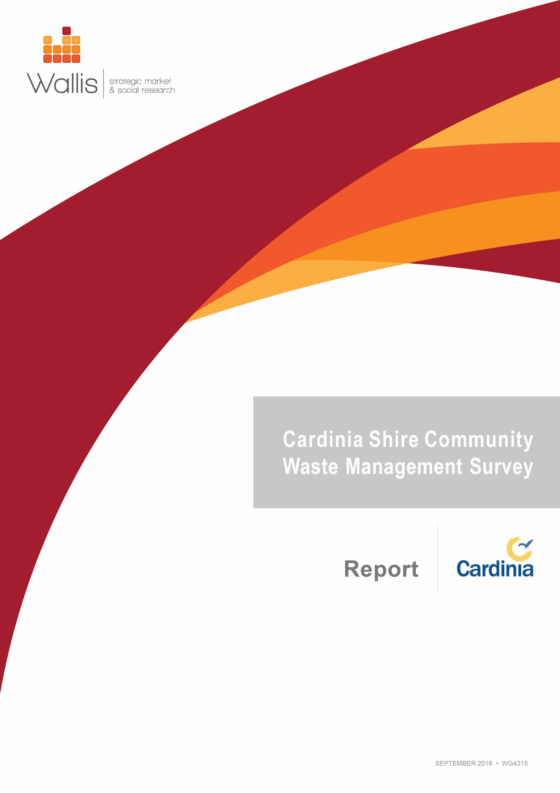

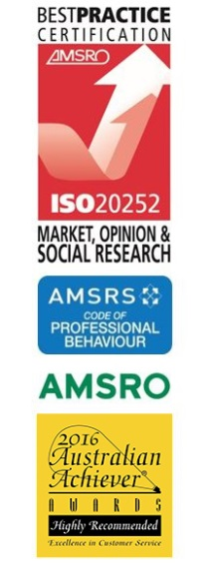

Wallis Market and Social Research achieved accreditation to the International Standard ISO20252 in September 2007. The Company is committed to maintaining administrative and operational procedures which comply with these accreditation requirements and to improving its performance in all aspects of the service it delivers to its customers. Wallis is an active participant in the market research industry, with senior staff making significant contributions to the Australian Market and Social Research Society (AMSRS) and the Association of Market and Social Research Organisations (AMSRO). As such we actively pursue the ethical objectives of the industry.

In addition to having attained the highest Industry accreditation, Wallis also participates in the Australian Achiever Awards, which recognises the customer service excellence of Australian companies. The Company has been awarded a high commendation every year since the inception of these awards in 1999.

Table of

Contents

Executive Summary 3

1.0 Introduction, Objectives & Methodology 5

1.1 Introduction 5

1.2 Objectives 5

1.3 Methodology 5

1.3.1 Questionnaire 5

1.3.2 Sample and Weighting 6

2.0 Hard Waste Service Requirements 7

2.1 Methods of Bulky Hard Waste Disposal 7

2.2 Support for a Booked Hard Waste Service 8

2.3 Meeting the Hard Waste Needs of Residents 9

3.0 Green Waste Service Requirements 11

3.1 Methods of Green Waste Disposal 11

3.2 The Future of Green Waste Disposal 12

4.0 Fees, Littering & Illegal Dumping Perceptions 14

4.1 Perceptions of Current Fees 14

4.2 Suggestions for Other Waste Services and Willingness to Pay 15

4.3 Concern for Various Waste Issues 16

4.4 Council Performance on Various Waste Issues 17

5.0 Education & Information 18

5.1 Waste Calendar Recall, Use and Preferences 18

5.2 Where Residents find Information on Local Waste and Recycling Services 19

5.3 The Future of Waste Services and Facilities 20

**Appendix 1 Questionnaire**

Table of

Figures

Figure 1 Methods of bulky hard waste disposal, by ward 7

Figure 2 Use of hard and bundled green waste service, by ward 7

Figure 3 Support for changing to a booked service, by age 8

Figure 4 Likelihood of using additional paid hard waste service, by age 8

Figure 5 Current hard and bundled green waste service meets needs, by ward 9

Figure 6 Suggestions for how Council could meet hard waste needs 9

Figure 7 Methods of Green Waste Disposal, by ward 11

Figure 8 Viability of green waste initiatives, by ward 12

Figure 9 Amount residents are willing to pay for green waste drop off facility, by ward 13

Figure 10 Frequency of drop off, overall 13

Figure 11 Reasons for finding the garbage charge and green waste fee unreasonable 14

Figure 12 Suggestions for other council services 15

Figure 13 Support for additional services resulting in an increased garbage charge 15

Figure 14 Concern for waste issues, by ward 16

Figure 15 Concern for waste issues, by age 16

Figure 16 Satisfaction with council performance, by age 17

Figure 17 Frequency of referring to calendar, by age 18

Figure 18 Preference for calendar to be issued in hardcopy or online, by age 18

Figure 19 Importance of waste management issues over the next 10 years 20

Figure 20 Importance of more tips and food/organics collection, by ward 21

Figure 21 Improvements in 10-years-time, by age 21

# Executive Summary

This report presents an insight into the attitudes and behaviours of Cardinia Shire Council residents in relation to waste management issues and options for the future of these services. These include disposal of hard rubbish, green waste, as well as littering, illegal dumping and Council provision of related education and information.

The report is based upon a survey of residents, commissioned by Cardinia Shire Council. Wallis Market & Social Research (Wallis) undertook the survey using a Computer-Assisted Telephone Interview (CATI) methodology. Fieldwork took place between 13 and 24 July 2016.

The vast majority (91%) of residents use the hard and bundled green waste service. For 88% of residents, the current hard and bundled waste service meets their needs. Of those who feel it does not meet their needs, the most common suggestion was more frequent collections (36%).

Support for changing to a booked service is only moderate overall, with a mean score of 6.2 out of 10. Support is highest in Central ward (6.9) and among those aged 18-29 (7.0)

Less than a third (31%) of residents would pay around $60 for an additional booked service. The vast majority of residents (97%) have disposed of green waste in the last 12 months. The most popular method of disposal is the green bin (60%), particularly in Central ward (76%).

Also relatively popular overall are composting and mulching (27%), particularly in Port (39%) and Ranges (37%) wards, and burning off (26%) which is actually the most common method of disposing of green waste in Port ward (40%). It is also very common in Ranges ward (47%).

Awareness of the green bin is very high overall (96%). Awareness is not as high for the twice yearly hard and bundled green waste service (82%) and is much lower for the additional three cubic metres available for $60 with less than a quarter of residents (22%) being aware of the service.

When presented with a list of potential green waste services, a free local drop of event for green waste was deemed the most viable (61%), particularly by Central ward residents (66%). This is followed by tip vouchers (55%), a home mulcher purchase rebate and additional bundled green waste collections (both 43%).

If Council were to establish a local drop off option for green waste 44% of residents state they would be likely to use it. Families with children under five would be particularly likely to use it (57%), while couples with no children at home (36%) and those living alone (25%) would be less likely.

Residents would be willing to pay an average of $20 to drop off a heaped 6x4 trailer of green waste locally. Those is Central ward would be willing to pay more ($24) and those aged 50+ would only be prepared to pay $14 on average. Residents would be most likely to use the service a couple of times a year or less (71%).

Just over two-thirds (68%) of residents think that the current garbage charge and optional green waste service fees are reasonable. The most common reasons for finding the fees unreasonable are that ‘it’s too expensive’ (25%), Rates are too high (14%), and the feeling that ‘we should not have to pay extra’ (13%).

One third (33%) of residents would like to see Council offer more services, top of the list being a hazardous/chemical waste collection (10%) which was particularly popular among families with children aged between 5-17 at home (15%). However less than a third (28%) of those residents would still feel the same if it resulted in an increase in the garbage charge. A further third (33%) said it would depend on the cost.

Concern for illegally dumped rubbish in bush reserves (8.3/10) is higher than for concern about illegally dumped rubbish in vacant blocks or on roads or nature strips (both 7.5) or concern for littering (6.6/10).

Around half (46%) of residents recall receiving councils new waste and recycling calendar. The majority of these residents (79%) have kept it, and are most likely to refer to it every 2-6 months (53%).

Over two-thirds (69%) of those who recall the calendar would prefer it in hard copy rather than to look it up online (26%), however the younger residents are much more open to the online version (42%).

Residents are most likely to look for information on local waste and recycling services on the Council website (60%).

Residents place high importance on various waste management issues over the next 10 years. In top spot was ‘capturing litter before it reaches waterways’ (100%), ‘community and childhood waste education’ (98%), ‘using recycled materials in Council assets’ (97%) and ‘minimising waste through buying goods without a lot of packaging or with a longer life’ (95%).

When asked what they would like to be different in terms of waste management in 10 years’ time the most popular response was allowing more materials to be recycled (30%), followed by reducing waste in general (14%), reducing packaging (11%) and more composting (10%).

# Introduction, Objectives & Methodology

## Introduction

This report presents the findings from a survey of Cardinia Shire residents on environmental attitudes and behaviours. The survey was undertaken by Wallis Market & Social Research (Wallis) on behalf of Cardinia Shire Council.

## Objectives

The key objectives of the survey are to gain an understanding of the views of Cardinia Shire residents around current waste collection services and options for the future of these services in order to inform the development of a new Waste Strategy for Cardinia Shire.

## Methodology

The survey was conducted between 13 and 24 July 2016 via telephone using Wallis’ Computer-Assisted Telephone Interviewing (CATI) facilities in Melbourne. All interviewers were given a full briefing prior to commencing work. In total, 700 interviews were completed with an average survey length of 15.2 minutes.

The questionnaire was also set up as an online survey, hosted on the Wallis platform, and promoted via Council’s social media and website channels. The online survey was open between 14 July and 24 August 2016, in which time 25 responses were received. The online results have not been included in the results presented in this report, except where specifically mentioned.

* + 1. Questionnaire

A questionnaire was developed by Wallis and refined in consultation with Cardinia Shire Council. The questionnaire was designed to include some topics similar to previous work undertaken by both Cardinia and Wallis.

A pilot test of 20 interviews was conducted on 7 July 2016, to identify any issues with question wording, flow, and timing. Following the pilot, some very minor revisions were made to the questionnaire. As a result, these 20 interviews were retained and included in the final analysis.

The survey captured information on the following topics:

Hard waste service requirements

Green waste service requirements

Fees, littering and illegal dumping perceptions

Education and information

Future opportunities.

The questionnaire used for this survey can be viewed in Appendix 1.

* + 1. Sample and Weighting

A random sample was drawn from a list of residential phone numbers, based on the three wards that make up the Cardinia Shire are. Each phone number/ household could only be represented by one household member. To participate in the interview, the respondent needed to be 18 or older.

Quotas by ward were set and achieved, so as to provide an adequate representation from the wards to allow for meaningful comparisons between them. The final number of interviews from each ward is shown below:

The data was weighted by age and gender to reflect the actual distribution of the population (aged 18+) across each ward within Cardinia Shire.

|  |
| --- |
| **Please note that:**  Survey results presented in this report are based on weighted data (but sample sizes shown are the unweighted bases).  In comparative Charts and Tables in this report, significantly higher proportions are indicated by **green** figures whilst significantly lower proportions are indicated by **red** figures.  Numbers (percentages) quoted in this report are subject to rounding.  Some of the base sizes for sub-groups in the data are small; care should be taken when interpreting findings where the base is fewer than 30 respondents. |

# Hard Waste Service Requirements

## Methods of Bulky Hard Waste Disposal

The main way Cardinia Shire residents dispose of their bulky hard waste overall is the hard waste collection (82%). Younger residents, aged 18-29, are less inclined to use the hard waste collection (72%), while conversely those aged 50+ (84%) are much more likely to use the service overall.

Figure 1 Methods of bulky hard waste disposal, by ward

|  |  |  |  |  |
| --- | --- | --- | --- | --- |
| **Methods** | **Total** | **Central ward** | **Port ward** | **Ranges ward** |
| Hard waste collection | 82% | 84% | **75%** | 18% |
| Waste facility (tip) | 20% | 19% | 24% | 84% |
| Skip bin | 3% | 4% | 4% | 3% |
| Donate to charity | 2% | 1% | 1% | 2% |
| Utilise a private collection/ house clearance company | 2% | 2% | 2% | 1% |
| Sell | 2% | 2% | 1% | 1% |
| Giveaway | 1% | 1% | 3% | 0% |
| Refused | 1% | 1% | - | 1% |
| Don't know | 4% | 3% | 5% | 5% |
| A1 - How do you currently dispose of your bulky hard waste?  Base: All respondents | | | | |

When prompted, the vast majority of residents (91%) confirm that they use the hard and bundled green waste service (82% unprompted).

Figure 2 Use of hard and bundled green waste service, by ward



## Support for a Booked Hard Waste Service

Support for changing to a booked service, where residents could phone Council to arrange a collection of hard and bundled green waste from their property at a time that suited, achieved a mean score of 6.2 out of 10. Across the wards, support is significantly higher in Central (6.9) and lower in Ranges (5.6). Support for the initiative is highest among younger residents (aged 18-29) with a mean score of 7.0 and significantly lower overall from those aged 50+ (5.6).

Figure 3 Support for changing to a booked service, by age



When presented with the option of having two free, booked services a year with the choice to pay around $60 for any additional services, less than a third (31%) of residents would be ‘very’ or ‘somewhat’ likely to use the paid services. However, significant differences were observed across age groups with over half (53%) of 18-29 year olds indicating they would be likely to use the paid services, while only 17% of those aged 50+ would do the same.

Those residing in Port ward (23%) are much less likely to use the additional services for a fee.

Figure 4 Likelihood of using additional paid hard waste service, by age



## Meeting the Hard Waste Needs of Residents

For the majority of Cardinia Shire residents, the current hard and bundled green waste service meets their needs (88% overall).

Figure 5 Current hard and bundled green waste service meets needs, by ward



Residents who feel that the current hard and bundled green waste service does not meet their needs provided a number of suggestions as to how Council could better meet their needs. Top of the list is more frequent pickups (36%), followed by having greater flexibility and allowing more materials to be collected (14%), and free or cheaper visits to the waste station or tip (12%).

Figure 6 Suggestions for how Council could meet hard waste needs

|  |  |
| --- | --- |
| **Suggestion** | **Total** |
| More frequent pick-up | 36% |
| Allow more materials to be collected/greater flexibility in collection piles | 14% |
| Free/cheaper visits to the waste station/tip | 12% |
| Allow for larger collections | 10% |
| Let resident book/choose pick up time | 10% |
| More FREE pick-up(s) | 9% |
| Better notification of collections | 4% |
| Other | 5% |
| No suggestions | 19% |
| A5 - Are there any other ways you think Council could better meet your needs regarding hard waste disposal?  Base: All who say the hard waste and bundled green waste service does not meet their needs | |

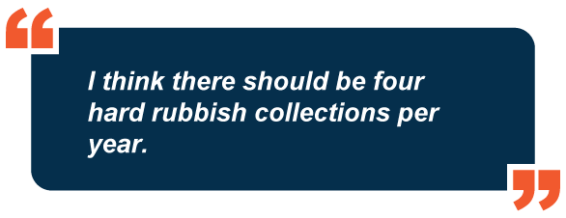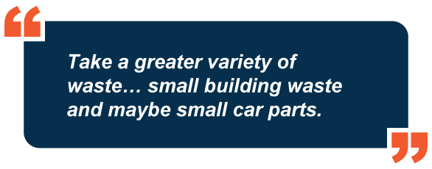

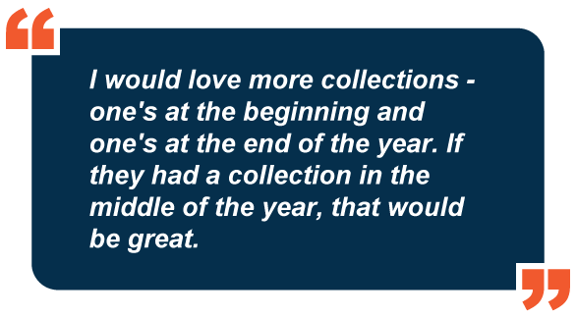

# Green Waste Service Requirements

## Methods of Green Waste Disposal

The vast majority (97%) of Cardinia Shire residents have disposed of green waste in the last 12 months. The most popular method of disposal is the green waste bin (60%), however significant differences can be seen across the wards. The proportion of residents using the green waste bin is much higher in Central ward (76%) and much lower in Port (39%) and Ranges (51%) wards. This proportion has increased overall since the 2010 survey, where only 37% of residents reported using the optional fortnightly kerbside green waste collection service.

The next most popular method of disposal is composting/mulching (27%) and again there are significant differences across the wards with residents of Port (39%) and Ranges (37% wards being much more likely to compost/mulch. Differences can also been seen across the age groups, with residents aged 50+ (36%) significantly more inclined to compost or mulch their green waste, and the 18 to 29 year olds (14%) much less likely to do so. Overall this proportion has remained relatively stable since the 2010 survey, where 33% of residents reported composting or mulching in the previous 12 months.

Overall, more than a quarter of residents (26%) ‘burn off’ their green waste, although this is much more common in Ranges (47%) and Port (40%) wards, and quite rare in Central ward (6%). The proportion of residents burning of has also decreased since the 2010 survey, where 49% of residents reported burning off green waste in the previous 12 months.

Figure 7 Methods of Green Waste Disposal, by ward

|  |  |  |  |  |
| --- | --- | --- | --- | --- |
| **Methods** | **Total** | **Central ward** | **Port ward** | **Ranges ward** |
| Green waste bin | 60% | **76%** | **39%** | **51%** |
| Composted/mulched it | 27% | **14%** | **39%** | **37%** |
| Burnt it | 26% | **6%** | **40%** | **47%** |
| Twice yearly hard and bundled green-waste collection | 6% | 7% | 5% | 5% |
| Taken it to a waste facility (tip) | 5% | 4% | 6% | 4% |
| Garbage bin | 3% | 4% | 4% | 2% |
| Fed it to animals | 3% | **1%** | **7%** | 5% |
| Have not disposed of green waste | 3% | **4%** | 2% | 1% |
| My gardener takes it away | 2% | **3%** | 1% | 0% |
| We use a skip/other bins | 1% | 1% | - | 0% |
| Other | 2% | 2% | - | 1% |
| B1 - In what ways have you disposed of green waste in the last 12 months?  Base: All respondents | | | | |

Awareness of the green bin service is very high overall (96%) and when prompted, around two-thirds of residents (71%) confirm that they use the service (60% unprompted). Use of the green bin service is significantly higher in Central ward (87%), and much lower in Port (52%) and Ranges (60%) despite similar levels of awareness. Of those residents who have not used the green bin service, 22% would consider using it in the future.

Not quite as many people know about the twice-yearly hard and bundled green waste service, although still a large proportion overall (82%), with residents aged 50+ (86%) significantly more likely to know about it. Over two-thirds (70%) of residents aware of the service have used it, and 43% of those who were not aware of the service would consider using it in the future. Less than a quarter (22%) of residents are aware of the additional three cubic metres available for collection (for $60) as part of the hard and bundled green waste collection, and again awareness is higher among those aged 50+ (24%). Of the residents who were aware of the service only 4% had made use of it however, of those who had not been aware of it, 30% would consider using it in the future. Residents of Central ward (41%) are significantly more likely to consider this option in the future.

## The Future of Green Waste Disposal

Residents were presented with a list of potential green waste initiatives and asked which would be a viable option for them. Free local drop-off events for green waste, similar to Councils e-waste services, is the most preferred initiative with 61% of residents overall feeling it is a viable option for them (significantly higher in Central ward at 66%). Tip vouchers for subsidised use at waste facilities (55%) is the next most popular, followed by a rebate to help purchase a home mulcher and additional bundled branch collections throughout the year (both 43%).

Figure 8 Viability of green waste initiatives, by ward

|  |  |  |  |  |
| --- | --- | --- | --- | --- |
| **Response** | **Total** | **Central ward** | **Port ward** | **Ranges ward** |
| Local drop off events for green waste for free (similar to Councils e-waste events) | 61% | **66%** | 57% | 56% |
| Tip vouchers for subsidised use at waste facilities | 55% | 58% | 62% | **45%** |
| A rebate to help purchase a home mulcher | 43% | **39%** | 50% | 45% |
| Additional bundled branch collections similar to the hard waste throughout the year | 43% | **49%** | 40% | 37% |
| Further help to do more home composting/ chicken rearing | 38% | 37% | 42% | 38% |
| An additional green waste bin at a lesser subsided fee | 25% | **29%** | 24% | 19% |
| Local drop off events for green waste for a fee | 19% | 21% | 18% | 18% |
| An additional green waste bin for a charge of $133 per year | 11% | 12% | 11% | 10% |
| None of the above | 13% | 13% | 10% | 15% |
| B2 - Which of these do you think it would be a viable option for you?  Base: All who have disposed of green waste | | | | |

If Council established a local drop off option for green waste 44% of residents would be ‘very’ or ‘somewhat’ likely to use the service. Likelihood to use the service is fairly stable across the wards.

Residents who are ‘somewhat’ or ‘very’ likely to use a local green waste drop off service would be willing to pay an average of around $20 to drop off a heaped 6x4 trailer load of green waste locally. The amount is significantly less for residents aged 50+ at around $14, and significantly higher for those in Central ward ($24).

Figure 9 Amount residents are willing to pay for green waste drop off facility, by ward



Residents would be most likely to use the service a couple of times a year or less (71%).

Figure 10 Frequency of drop off, overall



# Fees, Littering & Illegal Dumping Perceptions

## Perceptions of Current Fees

Just over two-thirds (68%) of residents think that the current garbage charge and optional green waste service fees are reasonable. Those residing in Port ward (74%) are the most likely to find the fees reasonable, while males (76%) are much more likely to find the fees reasonable than their female counterparts (61%). Residents living alone are significantly less likely (53%) to find the charges reasonable overall.

The most common reasons for finding the fees unreasonable are that ‘it’s too expensive’ (25%), Rates are too high (14%), and the feeling that ‘we should not have to pay extra’ (13%).

Those who participated in the survey online were more likely to think these charges were reasonable (72%) however the most common reason for expressing dissatisfaction with fees was as a result of green waste services being too expensive (42%).

Figure 11 Reasons for finding the garbage charge and green waste fee unreasonable

|  |  |  |  |  |
| --- | --- | --- | --- | --- |
| **Reason** | **Total** | **Central ward** | **Port ward** | **Ranges ward** |
| It's too expensive | 25% | **31%** | 29% | **14%** |
| Rates are too high | 14% | 13% | 11% | 15% |
| I thought it was covered by the rates/ we should not have to pay extra | 13% | 12% | 8% | 17% |
| Green waste service too expensive | 9% | 9% | 8% | 9% |
| I don't use the service all the time(at all) but I have to pay | 8% | 7% | 12% | 8% |
| It's hard to pay for those on the pension/low incomes | 8% | 11% | 9% | 3% |
| We don't get value for money for current fees/rates | 6% | 4% | 9% | 9% |
| C1b - Why do you say that? | | | | |
| Base: All who do not think/don't know whether the annual garbage fees are reasonable | | | | |

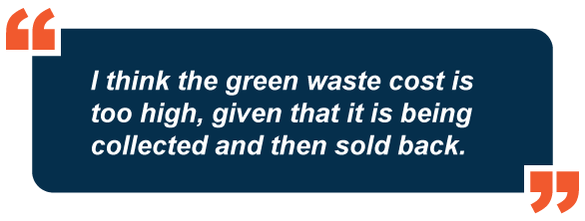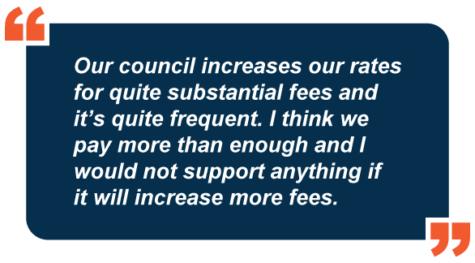

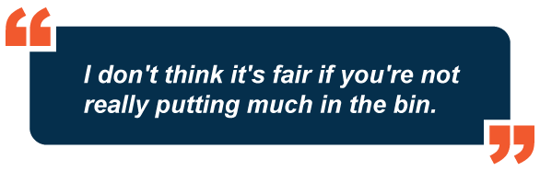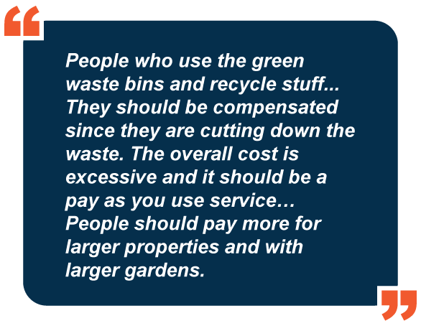

## Suggestions for Other Waste Services and Willingness to Pay

One third of residents (33%) would like to see other services provided by Council. The service most frequently mentioned is a hazardous/chemical collection, including oil and paint (10%). This is particularly popular amongst families with children aged 5-17 at home (15%).

A much higher proportion of online respondents, 60%, would like to see Council provide other services.

Figure 12 Suggestions for other council services

|  |  |
| --- | --- |
| **Methods** | **Total** |
| A hazardous waste/ chemicals collection (oil and paint) service | 10% |
| A electronic waste service (e waste)service | 4% |
| Batteries/car batteries | 4% |
| A car parts/tyre disposal service | 3% |
| More frequent hard waste collection | 3% |
| Extra bins at no further cost/ lower waste management costs | 3% |
| Better information on what/when you can recycle | 3% |
| B1 - In what ways have you disposed of green waste in the last 12 months?  Base: All respondents | |

However, when faced with the prospect of any additional services resulting in an increased garbage charge, support wavered. Residents were roughly split by thirds – 28% of those who would like to see further waste services provided would still feel the same if the garbage charge is increased to accommodate the additional services, while 35% would not. The remaining third (33%) feel that it would depend on the cost.

Figure 13 Support for additional services resulting in an increased garbage charge



## Concern for Various Waste Issues

Residents were asked to rate their concern for the following issues:

Littering

Illegally dumped rubbish on roads and nature strips

Illegally dumped rubbish in bush reserves

Illegally dumped rubbish in vacant blocks

Overall, residents have the highest level of concern regarding illegal dumping in bush reserves, with a mean score of 8.3 out of 10. Concern for this issue is highest among residents of Port (8.6) and Ranges (8.5) wards, but significantly lower in Central ward (8.0). There were equal levels of concern overall for illegally dumped rubbish on roads and nature strips and in vacant block (both 7.5) with concern in Port ward highest for both issues (7.9 and 7.8 respectively). The issue with the lowest, but still considerable, level of concern overall is littering (6.6) which is again slightly higher in Port ward (6.9).

Figure 14 Concern for waste issues, by ward

|  |  |  |  |  |
| --- | --- | --- | --- | --- |
| **Issue** | **Total** | **Central ward** | **Port ward** | **Ranges ward** |
| Littering | 6.6 | 6.6 | 6.9 | 6.5 |
| Illegally dumped rubbish on roads and nature strips | 7.5 | 7.3 | 7.9 | 7.6 |
| Illegally dumped rubbish in bush reserves | 8.3 | **8.0** | 8.6 | 8.5 |
| Illegally dumped material in vacant blocks | 7.5 | 7.5 | 7.8 | 7.4 |
| C3a-d - How concerned are you with the following issues within Cardinia Shire? | | | | |
| Base: All respondents | | | | |

Concern for these issues in general tends to increase with age. Residents aged 50+ have a significantly higher level of concern for all issues, while concern amongst the 18-29 year olds is much lower overall.

Figure 15 Concern for waste issues, by age



## Council Performance on Various Waste Issues

Residents were then asked to rate their satisfaction with Council’s performance in terms of:

Discouraging littering and illegal dumping

Cleaning up litter

Cleaning up illegally dumped rubbish

Providing enough litter and recycling bins in public

While satisfaction is fairly similar across the wards, it is significantly higher among the 50+ age group for each of the service aspects.

Figure 16 Satisfaction with council performance, by age



On average respondents were more satisfied with the Council’s performance in cleaning up litter (6.3) and were least satisfied with their performance in discouraging littering and illegal dumping (5.7). A notable proportion of residents (7%) didn’t know how they felt about this issue.

# Education & Information

## Waste Calendar Recall, Use and Preferences

Almost half (46%) of Cardinia Shire residents remember receiving Council’s new waste and recycling calendar, with highest levels of recall among those aged 50+ (59%) and lowest among the youngest cohort (18-29, 37%).

The majority of those who recall the calendar have kept it (79%) and this is again highest in the 50+ age group (85%), as well as residents in Ranges ward (86%).

Those who have held onto the calendar are most likely to refer to it every 2-6months (53%), and younger residents (aged 18-29) are more inclined to refer to it more frequently (weekly/fortnightly/monthly) than older age groups.

Figure 17 Frequency of referring to calendar, by age

|  |  |  |  |  |
| --- | --- | --- | --- | --- |
| **Frequency of Reference** | **Total** | **18-29 years** | **30-49 years** | **50+** |
| At least once a week | 5% | 10% | 5% | 4% |
| Once a fortnight | 9% | 17% | 8% | 6% |
| Once a month | 17% | 25% | 15% | 15% |
| Once every 2-3 months | 24% | 10% | 29% | 25% |
| Once every 4-6 months | 29% | 20% | 28% | **33%** |
| Less often/never | 15% | 14% | 14% | 17% |
| D2c - How often do you refer to the calendar? | | | | |
| Base: All who recall receiving a waste and recycling calendar and have kept it | | | | |

The chart below shows residents’ preference on receiving the calendar in hardcopy or looking it up online. Overall, the hardcopy is most preferred (69%) although the levels of preference varied by age group.

Figure 18 Preference for calendar to be issued in hardcopy or online, by age



## Where Residents find Information on Local Waste and Recycling Services

Cardinia Shire residents are most likely to look for information about local waste and recycling services on Council’s website (60%), although there is less use of this source by residents in Port ward, and those aged 50+ (both 49%).

Figure 19 Residents’ sources of information

|  |  |
| --- | --- |
| **Response** | **Total** |
| Council website | 60% |
| Internet - via search engine (e.g. Google) | 16% |
| Phone Council's customer service | 10% |
| Local newspaper(s) | 5% |
| Council's Connect magazine | 4% |
| Family, friends, neighbours | 3% |
| Flyers | 2% |
| Direct Mail/letters/newsletters | 2% |
| Visit the Council / go into the Council | 2% |
| Social media | 1% |
| Community noticeboards | 1% |
| Phone Book | 1% |
| Community groups | 1% |
| Council (no further info) | <1% |
| Posters | <1% |
| Apps | <1% |
| Post Office | <1% |
| Internet - named website e.g. recyclingnearyou.com.au | <1% |
| None / nowhere else | 3% |
| Other | 3% |
| Don't know | 2% |
| D3 - Where (else) would you look to find information about local waste and recycling services? | |
| Base: All respondents |  |

## The Future of Waste Services and Facilities

Respondents were asked to rate the importance of a number of waste management issues in Cardinia Shire over the next 10 years. All of the issues were rated very highly in importance, with scores ranging from 75% to 100% of residents feeling they were ‘somewhat’ or ‘very’ important.

Capturing litter before it reaches waterways is given the highest importance with almost 100% of residents considering it ‘somewhat’ or ‘very’ important. This is followed by ‘community and childhood related waste education (98%) and using recycled materials in council assets such as park furniture and road bases.

Figure 20 Importance of waste management issues over the next 10 years

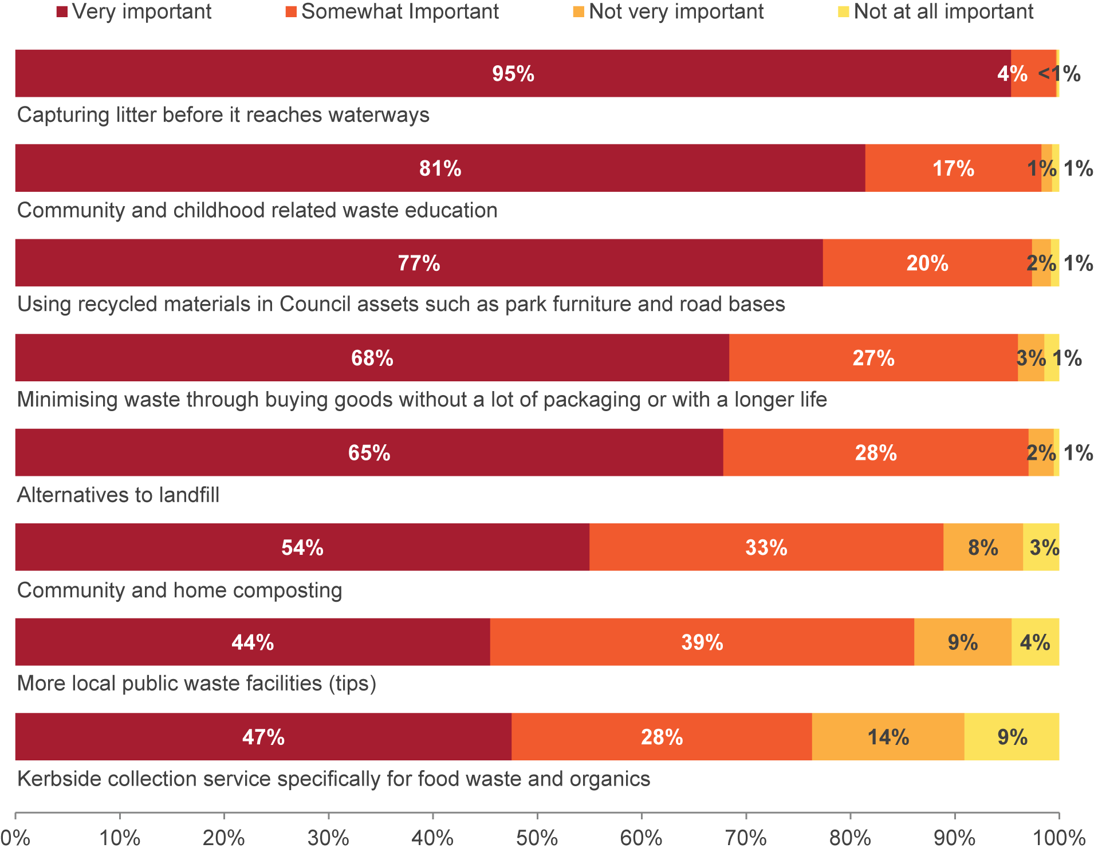



When compared with overall importance ratings, females are significantly more likely to place importance on using recycled materials in Council assets (99%), waste minimisation through smart purchasing (97%), composting (90%), more public local waste facilities (86%), and kerbside food waste and organics collection (80%).

Central ward residents were significantly more likely to place importance on more local public waste facilities (86%, compared to 83% overall) and a food waste and organics collection service (80%, compared to 75% overall). Conversely, those in the Ranges ward are significantly less likely to place importance on a food waste and organics collection (68%), although this is still relatively high overall.

Figure 21 Importance of more tips and food/organics collection, by ward



Respondents were given an open-ended question, asking them what they would like to be different in 10 years’ time in terms of kerbside collections, resource recovery, and/or landfill. The most popular response is allowing more materials to be collected/recycled (30%), which is particularly prevalent among 18-29 year olds (43%) but less popular in Port ward (20%). Seven per cent of residents overall are happy with the current service and have no suggestions to improve the waste management system within the Shire.

Figure 22 Improvements in 10-years-time, by age

|  |  |  |  |  |
| --- | --- | --- | --- | --- |
| **Suggestion** | **Total** | **18-29 years** | **30-49 years** | **50+** |
| Allow more materials to be collected /recycled | 30% | **43%** | 32% | **19%** |
| Reducing waste | 14% | 12% | 17% | **12%** |
| Reduce packaging/plastic bags | 11% | 10% | 11% | 11% |
| More composting | 10% | 10% | **14%** | **5%** |
| More education on reducing packaging | 8% | 11% | 7% | 8% |
| More education on waste reduction | 8% | 7% | 8% | 7% |
| It is currently good/ satisfactory | 7% | 3% | **2%** | **13%** |
| D7 - In 10 years' time what would you like to be different in terms of waste management? | | | | |
| Base: All respondents | | | | |

